

**Trailer Specifications:**

*Specializing in Customized Solar Powered Trailers and Skids*

*“Making Power Mobile”*

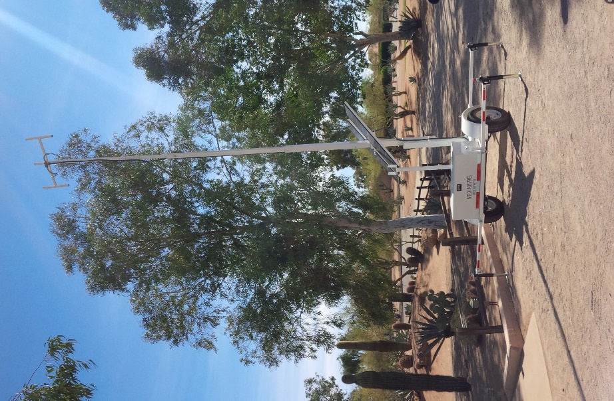

|  |  |
| --- | --- |
| Width | 4ft |
| Length | 6ft |
| Weight (max. load) | 2,500 lbs- Single axle |
| Chassis | Welded Steel Tubing Frame, Diamond Plating Deck, Weather/Vandal Resistant Housings |
| Lockable Tool Box | H 17” x W 18” x L 42” |
| Stabilization | 4-6 Point- Heavy Duty adjustable/retractable outriggers |
| Towing Connections | 2 inch ball receiver. |
| Mast Height | Deployed fully extended height: 20 feet-25 feet |
| Mast Length | Retracted horizontal length: 12 feet |
| Mast Deployment Mechanism | Manual raise, extend and lower |
| Towing Clearance | 7 feet |
| Solar Panels Placement | Mounted on Mast, ability to tilt to desired angle |
| Batteries | 2-4 - 110AH Deep Cycle |
| Solar Modules | 2 - 190 Watt, 24V Solar Modules |
| Charge Controller | Digital Charge Controller with Digital Screen |

|  |  |
| --- | --- |
| Optional Features | Lunette ring for Pintle Hook Receiver  4 Pole wiring harness & Brake lights system  Electrical wench for raise, extend and lowering of mast |

**EXAMPLES OF 4X6 TRAILERS**

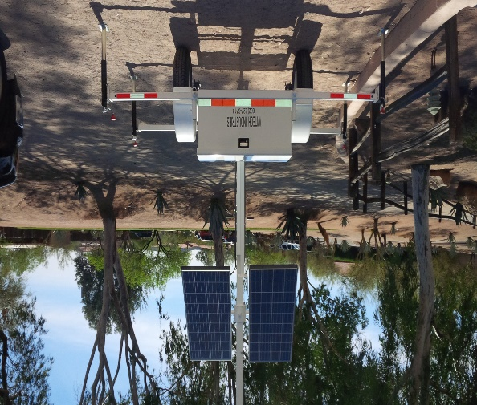 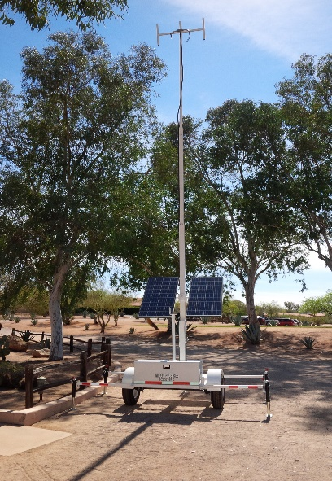

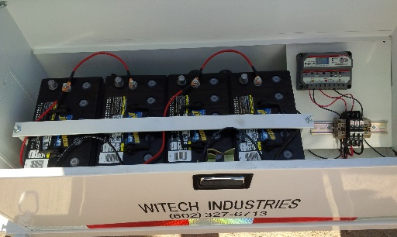 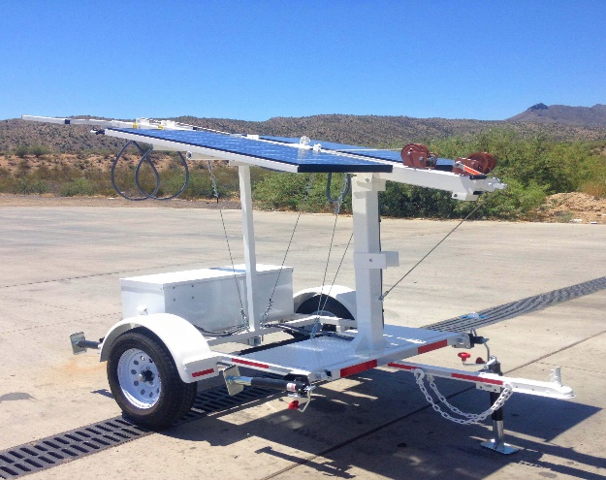

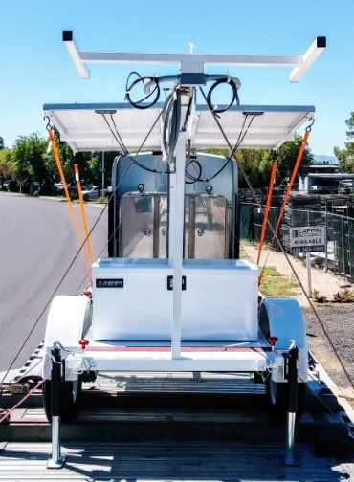 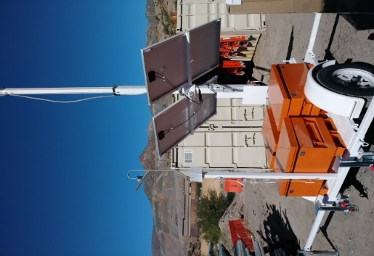 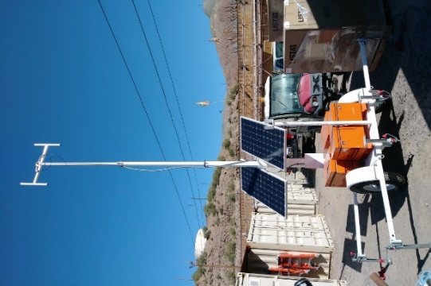

**EXAMPLES OF 3X4 TRAILERS**

