God’s Love Ministries Church  P.O. Box 2683  Stafford, Virginia, 22555  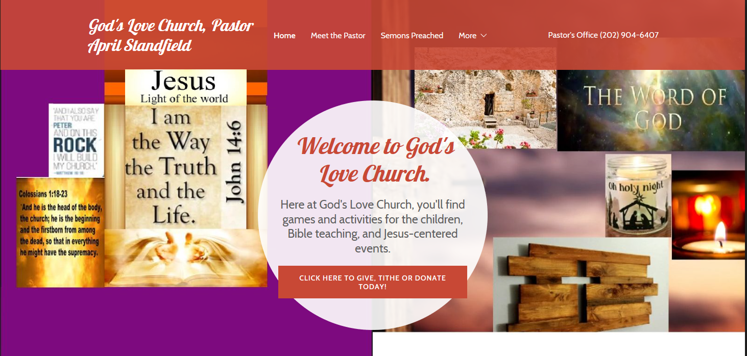 | [202-904-6407]

Baptism Form

Baptismal Candidate Information
 | Date
Name (Last, first, middle initial) | Age of Baptismal Candidate
Street address, City, ST, ZIP Code
Primary phone number | Other phone number | Email address
Type of Request:
- Baptism | - Rededication to Jesus
- Confidential communication | - Salvation Prayer
Please describe your Church affiliation, and whether you have been baptized before or not, in detail.
[Note: This is a Baptismal request form, please list if you are receiving medical services for seizures, paralysis, or muscle-control abnormalities, or any other medical information you feel we should know.]
Please list all Baptismal candidate members that you wish to receive Baptism:
Name |  | Age and Date of Birth
Name |  | Age and Date of Birth
Candidate or Parent Signature |  | Date Signed
For Church Staff Use Only:
 |  | Date received
Action taken
 |  | Date
Action taken
 |  | Date
Privacy Official signature |  | Date
Attach additional documentation, if applicable.

