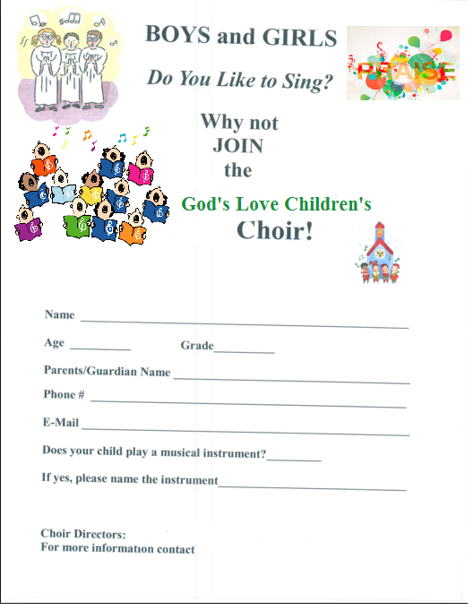
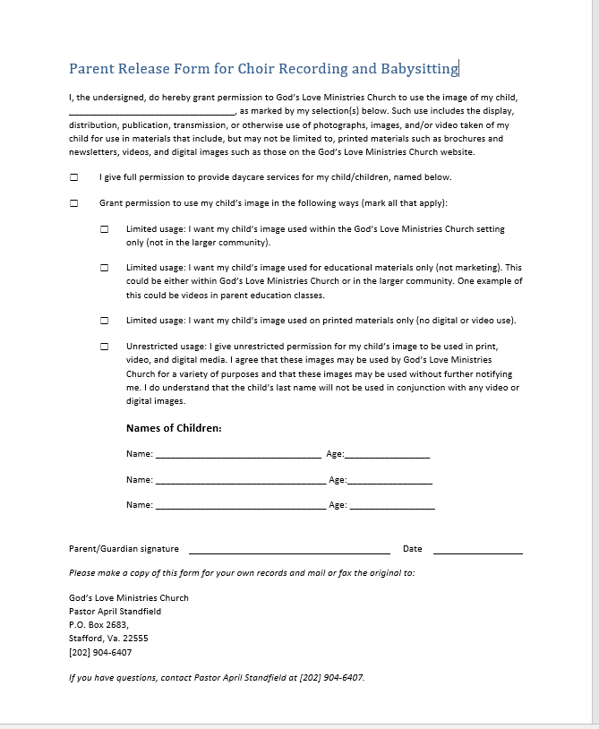

I, ____________________________________________________________, parent/guardian of ______________________________, do agree to allow God’s Love Ministries Church, and its Staff to care for my children. I agree to abide by the rules and notify the Church childcare staff if my child is sick, injured, or may have a communicable disease. I agree to the staff caring for my child for daycare, babysitting, Church fellowships, outings, and any Church-related activities. I agree to hold harmless the Church and its staff/workers for any physical and/or mental injury that may be incurred, including, but not limited to my child/children being hit or hurt by another child, or in the unlikely event of choking, fever, rash, falls, any allergic reactions, or injury. I understand that children play, and that I will not blame, or sue, or press any civil or criminal charges on any of the Church staff, or Pastor if my child is ever hurt, another child hits them, or any similar activity takes place, or any other activity that is not named herein, (including injury, illness, or worse). I will notify the Church staff of any allergies to any foods, creams, or lotions. I understand that especially in the summer months, the children will be protected with sunscreen, and/or bug-repelling lotion or spray, and I will notify the staff should my child be allergic to any of these creams, sprays, or lotions. Yes, the Church staff may babysit and care for my child/children.
Signed: __________________________________________________ Date: ___________
Here is important information about my child:
Child’s Name: _____________________________________________________________
Child’s Doctor: ____________________________________________________
Doctor’s Phone and Address: _____________________________________________________

Any allergies: ________________________________________________________________

Any dislikes: _______________________________________________________________

Special Pick-Up Instructions (Who is authorized to pick this child up?): ____________________________________________________

Nap/Quiet time information: _____________________________________________________

Favorite Songs/activities: _________________________________________________________________

