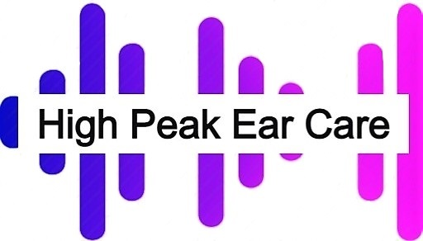
MICROSUCTION TERMS AND CONDITIONS
We are governed by these terms and conditions.
Wax removal via micro suction is considered safer than other methods. Complications of ear wax removal with micro suction are uncommon; however possible complications, side-effects and material risks inherent in the procedure include but are not limited to: Incomplete removal of ear wax requiring are turn visit (for severely impacted wax), minor bleeding, discomfort, ringing in the ear (tinnitus),perforation of the ear drum and hearing loss.
To ensure the risk of complication is minimal, it is essential that accurate past medical history is supplied to our clinicians. In addition, it is important that the patient remains relatively still during the procedure as sudden movement may significantly increase the risk of ear drum perforation, permanent hearing loss and/or bleeding.
The CE marked suction unit is to remove fluids from the airway or respiratory support system and infectious materials from wounds and has been adapted for aural micro suction.
By agreeing to these terms and conditions you accept that you have read and understand the possible complications that may occur and agree that High Peak Ear Care, or any of its employees, cannot be held responsible for them. I have read and understood the terms and conditions above and am willing to be bound by them.
Please enter the full name of guardian if the patient is under 18 years of age.
The guardian takes full responsibility that the patients application form is completed in full and correct. Details must be entered before the patient can receive any treatment.

10.10.22 High Peak Ear Care
Netherfield Rd, Chapel en Le Frith, Derbyshire

