**INTRODUCTION**

**2025 UPDATE**

The original Comprehensive Land Use Plan for the City of Moro was completed in 1977 and 1978 and was adopted in late 1978. In 1980, the Land Conservation and Development Commission acknowledged and approved the City’s Comprehensive Plan. That Plan has remained intact for nearly 30 years. In the autumn of 2005 and early in 2006, through a grant request filed, by Sherman County, on behalf of the County’s four incorporated cities of Wasco, Moro, Grass Valley, and Rufus, the Department of Land Conservation and Development made funds available to the County to facilitate the update of each jurisdiction’s Comprehensive Plan.

It is now almost 20 years since the 2006 update of the City’s Comprehensive Plan. The Transportation element was updated in 2015 for Moro and the other incorporated Cities in the County. The major change in that update was to adopt new street design standards. This 2025 update being undertaken as an ancillary task while the City looks at the concepts put forward by the State to solve the housing shortages throughout the State. The current focus is on Middle Housing, a program designed to provide more affordable housing in the City.

**ISSUES**

The City of Moro, along with the other three incorporated cities and Sherman County, are on the threshold of a period of growth and prosperity in the County. Events are taking place that will bring modest growth to all of the communities and to the County. As will be presented in this Plan, there are a number of activities on the horizon that will significantly change the stagnant population growth rate of all entities. The issue facing the jurisdictions is how to handle this modest growth, what public facilities must be provided, how to encourage specific types of growth, and to determine what types of amenities will be needed.

Since the early 2000’s, approximately 900 wind power machines have been brought on line in the County. These Wind Farms are primarily located north of the City of Moro as the City’s location marks the southern limit of suitable location of Wind Farms. The actual amount of wind available south of Moro is the determining factor for this limitation. The County is experiencing substantial development of Solar Power Energy Facilities in southern areas of the County as this is being written. While no one has applied or have been approved, it is understood that several Solar Power Energy Farms are in the planning stages.

**PLANNING FOR MORO IN 2025**

This update process began by reviewing the current Plan and deleting the information that is no longer considered relevant in a Land Use Plan. Then, where possible, update the material for which new information or database is available, while keeping the material that is still valid for the jurisdiction. For example, the information on the history of Moro has not changed and that will simply be reprinted as it was in 1978.

The City has undertaken a number of small planning efforts over the years, including two periodic reviews and other minor updates. The City participated in the countywide transportation system plan in 2015 and that information is included in this update. This Plan draft was prepared by the City’s long-time land use planner and was made available to the City Council and other interested parties for review and comment. There will be opportunities for public comment in the public hearing process leading to the final adoption of the updated Comprehensive Plan.

**PLANNING PROCESS**

The basic questions that are addressed in a land use planning process are as follows:

* What do we have today?
* What type of land use patterns do we want in the years to come?
* How do we achieve these aspirations?

In over simplified terms, the answers to these questions are sought through the planning process. Generally defined, the planning process includes researching inventories, analysis, planning, implementation, and review. The update of this Plan is segregated into four of these phases. The final phase, the review phase, provides that the process is dynamic and ongoing rather than a static one-time event. Review of the Comprehensive Plan should be scheduled annually with a total review and update schedule for a three to five year period. The reviews and updates are necessary to include and reflect changing social values, attitudes, and competition for the use of the land.

Citizen participation in the planning process is not only desirable, but also essential if the community is to have a good understanding of the Comprehensive Plan. Residents of the City of Moro have had the opportunity to become involved at the earliest stages of the planning process, through the written communications showing the discussions and other activities of the City Council Meetings. These meetings are open to the public and questions are welcome.

Special purpose districts and agencies of all types also have had their opportunity to be involved in the planning process.

**PLANNING INTENT**

The intent of this Plan is to establish a single coordinated set of policies that will act to provide for orderly development of Moro and the surrounding area. These POLICY statements are intended:

* To give direction to planning, to establish priorities for action, and to serve as guidelines for future decision-making;
* To provide a standard by which accomplishments and progress can be measured; and
* To promote a sense of common identity that will unite and strengthen the community so to maintain and improve the quality of life in the area.

Finally, it is the intent of the Plan to assist the general public, private enterprise, special purpose districts, federal, state and local agencies, city and county administrators, and all other special interests in understanding the desires of the citizens of Moro.

**PLAN AMENDMENTS**

**COMPREHENSIVE PLAN AMENDMENT PROCESS**

To simplify the Comprehensive Plan Amendment process, the City will utilize the same process as outlined in Article 7 in the City’s Zoning Ordinance. The Zoning Ordinance procedure contains the required process for both legislative and quasi-judicial amendments. The Zoning Ordinance provides specific notice procedures for each type of amendment. The City also intends to adopt a single Land Use Map entitled “Moro Comprehensive Plan/Zoning Map”. This Map will show the locations and boundaries of each Land Use Zone in the City Limits.

**CITIZEN PARTICIPATION**

The City of Moro does not have an established Planning Commission. The City Council is responsible for the administration of the Comprehensive Plan and Zoning and Subdivision Ordinances. The City Council has served in that capacity since the development of the City’s Land Use Program in 1978. There are two other established committees that assist in providing activities that ensure additional Citizen Involvement in City. The first is the Main Street Façade Committee who assists with Façade modifications to structures in the downtown core area of the City. They also managed a grant program to assist individual Commercial property owners seeking to improve the appearance of their downtown buildings. A number of citizens found that process interesting and joined in to help. The second committee that assists the City Council is the Budget Committee whose responsibility is to lead the City in the annual budget process. These open public meetings always garner substantial number of Citizens seeking to actively participate in that process.

In addition, the City Council is also designated as the Committee for citizen involvement. The City has adopted a specific citizen involvement program listed below. During the course of this project, a Technical Advisory Committee (TAC) was established to assist in the development and review of new housing opportunities available to the City. These meetings were always conducted in conjunction with the regular City Council meeting. The TAC meetings were always open to the public.

**CITIZEN INVOLVEMENT PROGRAM**

The following program was developed and adopted by the City to insure citizen involvement in planning for the City of Moro.

* Notification to the general public of scheduled meetings of the City Council acting as the Committee for Citizen Involvement. The City uses the Condon Times-Journal as its newspaper of record and also uses its website to advertise city meetings.
* When necessary to receive additional citizen input, it shall be solicited by public notice, press releases, or formal programs.
* Placement of all planning materials, including but not limited to plans, public reports, and related ordinances in the City Hall.
* Insure that all information gathered is made available to the general public.

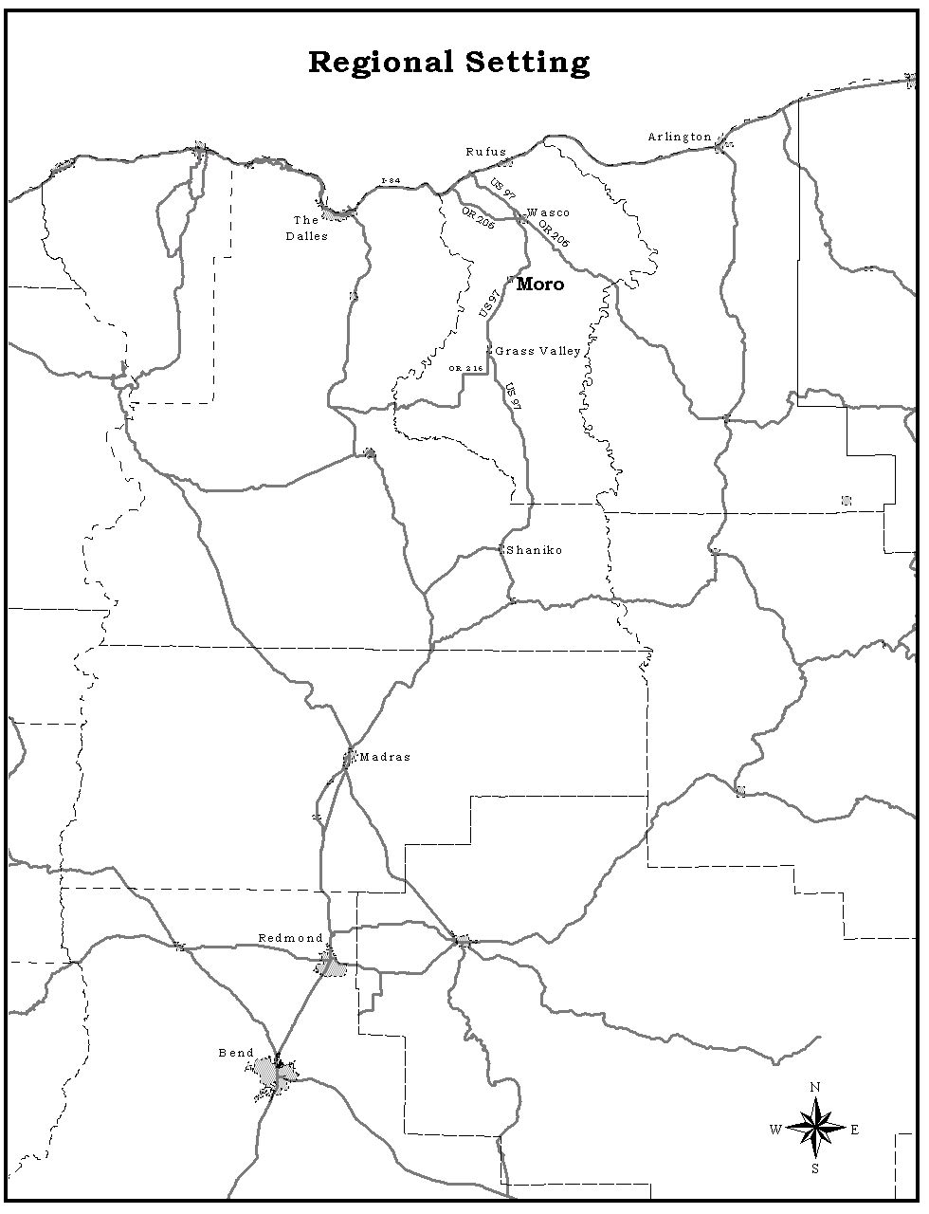

**PHYSICAL CHARACTERISTICS**

**GENERAL PHYSICAL SETTING**

The City of Moro is located in the high rolling plateau area of Sherman County, twenty miles south of the Columbia River and at an elevation of 1,870 feet. It is one of the larger small cities along U.S. Highway 97. Moro serves as the County Seat, since the separation of Sherman from Wasco County in 1889, The Sherman County School District Facility is the center of all public school activities in the County. All county students now attend school in Moro which serves administrative and educational functions which differentiate it from other Sherman County cities in terms of employment and income.

The Dalles is 42 miles distant and the nearest metropolitan area is Portland, 122 miles to the west. Because of the City’s natural setting between the Deschutes and John Day Rivers and the rural atmosphere, people from more urban areas are now attracted to Moro for retirement and recreational home sites. With hotel/motel facilities, and agricultural related business, Moro is able to function as an agricultural service center, supplying residents and tourists with goods and services. However, at the present time there is no public restaurant in the City.

Moro, located in Sherman County, is a member of the Mid-Columbia Economic Development District. The District is comprised of five counties: Hood River, Wasco, and Sherman Counties in Oregon and Klickitat and Skamania Counties in Washington. The District has three distinct geographical provinces of which the differences are abrupt and distinctive. The provinces are the Cascades, the High Plateaus, and the Columbia River Gorge. The High Plateaus are sparsely populated and contain mostly wheat land; it is in this regional province that Moro is located.

**TOPOGRAPHY AND DRAINAGE**

Moro is located in what is known as Barnum Canyon. Within the city limits there is an elevation change of 240 feet. Most of the urban development has occurred on the western slope of Barnum Canyon and to the west of U.S. Highway 97. Street development historically has been perpendicular to, or parallel with, the canyon slope. Vehicular traffic is only rarely disrupted when snow or ice forms on sloping streets. The topography has had only a moderate influence on existing land use patterns and will not significantly affect future land use patterns. Some flooding may occur in very localized areas along the canyon bottom near U.S. Highway 97 during periods of rapid runoff.

The Federal Emergency Management Agency (FEMA) determined the necessity to add the City to the national roster of its Floodplain Management Cities. In 2024, FEMA produced a draft Floodplain Map for review and consideration by the City. Other Cities in Sherman County have been in the National Floodplain Management since 1984-1987. Moro must now participate with the other Sherman County Cities in adopting a City wide Floodplain Management Map along with a Floodplain Hazard ordinance. The current cutoff date is July 22, 2026, as established by FEMA. The City will then be a participant in the National Floodplain Insurance Program (NFIP).

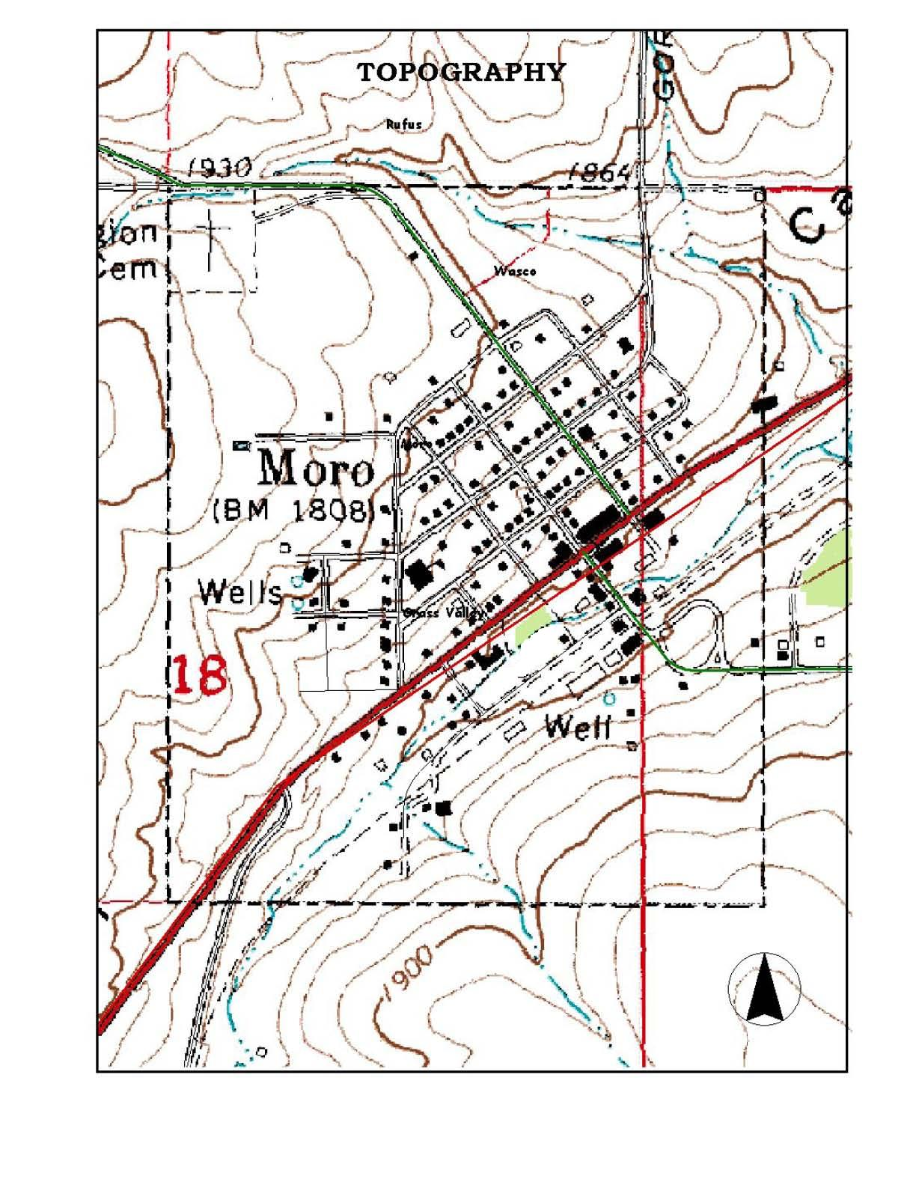**CLIMATE**

The monthly average low temperature in Moro is 0-14° Fahrenheit in January and February and the monthly average high is 98-99° Fahrenheit in July and August. The hottest month is July and the coldest month is January. The wettest month of the year is December. The average annual precipitation is 11.81 inches.

**GEOLOGY AND NATURAL HAZARDS**

Moro is located, as is all of Sherman County, on the Columbia Plateau. Geological units in Moro include Columbia River Basalt (Blue Basalt) and low land alluvial deposits along the drainage ways.

Flooding of the low-lying parts of the community is a known natural hazard, and FEMA is now mandating stronger management practices. Wildfires are a constant danger in the summer, every County Fire Department and every Sherman County Farmer steps up to assist in the firefighting when required. Other natural hazards are not likely to occur, with the exception of mud and earth slides that should be minimal provided standard grading practices are followed.

Flooding of the low-lying areas along the entire length of the Barnum Canyon drainage through Moro is mapped on the following page.

**MINERAL AND AGGREGATE RESOURCES**

There are no aggregate or mineral sites located within the city limits of Moro. There are no known sources of precious stones or metals exist within the City.

**SOCIAL CHARACTERISTICS**

**HISTORY**

Moro’s history began before it had a name—when Henry Barnum, a New York painter suffering from ill health, settled in the area in 1868. There are several stories of how the name Moro was selected, but according to Roy Kunsman in They Paved the Way, a Barnum descendant described a meeting held in his parents’ home wherein names were submitted and drawn from a hat. Melissa Hampden drew the winning name, and it was her entry, "Moro". Suggestions as to the derivation of the name vary: for the Moore Brothers, for the Illinois city of the same name, and—considered unlikely—for the Moore’s. None has been verified.

Moro was incorporated in 1897 and boasted a hotel, the Ellsworth, and a furniture store before the turn of the century. The good hearty meals served at the hotel by Mrs. Ellsworth were memorable. The coming of the Columbia Southern Railroad brought prosperity to the area, and Moro gained added importance when it became the county seat around the turn of the century when Sherman County was formed out of what had once been an extremely sizeable Wasco County.

With the advent of the auto, roads followed when the railroad's importance declined. Spearheading road development was the influential Samuel Hill, son-in-law of the railroad magnate James J. Hill who also played a key role in Oregon’s development. In 1914, the State of Oregon signed a contract for a road to connect Moro and other Sherman County cities with the main roads and the ferry across the Columbia River. At the same time the county built a road to The Dalles by way of Fulton Canyon. Even into the 1920’s, Sherman County citizens found it necessary to use Miller’s toll bridge to reach The Dalles. The Sherman County Highway was completed by 1924 as a result of Moro and Wasco citizens’ efforts in selling city bonds for curbing and grading. It was also thought that the Columbia River Highway would go through Moro, which led to further optimistic building. Instead, development and growth followed the Columbia River, and Moro remained primarily an agricultural service center.

Another major influence on Moro as well as the rest of the county was the introduction of a central electric power system by 1921. Moro, Wasco, and Grass Valley sold shares in a company to bring the power to the Cities. By 1939 a farmer-owned co-op was bringing power from the Bonneville Dam. The co-op was sold to the REA in 1940; by 1955 the REA and PP & L connected their systems.

Sherman County weathered the Depression by issuing its own county script to provide teachers and other public employees with something spendable. There was never more than $300 in use of the script, but it helped to bring the County through difficult times. When a large bank, the First National, opened a branch in Moro in 1937, the County felt it had safely moved out of a depressed era.

By 1952 plans began toward establishing a County High School; Moro, Grass Valley and Kent had already emerged into one school district. The four High School merged into one district, but the four cities retained their own K-8 School Districts until 1994. The new Sherman High School opened January 2, 1957. Another merger in which Moro participated was when its grain growers joined with those of Grass Valley to form Midco. This was done in order to ship by barge at the riverside shipping terminal of Biggs Junction.

In 1964, Sherman County experienced a devastating flood, losing many of its bridges. It took a week to reestablish electrical power to the County.

**POLITICAL STRUCTURE AND ADMINISTRATIVE FACILITIES**

Moro is administered by a mayor and four Council members. The Council Members are elected for staggered four-year terms and the mayor is for two-year terms. Regular meetings are held on the first Tuesday of every month. Current employees of the City of Moro are the City Administrator, Public Works Director, and a full time maintenance worker to assist with all public facilities of the City.

Moro is part of State Representative District 55, State Senate District 28, and U.S. Representative District 2. The 7th Circuit Court has jurisdiction over Sherman County, including Moro. MCEDD provides economic development facilitation for its member jurisdictions. The four incorporated cities and the County are part of the Lower John Day Area Transportation Commission.

**POPULATION CHARACTERISTICS**

The City has a long and colorful history dating back to the 1800s. The City was originally incorporated in 1897. At one point, it had a population of nearly 700, together with a number of businesses including hotels, a bank, several drinking establishments, a school, opera house, and other businesses typical of the beginning of the Twentieth Century. The first census recording for the City was in 1930, when the population was listed at 350. The population declined during the war years, rose slightly in the 1970s, and has been in a three-decade decline since that time. The current population is just now at 375. What was once a vibrant commercial core in the center of the community is now eroding and deteriorating. There are no restaurants, no service station, a small market, and a farm equipment/supply store. The largest employer within the City is now Azure Standard Farms followed by the Sherman County School District and finally by Sherman County government. The population history of the community is shown on Table #1.

**Table #1**

**CITY OF MORO POPULATION HISTORY**

|  |  |
| --- | --- |
| **Year** | **Population** |
| 1950 | 359 |
| 1960 | 327 |
| 1970 | 290 |
| 1980 | 336 |
| 1990 | 292 |
| 2000 | 337 |
| 2004 | 320 |
| 2005 | 320 |
| 2010 | 324 |
| 2020 | 367 |
| 2024 | 374 |

**POPULATION PROJECTIONS AND ALLOCATIONS**

A significant part of this Comprehensive Plan Update is to prepare new population projections for the City. Portland State University Population Research Center now has the responsibility to prepare the projections for each city and county in the State. This is considered the best available information, and each city or county must use that date for long-term planning. Table 2 below shows the PSU Population Projection for Moro through the year 2069.

**Table #2**

**CITY OF MORO POPULATION PROJECTION**

**PORTLAND STATE UNIVERSITY 2019**

|  |  |
| --- | --- |
| **Year** | **Population** |
| 2019 | 315 |
| 2033 | 299 |
| 2069 | 285 |

The table indicates the Population Projections for the City to be steadily decreasing over the next 45 years. However, the current population table showing the last 25 years shows the population of Moro still increasing, particularly since 2005. With the ability to work from home rather than commuting to work in larger cities, it is likely the population of the Sherman County cities, including Moro will experience additional growth in the future because of quality of life in a smaller community.

The development of 900 Wind Power Generation Facilities over the last two decades has had a profound impact on the County and its Cities. As noted earlier, Solar Power Generation Facilities are currently being positioned to further increase electrical power to the region and a much stronger economy to the County and its Cities.

**ECONOMIC CONDITIONS**

##### Overview

The City of Moro serves as a small farming community providing goods and services to ranches and farms within an approximately five to seven-mile driving radius from the City. It is approximately nine miles from Wasco, and nine miles from Grass Valley. Wasco and Grass Valley are also Rural Service Centers. Biggs Junction is a transportation hub located at the crossroads of Interstate 84 and U.S. Highway 97. Biggs Junction primarily provides goods and services to the traveling public.

A historic tabulation for the City of Moro indicated a total of 127 jobs in the community. A major employer at the time, Sherman County School District, offered K through 12th grade educational services. The declining population left the downtown core area of the City severely depleted in terms of goods and services offered to the public. There was simply not enough population to support a wider variety of retail goods and services offered in small communities. The City has attempted to bolster the economy over the years—with no appreciable success. However, that is changing as will be seen in the following economic opportunities analysis.

**ECONOMIC TRENDS**

**Sherman County**

Sherman County, beginning in the early years of the 21st Century, recognized an unforeseen windfall (no pun intended) with the development of major wind farm facilities in the County. The immediate results were two-fold. The property tax income stream, created by over 900 wind machines, at over 1.25 million dollars in value each, created a sizable annual revenue stream for public use and improvements in the County. In addition, the operation and maintenance of the wind farms created a significant job market for high-tech maintenance people and thus a significant impact on the small communities, in terms of job creation and housing to serve the new technicians. Moro’s December 17, 2024, certified population is 375. Interestingly all four of the Sherman County Cities have increased population over the last 5 years. The City of Wasco’s population is now 424. Rufus, on Interstate 84, is 277 and Grass Valley is 158. All four cities boast the latest technical advances, including modern cell phone towers, fire and police protection apparatus, communications facilities, and social services.

ECONOMIC OPPORTUNITIES ANALYSIS FOR SHERMAN COUNTY AND THE CITY OF MORO

The City of Moro is located approximately 18 miles from I-84 the interstate freeway and, as such, is not a primary location for general industrial development. The City did redesignate approximately 15-acres of land to house a natural foods distribution center specializing in natural foods. The operation imports other agricultural products for nationwide distribution. A report from 2023 indicated 120 employees at the Moro warehouse location.

Sherman County’s location in North-Central Oregon places it some distance away from the Portland urban market. Most industries that might locate in Sherman County would do so in response to the availability of some natural resources. It is not likely that an industrial operation involved in a fabrication or other manufacturing process would look to Sherman County because of the distance to markets and the transportation costs involved. Interstate 84, providing direct freeway access to the Portland urban area, is available on the north end of the County. There is also the Union Pacific Railroad, which parallels Interstate 84, into the Portland market and on easterly through the State. There is also river transport available, although there are no current docking areas in Sherman County other than near the John Day Dam, which is approximately two miles upriver from the City of Rufus. Sherman County does ship wheat to the Portland market via barge, truck, and train cars.

The four cities are located approximately nine miles apart, with Rufus being located furthest north and on Interstate 84. Wasco is nine miles south on Highway 97 at the beginning of the plateau. The City of Moro is located nine miles south of Wasco, and Grass Valley is located nine miles south of Moro. All four cities have limited amounts of public facility infrastructure. Rufus, Wasco, and Moro all have wastewater collection and treatment facilities, but Grass Valley does not. All four have domestic water systems.

###### DEVELOPMENT OPPORTUNITIES

In the last couple of years, Sherman County has experienced the benefit of being in the right location to utilize the updated technology. The use of renewable resources, including wind energy, has come to the forefront in many of the Eastern Oregon and Washington counties along the Columbia River just beyond the east end of the Columbia Gorge. The prevailing westerly winds provide, with new technology, the ability for significant development of wind farm activity. Two of these developments have occurred in a location known as Klondike, which is just 3 miles south of Wasco in Sherman County. The first project consisted of 16 towers generating 24 megawatts of power. A second project, known as Klondike II, will add 75 megawatts with a total of 50 new units. Currently in the planning stages are an additional estimated 200 units to be added in this same area. The long-range plans are for a total of almost 900 wind turbines to be located in the Klondike area behind Wasco in Sherman County. It is anticipated that growth will occur over the next ten years and there will be a number of spin-off businesses that will impact Moro and the northern part of Sherman County. Nearby Gilliam and Morrow Counties in Oregon and Klickitat County in Washington are also experiencing similar developments. The tax credits and the energy requirements of the nation are making these facilities profitable.

These developments will have an immediate and long-term impact on Sherman County and provide economic development within the County. The City of Moro serves as the County seat and many County employees live there.

In addition, the City may gain some benefit from the motor vehicle racing facility located near Grass Valley, some 9 miles to the south. It is also anticipated that there will be the need for motels and restaurants to serve the public.

The revenue stream, contributed by the wind farm industry, will be most felt in and around Moro due to it being the County seat. It is anticipated that additional County facilities would be constructed in Moro as the need warrants.

##### SHERMAN COUNTY ECONOMIC DEVELOPMENT

Perhaps the most dramatic change in economic outlook for Sherman County has been the advancement of wind farm technology and its applicability to Sherman County. What started as a small 26-unit wind farm near the Klondike area, south of the City of Wasco, is now around 900 wind machines. The direct benefit to Sherman County is an enhanced revenue stream, which has significantly increased the ability of the County to solve its own problems without relying upon state or federal government assistance. The County’s tax base increased significantly with the completion of the wind machines, which are valued at approximately $1.25 million each. Historically, County utilized some of the tax money to provide public improvements throughout the County. There are now 100 to 150 jobs for the operation, maintenance and repair of the wind machines. Though the efforts of Sherman County and the Columbia Gorge Community College, an Associate’s Degree in Wind Machine Technology and Repair is now in place.

**INDUSTRIAL LANDS**

**City of Moro**

The newest tract of industrial land is the site of the Azure Farms development containing approximately 15 acres and houses a distribution center complex of approximately 120,000 square feet after a warehouse expansion in 2022. It is anticipated that the natural food distributor will use that entire site at some point.

**SHERMAN COUNTY DEVELOPMENT ACTIVITIES**

The county has adopted a Rural Renewable Energy Development Zone (RREDZ) for all of Sherman County. The purpose of the RREDZ designation is to encourage the development of smaller energy power generation facilities to increase new business investment, job creation, higher incomes for local residents, and greater diversity of economic activity tax incentive through a limited duration. The Rural Renewable Energy Development Zone offers the standard property tax abatement of an enterprise zone to the qualified property improvements of renewable energy projects. The standard tax abatement period is for 3 years on all qualifying improvements. Any land value will continue to be taxed during the exemption period, and an additional year or two may be added to the tax abatement period depending on the investment and the average wage for any additional employees. This tax abatement is also subject to County Court approval.

**SHERMAN DEVELOPMENT LEAGUE**

The County Court has appointed a group of citizens who have volunteered to serve on the Sherman Development League (SDL), a non-profit corporation which has formed in conjunction with the wind farm development. The League is funded primarily by monies made available to them from the County Court, and the funds are derived in lieu of taxes from the wind energy farm operators. The SDL has awarded grants to assist non-profit local groups with meeting their needs in Sherman County.

The Sherman County Development League is a 501C3, whose mission is to provide charitable support, through grants and loans, to enhance the social, cultural, and educational environment in Sherman County. SDL also serves as a fiscal sponsor in implementing community development and self-help projects, which enhance the quality of life for the residents within Sherman County.

**HOUSING**

**Existing Conditions**

The housing stock in the City of Moro dates to before the turn of the 20th Century and to new homes being constructed or placed within the last year. There have been approximately 10 units constructed or placed since the 2020 census data was obtained. The actual housing count by the City Recorder’s office indicates a total of 170 units. In that, there is one 3-unit apartment complex, and one, possibly two, apartments above a downtown commercial building. There are a number of mobile homes and manufactured dwellings throughout the City. The City allows manufactured dwellings that meet the City’s standards as outright permitted uses in its residential zones. The City has no mobile home park. The Buildable Lands Map was originally prepared in 2021 and there have been approximately five or six homes added since that map was prepared. There are approximately 86 lots available and over 170 acres of vacant land in the Residential Zone, which may be urbanized over time. Many of the platted lots were created in the last century and do not have city utility services or improved streets. Other semipublic facilities including power, telephone and internet are available in the City but would have to be extended to serve these lots.

The City has taken steps to ease the zoning requirements to allow “middle housing” in its one residential zone. Multi-unit four plex’s, triplex’s and even duplex’s are allow on single lots now. Accessory dwelling units, ADU’s are also allowed by the recent zoning ordinance updates.

The significant aspect of the buildable lands inventory is the amount of vacant, undeveloped land inside the corporate city limits. There is an ample amount of acreage to accommodate future residential growth given the current population projections.

**COMMUNITY FACILITIES AND SERVICES**

**COMMUNITY SERVICES**

**Law Enforcement Services**

City of Moro does not have a peace officer on staff. The City relies upon the County Sheriff’s office to provide police protection if needed. There are deputies living in and near the City that can be called upon. The County Sheriff’s Office and legal facilities are located next to the renovated County Courthouse in the City.

**Fire Protection**

The City of Moro contracts with the Moro Rural Fire Protection District to provide fire protection. The Moro Rural Fire Protection District maintains a 6200 square foot building that houses a City Fire Structure Engine, Wildland Fire Truck, two Rural Brush Vehicles, Water Tender, Fire Rescue Vehicle and a Command Vehicle along with two Ambulances. The Moro Rural Fire Protection District is also available, under a mutual aid agreements to cover other parts of the County as needed.

**EDUCATION FACILITIES**

**Schools**

Sherman County School District #1 was created in 1994 when the school districts of Sherman County unified into one county-wide school district. The District operates one K-12 school district on one campus, located in Moro.

In 2016 an Elementary structure was built onto the existing Jr.-Sr. High School, and the Grass Valley school was closed. This gives the county a single campus pre-K - 12th grade. As of July 1st, 2016, we became "Sherman County School". The District office is also located in the building.

Sherman County School District is considered both rural and remote. Sherman County School District is one of six school districts in three counties served by North Central ESD. The ESD provides the necessary staff for all the district's special education and counseling needs. The ESD also provides funding which makes it possible for the district to offer music and foreign language, and to stay current with the latest technology. North Central ESD also provides staff to assist in the areas of curriculum development, library services, print services, and technology.

**Employs:** 48 individuals

**School Board Members:** Bryan Cranston, Seth von Borstel, James Alley, Kristie Coelsch, and Scott Susi.

**Transportation services are provided by North Wasco Bus Company**

A monthly newsletter is released by Superintendent Fall.

**Julia Fall** Superintendent/Principal

**Amanda Bagwell** Vice Principal

**Mary Sallee** Dean of Students

**Jen Berry** Secretary

**Tionie Kock** Secretary

The 2023-2024 adopted budget for the district was $20,923,298.00

Test scores routinely exceed state averages in all test categories. Graduating seniors have access to outstanding local scholarship opportunities and a high percentage of graduates go on to pursue post-secondary education.

The Sherman County High School enjoys a new state-of-the-art all-weather track facility, a new baseball field, a new gymnasium complex that sports two basketball courts, and a state-of-the-art weight training facility. The school competes athletically in the Big Sky Conference and has a 1-A classification as determined by the Oregon School Activities Association. Students in grades 5-12 have the opportunity to participate in activities including football, volleyball, basketball, cheerleading, wrestling, baseball, tennis, chess, and track and field.

**Library**

The new Sherman County Public/School Library triples the space and provides information and services to the public, students and faculty of Sherman County School District. The library houses a collection of books as well as audiobooks, CDs, DVDs, magazines and newspapers. An online catalog features inter-library loans through the Libraries of Eastern Oregon, a consortium of public, school and special libraries throughout Eastern Oregon. As part of the Oregon Digital Library Consortium, digital audiobooks and e-books are available through Library2go and the Libby app using your library card.

There is laptop access to the Internet and online services for all patrons. It presents more educational programs for kids, students, and adults in the planned community

**Daycare and Preschool Facilities**

There are two facilities in Moro, Little Wheats is a licensed, non-profit, in home daycare facility in Moro and Sherman County Preschool is also a non-profit facility located in the Sherman County K-12 Building.

**Historical Sites**

The only listed Historical Site in Moro is the Sherman County Courthouse, constructed in 1901.

**MAINTENANCE AND REFUGE DISPOSAL**

**Streets and Park Maintenance**

The City of Moro maintains the City Park consisting of three city blocks.  The park houses public restrooms and basketball court available 24/7.  The City maintains their streets all of which are surfaced and hires independently for blade patching.  The State maintains Highway 97, which goes through town.  In June 2002, the City’s Main Street (Highway 97) had a complete makeover with the streets being widened, bike lanes installed, brick bulb-outs, tree wells, and trees planted along with a new concrete mural wall in the park showing the history of Moro. In 2024, ODOT replaced the ADA handicapped sidewalks on Highway 97 throughout Moro.

**Solid Waste Disposal**

Federal and state laws require solid waste to be disposed of in a sanitary landfill. Solid waste is collected at the County’s transfer station above Biggs and then transferred to the regional landfill at Arlington.

**COMMUNICATION FACILITIES**

**Postal Service**

The Post Office in Moro receives and dispatches mail six days a week, Monday through Saturday, with mail arriving from Portland. Routes originate each day from Moro for delivery to the rural areas. Postal lock boxes are available for City residents. Window service is available Monday through Friday, 8:30 A.M. to 3:30 P.M.

**Telephone Service**

A Verizon Cell Tower is located at the Moro Water Tower in the City Limits. The location at a high elevation in the City makes excellent cell phone service available to the City. The location of the Cell Tower makes internet service available through a wide variety of internet providers.

**Newspaper**

*Condon Times Journal* and *Columbia Gorge News* are distributed by mail delivery to homes in the community. A local service, provided by the Sherman County Court, provides a Citizens Reporter quarterly to all box holders in the County for free. It oversees upcoming events in the County. Municipalities and group leaders are encouraged to contribute to the quarterly publication.

**Health Facilities**

The Sherman County Health District and Sherman County Medical Clinic employs a full-time physician assistant (PA). More serious health issues and imaging are generally referred to Adventist Health Columbia Gorge (formerly MCMC).

**UTILITIES**

**Electric Service**

Residents of the City of Moro receive their electricity from Pacific Power and Light Company out of Hood River, Oregon. Service is reviewed on a three or five-year basis with the City Council and the service area by mutual agreement, and the utility company pays a 3.5% franchise tax. PP&L Co. has 345 miles of wire and four substations within the County—Wasco, Grass Valley, Moro, and Gordon Hollow. Wasco Electric Co-op, Inc. serves a portion of the rural area surrounding Moro.

**Water System**

The City of Moro operates three wells: Hart Well draws from the 2nd aquifer at 280’ and pumps 49 GPM, City Hall Well draws from the 3rd aquifer at 500’ and pumps 200 GPM, Cemetery Well draws from the deep basalt (3rd) aquifer at 400 GPM. The City’s water reservoir stands 65 feet, holds 365,000 gallons of water, and is controlled by a telemetry system.

The City has installed water meters to all residents. Some major distribution lines were replaced during the installation of meters. The City has recently installed a more advanced system of water level monitoring. This system provides notification the Department of Public Works. The City has recently adopted, in 2024, an updated Water System Master Plan. This Plan’s implementation will provide a long list of system wide improvements. Based upon events occurring during a major Countywide fire a few years ago, the City has installed a Generac Emergency Generator at the City’s Cemetery Well to insure water service continues during an emergency.

# **Sanitary Sewer Service**

Currently the City operates a conventional gravity wastewater collection system and a three-cell facultative lagoon. Currently the City’s wastewater collection and treatment system serves its residents.

The City was issued a Mutual Agreement and Order by the DEQ to address past and future violations of the City’s WPCF Permit. Compliance issues were addressed related to irrigating treated wastewater outside of the irrigation and active growing season. This is due to the lack of sufficient storage during the seasons where irrigation is not allowed.

**TRANSPORTATION SYSTEM PLAN**

In the year 2015, the City of Moro and the other three incorporated cities of Sherman County, including Wasco, Grass Valley, and Rufus, and Sherman County, in cooperation with the Department of Land Conservation and Development and the Oregon Department of Transportation, through the Transportation Growth Management Program, developed a complete Transportation System Plan for the County and the four incorporated cities. The preparation of the Transportation System Plan was prepared by Kittelson and Associates and was assisted by the Sherman County Planning Department with a significant amount of input from interested citizens of the four communities and the County at large. The Plan is the first such effort to be undertaken in the County and is considered a milestone in marking the path for future development in the County and its communities.

The Transportation System Plan replaces the transportation element of this Comprehensive Plan and deletes the 30+ year-old information from this Plan. The Transportation Plan is a stand-alone document. It is published in a separate form and is available at City Hall, in the County Planning office, and in the County Court office. The Transportation System Plan recognizes the unique circumstances of Moro and the other incorporated communities and establishes realistic requirements in the future planning and improvement standards for new development. The Plan recognizes the existing street patterns and incorporates these into new street design standards matching that which currently exists in each community. Further, the Plan provides a listing of future improvement projects for each community and provides an easier mechanism for updating those capital improvement projects on an annualized basis. It is intended that each community’s Capital Improvement Programs, including street improvements, be updated during the budget cycle each fiscal year.

**ENERGY**

There are no known energy sources in the City of Moro. There are no geothermal or hydropower opportunities. The City is on the southern edge of the successful wind farm development in Sherman County. There are no known plans for wind farm development near the City at this time.

At this point, the south county area has been determined to have the potential of being very productive site for Solar Energy Production Facilities and many companies are in the process of preparing applications to be submitted to the State or County depending upon the amount of acreage involved in the Solar Energy Production Facilities project. There are no active applications at this time.

**URBANIZATION**

The City’s Urban Growth Boundary, with one minor exception, is coterminous with the City’s corporate city limits. There is a small 12-acre parcel fronting on Highway 97, running to the southwest corner of the City, which is planned OS/PF. There are approximately 170-acres of vacant, undeveloped land on the periphery of the developed portions of the City and a number of platted, but yet, undeveloped lots in the City. The need to expand the Urban Growth Boundary is not evident at the present time. However, there has been some discussion of bringing the County Fairgrounds property into the Urban Growth Boundary in order to it with provide services and to allow a variety of additional land uses on that site.

**POLICY STATEMENTS**

City of Moro

GOALS AND POLICIES

**Part I. Introduction**

Goal I.

1. To prepare, adopt and revise this plan in conformance with ORS Chapter 197 and the statewide planning goals.

**Part II. Plan Revision**

Goal II.

1. To Update the plan and keep it current with the changing needs and desires of the community.

Policies II.

1. That the goals, policies and maps shall be reviewed on a five-year basis.
2. That the resource information shall be updated every 5 years or when new and important information becomes available.
3. The Public Improvements list will be updated each year during the annual budget process.

**Part III. Citizen Participation**

Goal III.

1. To provide the opportunity for all citizens to participate in the planning process.

Policies III.

1. That all land use planning meetings shall be open to the public.
2. That all land use planning meetings shall be advertised in the general circulation newspapers or other means as necessary.
3. That any residents of the community shall be allowed to participate in the planning process.

**Part IV. Physical Characteristics**

Goal IV.

1. To prevent soil erosion and maintain water quality in areas of urban development within the city limits.

Policies IV.

1. That the best practical methods be used to prevent soil runoff when building or road construction occurs within the city limits. An Erosion Control Plan shall be submitted to the City Administrator.
2. That Barnum Canyon Creek be kept clean and free of debris which can, during periods of rapid runoff, cause additional flooding to occur
3. That the City will continue to maintain a clear channel along Barnum Creek to protect the riparian habitat.
4. To preserve historical sites and buildings that are worthy of historic preservation.

Policy IV.

1. That the city shall encourage the preservation of the Sherman County Courthouse as a historic building

**Part V. Social Characteristics**

Goal V.

1. To improve the economy of Moro and the state.

Policies V.

1. That development shall be encouraged which will improve employment opportunities and providing desirable living conditions in the City.
2. That those employment opportunities shall be encouraged which are compatible with existing and anticipated uses of land as shown in the plan.
3. That environmental effects to air, water and land resources quality shall be considered in addition to social economic factors when making economic planning decisions.

**Part VI. Community Facilities and Services**

Goal VI.

1. To provide for efficient development and maintenance of public facilities and services.

Policies VI.

1. That the city shall cooperate with the school districts to provide for adequate school facilities.
2. That the city shall provide the best law enforcement protection practicable.
3. That the city shall support the Moro Rural Fire Protection District for continued fire protection in the City.
4. That the city shall not provide sewer service outside the urban growth boundary.
5. That development, which may generate the need for urban services and facilities, shall be approved only in those areas where such services and facilities are available or anticipated.
6. That public facilities and various agency services should be designed and maintained to be as visually attractive as possible.
7. That water and sewer services shall be planned for in those areas where urban development is most suitable and desirable,
8. That roads created in subdividing or land parceling shall be designed to tie into existing road systems and overall road design approved by the City Council.
9. That street rights-of-way and all other public lands shall be evaluated for public use prior to being vacated.
10. That the capital improvements program for future public improvements, including streets, water, sewer, and other public facilities, shall be re-evaluated on an annual basis during the budgeting process. The annual capital improvements program is considered those projects which are worthwhile and could be completed within a foreseeable timeframe. The Capital Improvement Project list may be adopted by the City by resolution and attached to the Comprehensive Plan. Assistance shall be obtained from the Mid-Columbia Economic Development District or other sources for completing the grant application procedures where required. (Ord No. 249)
11. The city shall coordinate with ODOT in implementing its improvement program.

16. The Transportation System Plan and Land Use Review Policies

(Ord No. 249)

A. The Sherman County Transportation System Plan, including the City of Moro, is an element of the City Comprehensive Plan. It identifies the general location of transportation improvements. Changes in the specific alignment of proposed public road and highway projects shall be permitted without plan amendment if the new alignment falls within a transportation corridor identified in the Transportation System Plan.

B. All development proposals, plan amendments, or zone changes shall conform with the adopted Transportation System Plan.

C. Operation, maintenance, repair, and preservation of existing transportation facilities shall be allowed without land use review, except where specifically regulated.

D. Dedication of right-of-way, authorization of construction and the construction of facilities and improvements, for improvements designated in the Transportation System Plan, the classification of the roadway, and approved road standards shall be allowed without land use review.

E. For State projects that require an Environmental Impact Study (EIS) or Environmental Assessment (EA), the draft EIS or EA shall serve as the documentation for local land use review, if local review is required.

17. Local-State Coordination Policies (Ord No. 249)

A. The City of Moro shall coordinate with the Oregon Department of Transportation to implement the highway improvements listed in the Statewide Transportation Improvement Program (STIP) that are consistent with the Transportation System Plan and The City of Moro Comprehensive Plan.

B. The City of Moro shall provide notice to ODOT of land use applications and development permits for properties that have direct frontage or direct access onto a state highway. Information that should be conveyed to reviewers includes project location, proposed land use action, and location of project access points.

C. The City of Moro shall consider the findings of ODOT’s draft Environmental Impact Statements and Environmental Assessments as integral parts of the land use decision-making procedures. Other actions required, such as a goal exception or plan amendment, will be combined with review of the draft EA or EIS and land use approval process.

18. Protection of Transportation Facilities Policies (Ord No. 249)

A. The City of Moro shall protect the function of existing and planned roadways as identified in the Transportation System Plan.

B. The City of Moro shall include a consideration of a proposal's impact on existing or planned transportation facilities in all land use decisions.

C. The City of Moro shall protect the function of existing or planned roadways or roadway corridors through the application of appropriate land use regulations.

D. The City of Moro shall consider the potential to establish or maintain accessways, paths, or trails prior to the vacation of any public easement or right-of-way.

E. The City of Moro shall preserve right-of-way for planned transportation facilities through exactions, voluntary dedication, or setbacks.

19. New developments such as commercial operations or new residential subdivisions that require more capacity than the City currently has available in its public facilities may, as an option, provide the funding for completing the necessary improvements.

20. The City shall prepare and adopt by City Council Resolution an annual Public Improvements Program listing the projects by priority for each fiscal year. The project list shall be prepared during the budget preparation process each spring. The priority list, including the anticipated funds required, shall be adopted by City Council Resolution each year and placed in the City’s Comprehensive Plan.

**Part VII. Housing**

Goal VII.

1. To provide for the housing needs of the existing and future residents of Moro.

Policies VII.

1. That the city shall allow for the location of manufactured dwellings in all planned residential areas.
2. That a range of housing prices and variety of housing types and locations shall be encouraged.
3. That areas where residential development exists shall be protected from incompatible land uses.
4. That the City will continue to support changing housing trends and innovative housing technologies to meet the needs of the community and its residents.

**Part VIII. Land Use**

Goal VIII.

1. To provide for on orderly and efficient transition from rural to urban use.

Policies VIII.

1. That projected city growth shall remain inside the designated urban growth boundary, unless an Urban Growth Boundary expansion, under the term of Oregon Statewide Planning Goal 14 is undertaken.
2. That the costs for water, sewer, streets and other improvements deemed necessary by the City Council for unimproved land being converted to urban uses shall be borne by the developer.
3. That commercial and high-density residential development shall be located in areas where access, sewer, water and other related facilities and services can best accommodate such development.
4. That planning decisions shall be made on a factual basis and that such base be updated at the time of major plan revisions
5. That partitioning or subdividing shall be approved only for parcels adjacent or having approved access to a public street or road by a proposed public street or road in the new development.
6. Public services to existing platted lots, which are otherwise undeveloped, shall be provided by the applicant or developer.

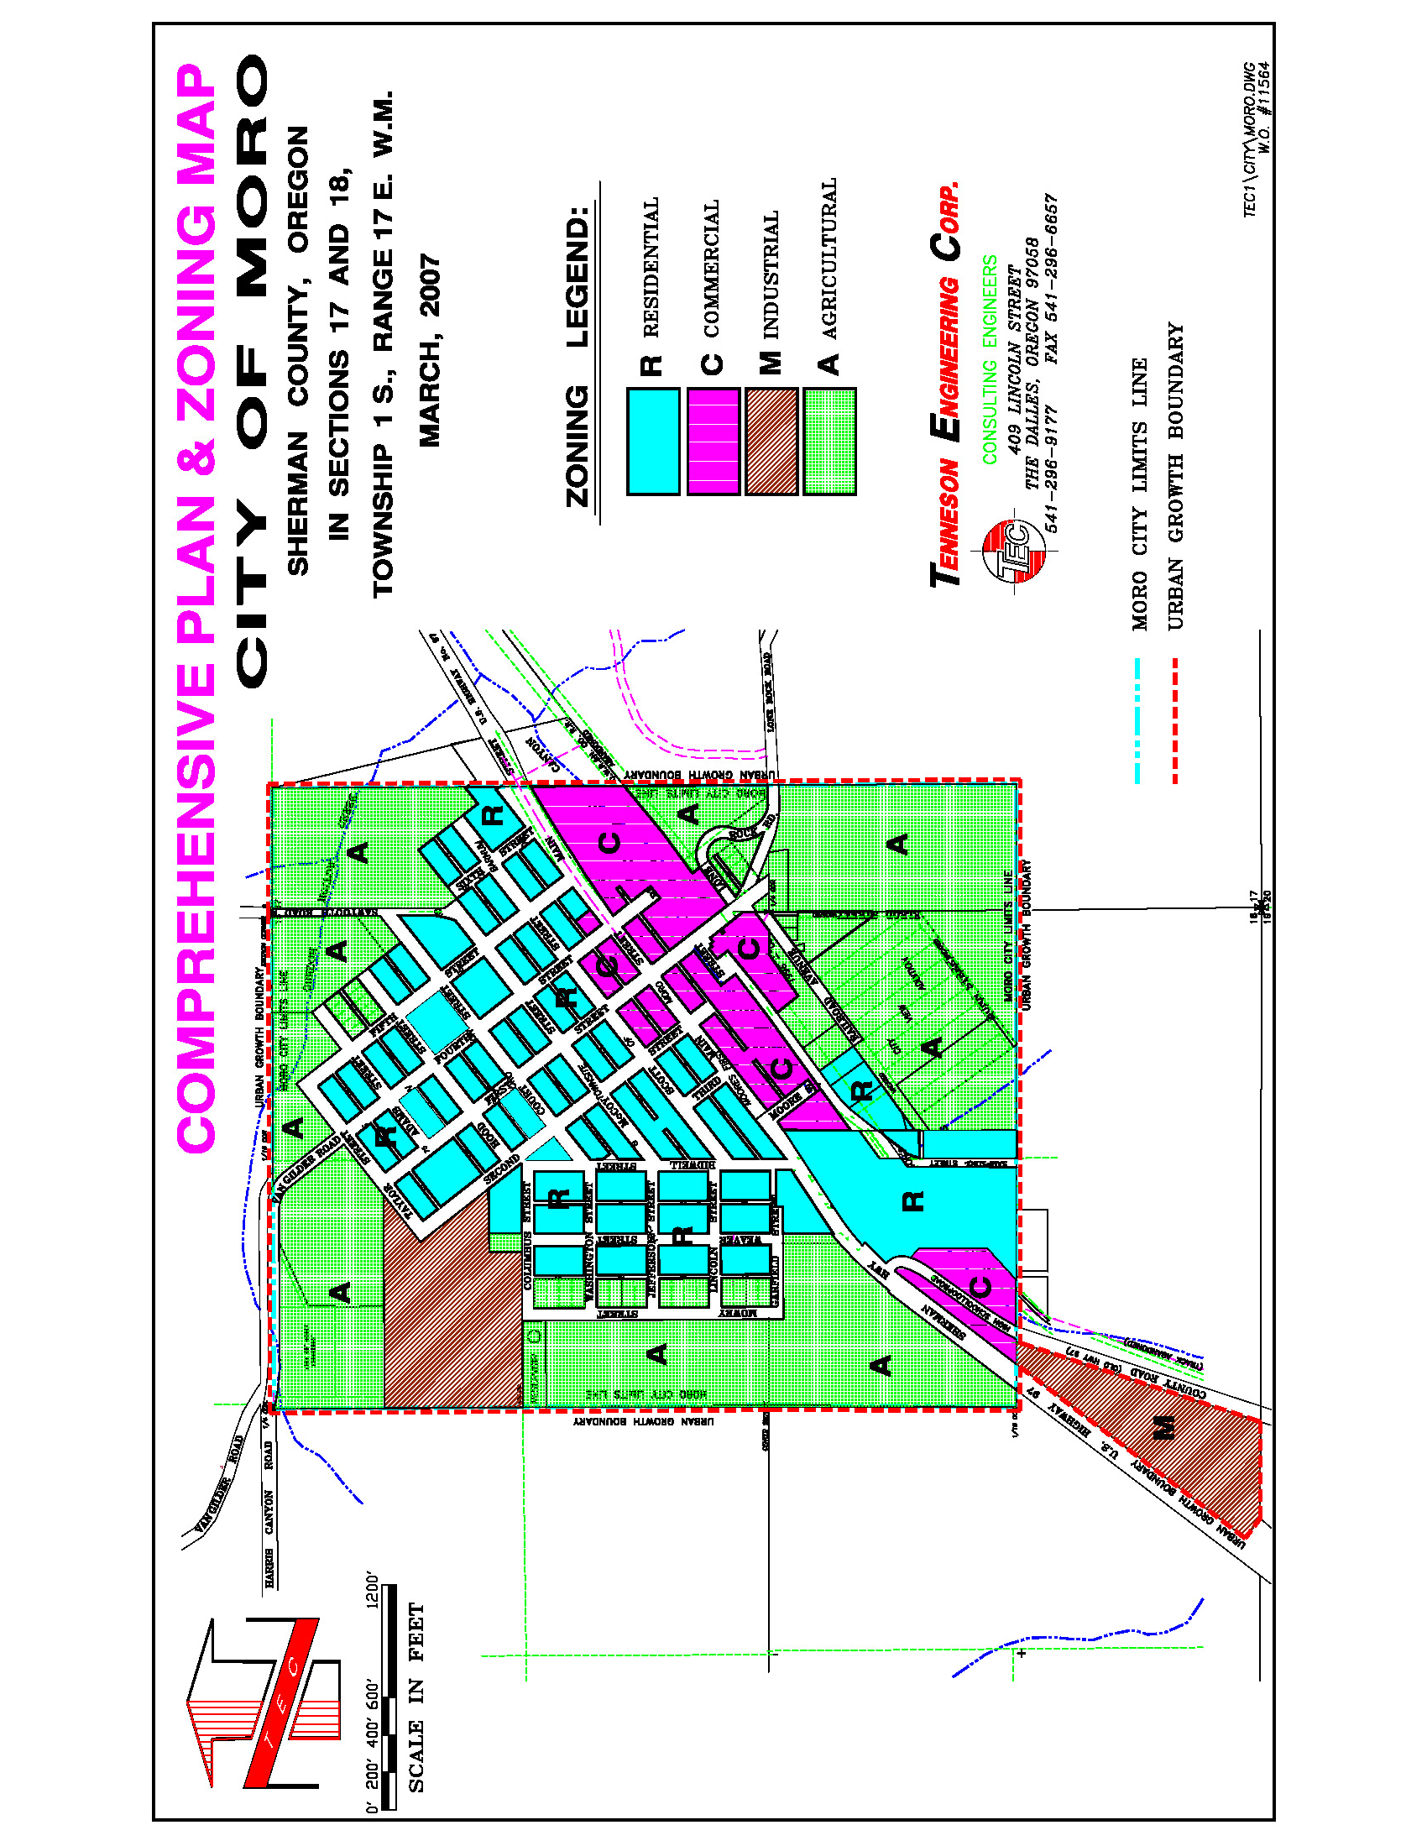

**CITY OF MORO**

**UPDATED**

**COMPREHENSIVE LAND USE PLAN**

**2025**

THIS PLAN WAS UPDATED THROUGH THE AID

OF A TECHNICAL ASSISTANCE GRANT

FROM THE

DEPARTMENT OF LAND CONSERVATION AND DEVELOPMENT.

Prepared by

Dan Meader, Senior Land Use Planner

Jaime Crawford, Land Use Planner

TENNESON ENGINEERING CORPORATION

An AKS COMPANY

**ELECTED AND APPOINTED OFFICIALS**

MORO CITY COUNCIL MEMBERS

Mayor Bert Perisho

Councilor James Alley

Councilor Travis West

Councilor Andy Anderson

Councilor Bryan Cranston

ADVISORY & STAFF

City Administrator, Brittany Wood

Director of Public Works, John English

Sherman County Planning Director, Georgia Macnab

Sherman County Assessor, Drew Messenger

Sherman County Emergency Services, Dana Pursley-Haner

Previous Staff Planning Consultant, Kirk Fatland

DLCD Central Oregon Regional Representative, Angie Brewer

**TABLE OF CONTENTS**

SECTION PAGE

I. INTRODUCTION

2006 Update 1

Issues 1

Planning for Moro 2

Planning Process 2

Planning Intent 3

II. PLAN AMENDMENTS

Comprehensive Plan Amendment Process 4

III. CITIZEN PARTICIPATION

Citizen Involvement 5

IV. PHYSICAL CHARACTERISTICS

General Physical Setting 7

Topography and Drainage 8

Climate 10

Geology and Natural Hazards 10

Mineral and Aggregate Resources 10

V. SOCIAL CHARACTERISTICS

History 12

Political Structure and Administrative Facilities 14

Population Characteristics 14

Population Projections and Allocations 15

VI. ECONOMIC CONDITIONS

Overview 19

Economic Trends 19

Economic Opportunities Analysis 20

Development Opportunities 21

Sherman County Economic Development 22

Economic Development Activities 24

Economic Development Leaders 25

Industrial and Other Employment Opportunities 26

Inventory of County’s Industrial Lands 26

Net Land Demand 28

Sherman County Development Activities 28

Sherman Development League 29

New Jobs Projection 30

VII. HOUSING

Existing Conditions 32

SECTION PAGE

VIII. COMMUNITY FACILITIES AND SERVICES

Community Services 33

Education Facilities 33

Maintenance and Refuge Disposal 37

Communication Facilities 38

Utilities 39

Transportation System Plan 40

Energy 41

Urbanization 42

Commercial Development 42

IX. GOALS AND POLICIES 45

LIST OF MAPS PAGE

1. REGIONAL SETTING MAP 6
2. TOPOGRAPHY MAP 9
3. GEOLOGIC HAZARDS 11
4. BUILDABLE LANDS INVENTORY 31
5. COMMERCIAL BUILDABLE LANDS INVENTORY 44
6. COMP PLAN & ZONING MAP 51

LIST OF TABLES

1. MORO POPULATION HISTORY 15

2. SHERMAN COUNTY POPULATION PROJECTION 15

3. POPULATION HISTORY 16

4. PERCENTAGE OF COUNTY POPULATION 17

5. SHERMAN COUNTY POPULATION ALLOCATION 17

6. JOBS PROJECTION 30