

**City of Moro**

**Application for Land Use Action**

**Type of Land Use Action Requested: (check all that apply)**

 Annexation



 Plan Amendment (Proposed Zone ________)



 Planned Unit Development



 Site Plan (square footage of building and parking area)



 Variance (list standards to be varied in description)



Conditional Use

Partition (# of lots ________)

Subdivision (# of lots ________)

Other: ___________________

*By submitting this form the Owner, or Owner’s authorized agent/ representative, acknowledges*

*and agrees that City of Moro employees, and appointed or elected City Officials, have authority to enter the project site at all reasonable times for the purpose of inspecting project site conditions and gathering information related specifically to the project site.*

Note: See City of Moro Current Fee Schedule at [www.cityofmoro.net](http://www.cityofmoro.net), under Local Government Section.

*Once complete, please return the Application form, and supporting documents to the Moro City Hall in person 104 1st Street in Moro, Oregon, or mail to Moro City Hall PO BOX 231 Moro OR 97039. City Hall will need to draft public notices: post them, run in the newspaper of record, and mail them to all affected property owners before a public hearing date*.

Please Print Legibly Using Black or Blue Ink. Typed Attachments will Also Be Accepted.

|  |  |  |  |  |  |  |  |  |  |  |  |  |  |  |
| --- | --- | --- | --- | --- | --- | --- | --- | --- | --- | --- | --- | --- | --- | --- |
| **Owner/Applicant Information:** | | | | | | | | | | | |  |  |  |
| Applicant: | |  | | | | | | | | | | Phone: | |  |
| Applicant Address: | | | | |  | | | | | | | Email: |  | |
| Owner: |  | | | | | | | | | | | Phone: | |  |
| Owner Address: | | | |  | | | | | | | | Email: |  | |
| Contact for Additional Information: | | | | | | | | | |  | |  |  |  |
| **Property Information:** | | | | | | | | | | | |  |  |  |
| Street Location: | | |  | | | | | | | | |  |  |  |
| Tax Lot and Map No: | | | | | | |  | | | | |  |  |  |
| Existing Structures/Use: | | | | | | | |  | | | |  |  |  |
| Existing Plan/Zone Designation: | | | | | | | | |  | | |  |  |  |
| Size of Property(ies) | | | | | | Acres or Sq Feet | | | | | |  |  |  |
| **Proposed Land Use Action:** | | | | | | | | | | | |  |  |  |
| Purpose and Description of Proposed Action: | | | | | | | | | | | |  |  |  |
|  |  |  |  |  |  |  |  |  |  |  |  |  |  |  |
|  |  |  |  |  |  |  |  |  |  |  |  |  |  |  |
|  |  |  |  |  |  |  |  |  |  |  |  |  |  |  |
|  |  |  |  |  |  |  |  |  |  |  |  |  |  |  |

**PROPERTY OWNERS**

LIST ALL PROPERTY OWNERS AND THEIR ADDRESSES THAT ARE WITHIN THE BOUNDS OF THE SUBJECT PROPERTY. Requirements vary depending upon zoning, and location of subject property. Please refer to the info below for specifics.

* Within 100 feet of the property which is the subject of the notice where the subject property is wholly or in part within an urban growth boundary;
* Within 250 feet of the property which is the subject of the notice where the subject property is outside an urban growth boundary and not within a farm or forest zone
* Within 500 feet of the property which is the subject of the notice where the subject property is within a farm or forest zone.

(COUNTY ASSESSOR RECORDS MAY BE USED)

|  |  |  |
| --- | --- | --- |
| **Owner Name** | **Address** | **Map & Tax Lot Number** |
|  |  |  |
|  |  |  |
|  |  |  |
|  |  |  |
|  |  |  |
|  |  |  |
|  |  |  |
|  |  |  |

**USE:**

EXISTING USE __________________________________

PROPOSED USE: _____________________________

BRIEF DESCRIPTION OF PROPOSAL:

_____________________________________________________________________________________________

_____________________________________________________________________________________________

______________________________________________________________________________________________________________________________________________________________________________________________________________________________________________________________________________________________________________________________________________________________________________________________________________________________________________________________________________________________________________________________________________________________________________

ANTICIPATED DEVELOPMENT DATE:

______________________________________________________________________

UTILITIES:

WATER SERVICE _______________________________________

SANITATION SERVICE __________________________________

***In addition to the base filing fees for Land Use Planning, the applicant will be billed for additional costs including materials and consultants.***

***Costs include, but are not limited to, advertising/public notice, mailings, legal counsel (at $275.00 per hour, planning consultant services (at $175.00 per hour), filings and engineering costs (at $245 per hour) identified with the specific land use request.***

***After completion of the review process or after a final decision is rendered by either staff or City Council, the City will send a final invoice to the applicant. Building permits will not be issued until the land use fees are paid in full to the City***

**Authorizing Signatures:**

I am the owner/authorized agent of the owner empowered to submit this application and affirm that the information submitted with this application is correct to the best of my knowledge.

I further acknowledge that I have read the applicable standards for review of the land use action I am requesting and understand that I must demonstrate to the City review authorities compliance with these standards prior to approval of my request.

|  |  |  |
| --- | --- | --- |
| Applicant’s Signature |  | Date |
|  |  |  |
| Owner’s Signature |  | Date |

***The following materials must be submitted with your application or it will not be accepted*.**

Once taken at the counter, the City has up to 30 days to review the materialssubmitted to determine if we have everything we need to complete the review. Applicant can verify submittal includes specific materials necessary for the application per checklist.

 **Application Form** completely filled out and signed by the property owner (orperson with authority to make decisions on the property.



 **Copy of Deed** to verify ownership, easements, etc.



 **At least 1** Sets of Project Plans (Sketch is OK, Plans must clearly illustrate lot dimensions,

location of all buildings and setbacks, utilities,. North Arrow, Scale and Legend is Requested)





 **Fee** (along with calculations utilized to determine fee if applicable)



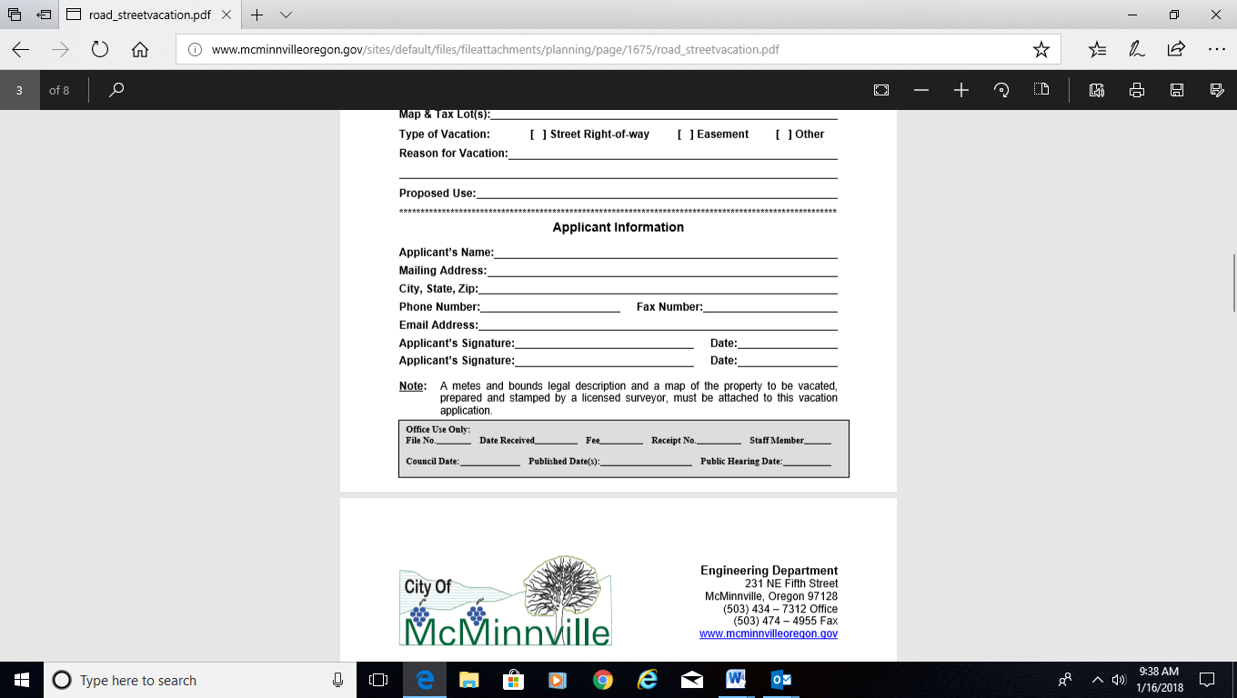

**NOTICE TO APPLICANT**

**LAND USE DEVELOPMENT FILING FEE**

**AND REIMBURSEMENT FOR ADMINISTRATIVE COSTS**

Dear Applicant:

The City of Moro, like many cities in Oregon, is faced with a severely reduced budget for the administration of the City's ordinances. The land use planning process in the State of Oregon has become increasingly complex. To properly process your land use application, the City must rely upon professional consultants to assist in preparing the legal notices, conducting on-site inspection, preparation of staff reports and attendance at the Planning Commission and/or City Council meeting. The City utilizes a consultant to ensure your application is processed fairly and promptly. Because of the reduced budgets, the City finds it necessary to transfer those administrative costs to you, the applicant, as a part of the land use planning process. Therefore, you are asked to read and sign the statement

below indicating you understand the requirement.

After completion of the review process or after a final decision is rendered by either staff or City Council, the City will send a final invoice to the applicant. Building permits will not be issued until the land use fees are paid in full to the City.

Costs include, but are not limited to, advertising/public notice, mailings, legal counsel (at ($275.00 per hour, planning consultant services (at $175.00 per hour), filings and engineering costs (at $245 per hour) identified with the specific land use request.

**LAND USE DEVELOPMENT FILING FEE AND ADMINISTRATIVE COST REIMBURSEMENT**

I/We, the applicant(s), __________________ agree that in addition to the Land Use Filing Fee per City of Moro Fee Schedule, to reimburse the City of Moro for actual cost of Contract Planner, Engineers and City Attorney, or other consultants incurred by the City to process your land use application.

Signed this date__________ of _____________________ 20______.

(day) (month) (year)

Property Owners/Applicant _____________________________________

(print)  
  
_____________________________________________________

(signature)