Thank you for your interest in our lodging services:
Our facility only houses dogs in glass front suite which are ~28 sqft or larger
What’s included:
- Kuranda bed
- Food & water bowls
- Fleece blanket
- Food, but you can bring your own
- A kennel technician to take care of your pups needs
Everyday our suites go through a strict cleaning regimen. All suites are scrubbed and disinfected. All bedding and bowls are washed to ensure your dog has the most hygienic place to call home for the night.
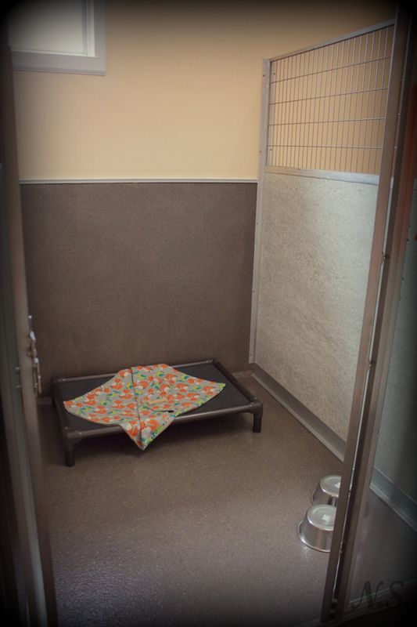

Nightly rate per dog: $36.50/single dog or $34.62/multiple dogs

Enrichments to enhance your dog’s stay, see enrichment sheet for descriptions and pricing.
Thank you for visiting out facility. We hope you found things as homey and inviting as we intended it to be. We know there is no place as comfortable for your pet as your own home but the staff at Paws on the Duck Strive to make each individual guest’s stay as good as they possible can. If you have already or should you choose to schedule a stay with us the following information may be helpful while preparing for your pets stay. We look forward to pampering your babies the way the deserve while you are away.
Immunization Requirements
All pets are required to have the below immunizations. These are to be administered under the care of a license veterinarian who will also be the holder of the official immunization records. There are no exceptions allowed as we feel strongly about the health of all our furry friends who come to Paws on the Duck.
Dog: Rabies, Distemper/parvo, and Bordetella
Feline: Rabies and FVRCP
Medications
We will be more than happy to administer any required medications or supplements during your pet’s stay. It is necessary that any medications/supplements that we administer to be in original packaging from manufacturer or your vet’s prescription vial. Altered or out of package medications will not be accepted. For safety reasons medications/supplements will only be administered according to package directions. No off-label administration will be allowed. There is an additional charge of $4.00 per day of stay for this service. Please include enough medication for their entire stay.
Diet
At the lodge we provide a high-quality low residue diet manufactured by Royal Cannin or Purina Pro Plan to all our guest. Many pets are more comfortable eating the diet they are used to. Foods may be brought canned or dry either in containers or individual portions. There is no additional charge for use of our diets. Dietary change in the lodging setting can often cause upset stomach or diarrhea. Please provide our caretakers with any special instructions at check-in. Please notify our caretakers of any food allergies at check in. No raw or undercooked meat or meat byproducts will be handled by our staff as they present a food safety handling hazard.
Medical
Care Guests with life threatening illness may require care that our facility is not equipped for. Please notify caretakers of any chronic or acute illness your pets may have prior to check-in. If your pet is being seen by your veterinarian for a current condition, please provide all contact information for your veterinarian and a summary of your pet’s medical condition. No pets with current or recent contagious illnesses will be allowed to lodge in our facility. Additionally, all pets must be able to move around under their own power to lodge in our facility. If your pet has any food or other allergic conditions, please notify us upon check-in.
Belonging
Many of our guests like to bring belongings from home. Paws on the Duck and our staff are not responsible for lost or damaged belongings. We provide each pet with food and water bowls along with Kuranda beds and fleece blankets providing they do not chew on them. Since we launder all bedding daily there are no retained smells. Due to our cleaning standards and the fact we provide beds and blankets we respectfully request you leave yours at home. Some pets behave differently during a lodging stay and may damage their own belongings. Any damaged toys, bedding or other items will be removed from your pet’s suite as soon as damage is noticed. Some types of toys are not deemed safe by our veterinary advisors for unsupervised play and will not be given to your pet during their stay with us. Toys should be of a non-destructible type such as Kong or Nylabone. Rawhides, pig ears, antlers and natural bones among other things will not be fed during a stay with us as they may cause digestive problems that could require medical attention.
Check in/Check Out
Check in time is after 1 pm Monday through Saturday. Check out time is before 11am Monday through Saturday. Early check in or late check out special arrangements can be made upon request. To allow for medication administration of the pets staying with us we request first drop-off not be before 7:30am and last pickup no later than 5:30pm. Check in or check out on Sundays/holidays is by appointment only. (All Sunday/holiday check outs must settle bill prior to Sunday/holiday.) Sunday/holiday staff will not release pets unless prior arrangements have been made and cannot check out a pet outside of scheduled times so, please plan accordingly and notify our front desk on Saturday if any changes need to be made. All dogs being released on a Sunday or holiday will have an orange sheet of paper authorizing the pet(s) named to be released on the stated date. It is advised to take a picture of the sheet as a picture of the release sheet is also honored by Sunday/holiday staff for release verification.
Business hours are Monday through Saturday 7 am – 6 pm, Sunday & holidays by appointment only with the pickup times being between 1:00pm and 4:30pm.
Salon Services
Want your pet to go home smelling better than when they arrived or looking like a movie star? Let’s schedule them for a groom or bath before they check out. Salon packages are available for all our cat and dog guests.

We look forward to your pet’s exciting time with us and can’t wait to get to know them. If you have any questions or concerns about their stay prior to check-in, please don’t hesitate to call us at any time. (931.548.8877)

Paws on the Duck Pet Resort and Salon
200 Bear Creek Pike
Columbia, Tennessee 38401
www.pawsontheduck.com
info.pawsontheduck@gmail.com
931.548.8877

Enrichments Activities
We offer a variety of enrichment services to turn your pets stay into an adventure. Guest services can schedule these activities for any and all days of their stay.
Treats – $1.50 – is your spoiled pet accustomed to having bunches of yummy treats? Our caretakers can give them throughout the day just like at home.

Brain Game – $7.00 – brain game is an interactive toy that releases treats to your pup. This self-paced game allows them to enjoy a fun time that stimulates both their body and mind.

Extra Walkie – $8.00 – our caretakers take special pride in their attentiveness to the needs of our guests and take them out as often as they show signs of need but sometimes a dog just needs more planned potty breaks than the standard two. Add extra walkie and our caretakers will schedule that into your pet’s daily plan.

Walk About – $11.50 – for the dog that needs to fulfill that inner urge to sniff and explore we offer a minimum 15 minute on lead walk with a caretaker around the campus within the perimeter fence.

One on One 15 – $11.00 – with this activity our caretakers will have individual playtime with your dog using our giant stash of toys in one of the activity yards for a minimum of 15 minutes. If your dog has a favorite activity you can tip off our staff and they will emphasize this one while exploring new possibilities as well. One on one time is available for our kitty guests as well in the Catatorium.
One on One 30 – $18.00 – this is the same activity as the One on One 15 and is available for cats and dogs for a minimum ½ hour.

Family Play – $18.00 – guests utilizing the Family Play activity will enjoy the same features as One on One 15 but open to your entire family of pets during their stay.

PlayCare – for current PlayCare members only.

