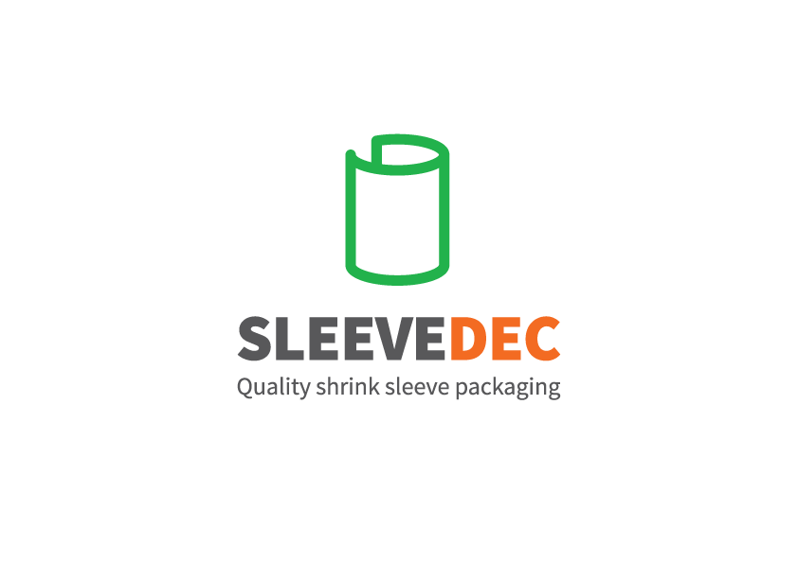

Oasthouse Engineering Ltd.

www.oasthouse-engineering.com

**Tips for Artwork**

* Use Spot Colours not CMYK
* Line thickness needs to be minimum 0.1mm
* Spec for text height is 1.5mm
* All the text needs to be outlined
* Crown match to the coated pantone book – if you use the uncoated book be aware that these can look different