Notes of the Sermon:  _______________________________________________  _______________________________________________  _______________________________________________  _______________________________________________  _______________________________________________  Sunday School Report – August 10, 2025  All Classes Total Present: 56  Adult Class 23: Sis. Rosalee Bradley (11)  Adult Class 24: Dea. Carl Henderson (9)  Adult Class 25: Sis. Darlene Powell (2)  Adult Class 26: Dr. Shirley Johnson (17)  Intermediate/Young People: Dea. James Patterson, Sis. Sanita Webb (8)  Beginners/Primary: Sis. Jakara Smith (7)  Report Submitted By: Sis. Harriet Chambers, Sis. Barbara Cobb  Superintendent: Sis. Carol McDougle  Home Daily Bible Readings  Mon. Aug. 18, Returns to the Lord,  Joel 2:12-17  Tue. Aug. 19, Faith without Works Is Dead,  James 2:14-26  Wed. Aug. 20, Everlasting Reign,  Psalm 146  Thu. Aug. 21, A New Song,  Psalms 149-150  Fri. Aug. 22, Teach Us to Pray,  Luke 11:1-13  Sat. Aug. 23, Practice Deeds of Mutual Love,  Hebrews 13:1-8  Sun. Aug. 24, Offer Sacrifices of Praise,  Hebrews 13:9-21 | Sunday, August 17, 2025  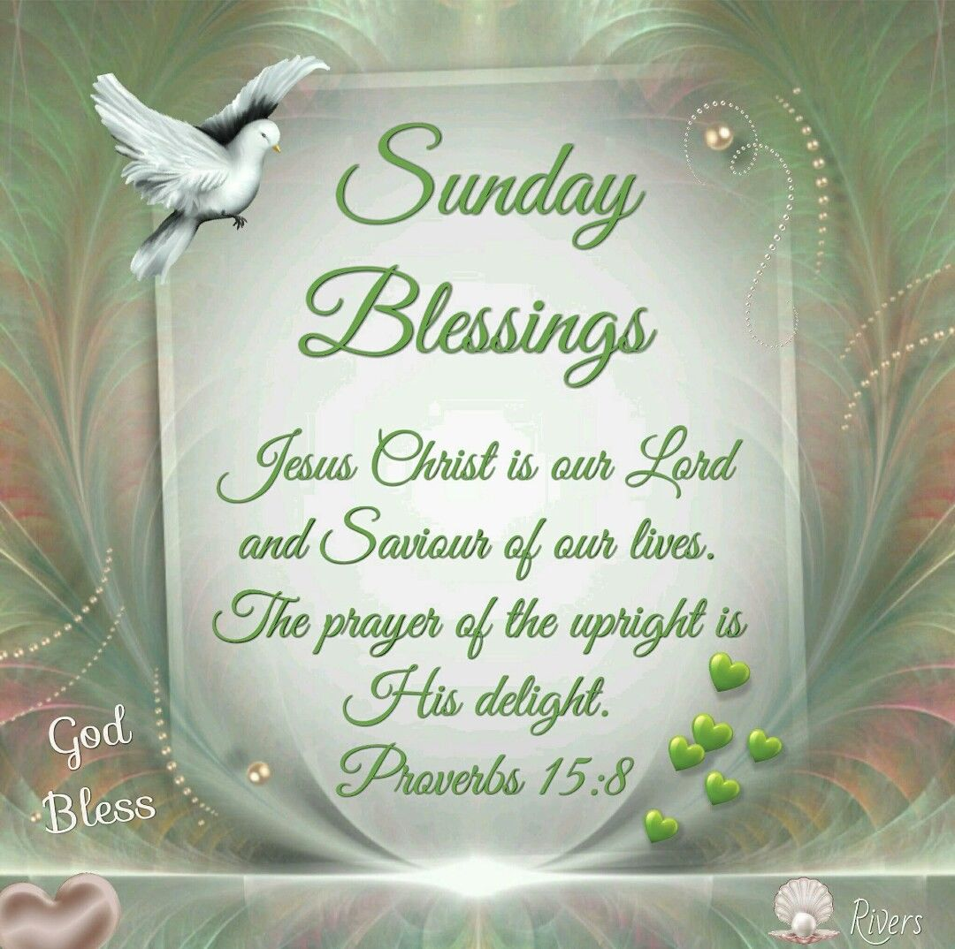  Rev. Dr. P. E. Henderson, Jr., Senior Pastor  Rev. Mark Hunt, Co-Pastor  Associate Ministers:  Rev. Alex George Rev. Charles Haddix Rev. Derrick Harris  Rev. Joseph Lambert Rev. Ella Mitchell  Rev. Paul Palmer Rev. Al Peters  10:00 A.M.  Corinthian Baptist Church  700 S. James H. McGee Blvd.  Dayton, Ohio 45402  937-223-2373  Website  www.https://corinthianbcdayton.org/  Email: corinthianbcdayton@gmail.com  Prayer line - 888-683-5512
Order of Worship Service  Call to Worship: Give unto the Lord the glory due unto his name; worship the Lord in the beauty of holiness. Psalm 29:2 (KJV)  Prayer  Scripture: Genesis 4:16-26 (NKJV)  Leader: 16. Then Cain went out from the presence of the Lord and dwelt in the land of Nod on the east of Eden.  People: 17. And Cain knew his wife, and she conceived and bore Enoch. And he built a city, and called the name of the city after the name of his son—Enoch.  Leader: 18. To Enoch was born Irad; and Irad begot Mehujael, and Mehujael begot Methushael, and Methushael begot Lamech.  People: 19. Then Lamech took for himself two wives: the name of one was Adah, and the name of the second was Zillah.  Leader: 20. And Adah bore Jabal. He was the father of those who dwell in tents and have livestock.  People: 21. His brother’s name was Jubal. He was the father of all those who play the harp and flute.  Leader: 22. And as for Zillah, she also bore Tubal-Cain, an instructor of every craftsman in bronze and iron. And the sister of Tubal-Cain was Naamah.  People: 23. Then Lamech said to his wives: “Adah and Zillah, hear my voice; Wives of Lamech, listen to my speech! For I have killed a man for wounding me, Even a young man for hurting me.  Leader: 24. If Cain shall be avenged sevenfold, Then Lamech seventy-sevenfold.”  People: 25. And Adam knew his wife again, and she bore a son and named him Seth, “For God has appointed another seed for me instead of Abel, whom Cain killed.”  All Together: 26. And as for Seth, to him also a son was born; and he named him Enosh. Then men began to call on the name of the Lord. Amen.  Morning Hymn It Is Well with My Soul (Page 3)  Announcements  Selection  Offering (Givelify)  Offertory Prayer  Page 2 | Our Sick & Shut-In List–*Denotes New/Change  Sharon Babb, 1195 Westbrook Rd., Dayton 45415  Billie Sue Brown, 217 Elmhurst Rd, Dayton 45417  Donald Cortner, 5019 Wellfleet, Trotwood 45426  John Dorsey, 127 N. Marion Street, Dayton 45417  Willie Horsely, 721 N. Upland Ave., Dayton 45417  Calvin Lanier, 4003 Foxboro Dr., Trotwood 45416  Winifred Long, 4107 Parkway Dr., Dayton 45416  *Betty Masey, 320 Heather Street #12, Englewood 45322  Jimmie McBeth, 1675 Kensington Drive, Dayton 45406  AP Richardson, 112 Cobblestone Lane, Springboro, 45066  Dorothy Ward, 1829 Weaver St., Dayton 45417  Anna White, 205 Sherman Street, Dayton 45403  Pamela Williams, 5266 Cobblegate Blvd. Apt. E, Moraine 45439  Nursing Homes or Assisted Living Centers:  Cornelia Bush, Grace Brethren, 1010 Taywood Road, Rm 50, Englewood, OH 45322  *Cristina Pearson, Walnut Creek, 5070 Lamme Rd, Room 108 Dayton, OH 45439  Mary White, Carriage Inn NH, 5040 Philadelphia Dr, Rm 331, Dayton 45415    Page 7
Congregational Hymn  “When We All Get to Heaven”  - Sing the wondrous love of Jesus,  Sing His mercy and His grace;  In the mansions bright and blessed  He'll prepare for us a place.  - While we walk the pilgrim pathway  Clouds will overspread the sky;  But when trav'ling days are over  Not a shadow, not a sigh.  Refrain:  When we all get to heaven,  what a day of rejoicing that will be!  When we all see Jesus,  we'll sing and shout the victory!  - Let us then be true and faithful,  Trusting, serving ev'ry day;  Just one glimpse of Him in glory  Will the toils of life repay.  - Onward to the prize before us!  Soon His beauty we'll behold;  Soon the pearly gates will open–  We shall tread the streets of gold. [Refrain]  Invitational to Christian Discipleship  “Just As I Am”  - Just as I am, without one plea, But that Thy blood was shed for me,  And that Thou bid’st me come to Thee, O Lamb of God, I come! I come!  - Just as I am, and waiting not To rid my soul of one dark blot;  To Thee whose blood can cleanse each spot, O Lamb of God, I come, I come!  - Just as I am, though tossed about With many a conflict, many a doubt;  Fightings within, and fears without, O Lamb of God, I come, I come!  Page 6 | Selection  Congregational Hymn When We All Get to Heaven (Page 6)  Gospel Sermon  Invitational to Christian Discipleship Just As I Am (Page 6)  Benediction  “THE DOXOLOGY”  “Praise God, from whom all blessings flow, Praise Him, all creatures here below; Praise Him above ye heav’n-ly host; Praise Father, Son, and Holy Ghost.”—Amen  Morning Hymn  “It Is Well with My Soul”  - When peace like a river attendeth my way,  When sorrows like sea billows roll;  Whatever my lot Thou hast taught me to say,  “It is well, it is well with my soul!”  - Though Satan should buffet, though trials should come,  Let this blest assurance control,  That Christ hath regarded my helpless estate,  And hath shed His own blood for my soul.  Chorus:  It is well with my soul!  It is well, it is well with my soul!  - My sin—oh, the bliss of this glorious thought—  My sin, not in part, but the whole,  Is nailed to His Cross, and I bear it no more;  Praise the Lord, praise the Lord, O my soul!  - And Lord, haste the day when my faith shall be sight,  The clouds be rolled back as a scroll;  The trump shall resound, and the Lord shall descend,  Even so, it is well with my soul. [Refrain]  Page 3
Announcements  - Thank you: To Dr. PE Henderson, Jr. Pastor, Rev. Mark Hunt, Co-Pastor and the Corinthian Baptist Church Family thank you so much for the sympathy cards, flowers from Carol McDougle and the Sunday School and all other acts of kindness shown during the passing of my husband. Sis. Linda Weatherspoon.  - To the Corinthian Church Family: We are grateful for your generosity, kindness and support that will make a huge impact on our children’s education. You may have provided the funding to purchase supplies, you may have donated supplies or volunteered to fill the backpacks. Or even prayed to make this endeavor possible. Your support allowed us to fill over 100 backpacks with the essential tools to start the school year. “Let’s us not become weary in doing good, for at the proper time we will reap a harvest if we do not give up”. Galatians 6:9 Thank you again for everything. Janet C. Jones and Mozelle Garcia  - Congratulations: Saturday, August 23, 2025, Lieutenant Colonel Taylor Jones III, U.S. Army, will be promoted to the rank of Colonel at the National Museum of the US Air Force, 1100 Spaatz St., Dayton, OH 45433. The ceremony will be held in the Space Gallery Overlook which is on the second floor of the fourth building from 1 -4PM. We invite you to join us in celebrating this honor. Our prayer is for God to continue to bless him as he advances in his career. Thank you, Ella Jones  - Youth Choir: All parents, grandparents, guardians and friends Corinthian Baptist Church needs your children and youth to come out for choir rehearsals on Wednesday, 6-7 PM, We will sing Sunday, August 31. We need your support. If you have any questions, contact Minister Derrick Harris  Page 4 | - Dayton Public Schools: WILL NOT TRANSFER high school students for the 2025 school year. “Families are encouraged to use the mode of transportation that works best for them to ensure their students can get to and from school each day.” WE MUST BEGIN TO PRAY, PRAY, PRAY FOR A SOLUTION TO THIS ALARMING AND TOTALLY DISHEARTENING TRANSPORTATION ISSUE CONFRONTING OUR YOUTH. Rev. Henderson is greatly concerned about this matter and is vigorously seeking a solution. We need to know how many youths attending Corinthian Baptist Church that will be affected by the Dayton Public Schools transportation mandate. Please give those names to Mozelle Garcia or the church secretary as soon as possible. School has started for students attending Dayton Public Schools. Thank you for your timely support in this matter.  - The Mass choir is sponsoring a Fish or Chicken dinner. Saturday, September 6th in the Family life center. Tickets are $15 Adults, $10 children (10 & under). Tickets will be available and can be purchased from any choir member. The delicious meal will consist of Fish or chicken, choice of 2 sides with bread. Cake, water, and soda will be available for purchase. Do not miss this event to support our choir. Invite your friends and family.  - Pack The Pews: Annual Reunion Picnic will be held on the 2nd Sunday in September. More details to come.  - Teachers Meeting: We’ll resume on our conference call studies at 7 PM in September. Thank you for your participation. Sis. Carol McDougle  Page 5

