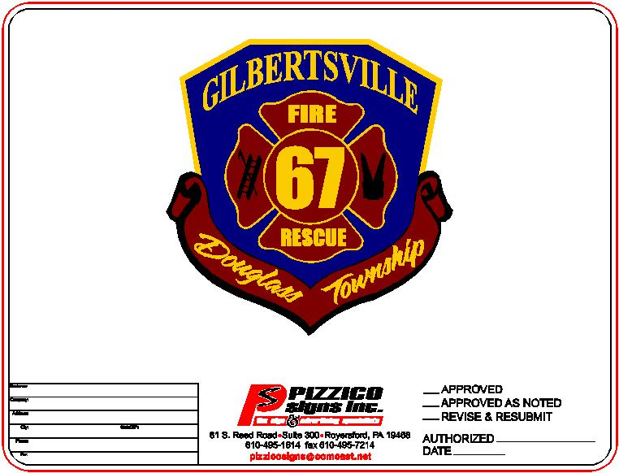
Gilbertsville Fire & Rescue Company
1454 East Philadelphia Avenue ● P.O. Box 454 ● Gilbertsville, PA 19525
Phone - 610-367-0277 ● www.gilbertsvillefireandrescue.org

FIRE PREVENTION / EVENT REQUEST FORM
REQUESTOR INFORMATION

Organization or Company: ________________________________________

Address: _______________________________________________________

Contact Name: ________________________ Position: ________________

Telephone: ____________________ Email: ______________________________

Cell Phone: ____________________
EVENT INFORMATION

Date of Event: _____/_____/______ Day of the Week Preferred: ________________

Physical Address of Event: ____________________________________________________

Event Start Time: __________ AM / PM Event End Time: __________ AM/PM

Age Group: __________ Number of Attendees: __________

# of Boys: __________ # of Girls: __________ # of Adults: __________

Anticipated Special Needs or Accommodations needed: _____________________________
________________________________________________________________
________________________________________________________________

Please Select the Type of Event Requested (Please choose 1 per event request)

_____ Fire Station Tour _____ Fire Extinguisher Training _____ Fire Truck Tour

_____ Fire Prevention Education Other: _______________________________________

Please send Completed Request to: eventsgfrc@gmail.com

Requestor Signature: _________________________ Date: _____/_____/_____

This form should be submitted 30 Days prior to the date of your scheduled event

