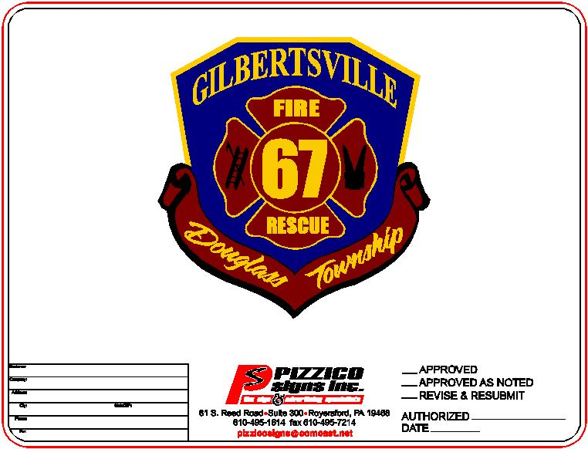
Gilbertsville Fire & Rescue Company
1454 East Philadelphia Avenue ● P.O. Box 454 ● Gilbertsville, PA 19525-0454
Phone 610-367-0277 Fax 610-369-0535

ACTIVE AND CONTRIBUTING MEMBERSHIP APPLICATION

PLEASE PRINT

NAME: _________________________________________________________ DATE: ____________________

ADDRESS: ___________________________________________________________________________________

TOWN: _____________________________________________ ZIPCODE: _____________________________

SOCIAL SECURITY NUMBER __________ - __________ - ____________________

DATE OF BIRTH: _____/_____/__________ CURRENT AGE: ________________

DRIVERS LICENSE # - __________________________________ LICENSE CLASS: ____________________

DRIVERS LICENCE EXPIRATION: _____/_____/__________

HOME PHONE #: ______-_____-__________ CELL PHONE #: _____-_____-__________

WORK PHONE #: _____-______-__________ EMAIL: _____________________________________________

EMERGENCY CONTACT: __________________________________ TELEPHONE #: _____-_____-__________

RELIGION (OPTIONAL): ___________________________________

OCCUPATION: _______________________________ EMPLOYER: __________________________________

EDUCATIONAL BACKGROUND

HIGH SCHOOL / TECH SCHOOL: _______________________________________________________________

COLLEGE / VOCATIONAL SCHOOL: ___________________________________________________________

POST GRADUATION: _________________________________________________________________________

MILITARY EXPERIENCE: _____________________________________________________________________

1

HEALTH INFORMATION

DO YOU WEAR GLASSES / CORRECTIVE LENSES?: _____YES _____ NO

DO YOU SUFFER FROM ANY OF THE FOLLOWING: (IF SO PLEASE EXPLAIN)

HEART / CORONARY CONDITION: _______________________________________

EPILEPSY / SEIZURE DISORDER: _________________________________________

HIGH BLOOD PRESSURE: ________________________________________________

DIABETES: _____________________________________________________________

SENSORY DISORDER: ___________________________________________________

IS THERE ANY REASON THAT YOUR PRESENT HEALTH CONDITION WOULD RESTRICT YOUR ACTIVITIES AS A FIREFIGHTER? (IF YES, PLEASE EXPLAIN)

DATE OF LAST PHYSICAL: __________/__________/__________

DATE OF LAST TETINUS SHOT: _________/___________/___________

PREVIOUS FIREFIGHTING EXPERIENCE

FIRE COMPANY: _______________________________DATE:_________________RANK: _________________

FIRE COMPANY: _______________________________DATE:_________________RANK:_________________

FIRE COMPANY:_______________________________DATE:_________________RANK:__________________

TOTAL YEARS AS A FIREFIGHTER: _____________

***PLEASE SUPPLY A COPY OF ALL FIRE SCHOOL AND TRAINING CERTIFICATIONS WITH APPLICATION***

BACKGROUND INVESTIGATION

HAVE YOU EVER APPLIED FOR MEMBERSHIP WITH GILBERTSVILLE FIRE AND RESCUE COMPANY?

YES __________ DATE: _____ / _____/ __________ NO ____________

HAVE YOU EVER BEEN DENIED MEMBERSHIP AT ANY OTHER ORGANIZATION?: YES ____ NO ____

(IF YES PLEASE EXPLAIN):____________________________________________________________________

2
PLEASE LIST BELOW PREVIOUS ORGANIZATIONS YOU HAVE BELONGED TO:

ORGANIZATION POSITION/TITLE YEARS

_________________________________________________________________________________________________________________________________________________________________________________________________________________________________________________________________________________________________________________________________________________________________________________________________________________________________________________________________________________

DO YOU DESIRE A PARTICULAR FUNCTION WITHIN THE ORGANIZATION?: ______________________

REASON YOU WISH TO JOIN OUR ORGANIZATION: _____________________________________________
__________________________________________________________________________________________________________________________________________________________________________________________

HAVE YOU EVER BEEN ARRESTED? ______ YES _____ NO

DO YOU HAVE A CRIMINAL RECORD? (CONVICTIONS ONLY) _____ YES _____ NO

(IF YES, PLEASE EXPLAIN): ___________________________________________________________________
__________________________________________________________________________________________________________________________________________________________________________________________

PLEASE COMPLETE THE FOLLOWING BACKGROUND CHECKS AND SUBMIT WITH APPLICATION:

PENNSYLVANIA STATE POLICE: https://epatch.state.pa.us/Home.jsp (SELECT VOLUNTEER)

PENNSYLVANIA CHILD ABUSE CLEARANCE: https://www.compass.state.pa.us/cwis/public/home

I agree to permit the Gilbertsville Fire and Rescue Company to conduct an investigation into my background through the Douglass Township Police Department, Pennsylvania State Police, Pennsylvania Child Abuse Clearance, FBI, or any other recognized law enforcement organization. I will also return any and all items that were issued to me by Gilbertsville Fire and Rescue Company that are considered to be fire company property at the time of my resignation or termination of membership. This information will be held in high confidence by Gilbertsville Fire and Rescue Company

SIGNATURE OF APPLICANT: _______________________________________DATE: _____/_____/__________

SIGNATURE OF GUARDIAN: _______________________________________DATE: _____/_____/__________

IF UNDER 18 YEARS OF AGE A PARENT OR GUARDIAN MUST SIGN THIS APPLICATION

OFFICIAL USE ONLY

SIGNATURE OF OFFICER ACCEPTING APPLICATION: _________________________DATE: ___/___/_____

DATE OF APPROVAL: _____/_____/__________ DATE OF DENIAL: _____/____/__________

REASON FOR DENIAL:________________________________________________________________________
__________________________________________________________________________________________________________________________________________________________________________________________

3

