cSTATE OF NEW MEXICO
COUNTY OF LINCOLN
TWELFTH JUDICIAL DISTRICT COURT

No.

DALE A. ANTILLA, NANCY ANTILLA, DAVID BALLARD, DIANE BALLARD, MICHAEL L. BROWN, PATRICIA M. BROWN, LYNNE E. BUDD, MICHAEL L. BUDD, JAMES C. BURNETT, JERI L.BURNETT, CRAIG W. CATHEY, SUE E.CATTERTON, AINSLEY CHITWOOD,WALTER CHITWOOD, BENNETT R. DAVIS, EVANGELINE M. DAVIS, DEBRA J. L. FALCON, CHRIS FARRINGTON, GALEN FARRINGTON, NANCY E. FEGELY, RALPH E. FEGELY, KEVIN FLEHARTY, NANCY D. FLEHARTY, AMY L. GOODE, LOUIS F. GOODE, CHARLES E. GORDON, GREGG R. GRIFFEN, LAVONNE L. GRIFFEN, ELLEN C. HIGHTOWER, STEVEN G. HIGHTOWER, PENELOPE S. HORTON, WILLIAM F. HORTON, JR., JUDY K. JUSTUS, RORY LACY, DENISE LAYTON, ROBERT LAYTON, MILDRED A. MASTIN, RICHARD D. MASTIN, LAWRENCE R. MATHER, CAROLINE MCCOY, JOHN D. MCCOY, DEBORAH MILLER, MICHAEL MILLER, IVAN R. MILLER, BRENDA RESTIVO, GARY RESTIVO, FARANZA SEDILLO, PAUL SEDILLO, BARBARA R. SEVERANCE, MARK L. SEVERANCE, EVERETT SKINNER, VIVIAN SKINNER, RANDALL L. SMITH, DARREL D. STIERWALT, DIORLY J. STEIRWALT, ANN STOUT, ROGER STOUT, KAREN A. SYZDEK, LEROY VIGIL, J. DALTON TARWATER, DOUGLAS E. THOMPSON, DAVID E. WEBB, DON R. WEEMS, KATHLEEN WEEMS, ROBERT WHITTEMORE, AND BARBARA J. YOUNT.

Plaintiffs,
v.

ROPER CONSTRUCTION, INC.,

Defendant.
VERIFIED COMPLAINT FOR ANTICIPATORY PRIVATE NUISANCE,
DAMAGES, AND DECLARATORY AND INJUNCTIVE RELIEF

For their Complaint against Defendant Roper Construction, Inc. (“Roper”), Plaintiffs state the following:
- NATURE OF THE CASE
- This action is brought by Plaintiffs, individually, to vindicate Plaintiffs’ interests in the quiet use and enjoyment of their land, by requesting a declaration from this Court that the construction and operation of a large, industrial concrete batch plant (“the plant”) proposed by Roper Construction, Inc. (“Roper” or “Defendant”) along NM Highway 220 and proximate to Plaintiffs’ residences in Alto, New Mexico, constitutes an impermissible private nuisance. This action also seeks an order enjoining the proposed construction of the concrete batch plant so that the nuisance can be prevented and abated.
- The proposed plant would constitute an intentional and unreasonable invasion of Plaintiffs’ quiet enjoyment of their properties and is wholly unsuited to the scenic, rural setting in the Alto area. Inevitable air pollution, water pollution, light pollution, and noise pollution, both from the plant and heavy truck traffic, beginning at 3:00 a.m. for much of the year, would substantially impair the area’s natural beauty and pristine conditions which enticed Plaintiffs to purchase lots and reside in the area. The pollution would also interfere with each Plaintiffs’ property uses, which are particularly compatible with the local environment, including agriculture, wildlife habitat, star gazing, and nature viewing. Additionally, fugitive dust emissions from the proposed concrete batch plant would severely harm Plaintiffs with existing respiratory conditions, and the proposed concrete batch plant would also significantly devalue Plaintiffs’ property and the resulting property tax base of the community. Plaintiffs residing near NM 220 will also be severely harmed by the disruption caused by early morning truck traffic and the extensive hours of plant operation.

- PARTIES, JURISDICTION, AND VENUE

3. Plaintiffs Dale and Nancy Antilla, husband and wife, are the owners of 135 Coyote Mesa Trail, Alto, New Mexico, a 5.42-acre residential property. Mr. and Mrs. Antilla purchased the property in July 2002.
4. Plaintiffs David and Diane Ballard, husband and wife, are the owners of 126 San Mateo Drive, Alto, New Mexico, a 5-acre residential property. Mr. and Mrs. Ballard purchased the property in April 2019.
5. Plaintiffs Michael and Patricia Brown, husband and wife, are the owners of 116 Bull Elk Court, Alto, New Mexico, a 2-acre residential property. Mr. and Mrs. Brown purchased the property in 1993.
6. Plaintiffs Lynne and Michael Budd, husband and wife, are the owners of 152 Sun Valley Road, Alto, New Mexico, a 0.64-acre residential property. Mr. and Mrs. Budd purchased the property on September 19, 2019.
7. Plaintiffs James and Jerri Lynne Burnett, husband and wife, are the owners of 340 Santiago Circle, Alto, New Mexico, a 10-acre residential property. Mr. and Mrs. Burnett purchased the property in August 2017.
8. Plaintiffs Craig Cathey and Barbara Yount, husband and wife, are the owners of 147 Legacy Lane, Alto, New Mexico, a 2.817-acre residential property. Mr. Cathey and Ms. Yount purchased the property in July 2013.
9. Plaintiffs David Webb and Sue Catterton, husband and wife, are the owners of 173 Sonterra Drive, Alto, New Mexico, a 5-acre residential property. Mr. Webb and Ms. Catterton acquired the property in September 2017.
10. Plaintiffs Ainsley and Walter Chitwood, husband and wife, are the owners of 146 Antler Drive, Alto, New Mexico, a 2-acre residential property. Mr. and Mrs. Chitwood purchased the property in July 2019.
11. Plaintiffs Bennett Ray and Evangeline Davis, husband and wife, are the owners of 146 Altamira Drive, Alto, New Mexico, a 5-acre residential property. Mr. and Mrs. Davis purchased the property in 2008.
12. Plaintiff Debra J. L. Falcon is the owner of Ranches of Sonterra lots nos. 219 and 291, totaling 10-acres of residential property. Ms. Falcon purchased the property in the 1990s.
13. Plaintiffs Chris and Galen Farrington, husband and wife, are the owners of 168 State Highway 220, Alto, New Mexico, a 2.5-acre residential property. Mr. and Mrs. Farrington purchased the property in 2016.
14. Plaintiffs Nancy and Ralph Fegely, husband and wife, are the owners of 148 Chama Canyon, Alto, New Mexico, an 18-acre residential property. Mr. and Mrs. Fegely purchased the property in December 2019.
15. Plaintiffs Kevin and Nancy Fleharty, husband and wife, are the owners of 121 Box Canyon Trail, Alto, New Mexico, a 43.5-acre residential property. Mr. and Mrs. Fleharty purchased the property in 1998.
16. Plaintiffs Amy and Louis Goode, husband and wife, are the owners of 190 Placitas Drive, Alto, New Mexico, a 10-acre residential property. Mr. and Mrs. Goode purchased the property in 2019.
17. Plaintiff Charles Gordon is the owner of 144 San Mateo Drive, Alto, New Mexico, a 10-acre residential property. Mr. Gordon purchased the property in 1996.
18. Plaintiffs Gregg and Lavonne Griffen, husband and wife, are the owners of 131 and 135 Legacy Lane, Alto, New Mexico, a 5-acre residential property. Mr. and Mrs. Griffen purchased the property in 2011.
19. Plaintiffs Ellen and Steven Hightower, husband and wife, are the owners of 137 Gray Fox Lane, Alto, New Mexico, an 11-acre residential property. Mr. and Mrs. Hightower purchased the property in 1996.
20. Plaintiffs Penelope and William Horton are the owners of 114 Legacy Lane, Alto, New Mexico, a 2-acre residential property. Mr. and Mrs. Horton purchased the property in 2007.
21. Plaintiff Judy Kay Justus is the owner of 174 Placitas Drive, Alto, New Mexico, a 5.167-acre residential property. Ms. Justus purchased the property in December 2016.
22. Plaintiff Rory Lacy is the owner of 143 Legacy Lane, Alto, New Mexico, a 7-acre residential property. Mr. Lacy purchased the residential tract in 2016 and purchased additional tracts in 2017 and 2021.
23. Plaintiffs Denise and Robert Layton, husband and wife, are the owners of 164 Santiago Circle, Alto, New Mexico. Mr. and Mrs. Layton purchased the property in September 2018.
24. Plaintiffs Richard and Mildred Mastin, husband and wife, are the owners of 113 Bela Cena, Alto, New Mexico, a 5-acre residential property. Mr. and Ms. Mastin purchased the property in 1995.
25. Plaintiff Lawrence R. Mather is the owner of 130 Winterhawk Heights Drive, Alto, New Mexico, a 5-acre residential property. Mr. Mather purchased the property in November 2005.
26. Plaintiffs Caroline and John Denys McCoy, husband and wife, are the owners of 199 Linda Vista Lane, Alto, New Mexico, a 10-acre residential property where they have resided for over 15 years.
27. Plaintiffs Deborah and Michael Miller, husband and wife, are the owners of 207 Racoon Court, Alto, New Mexico, a 1.3-acre residential property. Mr. and Mrs. Miller purchased the property in 2003.
28. Plaintiff Ivan Rex Miller is the owner of 100 Eagle Ridge Road, Alto, New Mexico, a 2-acre residential property. Mr. Miller purchased the property in January 2011.
29. Plaintiffs Brenda and Gary Restivo, husband and wife, are the owners of 153 San Mateo Drive, Alto, New Mexico, a 11.6-acre residential property. Mr. and Mrs. Restivo built their home in 2006 and purchased additional, adjacent property in 2008.
30. Plaintiffs Paul and Farzana Sedillo, husband and wife, are the owners of 87 Sandesta Drive, Alto, New Mexico, a 6.6-acre residential property. Mr. and Mrs. Sedillo purchased the property in December 2020.
31. Plaintiffs Barbara and Mark Severance, husband and wife, are the owners of 136 Santiago Circle, Alto, New Mexico, a 10-acre residential property. Mr. and Mrs. Severance purchased the property in September 2016.
32. Plaintiffs Everett and Vivian Skinner, husband and wife, are the owners of 123 Coyote Mesa Trail, Alto, New Mexico, a 7.3416-acre residential property. Mr. and Mrs. Skinner purchased the property in August 1988.
33. Plaintiff Randall Smith is the owner of 113 La Cueva, Alto, New Mexico, a 5-acre residential property. The property was purchased by his wife, Holly Elliot, in 2017.
34. Plaintiffs Darrel D. and Diorly J. Stierwalt are the owners of 137 and 149 Zorro Lane, Alto, New Mexico, a combined ten acres of residential property. Mr. and Mrs. Stierwalt purchased the first lot in 2000 and the second in 2014.
35. Plaintiffs Ann and Roger Stout are the owners of 115 La Cueva Court, Alto, New Mexico, a 5-acre residential property. Mr. and Mrs. Stout purchased the property in August 2020.
36. Plaintiffs Leroy Vigil and Karen Ann Syzdek are the owners of 172 Santiago Circle, Alto, New Mexico, a 17.5-acre residential property. Mr. Vigil and Ms. Syzdek purchased the property in August 2017.
37. Plaintiff J. Dalton Tarwater, Ph.D. is the owner of 114 Winter Park Road, Alto, New Mexico, a 1.5-acre residential property. Dr. Tarwater purchased the property in April 1999.
38. Plaintiff Douglas Thompson is the owner of 196 State Highway 220, a 5-acre residential property. Mr. Thompson purchased the property in August 2000.
39. Plaintiffs Kathleen and Donnie Weems, husband and wife, are the owners of 116 Legacy Lane, Alto, New Mexico, a 2.1-acre residential property. Mr. and Mrs. Weems purchased the property in February 2020.
40. Plaintiff Robert Whittemore is the owner of 133 Pecos Court, Alto, New Mexico, a 5-acre residential property. Mr. Whittemore purchased the property in July 1997.
41. Defendant Roper is a New Mexico corporation with its principal place of business located at 113 Coyote Mesa, Alto, New Mexico.
42. This Court has jurisdiction pursuant to Article VI, Section 13 of the New Mexico Constitution and NMSA 1978, Section 44-6-2 (Declaratory Judgment Act).
43. Venue is proper in this Court pursuant to NMSA 1978, Sections 38-3-1(A), (B), (D)(1).

III. CHARACTER OF THE LOCALITY
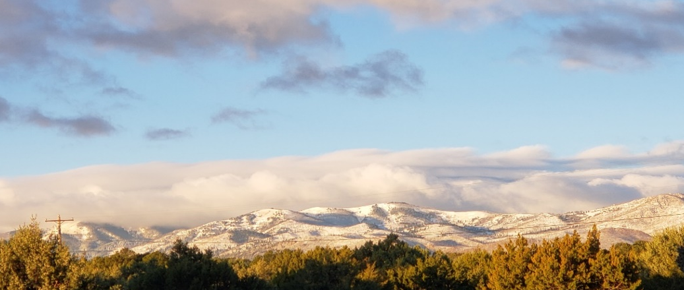
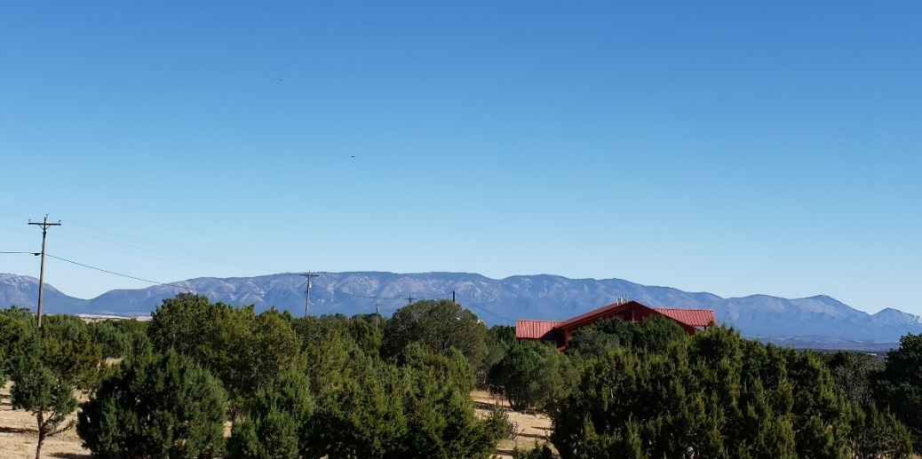
44. Plaintiffs reside in and around Alto, New Mexico, an unincorporated area in Lincoln County, located approximately six (6) miles north of Ruidoso, New Mexico. The area is between the Sierra Blanca Mountains to the west, pictured below, and the Capitan Mountains to the east, also pictured below. The Alto area shown below also includes parts of the Lincoln National Forest and the Fort Stanton Snowy River Cave National Conservation Area.
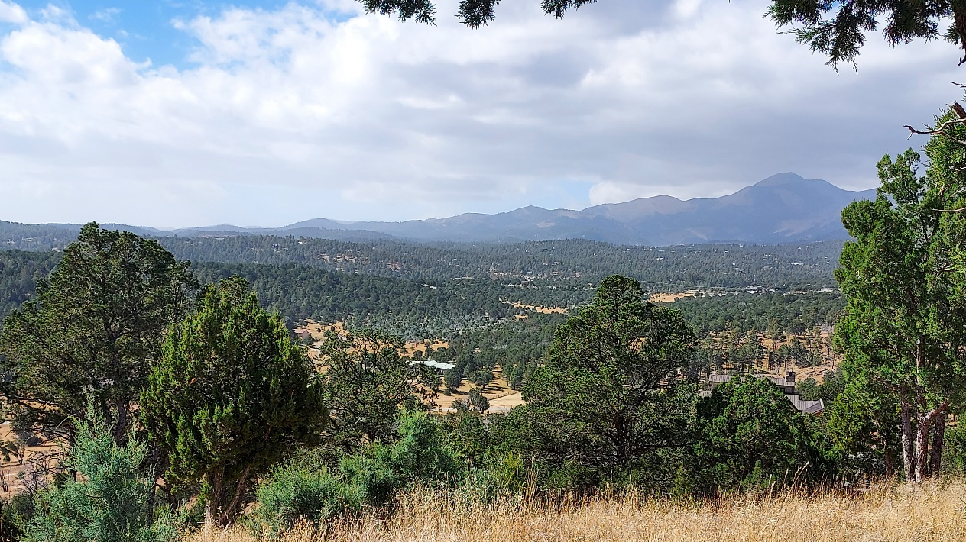
45. Roper has proposed to construct an industrial concrete batch plant in Alto near the intersection of NM State Highway 220 and NM Highway 48. The proposed location of the concrete batch plant is in a rural and virtually exclusive residential community. The photograph below depicts the view from Plaintiffs Mr. and Mrs. Restivos’ residence, in the direction of the proposed location of the concrete batch plant, and demonstrates the natural, rural, and residential character of the area.
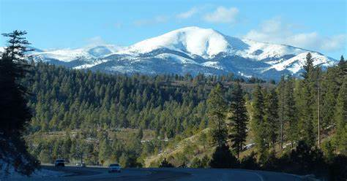
46. The residential neighborhoods surrounding the proposed concrete batch plant are scenic, quiet, and peaceful, enjoying unimpeded views the White Mountain Wilderness Area, including Sierra Blanca Peak, southern New Mexico’s highest peak. The residents of the area enjoy experiencing nature free from the noise, light pollution and air pollution of larger towns and cities that often include industrial plants, such as the concrete batch plant proposed by Roper.
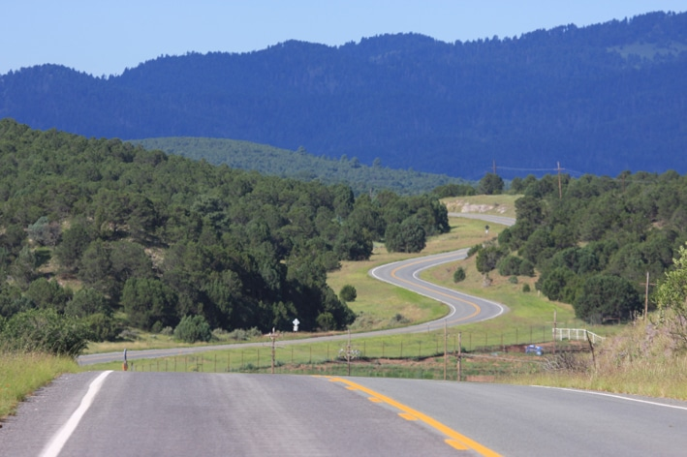
47. NM 220, where Roper has proposed to locate the industrial concrete batch plant, has been designated by the United States Department of Transportation Federal Highway Administration as a National Scenic Byway, which recognizes and seeks to preserve the natural and scenic qualities of the area.
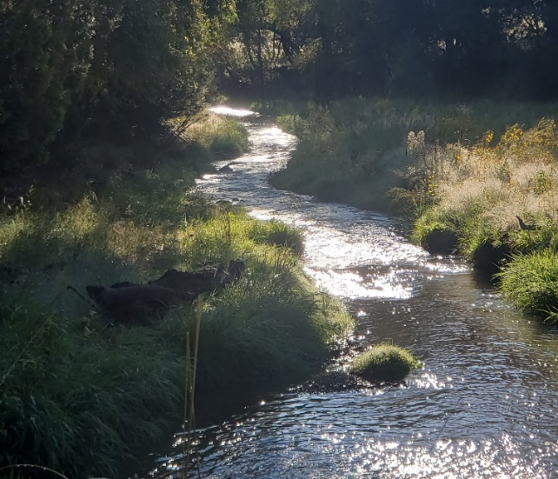
48. The pristine quality of the air provides for incomparable views of the surrounding beauty of the area, including the Sierra Blanca mountains, shown below, and local water ways, such as Little Creek, also shown below.

49. Currently, there is minimal, if any, traffic noise, including traffic noise generated by large trucks, in the area of Plaintiffs’ residences on or near NM 220 and NM 48. There are no industrial enterprises, heavy or light, located in the area, resulting in the absence of any industrial noise or light pollution in the area.
50. The lack of noise pollution allows Plaintiffs to enjoy observing myriad wildlife on their property, including wild horses, elk, wild turkeys, hummingbirds, foxes and deer.
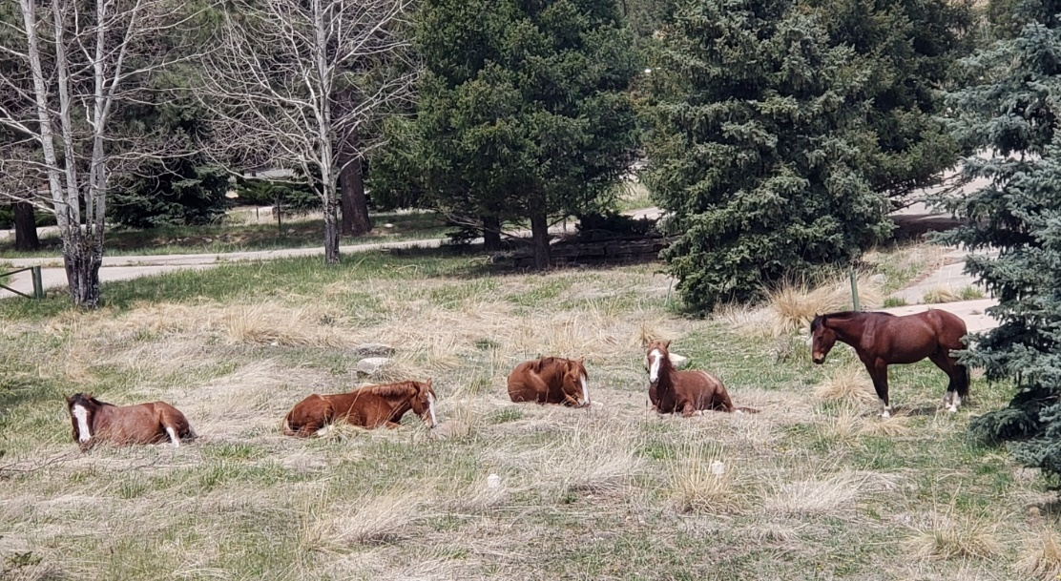

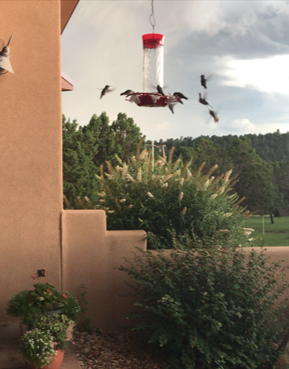
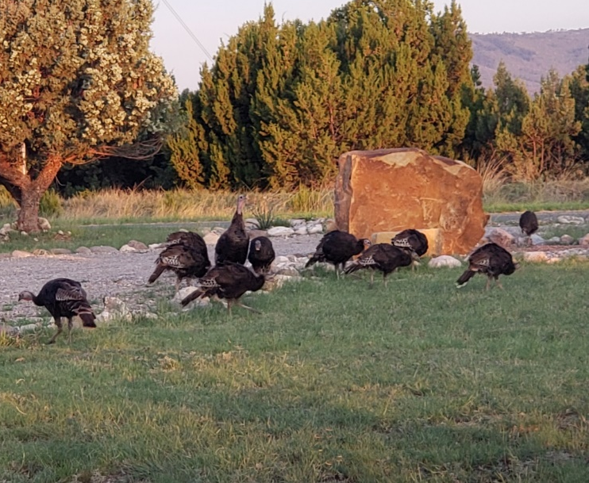
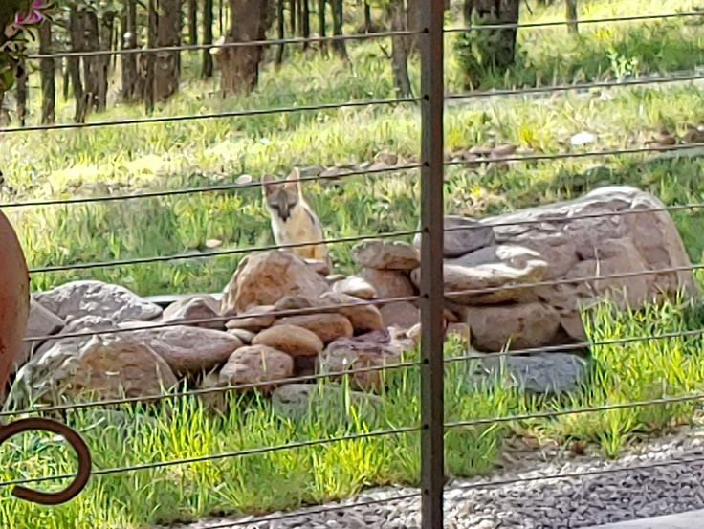
51. Because the area is rural and predominantly residential, there is no discernable light pollution and Plaintiffs are able to enjoy unfettered views of the night sky. In fact, this area is well-known for its dark skies and pristine nighttime viewing conditions. Plaintiff Charles E. Gordon is an amateur astronomer and has captured stunning photographs of celestial objects as a result of the clear air and absence of light pollution in this area.
52. Recognizing the natural quality and pristine character of this rural and residential area, the deed covenants of many of the lots adjacent to the proposed site of the concrete batch plant contain covenants of quiet enjoyment, with specific restrictions against any use which, by its nature (whether noise, odor, hours of operation, etc.) would be a nuisance to adjoining lot owners.
53. Notably, the warranty deed that conveyed the lot where Roper proposes to construct and operate the concrete batch plant also contains the very same covenant of quiet enjoyment and prohibits any activity that would be considered a nuisance to adjoining lot owners. See Exhibit A, Deed for site of proposed concrete batch plant.
54. Moreover, the disclosure statement from at least one (1) neighborhood subdivision surrounding the proposed site of the Roper concrete batch plant, found at Record # 8109 of the Lincoln County records, specifically noted, as an enticement for potential purchasers, that there were “no activities or conditions adjacent to or nearby the Subdivision, such as feedlots, cement plants, or the like, which would subject the Subdivision land to any unusual conditions affecting its use or occupancy.” See Exhibit B, Disclosure Statement (emphasis added).
55. The proposed location of Roper’s concrete batch plant would be contrary to both Roper’s deed covenants and to the representations in the disclosure statement, found at Record # 8109, assuring prospective buyers purchasing residential property that a concrete batch plant would not be located in this area.
56. The construction and operation of an industrial concrete batch plant will create materially adverse and detrimental conditions that are markedly divergent from the character of the area as described above.
57. The Board of County Commissioners of Lincoln County, New Mexico, has recognized the inevitable deleterious effects from the potential construction of Roper’s concrete batch plant and passed Resolution No. 2021-24, concluding that Roper’s proposed concrete batch plant could be considered a public nuisance to the surrounding property owners. The Resolution specifically found that the existence of such a plant would “likely result in visual and environmental blight, and unhealthy, unsafe and devaluing conditions.” See Exhibit C, Lincoln County Board of Commissioners Resolution. One participant at the Commission meeting cautioned that construction of the concrete batch plant would require a re-assessment of property values in the community, likely resulting in a deteriorating property tax base to provide public services.
IV. DESCRIPTION OF CONCRETE BATCH PLANT OPERATIONS
58. Roper intends to construct and operate a concrete batch plant approximately 0.35 miles east of the intersection of NM 48 and NM 220 in Lincoln County. The Plaintiffs’ residences are located in the area surrounding the proposed concrete batch plant. See Exhibit D, Google Earth map depicting locations of Plaintiffs’ residences.
59. Roper currently operates a substantially similar concrete batch plant in Carrizozo, New Mexico. As shown below, this concrete batch plant includes substantial industrial components covering a large footprint, including significant volumes of aggregate materials scattered across the premises.
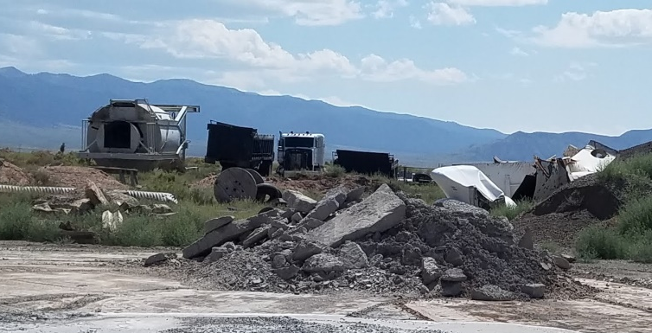
60. Additionally, at Roper’s existing plant in Carrizozo, shown below, concrete rubble and other debris are strewn haphazardly across the site, with no safeguards in place to prevent fugitive emissions from these materials and without any authorized permit for this on-site solid waste disposal. There is no basis to expect that the proposed Alto concrete batch plant would have dissimilar characteristics.

61. The industrial components of a concrete batch plant, as exemplified by Roper’s existing plant in Carrizozo, do not conform to the natural character of the Alto area as described above and as further amplified in this complaint.
62. The Application for an Air Quality Permit submitted by Roper to the New Mexico Environment Department (“NMED”) reveals that Roper’s proposed concrete batch plant will be a source of Hazardous Air Pollutants (“HAPs”). See Exhibit E, Roper Application, Section 1, p. 4.
63. Roper claims that the proposed concrete batch plant will only be a “minor” source, i.e., emitting less than 10 tons per year (“TPY”) of any single HAP and less than 25 TPY of all HAPs, only by virtue of Roper’s proposed intent to implement certain controls designed to reduce HAP emissions. See Exhibit E, Roper Application, Section 1, p. 4; id., Table 2-C, p. 1; id., Table 2-D, p. 1; id., Table 2-E, p. 1 (showing a purported reduction in emissions from the estimated emissions with pollution controls). However, the only pollution controls proposed by Roper to limit the fugitive dust emissions at the proposed concrete batch plant are water sprayers at the exit of the aggregate/sand feed hopper. See Exhibit E, Table 2-C, p.1 (showing the majority of emission control equipment as “additional moisture content.” ).
64. Without an adequate water supply to implement the pollution controls and Roper’s on-going commitment to implement the controls on a constant basis, the proposed concrete batch plant would emit over 520 TPY of PM (particulate matter), 263 TPY of PM 10 (particulate matter with a diameter of 10 micrometers or less), and 68 TPY of PM 2.5 (particulate matter with a diameter of 1.5 micrometers or less). See Exhibit E, Roper Application, Table 2-D, p. 1. As a result, the proposed concrete batch plant would be a “major” source of HAP, defined as a source that has the potential to emit more than 10 TPY of one or more HAPs or more than 25 TPY of all HAPs.
65. Roper has not calculated the water consumption necessary to implement the pollution controls proposed for the concrete plant; however, in order to produce the large volumes of concrete estimated by Roper (500,625 cubic yards per year based on 267 days of continuous operations), Roper’s own submittals to NMED acknowledge that the concrete batch plant would consume at least 15,600,000 gallons of water, or 48 acre-feet, on an annual basis. Roper does not have a water right sufficient to supply such a massive quantity of water, and Roper has presented no analysis for the vast number of trucks that would be required to transport such a large quantity of water to the concrete batch plant location. Upon information and belief, the consumption of such a large quantity of water would require virtually constant truck deliveries on NM 220, beginning from 3:00 a.m. and continuing until 9:00 p.m., 267 days per year.
66. Roper has not proposed any mitigation measures to prevent the inevitable runoff from the purported control measures from polluting the surrounding surface waters, including Little Creek, and the groundwater, which all Plaintiffs rely upon for their water consumption needs.
67. In the event Roper seeks to deliver water by trucks to the proposed concrete batch plant to implement the water spray control measures, such a proposal would exacerbate truck traffic on NM 220, in addition to the traffic from trucks necessary to transport concrete, and increase the noise emanating from both the proposed concrete batch plant site and from the highway itself.
68. Even with the purported controls to contain air pollution, Roper estimates that the proposed concrete batch plant will emit over 5 tons of PM per year, almost 2 tons of PM10 per year, and 0.37 tons of PM 2.5 per year. See Exhibit E, Table 2-E, p. 1. These dust emissions will undoubtedly become fugitive and migrate to nearby properties. The fugitive dust would be particularly difficult to control after it solidifies with the application of moisture.
69. Fugitive dust emissions will also occur when required routine maintenance is performed on the silo filters.
70. Roper intends to operate the concrete batch plant from 3:00 a.m. until 9:00 p.m. for the months of May, June, July and August; from 4:00 a.m. until 8:00 p.m. for the months of April, and September; from 5:00 a.m. until 7:00 p.m. for the months of March and October; and, from 7 a.m. until 6 p.m. for the months of January, February, November and December. See Exhibit D, Section 3, p. 2. These extensive operations will result in significant and unreasonable noise levels, including noise from the aggregate materials (sand, cement, and rock) being loaded into metal aggregate storage bins. Substantial noise will also be generated by the transportation of the aggregates by conveyor belt from bins into large metal silos.
71. The operation of the concrete batch plant at 3:00 a.m. until 9:00 p.m. will cause significant heavy truck traffic and traffic noise emanating from the plant and from the highway itself during times when, at present, there is virtually no traffic noise from NM 220. The trucks delivering aggregate materials are typically 80,000-pound diesel trucks. The trucks delivering water are also typically 80,000-pound diesel trucks. Cement mixer trucks are typically 50,000-pound diesel trucks.
72. Additionally, operation of the proposed concrete batch plant will significantly increase the light pollution in this rural, residential area, with light pollution emanating from the proposed plant operations and from the increased truck traffic beginning at 3:00 a.m. and continuing until 9:00 p.m. for several months a year.
V. FACTS COMMON TO ALL PLAINTIFFS
73. The construction and operation of the proposed concrete batch plant will cause significant fugitive dust emissions and other HAP emissions that will migrate and settle onto the Plaintiffs’ property and unreasonably interfere with each Plaintiff’s quiet enjoyment and use of their residential, rural property.
74. The pollution controls advocated by Roper will not be sufficient to prevent pervasive and uncontrolled air pollution emanating from the plant to the areas surrounding the plant and will severely negatively impact each Plaintiff’s ability to enjoy the clean air, the unimpeded views of the natural surroundings, and the flora and fauna of the area.
75. The construction and operation of the proposed concrete batch plant, for up to 18 hours a day, will create substantial noise pollution and unnatural vibrations that will unreasonably interfere with each Plaintiff’s quiet enjoyment and use of their property.
76. The construction and operation of the proposed concrete batch plant will cause light pollution that will unreasonably interfere with each Plaintiff’s ability to enjoy the clear night skies.
77. The construction and operation of the proposed concrete batch plant will result in unreasonable heavy truck traffic on NM 220, including cement hauling and mixing trucks, aggregate hauling trucks, and water delivery trucks.
78. The heavy truck traffic will cause unreasonable noise pollution and constitute a health and safety hazard negatively impacting each Plaintiff’s reasonable ingress and egress to their property.
79. The proposed concrete batch plant is a visual blight and is aesthetically out of character for the residential and rural locality.
80. Runoff from the plant creates a likelihood of impact to surface and groundwater in the area.
81. The construction and operation of the proposed concrete batch plant will cause Plaintiffs’ property values to decrease by radically changing the residential and rural character of the area, causing a degradation of the public roadways for ingress and egress to the residential areas surrounding the proposed plant, and negatively affecting the quiet nature of the residential and rural areas and the clear natural views in the area. These attributes formed a significant basis for Plaintiffs to purchase residential property in this area, without trepidation of interference by an improperly-located concrete batch plant.

VI. INDIVIDUAL PLAINTIFFS’ USE AND ENJOYMENT OF PROPERTY
82. Plaintiffs Craig W. Cathey, Barbara J. Yount, Chris Farrington, Galen Farrington, Gregg Griffen, Lavonne Griffen, Ellen C. Hightower, Steven G. Hightower, Rory Lacy, Don R. Weems, and Kathleen Weems all reside less than 0.5 mile from the proposed concrete batch plant, with the Weems living approximately 450 yards from the proposed site. See e.g., Exhibit G, approximate areas where all Plaintiffs reside.
83. Plaintiffs Dale Antilla, Nancy Antilla, David Ballard, Diane Ballard, Michael L. Brown, Patricia M. Brown, Lynne E. Budd, Michael L. Budd, Amy L. Goode, Louis F. Goode, Charles E. Gordon, Penelope S. Horton, William F. Horton Jr., Judy Kay Justus, Caroline McCoy, John D. McCoy, Ivan Rex Miller, Brenda Restivo, Gary Restivo, Everett Skinner, Vivian Skinner, Randall L. Smith, Darrel D. Stierwalt, Diorly J. Stierwalt, Ann Stout, Roger Stout, and J. Dalton Tarwater all reside between 0.5 miles and two (2) miles of the proposed concrete batch plant. See Exhibit G.
84. Plaintiffs James C. Burnett, Jeri Lynne Burnett, Sue E. Catterton, David Webb, Ainsley Chitwood, Walter Chitwood, Bennett Ray Davis, Evangeline M. Davis, Debra J.L. Falcon, Nancy E. Fegely, Ralph E. Fegely, Kevin Fleharty, Nancy D. Fleharty, Denise Layton, Robert Layton, Mildred A. Mastin, Richard D. Mastin, Lawrence R. Mather, Faranza Sedillo, Paul Sedillo, Barbara R. Severance, Mark L. Severance, Karen A. Syzdek, Leroy Vigil, and Robert Whittemore all reside between two (2) miles and six (6) miles of the proposed concrete batch plant. See Exhibit G.
85. Plaintiffs Dale and Nancy Antilla have owned their property in Alto, New Mexico for nearly twenty years. Although Mr. and Mrs. Antilla have lived throughout the American west, in California and other parts of New Mexico, Alto is their favorite location. The proposed concrete batch plant will disturb Mr. and Mrs. Antilla’s peaceful property, create harmful dust that will impact Mrs. Antilla’s asthma, produce disruptive light and noise, and destroy local roadways, thereby negatively impacting ingress and egress to their property.
86. Plaintiffs David and Diane Ballard reside in Alto with Mrs. Ballard’s eighty-three-year-old mother and the couple’s horses. Mrs. Ballard’s mother suffers from bronchial inflammation, a condition that will be adversely affected by the fugitive dust emissions from the proposed batch plant. Moreover, Mr. and Mrs. Ballards’ horses are quartered on their property and the food and water sources for their horses will be adversely affected by the fugitive dust emissions from the proposed plant.
87. The proposed concrete plant will destroy the peace and quiet in Alto, the clear skies at night, and the pristine air quality that Plaintiffs Lynne and Michael Budd currently enjoy on their property.
88. Plaintiffs James and Jerri Lynne Burnett are New Mexico natives, who vacationed in the Alto area as children and retired to the area four years ago. The proposed concrete plant will disturb their enjoyment of their land and community in multiple ways, including disturbances from air, noise and light pollution. The concrete plant will also dissuade the Burnetts’ relatives from visiting their land. Mrs. Burnett’s sister currently visits her regularly and has Chronic Obstructive Pulmonary Disease (“COPD”), a condition that requires clear air, free from the fugitive dust emissions that will emanate from the proposed concrete batch plant onto the Burnetts’ land.
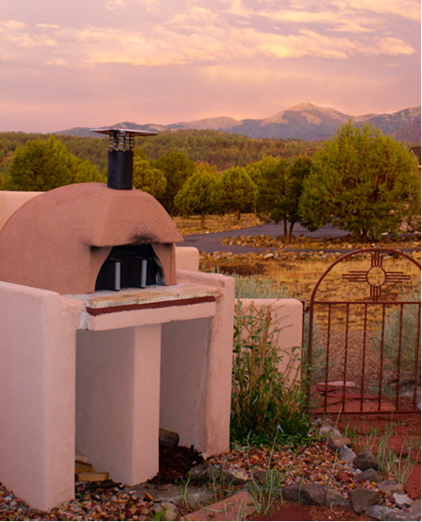
89. Plaintiffs Craig Cathey and Barbara Yount moved from Dallas, Texas to Alto for the clean air and scenic beauty. The proposed plant will unreasonably and substantially impair Mr. Cathey and Mrs. Yount’s ability to enjoy the clean air and scenic beauty of their land, shown below. Further, the proposed concrete batch plant operations will create traffic issues that will negatively impact their ingress and egress from their property. The proposed concrete batch plant operations will also aggravate Mr. Cathey’s chronic allergic condition.
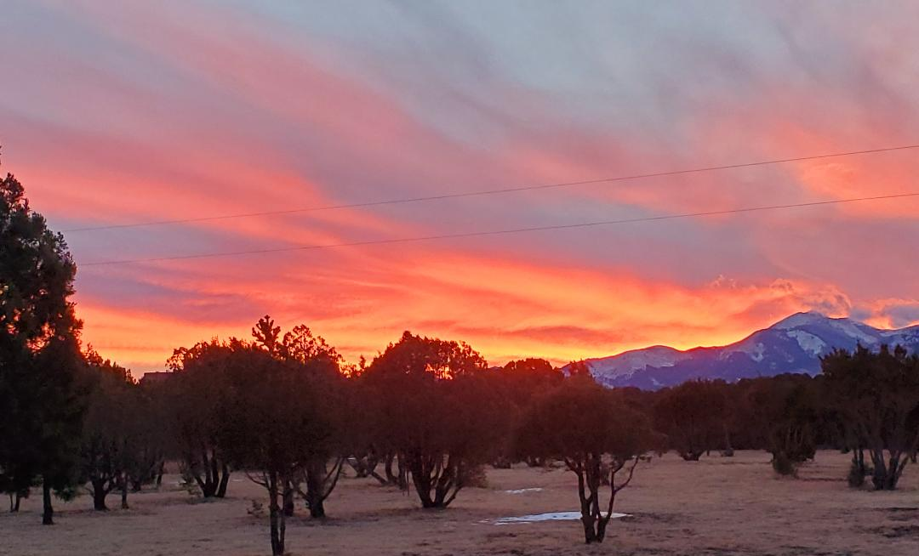
90. Plaintiffs David Webb and Sue Catterton were ranchers in Texas before moving to the Alto area in 2005 and settling on the land shown below. Mr. Webb and Ms. Catterton enjoy the wildlife that come to visit their property; the noise and lights from the plant will likely cause the deer, elk, wild turkeys, and rabbits, currently seen on a daily basis, to vacate their property.

91. Plaintiffs Bennett Ray and Evangeline Davis moved to Alto from Washington D.C. after Mr. Davis retired. Mr. Davis was a federal employee for many years. Mr. and Mrs. Davis came to Alto to enjoy an entirely different life: the high altitude, peace and quiet, abundant wildlife, clear skies, and clean air – all of which will be disrupted by the proposed concrete batch plant.
92. Plaintiffs Chris and Galen Farrington have been residents of Lincoln County since 1973. Mr. and Mrs. Farrington inspected various properties for five years before selecting their current property in Alto – their dream home. Mr. Farrington credits the couple’s good health to this property; the Farringtons have access to the outdoors for daily exercise. Mr. Farrington is an avid cyclist and rides his bicycle every day. Mrs. Farrington enjoys playing pickleball with friends. Light and noise from the plant will adversely affect their current lifestyle, including their ability to exercise outdoors.
93. Plaintiffs Nancy and Ralph Fegely resided in Florida and Nevada before moving to Alto for the peace and quiet and scenic natural environment; the proposed concrete batch plant will negatively impact that environment. Mr. Fegely is a disabled veteran whose health will be negatively impacted by the air quality issues caused by the proposed plant operations.
94. Plaintiffs Kevin and Nancy Fleharty have lived in the Alto area for nearly their entire lives. Mr. and Mrs. Fleharty moved to the area in 1974. Mr. and Mrs. Fleharty have raised two generations of children in the area, and the disturbance caused by the proposed concrete plant is not in character with their natural, residential environment, as shown below, in which they have raised their family. Several horses, a donkey, five dogs, and a rafter of wild turkeys reside on their property. The proposed concrete batch plant will negatively impact the environment, the health of their animals, the roadways in Alto which constitute ingress and egress to their property, and the clarity of the night sky.
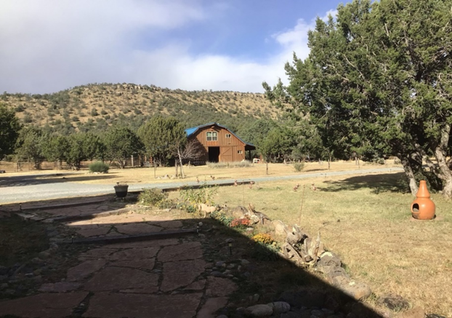
95. Plaintiffs Amy and Louis Goode moved to Alto from Dallas, Texas when Mr. Goode retired from his position as a defense contractor. The couple moved to the area specifically for a quiet and pristine environment, both of which will be negatively impacted by the proposed concrete batch plant.
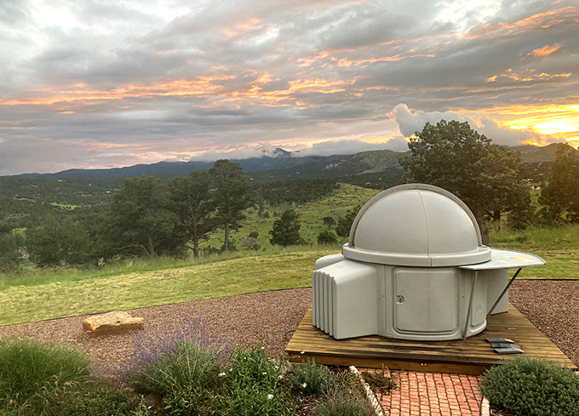
96. Plaintiff Charles Gordon moved to Alto from Erie, Colorado in 1996, after retiring. Mr. Gordon owns his own observatory and studies astronomy, as shown below. The light emitted from the plant and the traffic associated with the concrete batch plant operations will make the observatory on his property unusable in the manner he currently enjoys.
97. Plaintiffs Gregg and Lavonne Griffen are attracted to the climate in Alto because Mr. Griffen has chronic issues with his lungs and is susceptible to pneumonia. Given their proximity to the proposed concrete plant site, the fugitive dust emissions from the plant will negatively impact his health.
98. Plaintiffs Ellen and Steven Hightowers’ eleven acres of land consist of a greenhouse, a sizeable vegetable garden, a barn with livestock, and multiple orchards, including an apple orchard that has been on the property for over a century, as shown below. Mr. and Mrs. Hightower grow fresh produce which they often sell at local farmers markets. Fugitive dust emissions from the proposed concrete batch plant, located less than 0.5 miles away, will negatively impact the orchard and the produce the Hightowers enjoy growing on their land.
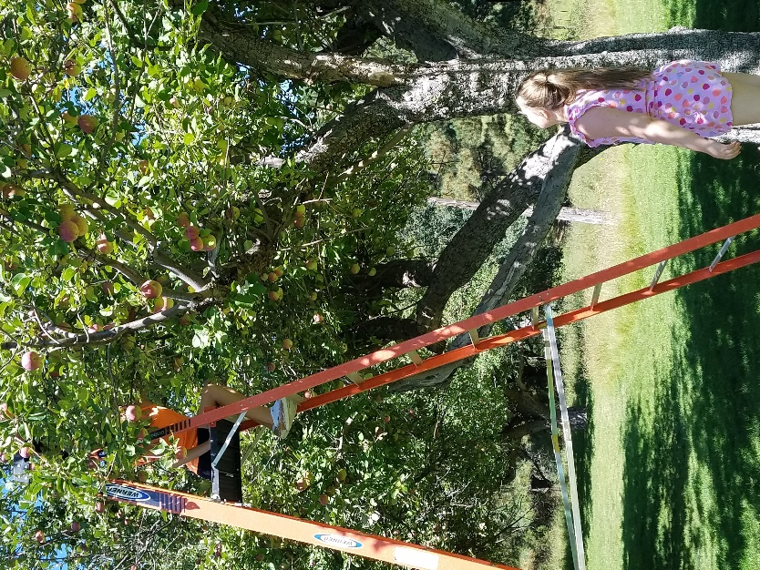

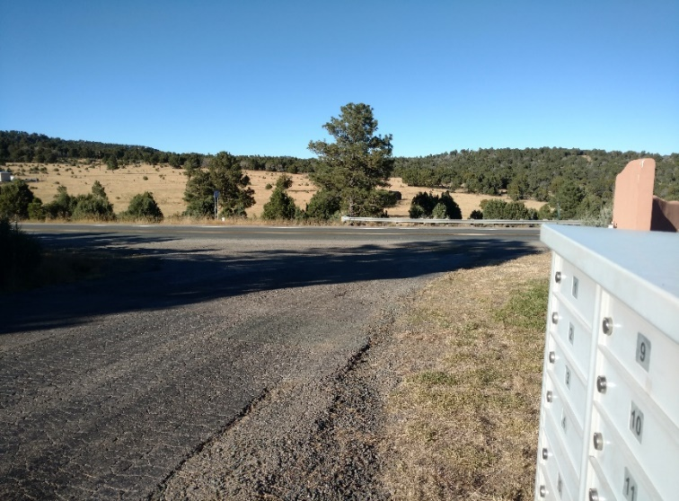
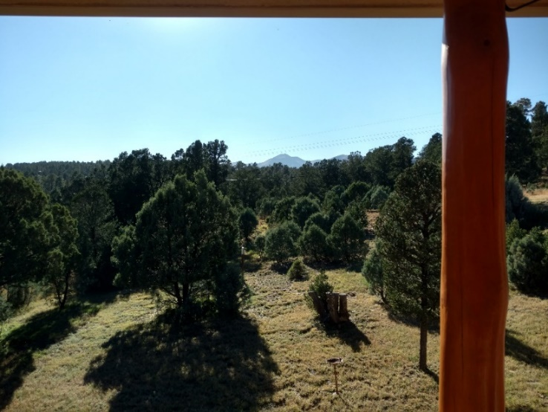
99. Plaintiffs Penelope and William Horton enjoy the natural beauty around their property, shown below, and maintain its natural character for the abundant wildlife. Prior to living in Alto, Mr. and Mrs. Horton lived in Colorado Springs, Colorado. The couple visited the Alto area on vacation and decided to move to the area. They enjoy the peace and quiet, as well as easy access to hiking trails. Dust-free, clean air is important to the Hortons and one of the primary reasons they chose this area for their residence. When they moved to Alto from Colorado Springs, Mrs. Horton was diagnosed with Reactive Airway Disease. At one point, this condition required her to use an inhaler, but her condition has improved as a result of the clear air surrounding their land. Any dust emitted from the proposed concrete plant will negatively impact Mrs. Horton’s health issues because of her proximity to the proposed site, demonstrated by the second picture below, showing the proposed location of the plant directly across the street from the Hortons’ property.
100. Plaintiff Rory Lacy typically resides at his property in Alto for half of the year. Mr. Lacy intends on retiring permanently to Alto in March 2022. Mr. Lacy has chosen to retire in Alto because of its scenic beauty, proximity to the mountains, and the abundant wildlife. The property is one hundred yards from the boundary of the proposed site, and Mr. Lacy’s peaceful enjoyment of his home will be severely compromised and diminished by the noise, light, and dust emanating from the concrete batch plant.
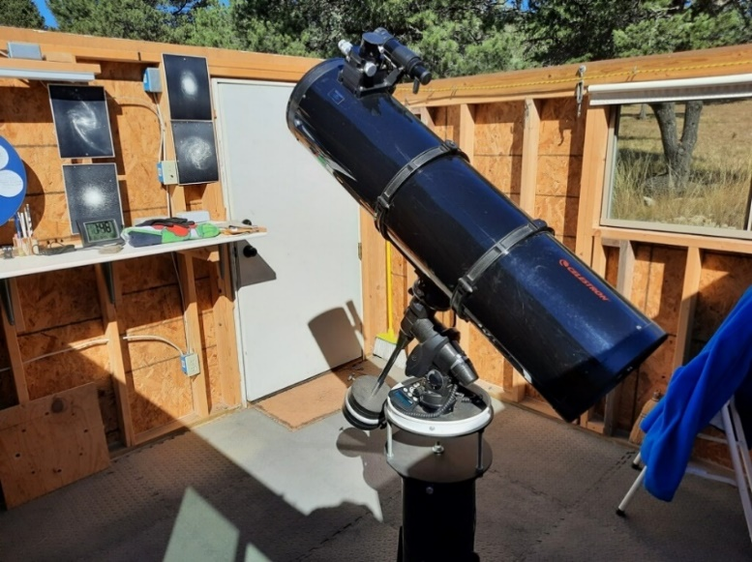
101. Plaintiff Richard Mastin is the Vice President of the Ranches of Sonterra Property Owners Association. Mr. Mastin and his wife, Mildred, enjoy the peaceful, quiet area and are dismayed that a concrete batch plant is proposed in Alto, which would necessarily destroy their peaceful and quiet environment. Mr. Mastin enjoys astronomy and built an observatory on the property, shown below, with an investment of thousands of dollars. The dust and light pollution from the plant and the trucks will make his observatory unusable in the manner to which he is accustomed.
102. Plaintiff Lawrence Mather retired, with his wife, from New Jersey to Alto. Mr. Mather installed a thirty-thousand-dollar rainwater collection system on his house at the time they purchased the property. The fugitive dust from the plant will be captured by the rainwater collection system, rendering his home’s main water supply either unusable or likely requiring additional filtration.
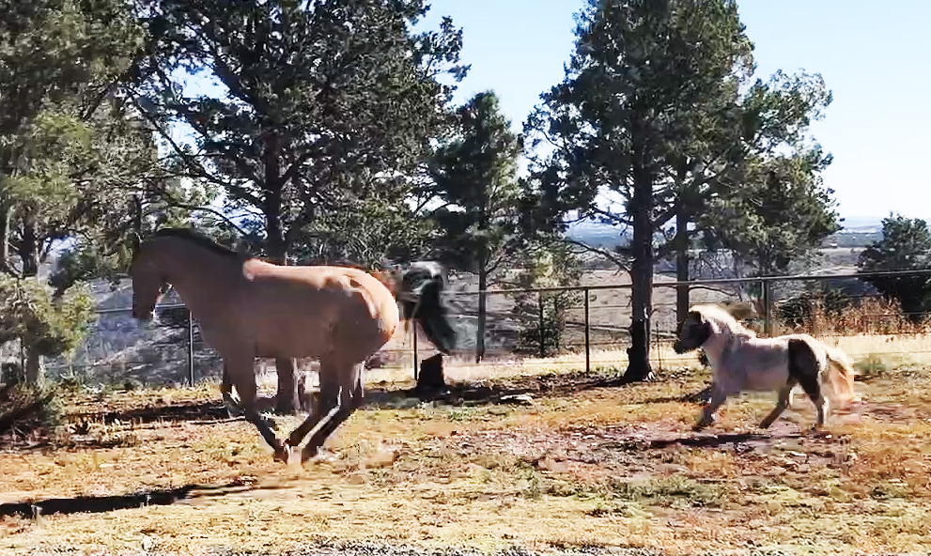
103. Plaintiffs Caroline and John McCoy raise performance horses on their property. Mr. and Mrs. McCoy have invested their time and money into making their property an ideal place for their horses, shown below. Mr. and Mrs. McCoy are in their eighties and purchased their property because it is in a quiet, clean, and remote area. Mr. McCoy anticipates that dust from the plant will negatively impact his COPD. Mr. and Mrs. McCoy are apprehensive about how they will protect their horses, which are stabled on the property, from the fugitive dust and noise pollution.
104. Hiking enthusiasts, Plaintiffs Deborah and Michael Miller, moved to Alto to be close to the local hiking trails and to enjoy the night skies. Prior to living in Alto, they lived in metropolitan areas in Texas, Ohio, and Colorado. The Millers enjoy living in Alto because of its clean air, scenic beauty, and the proximity to the White Mountain Wilderness area and the Fort Stanton-Snowy River Conservation Area. The dust, light and noise emanating from the proposed concrete batch plant will adversely affect the night sky, their favorite hiking trails, including hiking on their land, and the peace and quiet of their home and land.
105. Plaintiff Ivan Rex Miller escapes to his second home in Alto from the heat of summer in Texas. Mr. Miller enjoys the climate and fresh air of his Alto home and the local golf courses. Mr. Miller’s home will be disturbed by dust and noise emanating from the proposed concrete plant. The increased heavy truck traffic will also negatively impact Mr. Miller’s ingress and egress to his home.
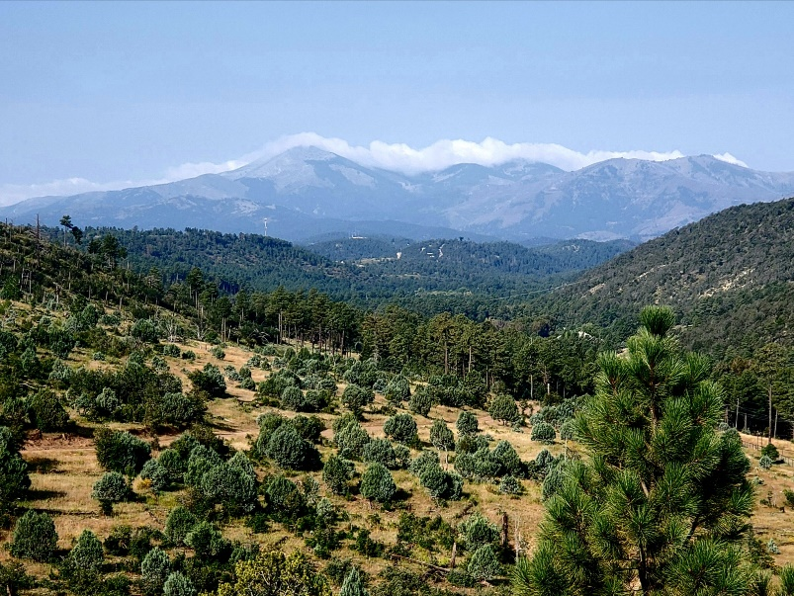
106. Plaintiffs Brenda and Gary Restivo moved from New Jersey to Alto more than ten years ago. Mr. and Mrs. Restivo enjoy being visited by the local wildlife, shown below, spending time enjoying nature, and with the friends they have made in the area. Based on their experience living in the area, Mr. and Mrs. Restivo anticipate windy conditions transporting fugitive dust and noise from the proposed concrete batch plant to their property. Mr. and Mrs. Restivo’s property, shown below on the right, looks down on the proposed concrete batch plant site.

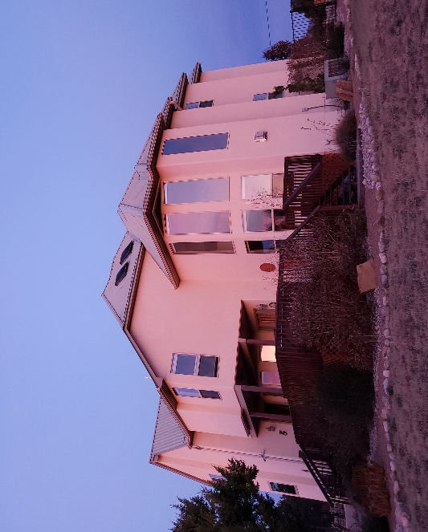
107. Plaintiffs Barbara and Mark Severance moved to Alto from Houston, Texas to retire. Mr. and Mrs. Severance are enthusiastic about their property, shown below, and the scenic beauty of Alto. Mr. and Mrs. Severance enjoy gardening, sighting wildlife on their property (also pictured below), and stargazing. The Severances enjoy the natural habitat and scenic beauty of the area. The noise, light, and dust from the proposed concrete batch plant will disturb their environment and negatively affect their recreational activities.
108. Plaintiffs Everett Skinner and Vivian Skinner enjoy the clean air, pleasant weather, and abundant wildlife in Alto and are concerned that the proposed concrete plant will produce disruptive noise and negatively impact their health.
109. Plaintiff Randall Smith has a second home in Alto to enjoy the scenic beauty of the area. The proposed concrete batch plant will produce disruptive noise and light, negatively impacting Mr. Smith’s enjoyment of the scenic beauty and his ability to relax on his own land. Mr. Smith’s health will be further negatively affected by the dust emissions emanating from the plant due to his chronic heart disease.
110. Plaintiffs Leroy Vigil and Karen Ann Syzdek moved to Alto from El Paso to live in a scenic and remote area, with clean air. Mr. Vigil and Ms. Syzdek enjoy the mild climate, the wildlife, the forest, living close to a hospital, and the amenities in Ruidoso. Mr. Vigil has occupational lung disease and cardiac issues, and his health will be negatively impacted by fugitive dust emissions from the proposed concrete batch plant. Emissions from increased heavy truck traffic will also exacerbate the negative impacts to Mr. Vigil’s health.
111. Plaintiff J. Dalton Tarwater, Ph.D. has a second home in Alto. Dr. Tarwater spends part of the year in Lubbock, Texas and part of the year in Alto. He enjoys the clean air and the peace and quiet in Alto. The noise, light, and dust from the proposed concrete batch plant will unreasonably disturb Dr. Tarwater’s peaceful home. The pollution and the eventual degradation of local roads caused by the plant will also negatively impact Dr. Tarwater’s property value.
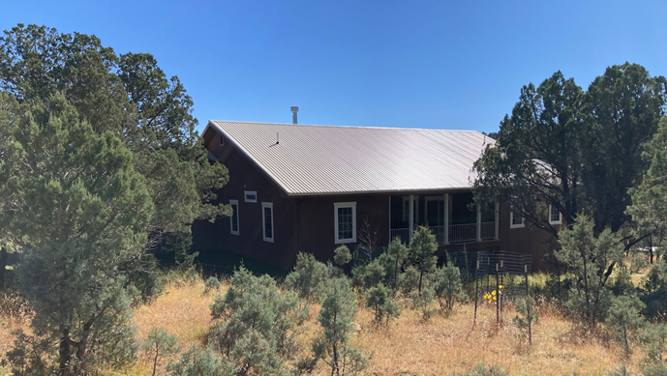
112. Plaintiffs Kathleen and Don R. Weems enjoy the peace and quiet in Alto, the minimal traffic, and the seclusion of their property, shown below. Their health will be negatively impacted as a result of breathing fugitive emissions dust from the proposed concrete batch plant. Further, the light from the proposed concrete batch plant will make it more difficult for them to enjoy the night sky, and noise generated by the plant will disturb the Weems’ quiet enjoyment of their property.
COUNT I
Anticipatory Private Nuisance – Declaratory Judgment (NMSA 1978, § 44-6-2)

113. Plaintiffs incorporate the allegations in paragraphs 1 through 112 the same as if fully set forth.
114. An actual controversy exists concerning whether Roper’s proposed construction and operation of the plant would substantially harm and invade Plaintiffs’ interests in the enjoyment of their respective properties. Accordingly, this Court has jurisdiction under NMSA 1978, Section 44-6-2 to declare that the proposed construction of the concrete batch plant constitutes an anticipatory private nuisance with respect to each Plaintiff individually, and all Plaintiffs in the aggregate.
115. Defendant’s proposed construction and operation of the concrete batch plant is intentional and will constitute an invasion of Plaintiffs’ property interests through substantial air, noise, light and water pollution. This invasion will directly impair Plaintiffs’ use and enjoyment of their respective properties, including, but not limited to, the following:
A. Substantial aesthetic harm due to the construction of a concrete batch plant in a rural, residential locality;
B. Substantial air pollution due to dust emissions from the plant;
C. Substantial noise pollution due to the regular industrial operations of the plant;
D. Substantial light pollution due to the regular operation of the plant;
E. Potential surface water and groundwater pollution due to inevitable runoff from the plant; and
F. Heavy truck traffic in the immediately surrounding neighborhood, beginning as early as 3:00 a.m., thereby creating further noise, air, and light pollution.
116. Defendant’s intentional invasion of Plaintiffs’ property interests will interfere with Plaintiffs’ quiet use and enjoyment, particularly pre-existing uses that are well-suited to the locality, including the following:
A. Quiet enjoyment in a residential locality;
B. Quiet enjoyment in a rural locality;
C. Quiet enjoyment for Plaintiffs with breathing conditions affected by dust;
D. Wildlife and nature viewing;
E. Astronomy and stargazing; and
F. Agriculture/raising of livestock.
117. Defendant’s proposed construction and operation of the batch plant is unreasonable under at least eleven separate analyses, set forth in paragraphs 117 – 127 below, the establishment of any one of which is legally sufficient to declare the proposed concrete batch plant an anticipatory private nuisance.
118. Defendant’s anticipated intentional invasion of Plaintiffs’ interests in the use and enjoyment of their respective and collective properties is unreasonable because the gravity of the harm outweighs the utility of Defendant’s proposed conduct.
119. Defendant’s anticipated intentional invasion of Plaintiffs’ interests in the use and enjoyment of their respective and collective properties is unreasonable because it would be practicable for Defendant to avoid the harm in whole by constructing and operating the proposed plant at another site located in Lincoln County, New Mexico.
120. The inevitable results of Defendant’s proposed construction of the concrete plant, including inevitable decreased property values, increased air pollution, increased noise pollution, increased light pollution, increased heavy truck traffic during late night and early morning hours, and increased surface water and groundwater pollution, all constitute an unreasonable invasion of each Plaintiff’s right of quiet enjoyment of their property in a predominantly residential locality.
121. The decreased property values, increased air pollution, increased noise pollution, increased light pollution, increased heavy truck traffic during late night and early morning hours, and increased surface water and groundwater pollution constitute an unreasonable invasion of each Plaintiff’s right of quiet enjoyment of their property in a rural locality.
122. For those Plaintiffs who suffer from medical conditions adversely affected by fugitive dust, the increase in air pollution will be an unreasonable invasion of those Plaintiffs’ interests because the harm is significant and greater than an ordinary person should reasonably be required to bear without compensation.
123. Further, Defendant’s proposed construction and operation of the plant is unreasonable because the locality is particularly well-suited for individuals whose medical conditions improve with clean air and the locality is particularly unsuited for a concrete batch plant.
124. For those Plaintiffs who are engaged in agricultural activities on their properties, the anticipated air and water pollution created by Defendant’s proposed construction and operation of the concrete batch plant is unreasonable because the harm is significant and greater than an ordinary person should be required to bear without compensation.
125. Further, Defendant’s proposed construction and operation of the plant is unreasonable because the locality is particularly well-suited for agriculture and Defendant’s proposed plant is particularly unsuited for the character of the locality.
126. For those Plaintiffs who live close enough to Highway 220 to encounter, hear and observe truck traffic, Defendant’s proposal to increase truck traffic, including operations beginning at 3:00 a.m., will constitute an unreasonable invasion of those Plaintiffs’ interests because the harm is significant and greater than an ordinary person should reasonably be required to bear without compensation.
127. For those Plaintiffs who engage in the wildlife and nature viewing on their property, Defendant’s proposed construction and operation of the concrete batch plant is unreasonable because the locality is particularly well-suited for that purpose and Defendant’s proposed concrete batch plant is particularly unsuited for the characteristics of the locality.
128. For those Plaintiffs who use their property for star gazing and astronomy, Defendant’s proposed construction and operation of the concrete batch plant is unreasonable because the locality is particularly well-suited for that purpose and Defendant’s proposed plant will interfere with that activity.
129. For the reasons set forth in paragraphs 117 – 127 above, each of which sets forth an independent basis establishing an anticipatory nuisance, Defendant’s proposed construction and operation of the concrete batch plant will constitute a nuisance in fact as a result of the substantial and objectively unreasonable invasion of Plaintiffs’ interests in the quiet use and enjoyment of their respective properties.
WHEREFORE, Plaintiffs request judgment on Count I as follows:
A. A declaration that the construction and operation of Defendant’s proposed concrete batch plant at Highway 220, approximately 0.35 miles east of the intersection with Highway 48, in Alto, New Mexico, constitutes an anticipatory private nuisance with respect to Plaintiffs’ individual and collective property interests;
B. An award of damages in the event Defendant proceeds with any aspect of the construction of the proposed concrete batch plant, in an amount sufficient to compensate each Plaintiff for diminution in value of their property, together with all other general and special damages sustained; and
C. For costs and such other relief as the Court deems proper.
COUNT II
Preliminary and Permanent Injunctive Relief

130. Plaintiffs incorporate the allegations contained in paragraphs 1 through 129 the same as if fully set forth.
131. Each Plaintiff will suffer irreparable injury to their interests in the use and enjoyment of their property without injunctive relief because the proposed industrial plant would fundamentally alter the scenic, residential and rural nature of the locality and deprive Plaintiffs of the quiet use and enjoyment of their respective, unique real properties.
132. The threatened injury to Plaintiffs outweighs any potential harm to Roper, who may construct and operate a concrete batch plant at a different, suitable location in Lincoln County.
133. The issuance of an injunction would vindicate public rights and would not be adverse to the public interest; on the contrary, the public interest would be served by preserving the character of the locality, as set forth above and as recognized in the Lincoln County Board of Commissioners’ Resolution, by protecting Plaintiffs’ pre-existing uses which are well-suited to the locality.
134. Each Plaintiff has a substantial likelihood of success on the merits of their claims for private nuisance and declaratory relief because Roper’s intentional construction and operation of a concrete batch plant at the proposed site will result in multiple and repeated invasions of Plaintiffs’ quiet use and enjoyment of their respective properties due to the harm to the aesthetic scenery, the air pollution, the noise pollution, the light pollution, and the heavy truck traffic caused by the operation of the proposed concrete batch plant.
135. Each Plaintiff, individually, is entitled to preliminary and permanent injunctive relief preventing the construction of the concrete batch plant as an anticipatory nuisance.
WHEREFORE, Plaintiffs request judgment on Count II as follows:
A. After hearing, issuance of a preliminary injunction pursuant to Rule 1-066(A) NMRA enjoining Defendant from constructing and operating the concrete batch plant at the proposed location;
B. After trial, issuance of a permanent injunction containing the same terms as the preliminary injunction; and
C. Costs and such further relief as the Court deems proper.
Respectfully submitted,

HINKLE SHANOR LLP

/s/ Thomas M. Hnasko
Thomas M. Hnasko
Julie A. Sakura
Dioscoro A. Blanco
Post Office Box 2068
Santa Fe, NM 87504
(505) 982-4554
thnasko@hinklelawfirm.com
jsakura@hinklelawfirm.com
dblanco@hinklelawfirm.com

Attorneys for Plaintiffs

