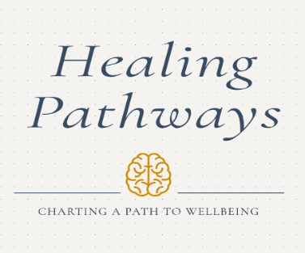
EMDR Basic Training Registration Form
Participant's First Name:

Participant's Last Name:

Participant's Email Address:

Phone number:

Cost and Payment Information:
$1200.00 (This cost includes both part 1, part 2 of EMDR Basic Training and the 10 hours of EMDR Basic Training Consultation calls)
Participants will receive an email with a link for payment 90 days prior to the training date.
Thank you for registering for EMDR Basic Training with Healing Pathways Training and Consulting.
Questions? Contact Suzanne Anderson, LMFT at saanderson.lmft@gmail.com

