**Pregnant individuals are eligible for the COVID-19 vaccine in Ontario, and now have a decision to make about getting vaccinated while pregnant.**

COVID-19 & pregnancy

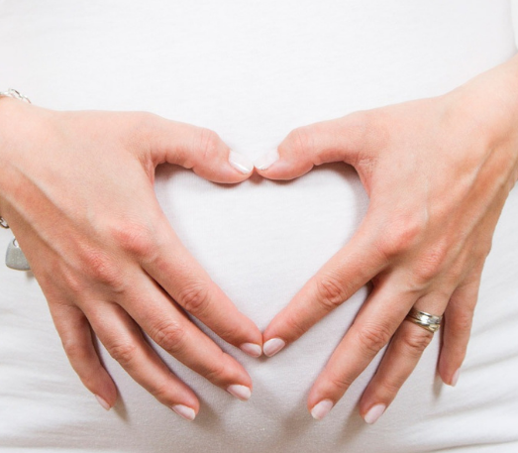

*Should I Get the Vaccine?*

Making sense of information from various sources can be difficult.

There is an urgent need to deliver COVID-19 messaging from reliable sources and empower individuals to make an informed choice.

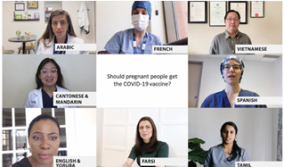Pregnancy care providers in Ontario are sharing a video message for pregnant individuals in multiple languages. For more resources about COVID-19 and pregnancy, please visit [www.prenatalscreeningontario.ca](http://www.prenatalscreeningontario.ca).

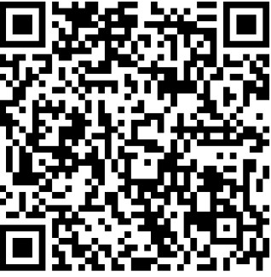Video Link available at <https://vimeo.com/showcase/covid19pregnancy>

