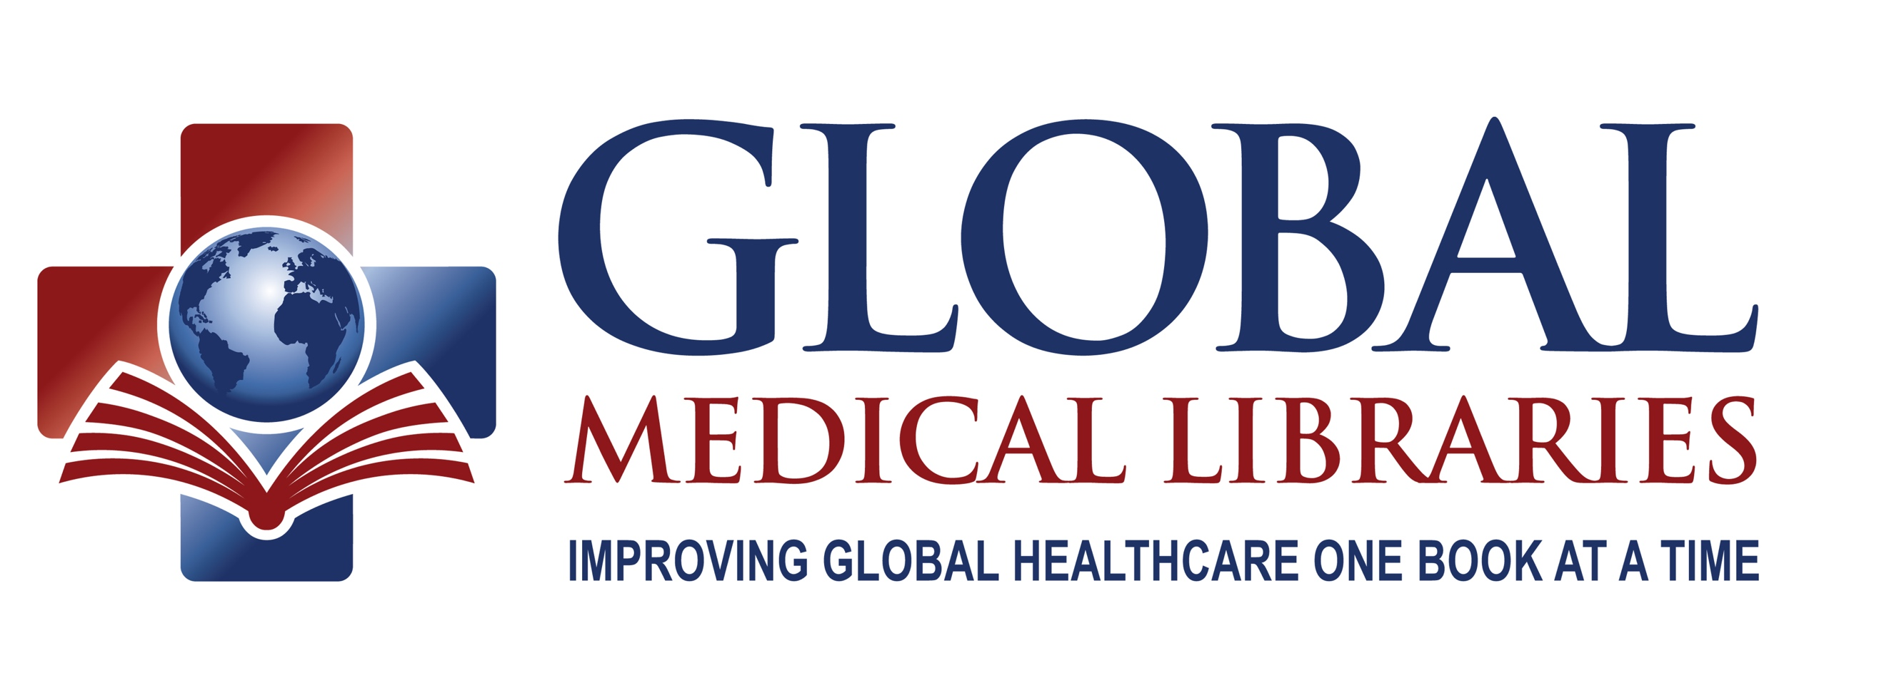

**Declaration Note for Ethiopia**

**Sender Information: (For GML Bookkeeping Purposes Only)**

Name: ____________________________________________________________

Street address ______________________________________________________

City_____________________________ State ___________ Zip Code __________

Email address______________________________________________________

Phone ________________________________________(for GML purposes only)

**To:**

CDC-Ethiopia

2030 Addis Ababa Place

Washington, DC 20521

ATTN: GML – Kifle Zeleke

**Detailed Description of Contents:** Used medical textbooks forCDC partners

**Quantity: _____________ Estimated Value: ____________**

These books are a gift.

**AES/ITN/Exemption:** NOEEI 30.37 (a)

**Certification**

I certify that the particulars given on this paper is correct. The box does not contain any undeclared dangerous articles or articles prohibited by legislation or by a postal or customs regulations.

**Signature ________________________________________________________**

**Date ____________________________**