Actualize Wellbeing

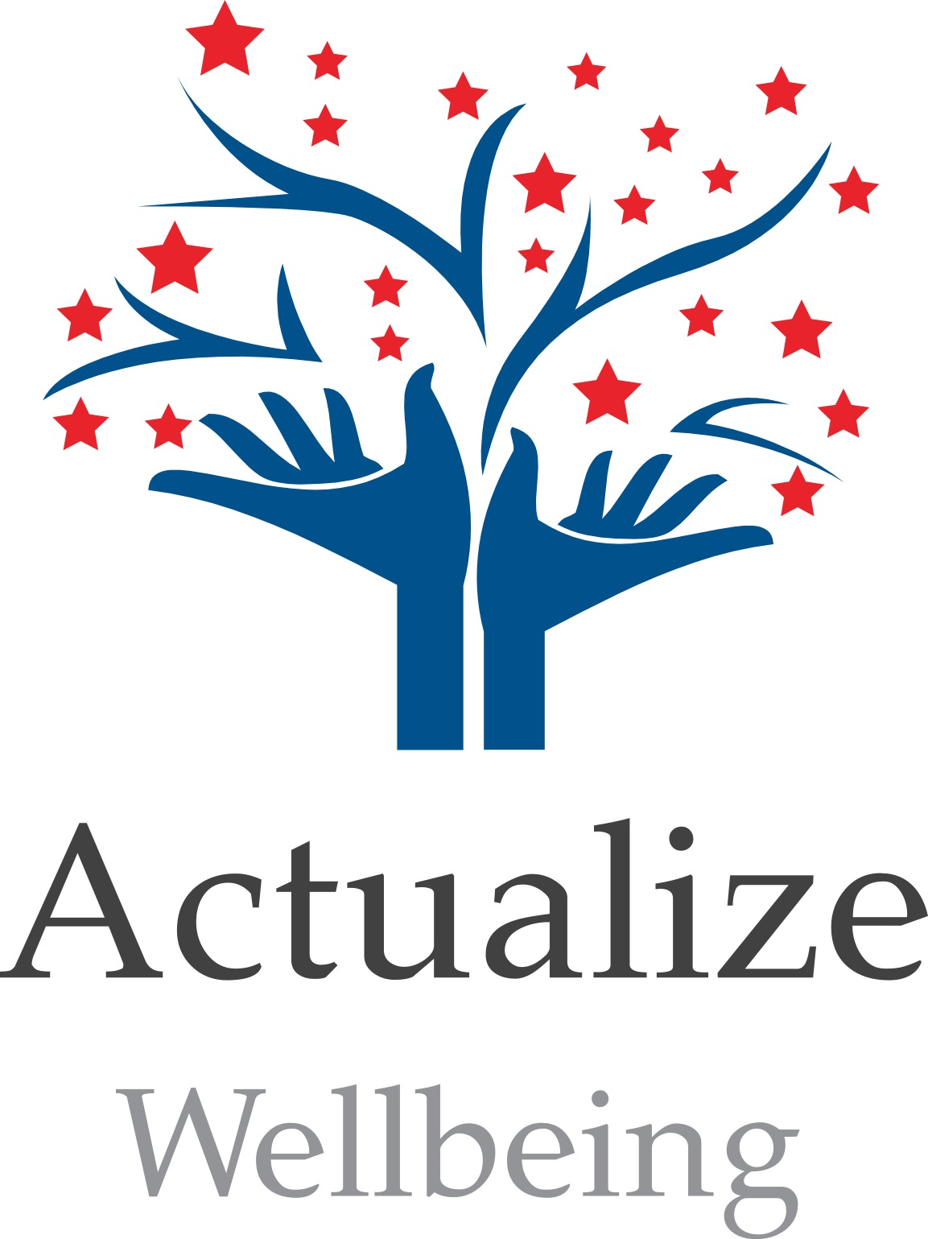

Please complete this form and return to:

Actualize Wellbeing

Chess Medical Centre

260-290 Berkhampsted Road

Chesham

Bucks

HP5 3EZ

Or electronically to:

[actualize@hotmail.co.uk](mailto:actualize@hotmail.co.uk)

Tel 07901593404

Counselling and

Emotional Wellbeing

Children, Young People and Families

Services for Schools

Booking Form

|  |  |  |
| --- | --- | --- |
| Office use only: | | |
| File name: | | Contact date: |
| Code: | | Contact: |
| PLEASE READ THE FOLLOWING SECTIONS CAREFULLY AND COMPLETE ELECTRONICALLY OR IN BLOCK CAPITALS  School Details | | |
| School name: | School Address: | |
| Post Code: | County: | |
| Age Range of Students: | Number of Pupils on Roll: | |
| Is the school a Faith school? Yes/ no | Gender of pupils: Mixed / Girls’ school/ Boys’ school | |
| Percentage of children eligible for free school meals: | | |
| School Contact | | |
| Name: | | Job Title: |
| Telephone: | | Email: |
| Safeguarding officer | | |
| Name: | | Telephone: |
| Email: | | |
| Services | | |
| Please tell us which Actualize Wellbeing services you are interested in: | | |
| One-to-one counselling Y/ N | | Group counselling (students) Y/ N |
| Reflecton groups (staff) Y/ N | | Individual staff wellbeing Y/ N |
| Staff training Y/ N | | Other (please specify): |
| Will we be working with any children with special needs? Y/ N If yes, please specify: | | |