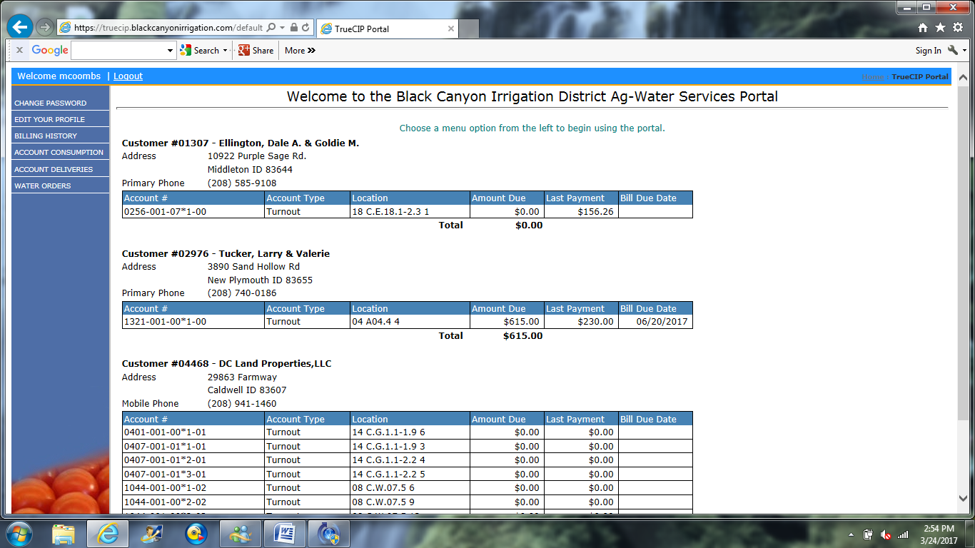
On the Home screen you will see a list of all the customers that you have access to.
To begin ordering water, click Water Orders on the left side menu

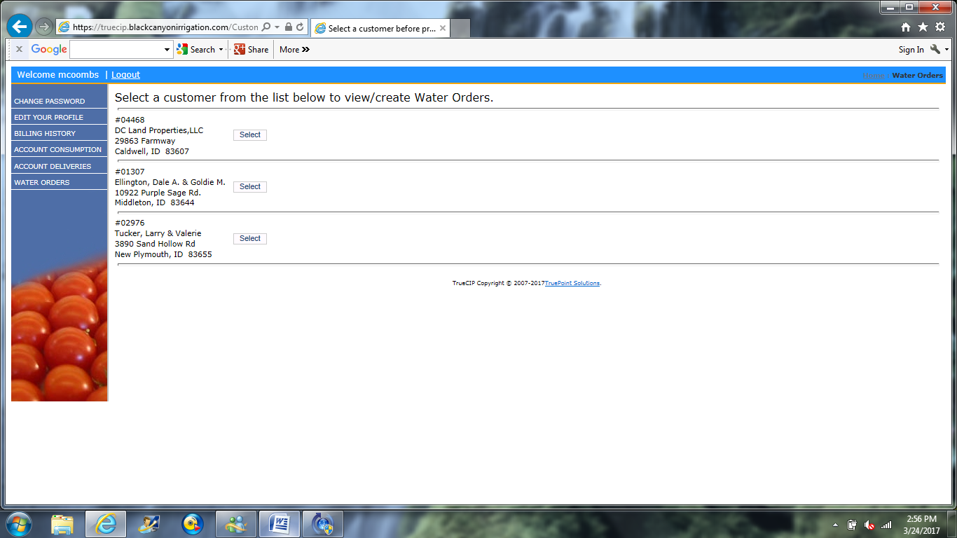
Click Select next to the account you want to order water on. If you only have your account on your profile you will NOT see this screen.
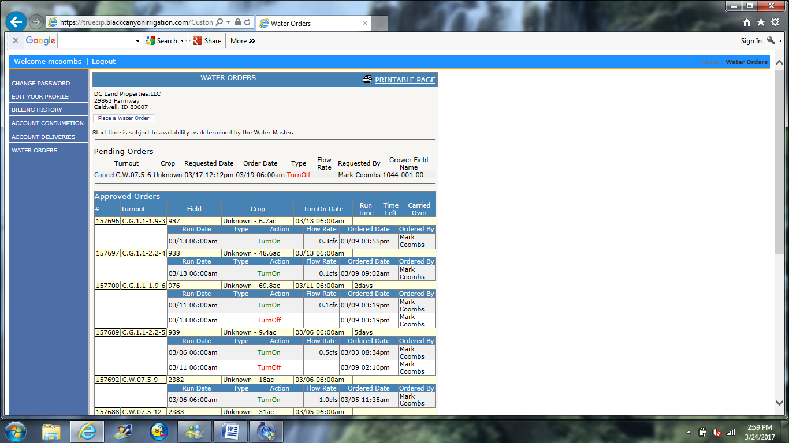
Click Place a Water Order

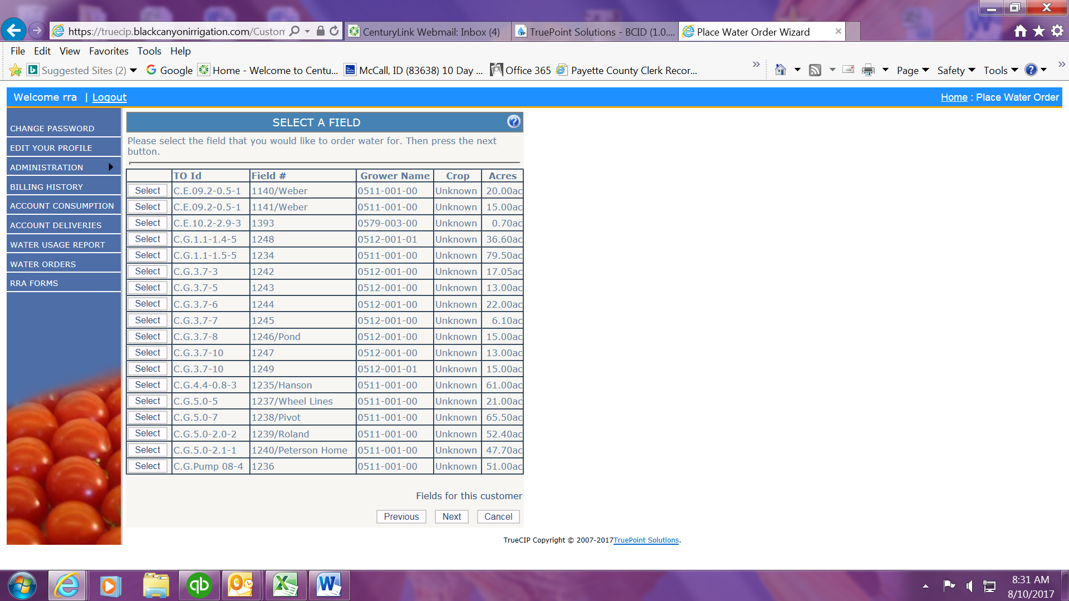
Click Select next to the field you want to order water on. If you only have one lateral and tap, the software will skip this screen and take you right to the next screen.
Click Next
**At any point from here on, you can click the Previous button to go back.

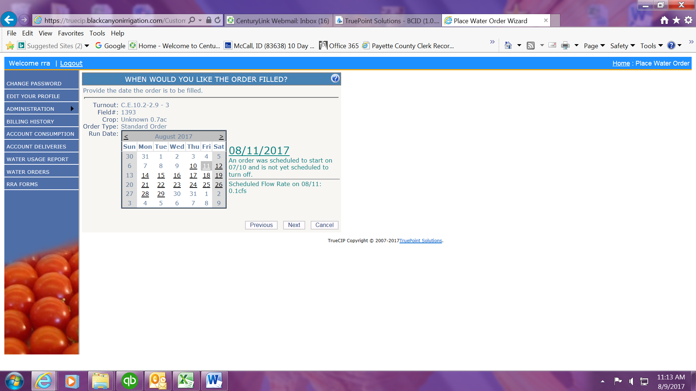
Click the date on the calendar that you want to turn water On / Off / or Change Flow.
Click Next

BUSINESS RULES:
- If water is running for a date you pick the system tells you the status of the field you are on to the right of the calendar:
  - When the current order started
  - The current flow rate
- You cannot order water for tomorrow after 2 p.m. today.
- You cannot order water changes for Sunday.
- Water changes for Monday need to be done by 2 p.m. on Saturday.
  - If you try to choose a date that is not available for one these reasons, the screen will not move forward and you will get a red error message at the bottom of the screen telling you why you can’t order on that date or the software won’t allow you to pick a date at all.

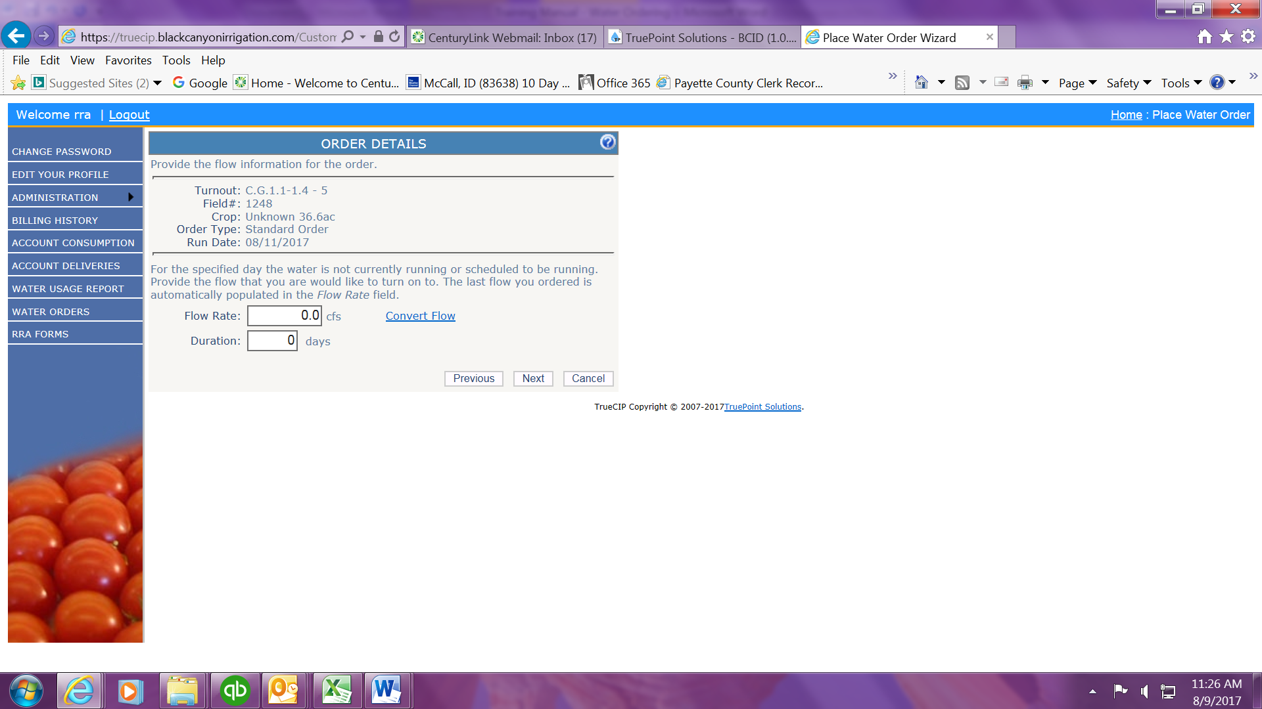
- I strongly recommend that you use the Convert Flow link to order as the system uses CFS and NOT INCHES.
- TURN ON: THIS IS IN CFS – NOT INCHES!!
- **If you know the CFS, you can fill in the box yourself but don’t forget the decimal point!!! There is a chart on Page 6 that converts inches to CFS.

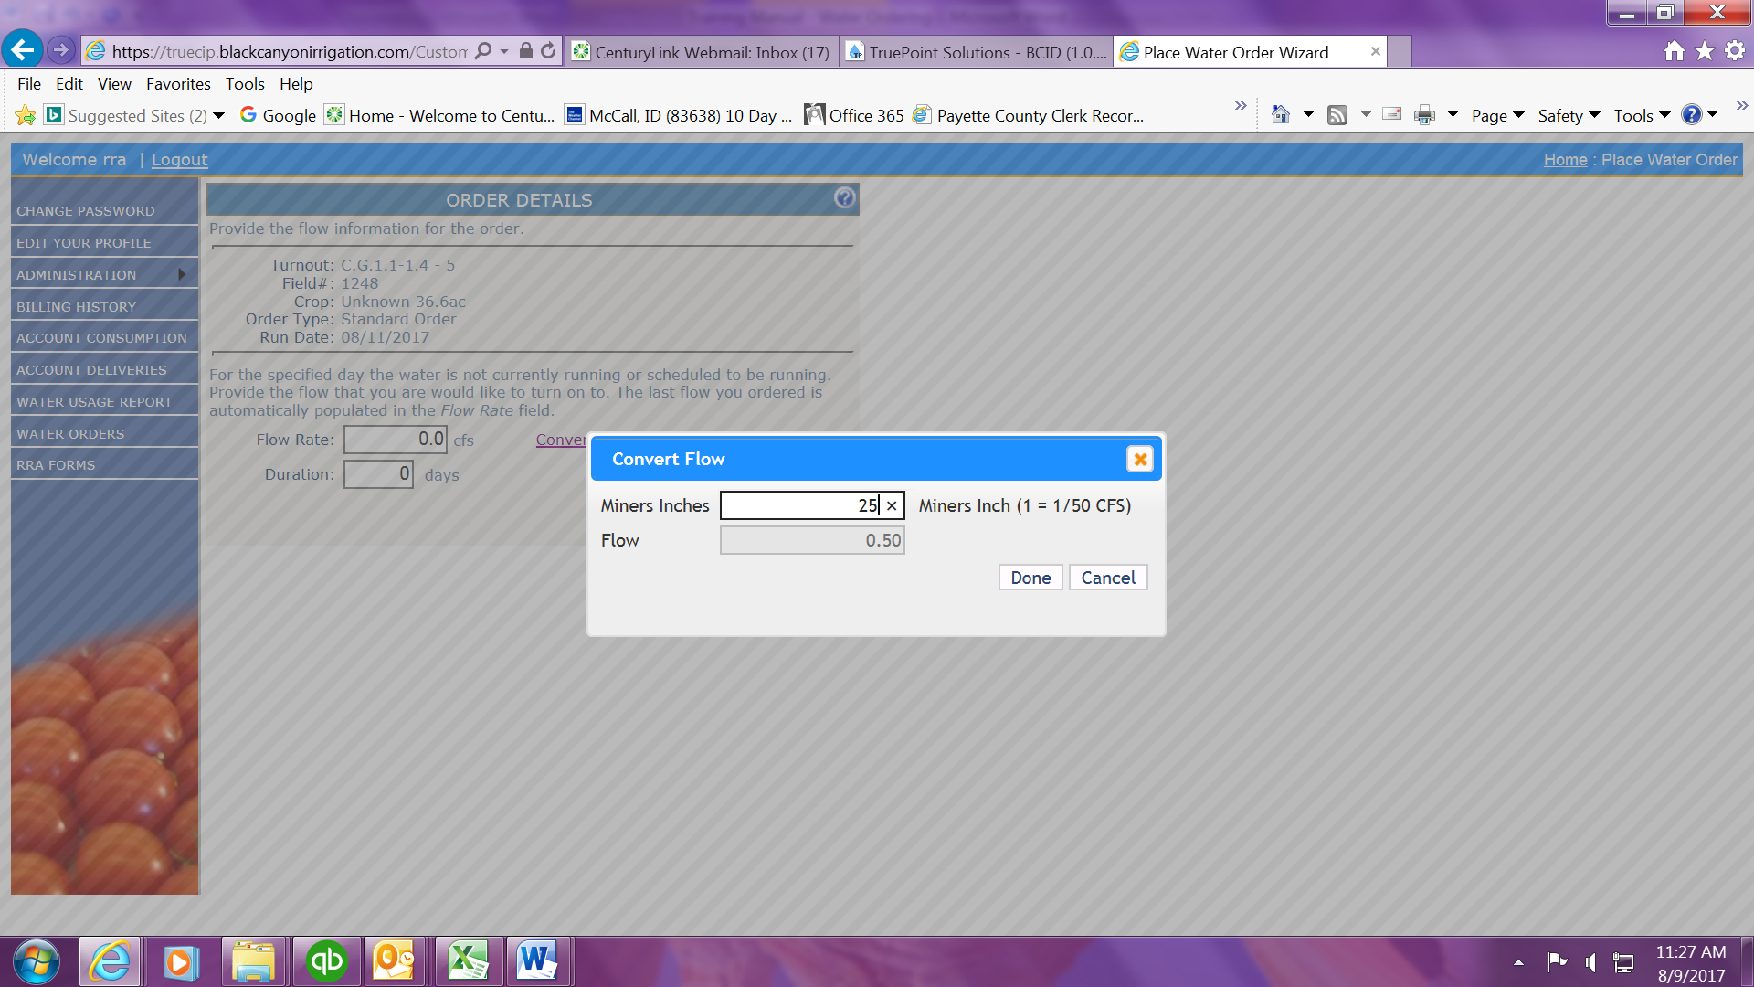
When you enter in the inches you want, this tool will convert the inches to CFS. Click Done and the CFS Flow Rate will be entered.
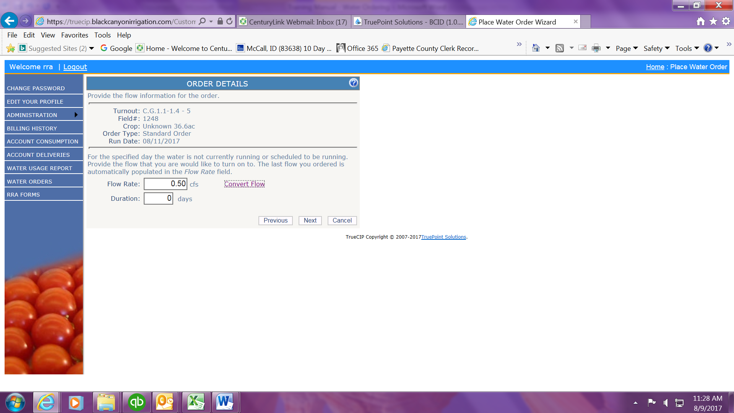

- You DO NOT have to put a number in the Duration box. If you leave it alone the water will run until you put in a Turn Off request. However, if you know how long you want water to run, you can enter a number in this box and the system will automatically create a Turn Off order for you on that date.

  - Example: You request a Turn On for 25 inches (.50 cfs) for Monday, August 8th and put 3 in the Duration box. The system will automatically create a Turn Off order for August 11th.

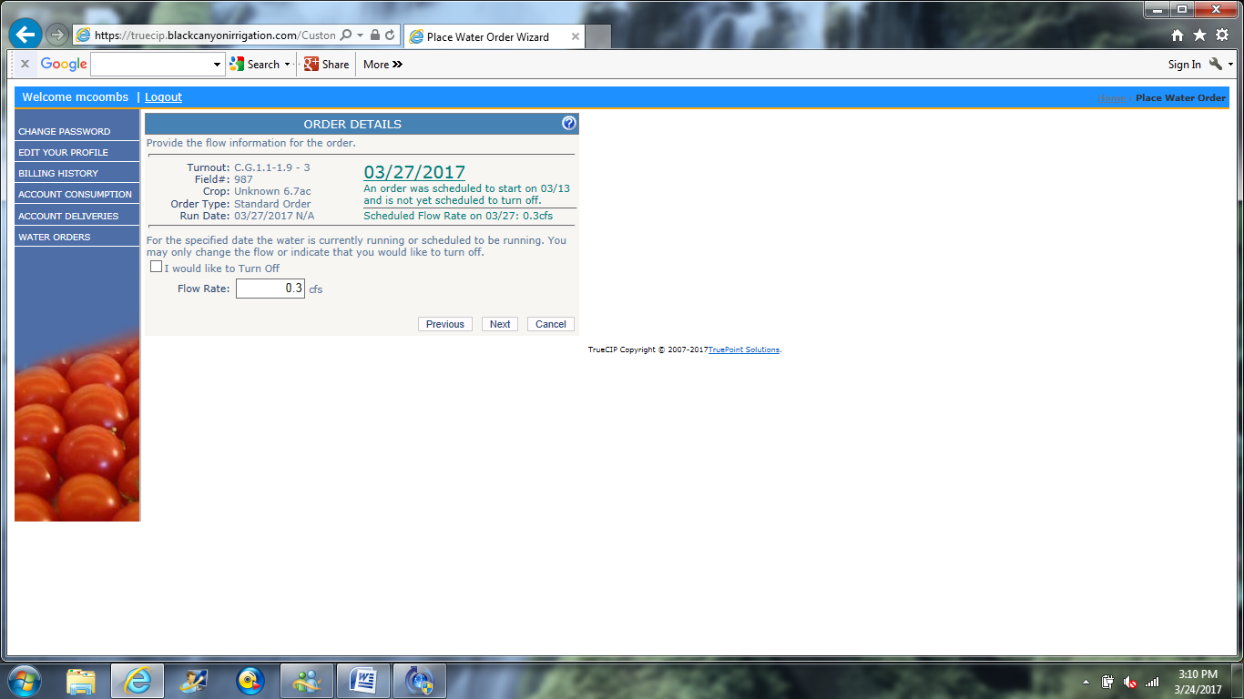
TURN OFF – Click the box to the left of ‘I would like to Turn Off’
Next

FLOW CHANGE – Use the Convert Flow link OR enter the cfs in the Flow Rate box
Next

This chart shows inches to CFS. To calculate Acre Feet, double the CFS and that is the Acre Feet used in a 24 hour period (50” = 1.00 CFS = 2 Acre Feet)
Inches |  | CFS |  | Inches |  | CFS |  | Inches |  | CFS |  | Inches |  | CFS
5 |  | .10 |  | 55 |  | 1.10 |  | 105 |  | 2.10 |  | 155 |  | 3.10
10 |  | .20 |  | 60 |  | 1.20 |  | 110 |  | 2.20 |  | 160 |  | 3.20
15 |  | .30 |  | 65 |  | 1.30 |  | 115 |  | 2.30 |  | 165 |  | 3.30
20 |  | .40 |  | 70 |  | 1.40 |  | 120 |  | 2.40 |  | 170 |  | 3.40
25 |  | .50 |  | 75 |  | 1.50 |  | 125 |  | 2.50 |  | 175 |  | 3.50
30 |  | .60 |  | 80 |  | 1.60 |  | 130 |  | 2.60 |  | 180 |  | 3.60
35 |  | .70 |  | 85 |  | 1.70 |  | 135 |  | 2.70 |  | 185 |  | 3.70
40 |  | .80 |  | 90 |  | 1.80 |  | 140 |  | 2.80 |  | 190 |  | 3.80
45 |  | .90 |  | 95 |  | 1.90 |  | 145 |  | 2.90 |  | 195 |  | 3.90
50 |  | 1.00 |  | 100 |  | 2.00 |  | 150 |  | 3.00 |  | 200 |  | 4.00

Don’t forget the decimal point!!!!!!
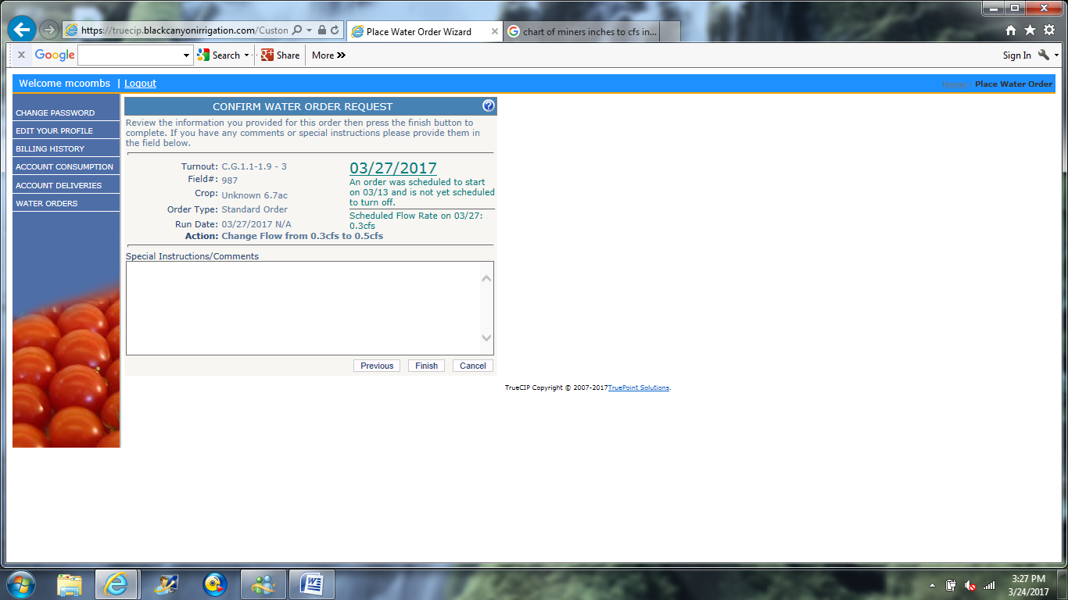
The last screen shows the date you have requested the change and what action you have requested.
This screen also allows you to send a note to the ditch rider if you have any comments.
Click Finish
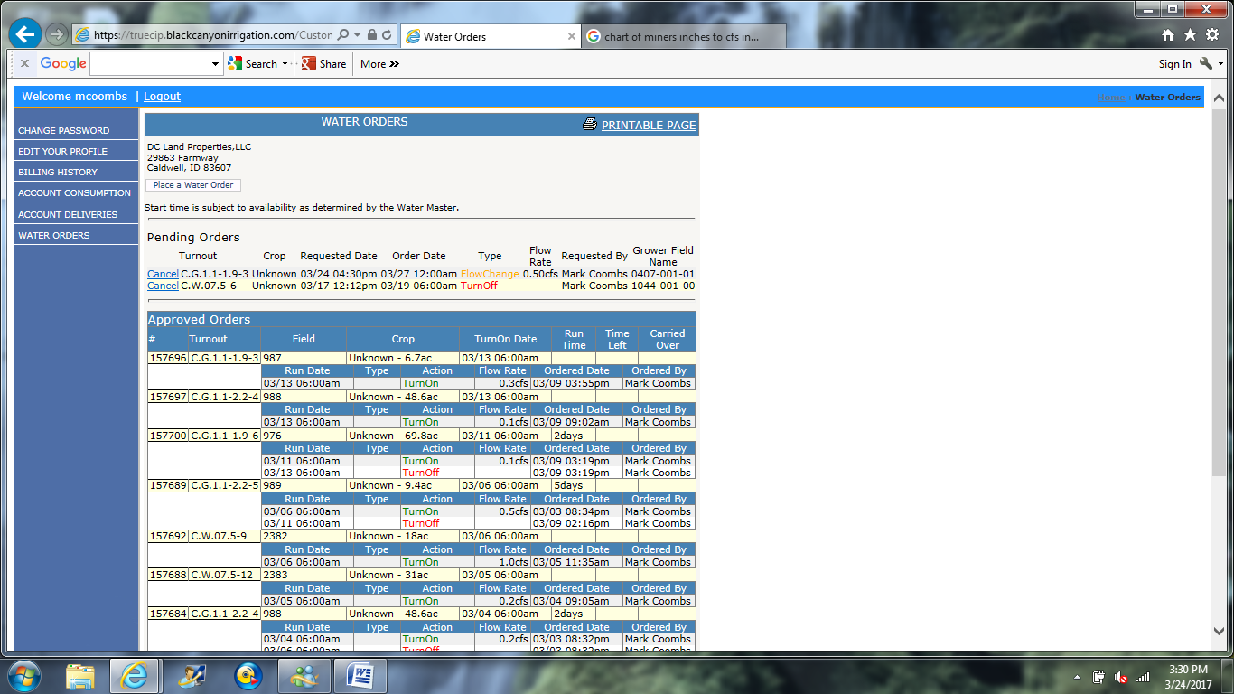
Once you have finished a water order you are returned to the beginning screen. You will know that the process worked correctly if you see the order you just placed under the Approved Orders heading.
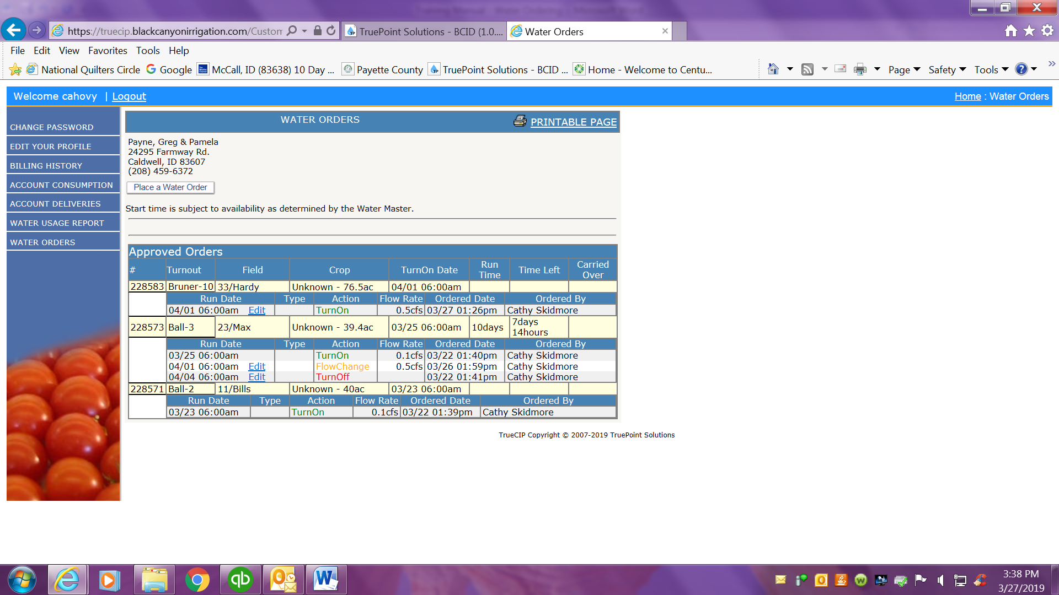
NEW FEATURE:
You can now edit your water orders as long as the business rules are still followed: You can only edit water orders before 2 p.m. on the business day (Sunday is NOT a business day) prior to the order.

Tips for Editing Water Orders:
- If you delete an On order the system will delete the Off and/or any Flow Changes associated with that On order.
- When you Edit an order you can change the date on a Turn On, Flow Change, or Turn Off as long as it doesn’t conflict with something that is already scheduled to happen.
- It is your responsibility to ensure every order is correct so you will want to double check any order you edit or delete for accuracy.

Editing an Order:
Click the blue Edit link next to the order you want to change.

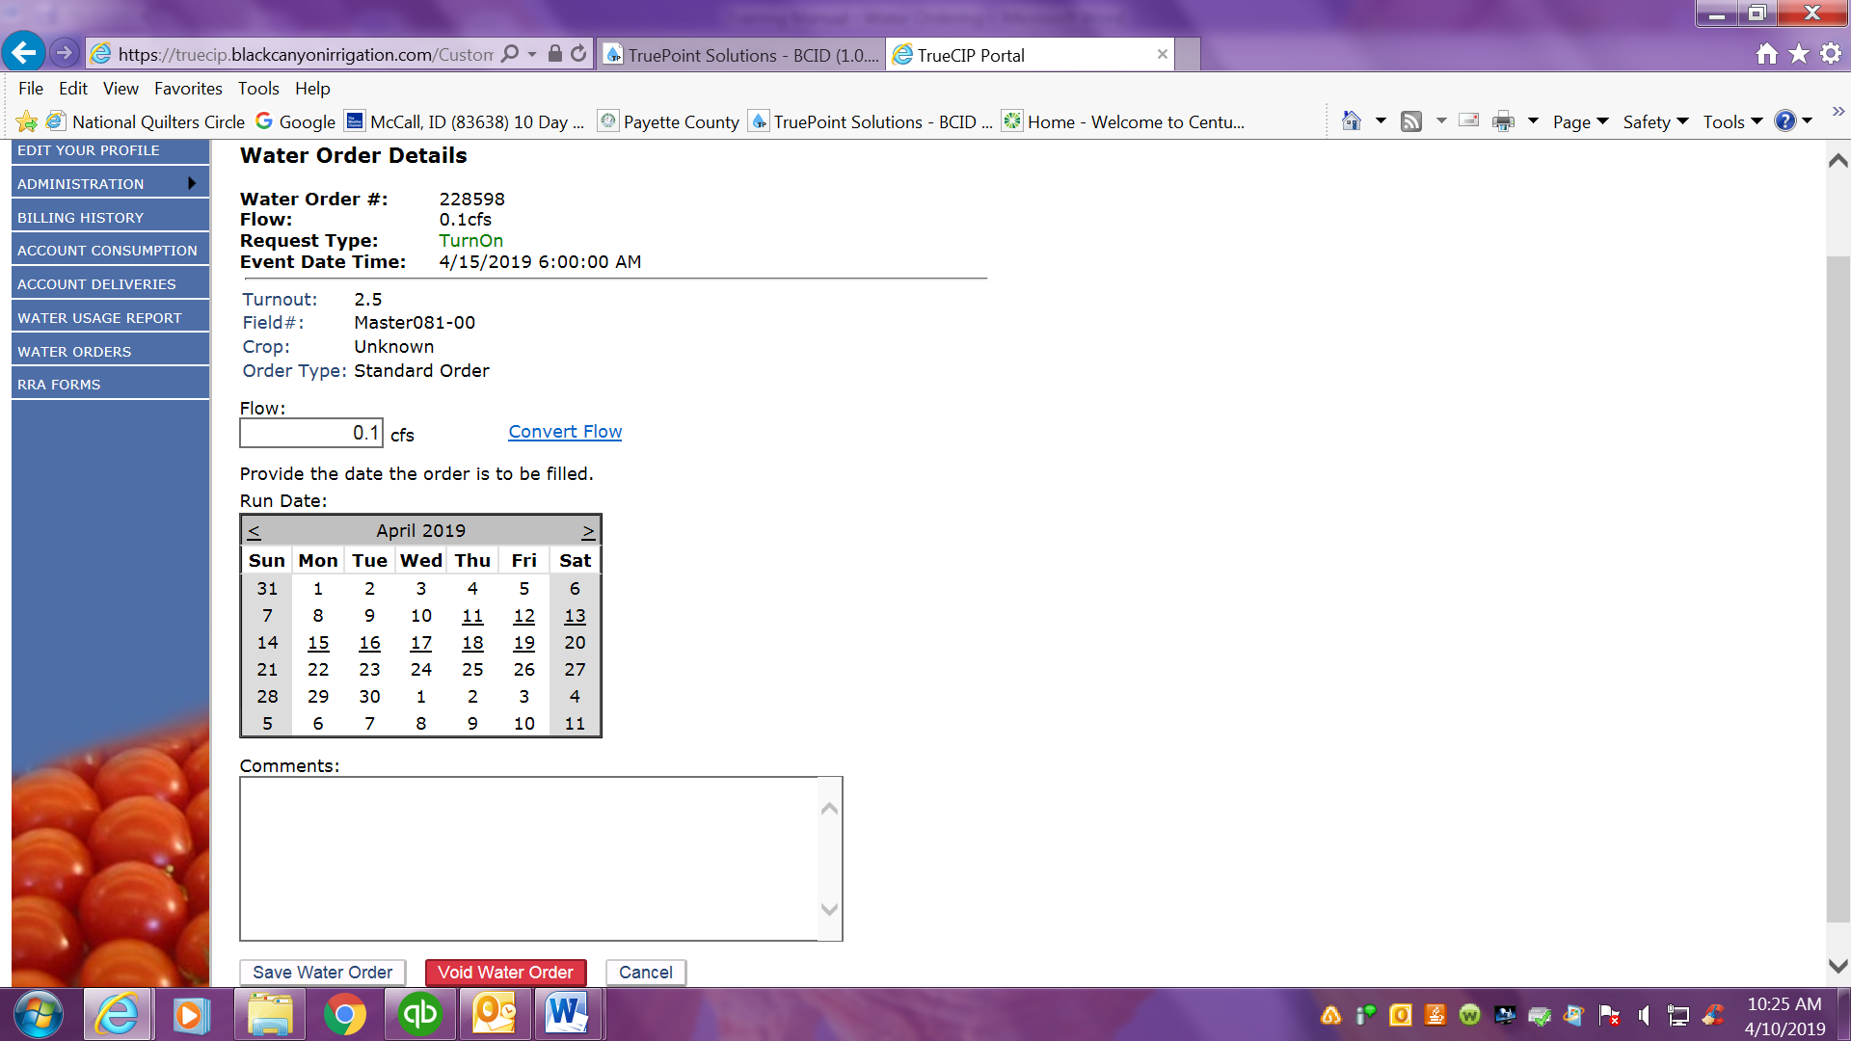
Once you click the Edit button you will be taken to this screen. At the top of the screen you will see the order as it currently exists.
- Edit the order by changing the flow or the date.
- Once you are done editing you will click the Save Water Order button at the bottom of the screen. You may need to scroll down to see this button.
- You will be returned to the first screen where you can double check that your order is what you want.

- If you want to delete the order completely, you will use the RED button at the bottom that says Void Water Order.
- You will be asked to input a comment as to why you are deleting the order.
- Click Void Water Order again.
- You will be returned to the first screen where you can double check that the order is no longer there.

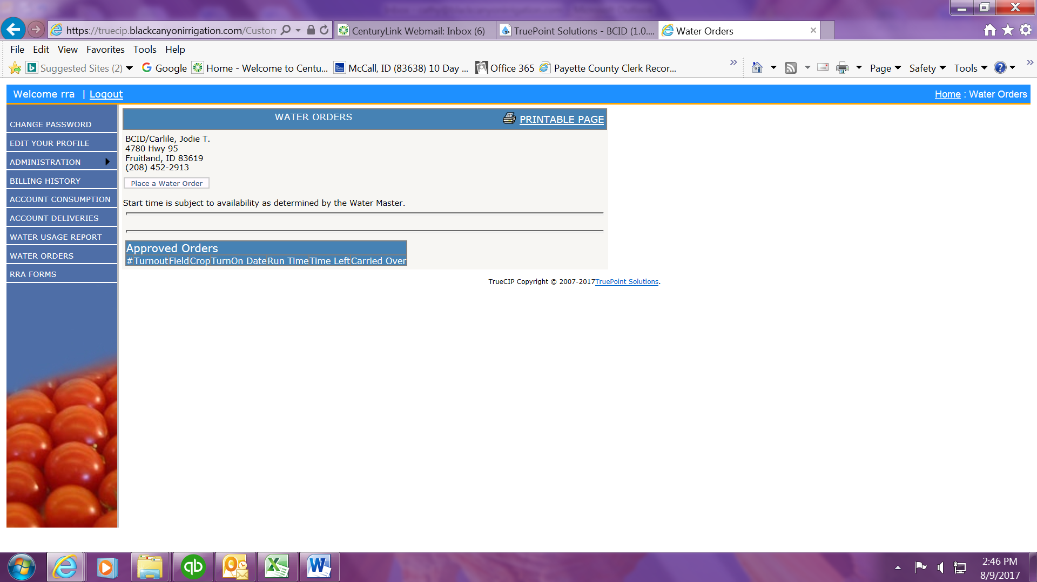

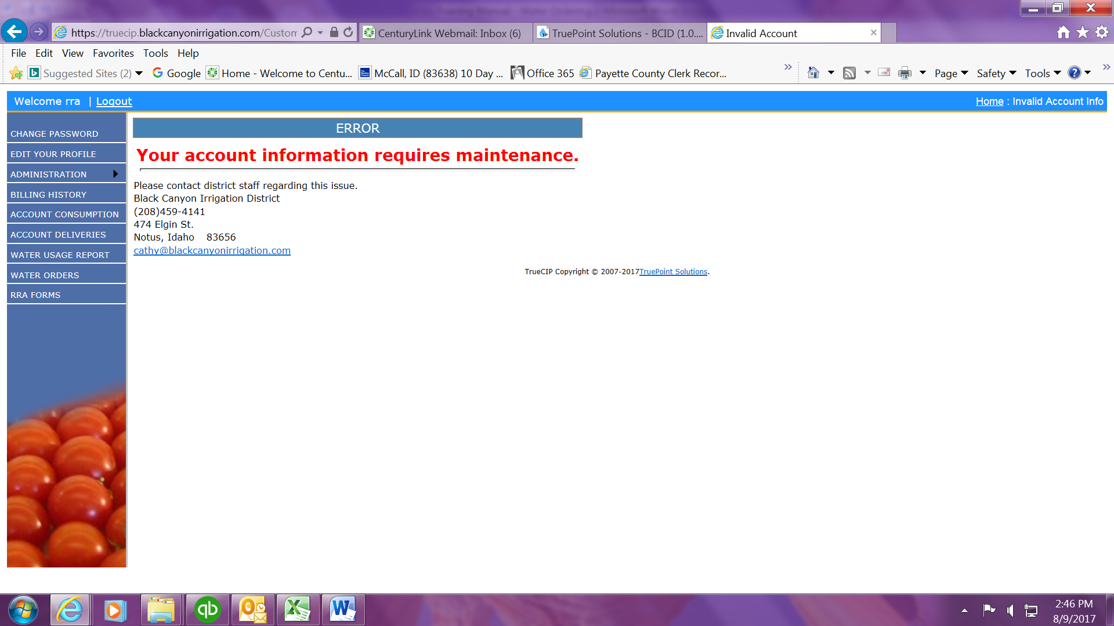
If you select a customer account and click Place a Water Order and you get the message above there is something that has the account on hold:
- If there is a balance larger than $10.00 owing on the account you will be able to see it if you click the Home button (upper right hand corner of all screens).
- If there is no balance, the customer either needs to sign RRA papers, or there is some issue with the account that the office will need to address.

Water Usage Report:

One of the handy features we’ve customized will allow you to see the status of all accounts assigned to your user name in one place. This screen will allow you to see your consumption, your remaining balance, the current flow, and future orders (if they exist). This report will also allow you to place an order directly from it.

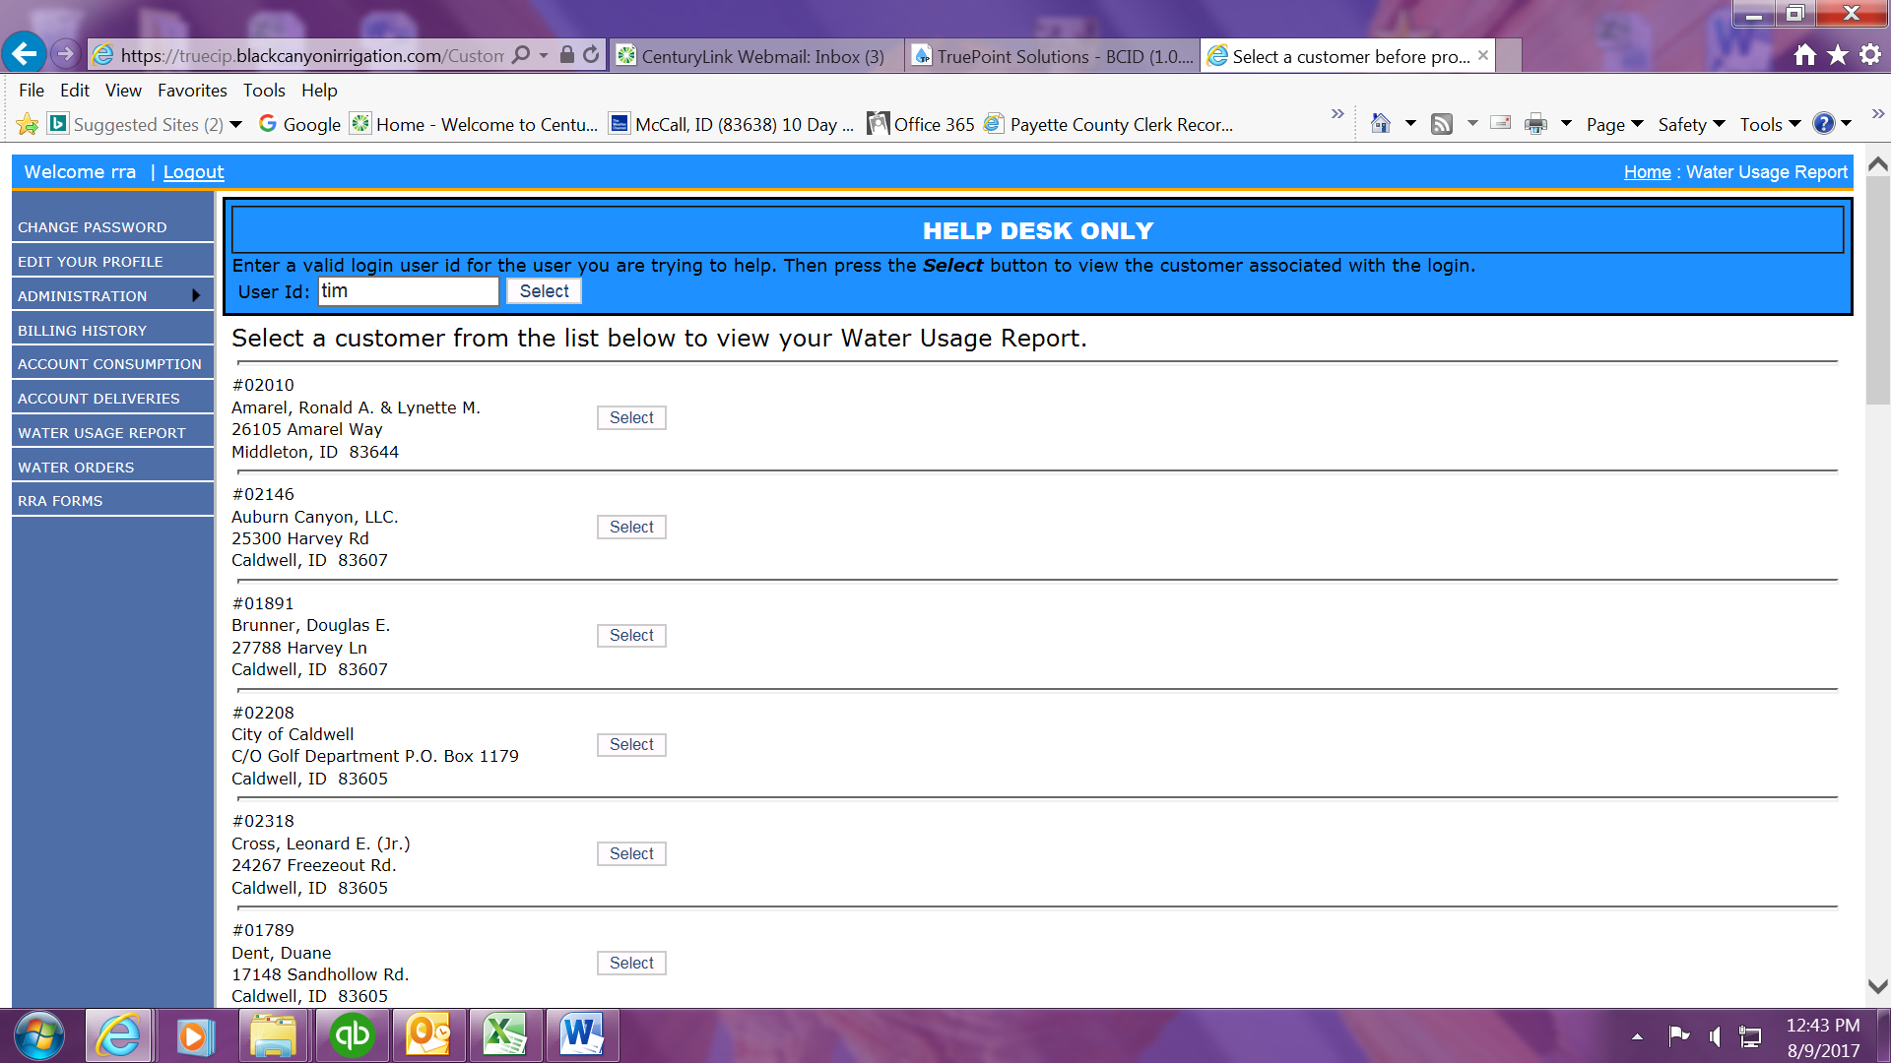
Click Water Usage Report on the left side menu.
Click any of the Select boxes – they will all take you to the Water Usage Report.

See the next page for the report itself.

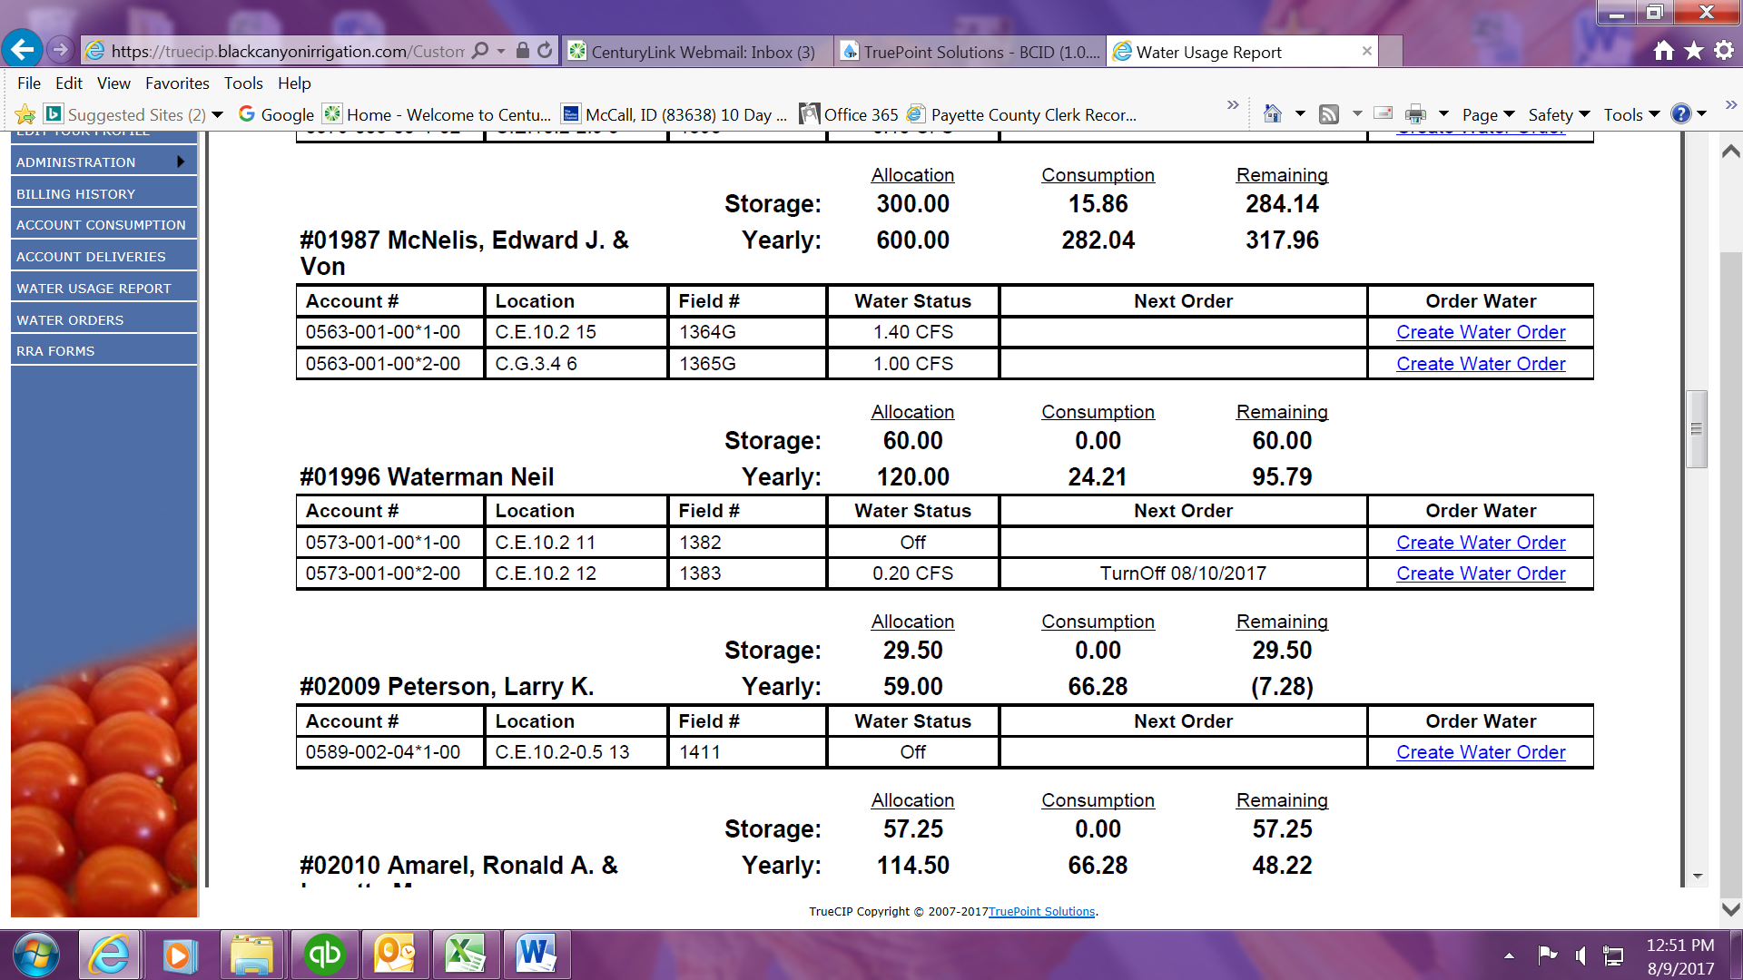
You will now see all accounts assigned to your user account.
- Storage = The allocation you receive when we go into Storage later in the season. These numbers will not populate until we actually go on Storage.
- Yearly = The 5 feet (per acre) that you are allowed before going into Excess
- Water Status = What is currently happening on that lateral, tap, and account #
- Next Order = The next change on that lateral, tap, and account # (if applicable)
- Create Water Order = This link will take you to the calendar page of the ordering water process for the specific account that you clicked the link for.

- Note: Orders are listed in CFS. In order to determine how many days you have left at a particular flow, you will double the CFS. Then you will take your Remaining amount divided by the doubled CFS.
  - As an example: McNelis has 284.14 acre feet left on storage and is running at a total of 2.40 CFS. 2.40 x 2 = 4.80
284.14 ÷ 4.80 = 59.20
You can run 59 more days at this flow.

