PAIN DIAGRAM AND PAIN RATING

Patient Name |  |  |  | Date
Please use the diagram to indicate the symptoms you have experienced with your condition. Use the key to indicate the type of symptoms.

KEY:
Pins/Needles |  | 0000000 | Stabbing |  | ////////
Burning |  | xxxxxxxx | Deep ache/throbbing |  | zzzzzzzz
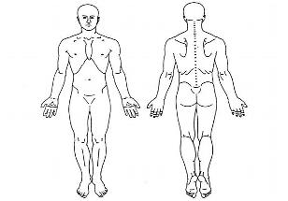

Please rate your current level of pain on the following scale: (circle)

0 1 2 3 4 5 6 7 8 9 10
(no pain) (worst pain)

