Children’s COVID Resources

My COVID Time Capsule…………………………………………………………………….2
The Meltdown Cycle…………………………………………………………………………..13
The Incredible 5 Point Scale…………………………………………………………………..14
Circle of Control……………………………………………………………………………….16
Poison Thoughts vs Antidote Thoughts………………………………………………………..18
5-4-3-2-1 Grounding Technique……………………………………………………………….20
Square Breathing……………………………………………………………………………….21

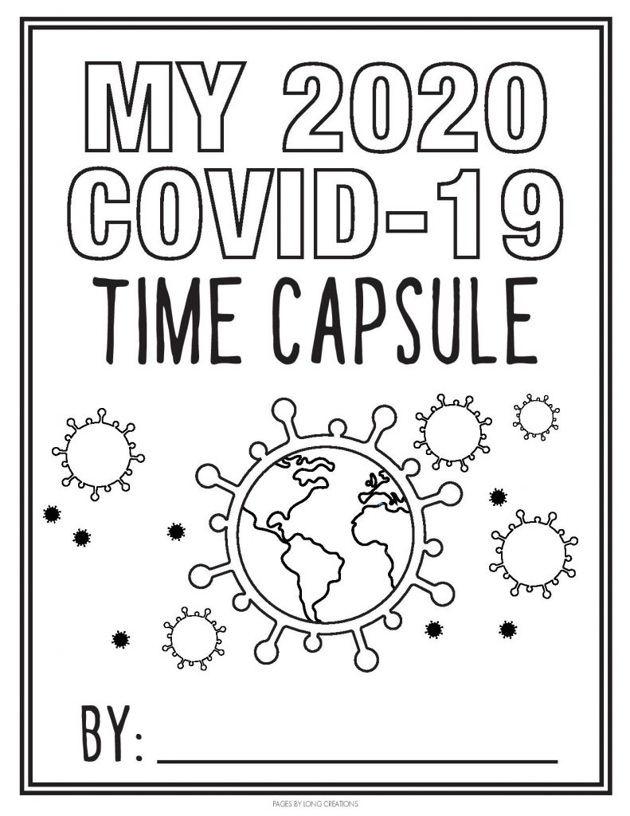

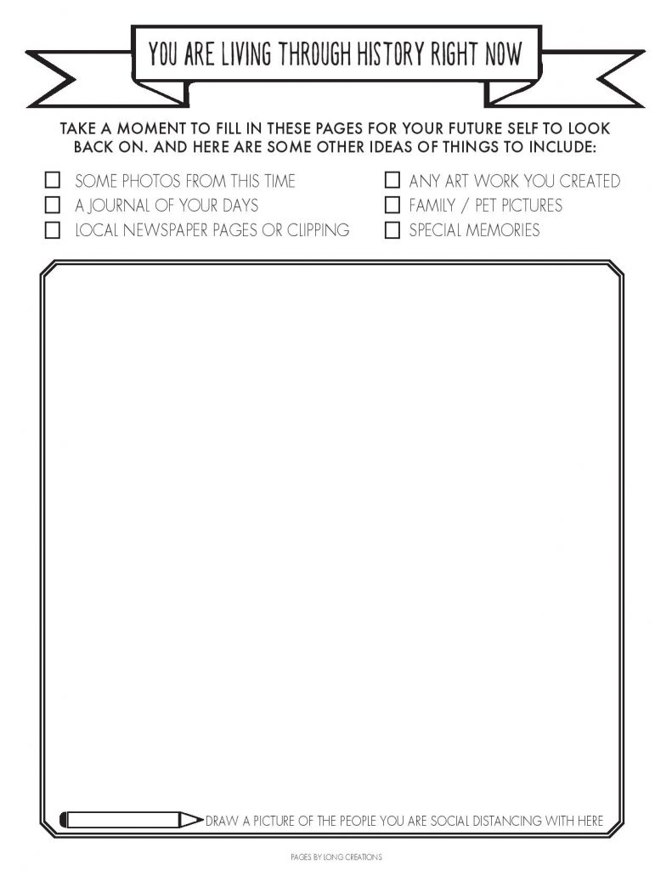

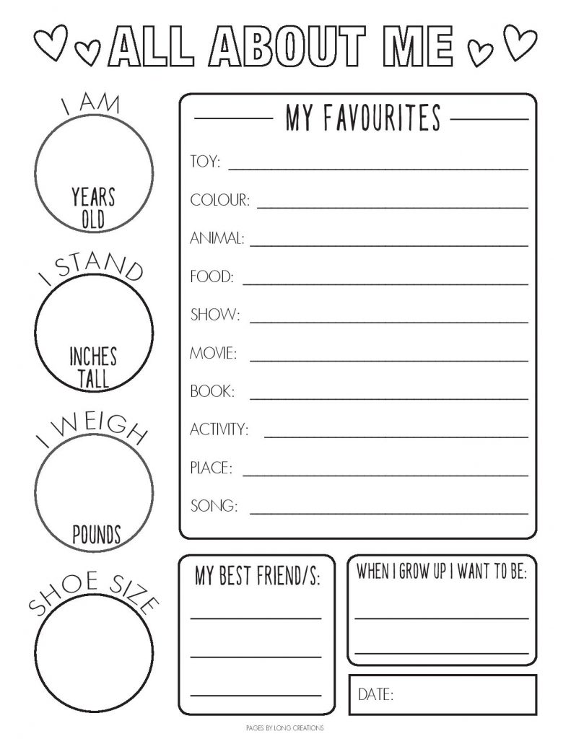
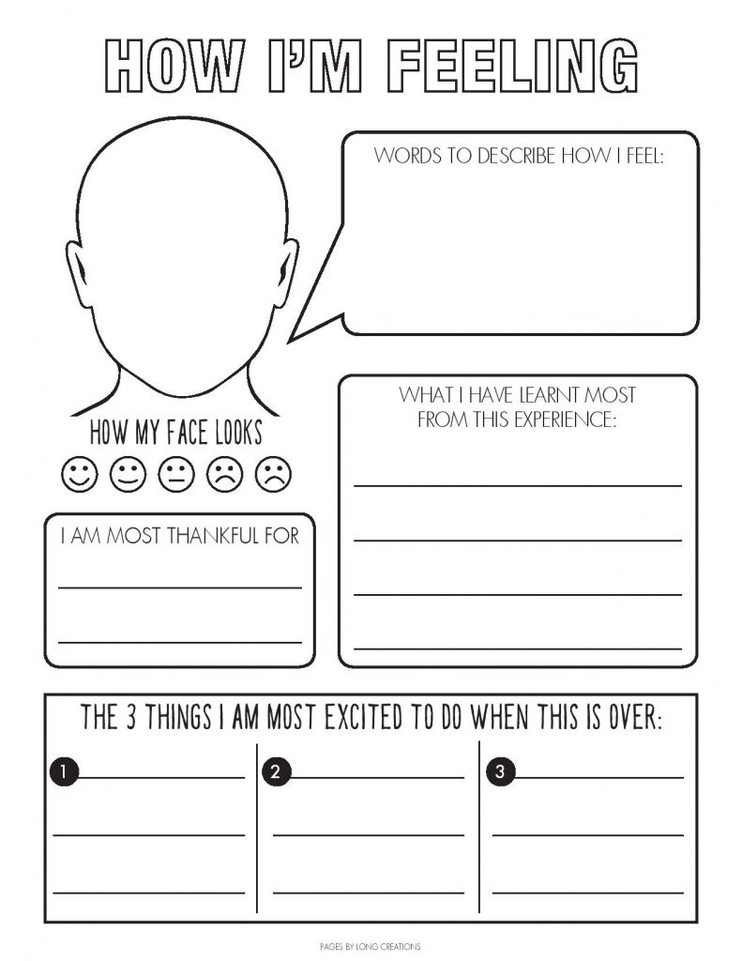
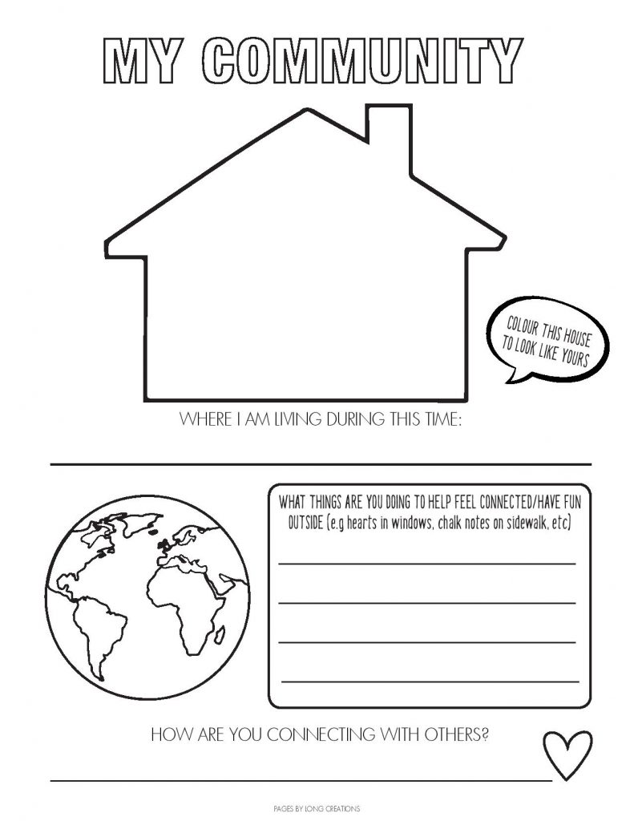
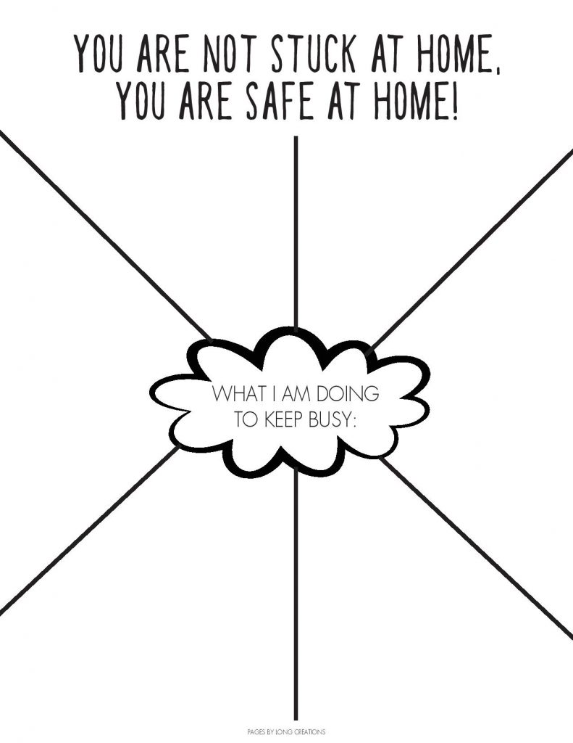
Report this ad
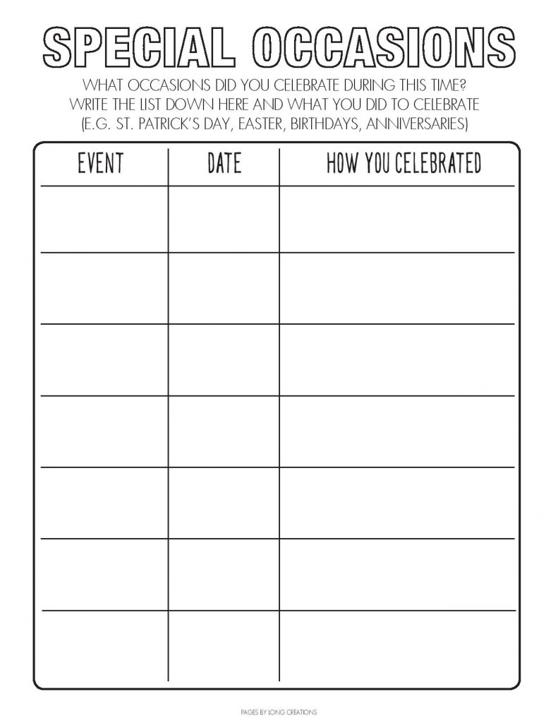
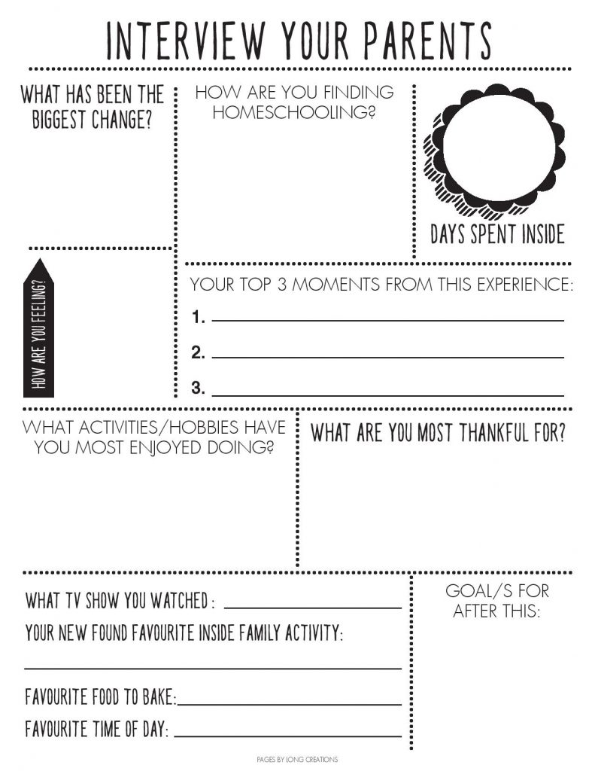

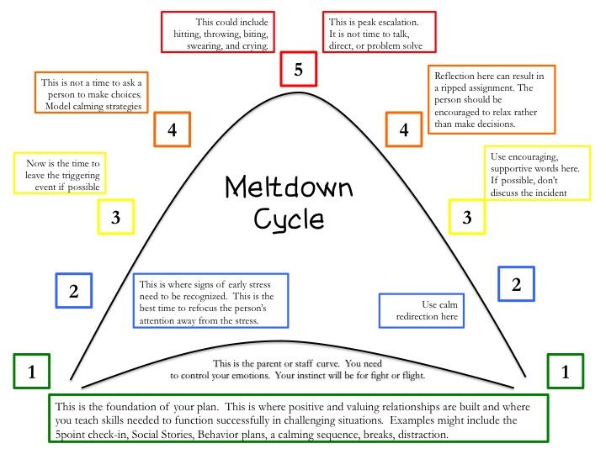

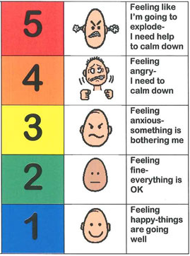

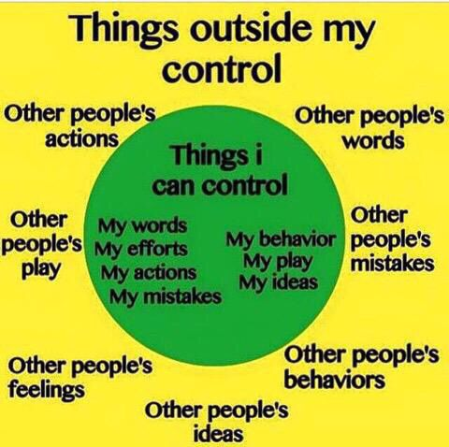

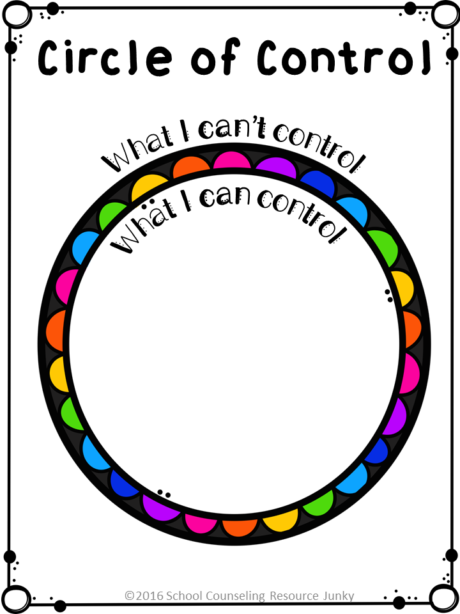

LINDA A CARMODY, MS, LPC
SPECTRUM BEHAVIORAL HEALTH LLC Visual to accompany the following video: https://www.youtube.com/watch?v=af04iwPN6vI&list=PLdMG7sCpdy4cfPx6V4I9xvJvlvZcGBnTc

POISON THOUGHTS

ANGER ANXIETY SADNESS
WORRY IRRITATION
FRUSTRATION

ACTION

LINDA A CARMODY, MS, LPC
SPECTRUM BEHAVIORAL HEALTH LLC
Visual to accompany the following video: https://www.youtube.com/watch?v=af04iwPN6vI&list=PLdMG7sCpdy4cfPx6V4I9xvJvlvZcGBnTc
ANTIDOTE THOUGHTS

CALM HOPEFUL FOCUSED
CONFIDENT STRONG
PROUD
ACTION

Coping Skill Spotlight: 5, 4, 3, 2, 1 Grounding Technique

How to do it:
This technique will take you through your five senses to help remind you of the present. This is a calming technique that can help you get through tough or stressful situations.
Take a deep belly breath to begin.
5 - LOOK: Look around for 5 things that you can see and say them out loud. For example, you could say, I see the computer, I see the cup, I see the picture frame.
4 - FEEL: Pay attention to your body and think of 4 things that you can feel and say them out loud. For example, you could say, I feel my feet warm in my socks, I feel the hair on the back of my neck, or I feel the pillow I am sitting on.
3 - LISTEN: Listen for 3 sounds. It could be the sound of traffic outside, the sound of typing or the sound of your tummy rumbling. Say the three things out loud.
2 - SMELL: Say two things you can smell. If you are allowed to, it’s okay to move to another spot and sniff something. If you cannot smell anything at the moment or you can’t move, then name your 2 favorite smells.
1 - TASTE: Say one thing you can taste. It may be the toothpaste from brushing your teeth, or a mint from after lunch. If you cannot taste anything, then say your favorite thing to taste. Take another deep belly breath to end
.