Spiralized Vegetables with Kimchi
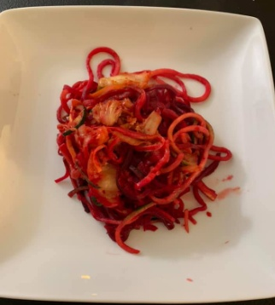
Prep Time Cook Time Total Time
10 Min 10 Min 20 Min

Ingredients
- 1 Beet
- 1 small zucchini
- 1 small yellow squash
- 1 TBSP olive oil
- 1 Jar spicy Kimchi
- Optional: 3oz chicken or shrimp

Instructions
- Spiralize vegetables
- Add olive oil to skillet set on Medium temperature
- Add spiralized vegetables and sauté ~8 minutes
- Add pre-made kimchi and cook ~2 minutes or until all is heated through
- Add protein to this dish for a complete meal. Suggest adding 3 oz shrimp or chicken. You can sauté shrimp or chicken with olive oil and garlic sauté until cooked and then follow recipe starting at step 1.

Nutrition Information
Yield: 3 Servings. Calories: 84, Fat 5.4g, Saturated fat 0.3g, Cholesterol 0 mg, Sodium 684 mg, Total Carbohydrates 27g, Dietary Fiber 3.7g, Sugar 5.1g, Protein 2.8g, Vitamin A 8.3%, Vitamin C 36%, Calcium 8.6%, Iron 21%, Phosphorus 72.6mg, Potassium 494.4 mg

