|  |  |
| --- | --- |
| SHARING FORWARD REALTY  ***A Unique Approach to Your Home*** |  |

**WHAT KIND OF HOME AM I LOOKING FOR?**

|  |  |  |
| --- | --- | --- |
|  | **Minimum** | **Maximum** |
| Price range |  |  |
| Bedrooms |  |  |
| Bathrooms |  |  |
| Square footage |  |  |
| Garage |  |  |
| Floors |  |  |
| Distance from (work, town, school, etc.) |  |  |

**Features**

|  |  |  |  |  |
| --- | --- | --- | --- | --- |
|  | **Need** | **Want** | **Nice to Have** | **Do Not Want** |
| **Location** |  |  |  |  |
| Walk to town |  |  |  |  |
| Close to highway |  |  |  |  |
| Close to public transit |  |  |  |  |
| Close to parks |  |  |  |  |
| School district: |  |  |  |  |
| Close to: |  |  |  |  |
| **Home type** |  |  |  |  |
| One Story |  |  |  |  |
| Two Story |  |  |  |  |
| Other: |  |  |  |  |
| **OTHER** |  |  |  |  |

|  |  |  |  |  |
| --- | --- | --- | --- | --- |
|  | **Need** | **Want** | **Nice to Have** | **Do Not Want** |
| **Amenities** |  |  |  |  |
| Large yard |  |  |  |  |
| Fenced yard |  |  |  |  |
| Swimming pool |  |  |  |  |
| Large deck |  |  |  |  |
| Paved driveway |  |  |  |  |
| Screened porch |  |  |  |  |
| First floor master |  |  |  |  |
| Walk in closet |  |  |  |  |
| Formal dining rm |  |  |  |  |
| Finished basement |  |  |  |  |
| Fireplace |  |  |  |  |
| Hot tub |  |  |  |  |
| First floor laundry |  |  |  |  |
| Hardwood floors |  |  |  |  |
| Home office |  |  |  |  |
| Other: |  |  |  |  |
| **Mechanicals** |  |  |  |  |
| Oil heat |  |  |  |  |
| Gas heat |  |  |  |  |
| Electric heat |  |  |  |  |
| Central air |  |  |  |  |
| Baseboard heat |  |  |  |  |
| Forced hot air heat |  |  |  |  |
| Generator hookup |  |  |  |  |
| Other |  |  |  |  |
| **OTHER** |  |  |  |  |

**WHICH HOUSE IS RIGHT FOR ME?**

Example:

Address: 123 Maple Street

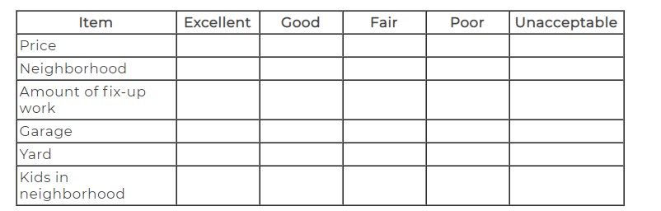

Address: ______________________

|  |  |  |  |  |  |
| --- | --- | --- | --- | --- | --- |
| Item | Excellent | Good | Fair | Poor | Unacceptable |
|  |  |  |  |  |  |
|  |  |  |  |  |  |
|  |  |  |  |  |  |
|  |  |  |  |  |  |
|  |  |  |  |  |  |

Comments:

Address: ______________________

|  |  |  |  |  |  |
| --- | --- | --- | --- | --- | --- |
| Item | Excellent | Good | Fair | Poor | Unacceptable |
|  |  |  |  |  |  |
|  |  |  |  |  |  |
|  |  |  |  |  |  |
|  |  |  |  |  |  |
|  |  |  |  |  |  |

Comments:

Address: ______________________

|  |  |  |  |  |  |
| --- | --- | --- | --- | --- | --- |
| Item | Excellent | Good | Fair | Poor | Unacceptable |
|  |  |  |  |  |  |
|  |  |  |  |  |  |
|  |  |  |  |  |  |
|  |  |  |  |  |  |
|  |  |  |  |  |  |

Comments:

Address: ______________________

|  |  |  |  |  |  |
| --- | --- | --- | --- | --- | --- |
| Item | Excellent | Good | Fair | Poor | Unacceptable |
|  |  |  |  |  |  |
|  |  |  |  |  |  |
|  |  |  |  |  |  |
|  |  |  |  |  |  |
|  |  |  |  |  |  |

Comments:

Address: ______________________

|  |  |  |  |  |  |
| --- | --- | --- | --- | --- | --- |
| Item | Excellent | Good | Fair | Poor | Unacceptable |
|  |  |  |  |  |  |
|  |  |  |  |  |  |
|  |  |  |  |  |  |
|  |  |  |  |  |  |
|  |  |  |  |  |  |

Comments: