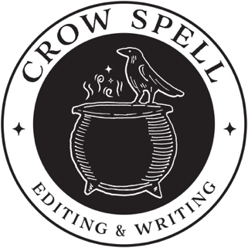 CROW SPELL EDITING & WRITING
2025 Estimate Form

Document type and size (novel, short story, non-fiction book, academic article, website copy, fundraising email, etc.; word count and page count):

Type of editing desired (if known—structural, stylistic, copyediting, line editing, or all):

Previous writing experience, if applicable (e.g., secondary and/or post-secondary education, business content, previously published material, etc.):

Project timeline (or, by when does the document or manuscript need to be finished?):

Goals for edited document (e.g., what do you hope the editing process adds to your writing?):

Who are your intended readers?

Ideal editing budget for this project:

Email Address:

Additional Information:

