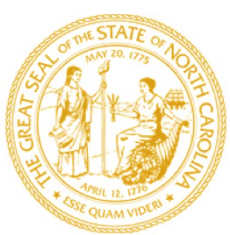

North Carolina General Assembly

**FOR IMMEDIATE RELEASE**

February 13. 2023

# Rep. Paré Files Bill to Change Wake Commissioner Elections

# RALEIGH- Today Representative Erin Paré (R-Wake) introduced HB 99, “Wake County Board of Commissioners Elections/Nonpartisan.”

# The bill provides that Wake County Commissioners shall be elected from electoral districts in nonpartisan plurality elections, beginning in 2024. “This is a common-sense bill. This bill does not redraw lines, and it leaves the commissioners’ term lengths intact. It mirrors how we elect the Wake Board of Education,” said Rep. Erin Paré (R-Wake). “The people of Wake County deserve to know that there is someone accountable to them on the Board of Commissioners and that communities of interest are represented. The current makeup of the Board of Commissioners is not proportional to the population of Wake County. What we have now is taxation without representation. Wake County is larger than eight states.”

# ###