**Ridge Archers 70th Anniversary with President Maurice Campbell**

David Jarrett

CAD Department, Southeastern University

4453 Advanced Digital Reporting

Dr. Adrienne Garvey

April 1, 2024

**Ridge Archers 70th Anniversary with President Maurice Campbell**



*70th Anniversary Ridge Archers Merchandise via Ridge Archers Facebook Group…*

One of the longest standing archery clubs in the United States, Ridge Archers, established in 1954 is celebrating its 70th anniversary this year. Located in Lakeland, Florida, Ridge Archers seeks to promote good fellowship between archers and engage in competition by hosting monthly 3-D tournaments and special events at the Tenoroc Shooting Center.

Maurice Cambell, the current president of Ridge Archers Archery Club has been the current president for three years, and oversees spearheading events, engaging with archers and hosting celebrations for the 70th anniversary of the club.

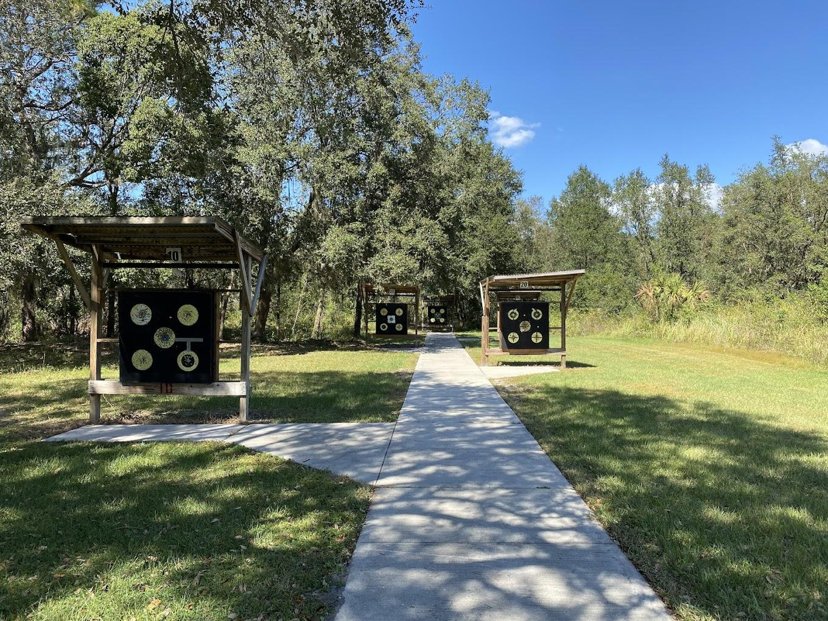

*(Target shooting area - ninshanth kumar google photo).* Campbell has enjoyed his time as president thus far, with his wife as secretary, in charge of handling social media affairs and promoting the club to new members. When Campbell and his family took over, there were only 40 to 45 members and has significantly grown since then.

“This is our 70th anniversary this year. Most archery clubs start up and end up closing because of the lack of members and management, but we are grateful to still be around with about 130 members locally and the largest club in Florida” he said.



*(Donald and Ann Grimes - legacyfunerals.com).* The first kickoff of the celebrations started with a memorial shoot day recognizing an original founding member of the club, Donald Grimes. Donald not only helped found Ridge Archers Club, but his wife Ann Grimes was also inducted into the Archery Hall of Fame in 2020.

“Recognizing these founding members and passionate archers was an important part of starting our 70th year”, said Campbell.

Maurice knew Donald Grimes before his passing, prior to getting involved with Ridge Archers, and even had the chance to work with his wife before her passing this past year.

“I actually knew Donald before becoming involved with Ridge Archers, I used to hunt with him frequently, as I’m more of an archery hunter,” said Campbell.

More celebratory festivities include exclusive merchandise which can be purchased [here](https://ridgearchersfl.printify.me/products), and the upcoming ASA State Qualifier which is being hosted by Ridge Archers in June. The club also partners with local organizations to promote archery and community by holding shooting events with the Lakeland PALS (Police Athletic League) and going to schools to advocate for youth to join the club.

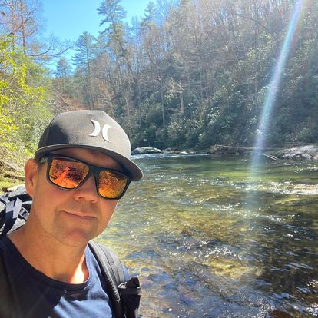

Club member and Adventures Archery Employee, Tim Longest got into bow hunting 20 years ago with a friend. When Longest moved to Florida he checked out Ridge Archers and found his new archery practice home.

“Many people buy bows at Adventures Archery and head on over to the club to shoot” said Tim.

“Ridge Archers has plenty of lands and targets for all skill levels. Tournaments are a blast and target shooting can be a great time with some fellow archers” said Tim.

At the heart of this anniversary, is the community within it. Ridge Archers brings people together to compete and enjoy the nature of Central Florida together in a unique way. Reaching out to all age groups and growing the club by partnering with local organizations helps the club feel more like a family than just an archery club.

“Archery is a tight-knit group of people, and it’s been a joy to have been president these past few years. There’s something special about getting to know each archer and celebrating the committee we have built this year for the anniversary. We appreciate hosting great groups of people,” said Campbell.