The Spiritual Landscape of Lakeland Amidst An Election

David Jarrett
CAD Department, Southeastern University
4453 Advanced Digital Reporting
Dr. Adrienne Garvey
February 12, 2024

The Spiritual Landscape of the Local Church in Lakeland Amid An Upcoming Election

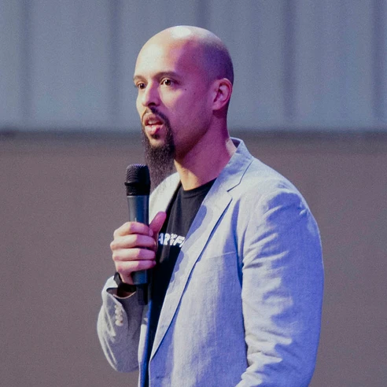
(Brandon Jenkins, Heart of The Father Website)
Elections are often thought about in a national or global impact. How will economies change, what policies are being brought forth by the candidate and how does it impact people’s lives? Sometimes to look at the bigger picture you have to look closer. What’s going on behind the scenes? As the campaign season is coming to a boil, many things are happening spiritually that influence what happens politically. I recently had the opportunity to visit Lakeland and sit down with a local pastor and church elder, Brandon Jenkins at Heart of The Father Church, a church that believes relationship with people and God comes first.

“We believe God wants to see a covenant community where relationships are supernaturally deep, and love is sacrificial and real. For us, loving our brothers and sisters is extremely important because it is one of the signs of true spiritual maturity.” – Heart Of The Father Church

Heart of The Father recently came out with a mission statement regarding politics, stating that their primary goal is to spread the Gospel no matter race or political party. Jenkins, a lead elder at Heart of The Father shares how elections can affect local communities and Christians. Jenkins has a passion for family ministry and young adult leaders, alongside his wife and three children. Since 2010, Brandon has been pastoring and counseling members of the church.

One of the common patterns of issues brought up during counseling was conflict between people over politics. Jenkins realized there was a lot of unrest even among the church when it came to politics, and it began to rear its ugly head during the pandemic. That’s when Heart of The Father stood on a statement in each aspect of their church titled “covenant community”. Personal convictions play a huge role in deciding what side of the aisle’s principles to vote for. One controversial personal conviction debate was the mask issue starting in 2020.

“The mask issue was a big debate in our church. The political correctness of wearing a mask versus the spiritual principle of living in fear over a disease divided people,” said Jenkins.

“Who you vote for is not a Heaven or Hell decision, it’s a personal conviction. However, your voting decision should be based on a Biblical perspective and you as an individual will be judged at the end of the age if you voted for an issue, you deemed political but was against the heart of God,” Jenkins said.

He also mentioned issues like abortion being a biblical issue and not a political issue, stating that because of the politicization of biblical issues, members in the church and the Lakeland community often don’t know when to take a stand and separate biblical beliefs from political decisions.

For Jenkins, it seems that politics and biblical beliefs should be intertwined and not separated. “While the presidential office has power, the true power belongs to the local community and local church and I believe we can all unite together to make an impact on issues that matter this election season and the elections to come after,” he said.

