**Visiting 3 of Florida's Best Restaurants Through The Lens of the Creatives (Yelp 100 Best 2024)**

David Jarrett

CAD Department, Southeastern University

4453 Advanced Digital Reporting

Dr. Adrienne Garvey

February 21, 2024

**Visiting 3 of Florida's Best Restaurants (Yelp 100 Best 2024)**

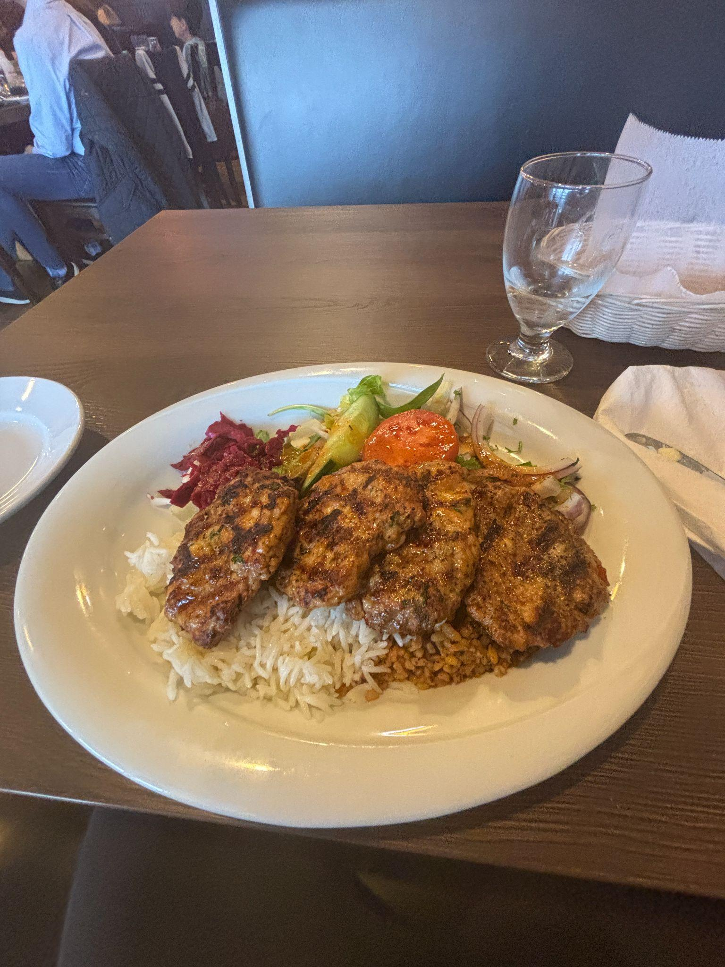 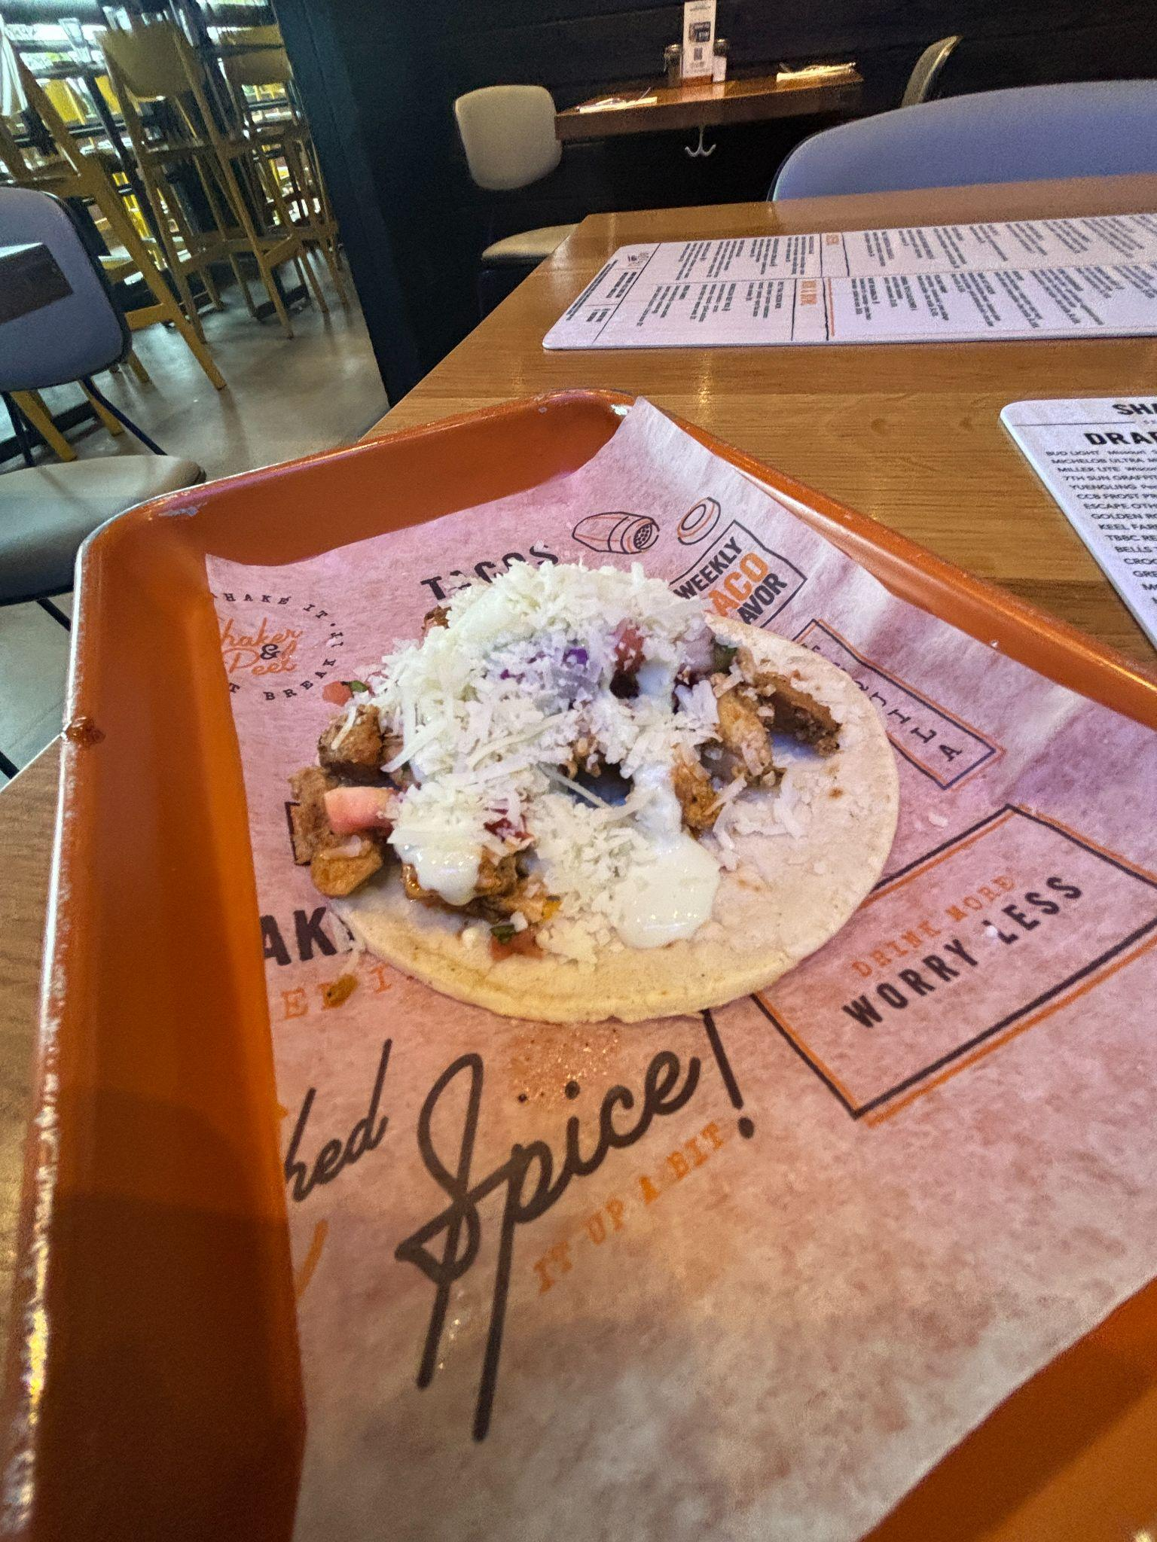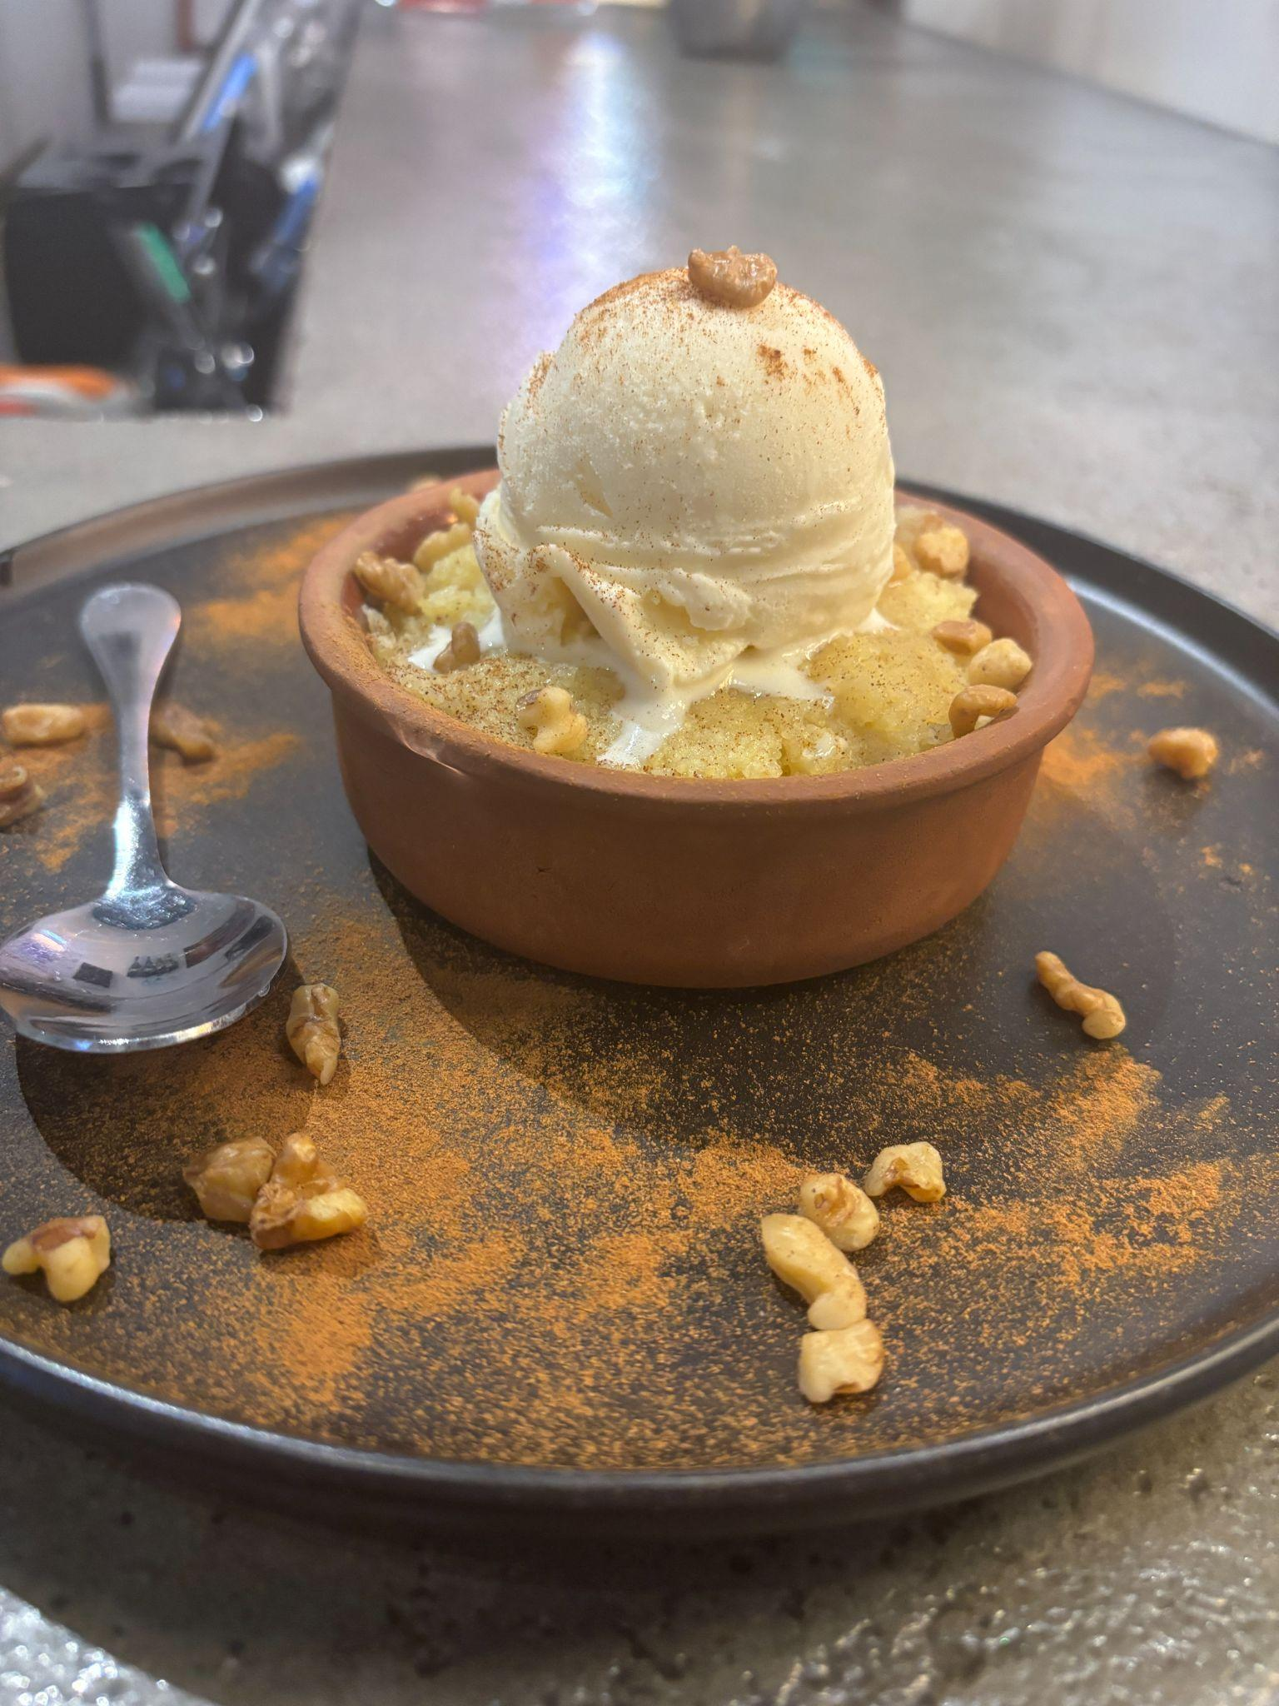

*Food from all three restaurants, (from left to right), Chicken Adana, Basic Chicken, Sutlac with Ice Cream*

Some of the best stories are told around a table. Of course, a well-crafted story can’t be told around a table without some homemade food. What better way to try some food than to uncover the stories behind them? There are three restaurants with unique stories, which all were featured on Yelp, the online review and entertainment-based company that makes a [top 100 restaurants list](https://www.yelp.com/article/top-100-us-restaurants-2024) each year. These restaurants made it on the list this year and here’s what the owners had to say.

One restaurant is [Bayshore Mediterranean Grill](https://bayshoremediterraneangrill.com/menu/), located in Tampa. A hole-in-the-wall restaurant with food prepared by Turkish chefs with more than 30 years of experience. When you walk into the room, you are dining at tables that are neat and the environment is low light accompanying a rustic feel on the outside.

“We have been here not that long, but we have seen many tourists that come to Florida love our food. The experience of coming to work to see smiles on faces and serve food I am proud of makes me enjoy coming to work each day.” – Rania (Restaurant Staff)

The restaurant looked brand new, but after speaking to the restaurant manager I was told a different story. The environment customers are served is quiet and interactions with staff are friendly and informative Google users reported.

“We have been open for about seven years. We love serving customers and providing authentic and quality food.” - Mario R. (Manager)

This restaurant was ranked #75 on the list, and the staff service may have played into that.

Next on the list is  [Shaker and Peel](https://shakerandpeel.com/), a tacos and cocktail restaurant located in Orlando. This restaurant has been known for serving specialty tacos for as low as three dollars.

“We have been open since 2019. We knew that we loved cocktails and all things tacos could be. We are family-operated and if I had to recommend a taco to a newcomer, I would recommend the Flower Power. Tacos are what we do, and the local community loves our tacos, so we are honored to make the list.” - Steven Fabretti (Kitchen Manager)

Also, the restaurant has multiple staff that offer samples to try a specialty taco before customers reach a decision. Customer care is important at Shaker and Peele, as Aisha a waiter there said “There are so many options to choose from but you are sure to get a good taco experience.”

For $3, include ingredients like braised short ribs and Nashville hot chicken - ranking #80 on the list.

For dessert, Mio’s Grill and Café was also ranked on the list.

[Mio’s Grill and Cafe](https://order.miosgrill.com/view/mio/eat/Desserts) is located in the heart of Downtown Saint Petersburg. The grill is a corner shop with bright lights and natural theming with artwork from the Mediterranean with staff that greets customers right at the door.

Mio’s Grill and Café made the list with customers often satisfied with experiencing another culture while eating the food based on Yelp.

Borahan, head chef had this to share about his experience bringing his culture into the hearts of new customers and food junkies alike.

“After almost five years in business, making authentic Mediterranean food has been so rewarding in the sense that people are satisfied with trying other cultures’ food and it’s fulfilling to provide that experience.” – Borahan C. Head Chef and Manager

And it’s this experience that ranks Mio’s Grill and Cafe at spot #12.

No matter which restaurant you may end up visiting, each one on the list is recognized for quality customer service alongside the creativity of their owners and workers that put their restaurant on the map with Yelp’s 100 best this year.