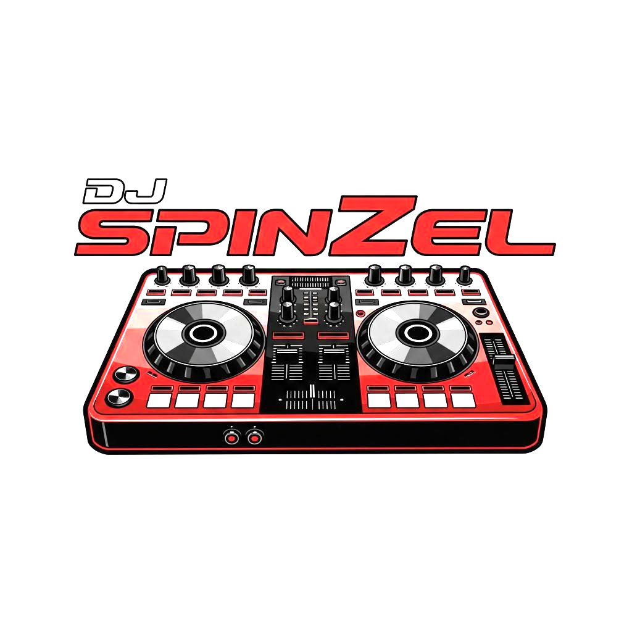
DJ SPINZEL SERVICES CONTRACT
This Agreement is entered into on ____________[Date of Signing] by and between the parties listed below, for the provision of disc jockey entertainment services.
The client is required to complete all red-text fields, follow the instructions for signing, and return the email to DJ Spinzel.
1. PARTIES AND EVENT DETAILS
DJ/Service Provider: Denzal Hancock (DJ Spinzel)
Company Name: Genius Tech Solution
Contact: 214-518-5699
Email: djspinzel@gmail.com

Client/Purchaser [Client’s Legal Name/Company Name]: ____________________________
Client Contact [Client Phone Number]: _________________________________________
Client Email [Client Email Address]: ___________________________________________

Event Name: ___________________________________
Date of Event: ___________________________________
Venue Name: ___________________________________
Venue Address [Must be filled in by Client]:___________________________________
Performance Time ($275 - 4 Hr Increments): ___________________________
* See Payment Terms for Overtime Rates *

2. SERVICES PROVIDED
The DJ agrees to provide the following services:
* Music Entertainment: DJ services for the specified performance time.
* Equipment: Provision of all necessary professional-grade audio equipment, including:
- 1 PA Speaker (Gemini PA Speaker System)
- 2 Short Range Wireless microphones
- 1 Corded Microphone
- Laptop for performance
- 1 Table w/ black table cloth. (Unless provided by the venue.)
* Setup/Tear Down: The DJ requires 60 to 90 minutes prior to the start time for setup and 60 minutes after the end time for tear down. This time is not included in the performance fee.

3. PAYMENT TERMS
Total Fee: $_275___________
Non-Refundable Deposit/Retainer: 50% of Total Fee or $_137.50___________
Deposit Due Date: ____________
Balance Due: $__137.50__________
Balance Due Date: ____________
Overtime Rate: $75.00 per hour (or any portion thereof), payable immediately upon extension.
Accepted Payment Methods: Cashiers/Certified Check, Zelle, Debit/Credit Card, or Paypal.

4. CANCELLATION AND RESCHEDULING
* Client Cancellation:
- If canceled more than 30 days before the event the Deposit/Retainer is forfeited.
- If canceled 30 days or less before the event the Client forfeits the deposit and must pay 75% of the Total Fee.
* Force Majeure: If the event is canceled due to acts of God, governmental restrictions, or other events beyond the control of both parties, the DJ shall retain the deposit, and will not be liable for further performance.
* DJ Cancellation: In the event the DJ must cancel due to unforeseen circumstances (e.g., illness, emergency), the DJ will provide a suitable, comparable replacement DJ or return all money paid by the Client, including the deposit.

5. VENUE REQUIREMENTS AND LOGISTICS
* Access: Client shall ensure adequate and timely access to the venue for the DJ's setup and tear down during the required time frames specified in Section 2.
* Food and Beverage: For performances exceeding one (1) hour, the Client agrees to provide the DJ with one (1) complimentary non-alcoholic beverage during the performance and one (1) hot meal or substantial snack if the total duration of service (including setup and tear-down) falls over a typical meal time (lunch or dinner).*
* Power: Client must guarantee access to at least two 15-amp dedicated circuits of reliable, grounded power near the performance area or a reliable power source to handle the equipment. The DJ is not responsible for power interruption issues outside of their control.
* Performance Area: Client must provide a clean, level, and stable space of at least 6 x 6 feet for the DJ's setup. (The DJ can modify this request at their discretion.)
Safety and Shelter (Outdoor Events): For any performance taking place outdoors, the Client must provide complete, adequate overhead shelter and a dry, safe performance area for all equipment and personnel. The DJ reserves the right to immediately cease performance and dismantle equipment if safety is compromised by severe weather (e.g., rain, high winds, lightning, extreme heat). In such an event, the DJ is not obligated to resume performance, and the Client remains responsible for payment of the Total Fee in full, with no refunds provided. The DJ may return to continue performance once weather conditions have demonstrably subsided, at the DJ’s sole discretion.

6. LIABILITY AND INDEMNITY
* Limitation of Liability: The DJ's liability for any claim, loss, or damage arising from this contract shall be limited to the amount of the Total Fee paid.
* Indemnification: Client agrees to indemnify and hold harmless the DJ and Genius Tech Solution from any loss, damage, or injury arising from the event, except for injury directly caused by the DJ’s gross negligence or willful misconduct.
* Damage to Equipment: Client is responsible for any damage to the DJ's equipment caused by the Client, their guests, other vendors, or venue staff. The Client will be billed for the cost of repair or replacement.
7. MUSIC AND REQUESTS
* Playlist Submission: Client will provide any detailed list of "Must Play" and "Do Not Play" songs/genres at least 7 days prior to the event. (Client will receive a Music & Vibe Questionnaire. It’s highly recommended it be completed but it is not a requirement.)
* Song Requests: The DJ will accept reasonable song requests from guests during the event, provided they are appropriate for the event type and do not violate the Client’s "Do Not Play" list. (See Music & Vibe Questionnaire)
* DJ Discretion: The DJ retains the right to use their professional judgment to adjust the playlist, volume, and song selection based on the mood, timing, appropriateness, and safety standards of the event and venue.

8. SIGNATURES
Digital Acknowledgment and Consent
As a substitute for a formal electronic signature, consent to this agreement's Terms and Conditions is provided through the following method:
- The User must replace the text [INSERT YOUR FULL LEGAL NAME HERE] below with their full legal name.
- The User must then copy and paste the entire acknowledgment statement provided in the "User's Acknowledgment Statement" section into the body of a reply email.
- The User must return the modified document and the reply email containing the acknowledgment statement to djspinzel@gmail.com.
The act of modifying the document and sending the required email constitutes a legally binding agreement to all terms and conditions herein.
Document Acknowledged By: [INSERT YOUR FULL LEGAL NAME HERE]

User's Acknowledgment Statement (Copy/Paste/Return)
"I, [YOUR FULL LEGAL NAME], confirm that I have read, understand, and agree to all the terms and conditions outlined in the attached contract. By changing my name within the document and sending this email to djspinzel@gmail.com, I am providing my explicit and legally binding consent to this agreement."
Client/Purchaser:
Printed Name: [YOUR FULL LEGAL NAME]
Date: ____________________________

DJ/Service Provider:
Company Name: Genius Tech Solution
DJ Name: DJ Spinzel
Printed Name: Denzal Hancock
Date: 12/03/2025___________________

