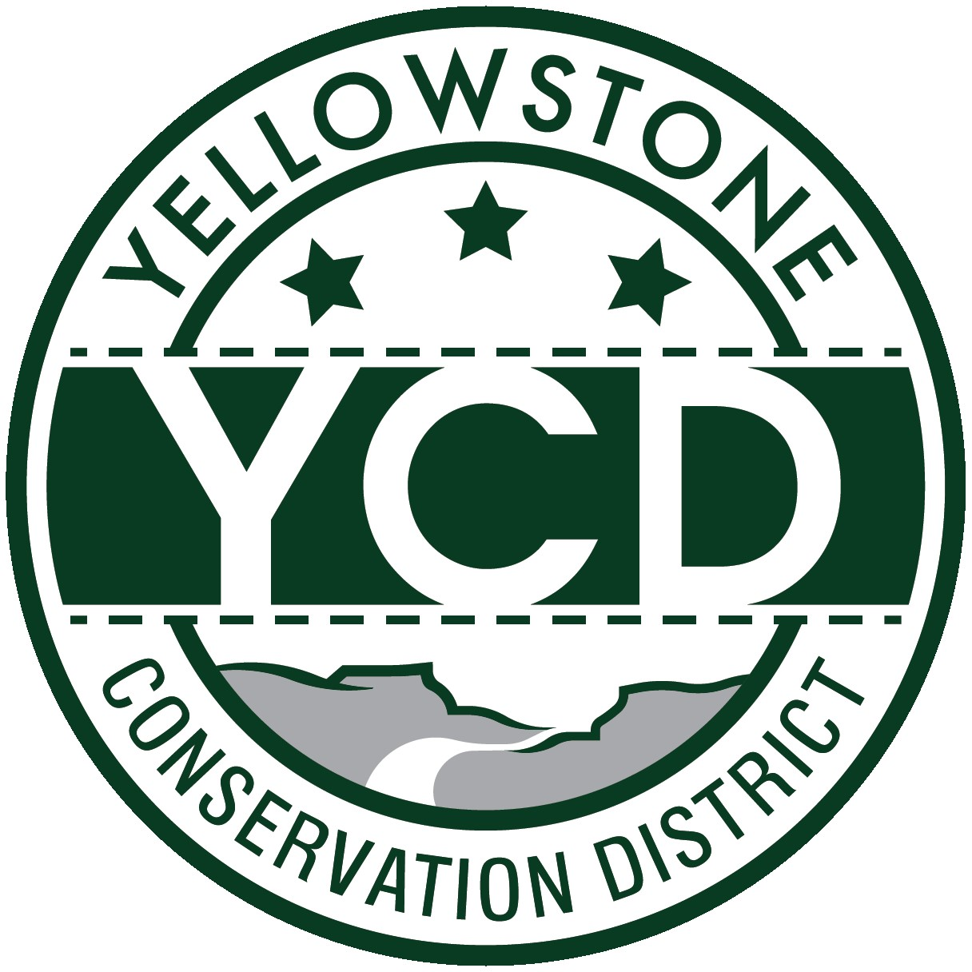 PO Box 80088, Billings MT 59108

YELLOWSTONE CONSERVATION DISTRICT 1670 48th St. W Suite 2 406.690.9326

yellowstoneconservationdistrict.org

YELLOWSTONE CONSERVATION DISTRICT BOARD MEETING
AGENDA
November 18, 2025
YCD office, Suite #2, 1670 South 48th St. West, Billings, MT
1:00 – 3:00 pm
(closed session 1:00 – 1:30)

- Call YCD board meeting to order
- Immediately convene a closed session to discuss legal strategy with Yellowstone County Attorney Steve Williams

- Open meeting to public – 1:30 pm
- all issues will be addressed to the Chairman; public comments are always welcome but request that you wait until the issue is addressed on the agenda, asked to be recognized by the chair, and then limit comments to 3 minutes. No action will be taken on any item, not on the agenda.
- Agenda Changes
- Minutes Approval – October 21, 2025
- YCD Board member absences
- 310’s
  - Applications/Emergencies/Complaints/Work Completion forms
- YE-04-26 – Tri-County Telephone Association, Blue Creek – HDD
  - Yellowstone River Conservation Districts Council – Gabel
- Business Meeting
  - Old Business
  - New Business
  - Treasurer’s Report
- T-Report – October 2025
- Dues and/or donation requests - NILE
- Travel and meetings
- Blinds installation in office
- Standing Committees/Programs
  - Westend Reservoirs – Project update
  - Fly Creek - White
- water sampling results from latest testing
- cancellation of the DNRC grant by Big Horn CD
  - Pollinator Fair grant applications – Haaland, White
  - YR Water Reservations 10 year review
- YCD/Agencies - supplementary information to agency reports received & provided to Supervisors before meeting
  - Administrator’s Report
  - YCD/PF Report
  - DNRC
  - FWP
  - NRCS
  - Yellowstone County
- Commissioners
- Extension
- Floodplain
- Weed District
- METRA Park activities -Tim Goodgridge, METRA Assistant Manager (invited)
- Unscheduled matters
- PUBLIC COMMENT PERIOD – Any subject not on the agenda; discussion limited to 3 minutes
- Next meeting date – December or January?
- Adjourn

