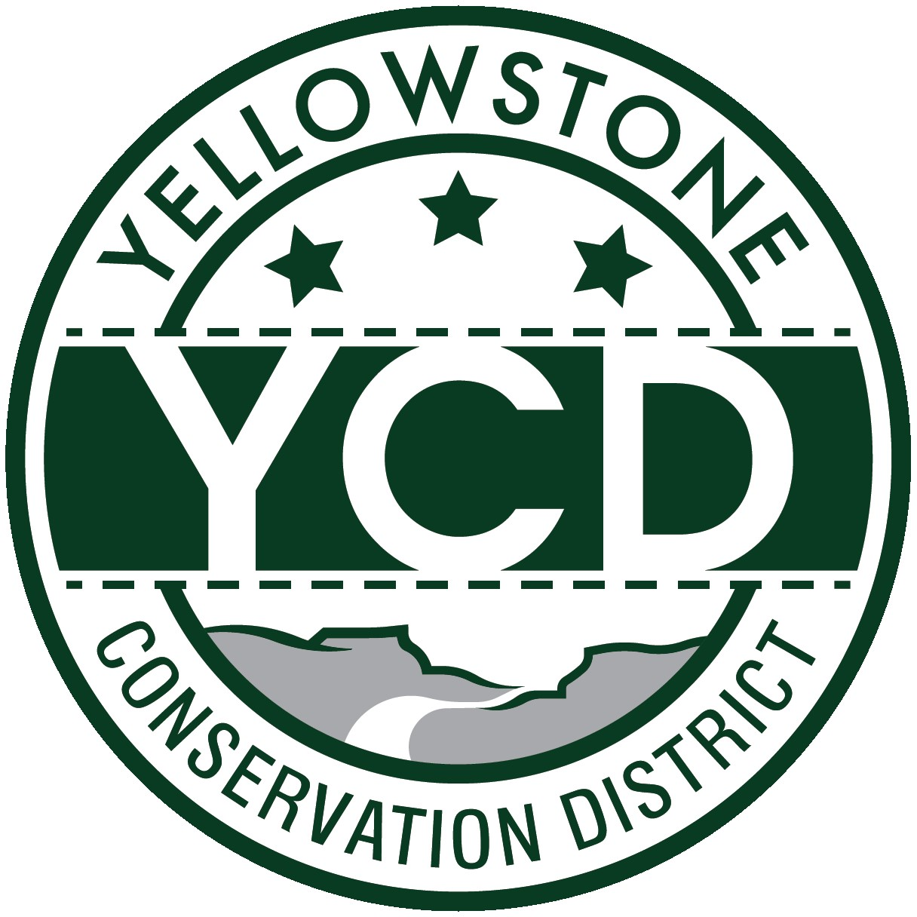 PO Box 80088, Billings MT 59108

YELLOWSTONE CONSERVATION DISTRICT 1670 48th St. W Suite 2 406.690.9326

yellowstoneconservationdistrict.org

YELLOWSTONE CONSERVATION DISTRICT BOARD MEETING
AGENDA
October 21, 2025
YCD office, Suite #2, 1670 South 48th St. West, Billings, MT
11:30 a.m. ~ 1:30 p.m.
(public meeting starts at 12:00 pm)

- Call YCD board meeting to order
- Immediately convene a closed session to discuss legal strategy with Yellowstone County Attorney Steve Williams

- Open meeting to public – 12:00 p.m.
- all issues will be addressed to the Chairman; public comments are always welcome but request that you wait until the issue is addressed on the agenda, asked to be recognized by the chair, and then limit comments to 3 minutes. No action will be taken on any item, not on the agenda.
- Agenda Changes
- Minutes Approval – August 19, 2025
- YCD Board member absences
- Business Meeting
  - Old Business
- Scheduled report from Tim Goodgridge, METRA Assistant Manager – postponed
  - New Business
  - Treasurer’s Report
- T-Report – August & September 2025
- Dues and/or donation requests
- Travel and meetings
- Blinds installation in office
- 310’s
  - Applications/Emergencies/Complaints/Work Completion forms
- YE-01-26 – Robert Castleberry – update
- YE-03-26 – BBWA, Yellowstone River – new headgate installation
- YE-04-26 -- PAR Montana – Dry Creek culvert placement for purposes of constructing a rail yard – James Forsyth, Environmental Advisor (board to decide if it is a project or non-project)
- Complaint: YE-01-26-C – submitted by DEQ for unauthorized activity on the Henry Pike property adjacent to Canyon Creek – inspection date 9-19-25
- Complaint: YE-02-26-C – submitted by Chylo Laszloffy for road crossings and culvert placement in floodplain on the Excellence Unlimited, LLC property, Clarks Fork River
  - Other 310 Business & Committee Reports
- Yellowstone River Conservation Districts Council – Gabel
- Standing Committees/Programs
  - Westend Reservoirs – YCD tour held Oct. 15th – attendees report
  - Fly Creek water sampling results from latest testing – Crystal White
  - Pollinator Fair grant applications – Haaland, White, Ivie
- Double L Ranch, LLC -- Yellowstone River CD water reservation application – 1:00 p.m.
- Overview of application – Cole Peebles, PE – WGM Group & Taite Johnson - applicant
- Call for objections
- YCD Board discussion & decision
- YCD/Agencies - supplementary information to agency reports received & provided to Supervisors before meeting
  - Administrator’s Report
  - YCD/PF Report & partnership work plan for FY26 - finalize and approve - White
  - DNRC
  - FWP
  - NRCS
  - Yellowstone County
- Commissioners
- Extension
- Floodplain
- Weed District
- Unscheduled matters
- PUBLIC COMMENT PERIOD – Any subject not on the agenda; discussion limited to 3 minutes
- Next meeting date – November 18, 2025
- Adjourn

