YELLOWSTONE CONSERVATION DISTRICT

PO Box 80888, Billings MT 59108 1670 48th St. W Suite 2, Billings, MT 59106

Phone: 406.690.9326 email: livie@mt.gov

YELLOWSTONE CONSERVATION DISTRICT

May 21, 2025 - Meeting Minutes
1670 48th St. West Suite #2, Billings MT 59106
1:00 pm

BOARD MEMBERS PRESENT: Chad Sedgwick - Chair; Brad Kraft – Vice-Chair (via speaker phone), Jackie Haaland, Leroy Gabel,
Bryan Mothershead, Stacey Robinson

BOARD MEMBERS ABSENT: None

NON-BOARD PRESENT: LaVerne Ivie - YCD; Crystal White, YCD/PF; Seanna Torske & Zoe Craft, NRCS;
Demi Blythe, Shannon Blackburn – FWP; Ronni Tallerico – Co. Public Works
Steve Williams, Yellowstone Co. Attorney
Virtually: Stephanie Criswell - DNRC
310 applicants: none

Chair Sedgwick called the meeting to order at 1:00 p.m.
Agenda Changes: Move 310 agenda item Joy Stevens, Alkali Creek to a closed session to discuss litigation.

Close meeting: Robinson made a motion to close the meeting to the public to discuss a legal matter with Attorney Steve Williams,
second by Haaland, motion passed.

Open meeting: Gabel made a motion to open the meeting to the public at 1:30 p.m., second by Mothershead, motion passed.

Roll Call
After the introductions, Chair Sedgwick informed attendees: All issues will be addressed to the Chair; public comments are always
welcome but ask that you wait until the issue is addressed on the agenda, ask to be recognized by the chair, and then limit comments
to 3 minutes; no action will be taken on any item, not on the agenda. Attendees were reminded to sign the attendance sheet

Minutes: Mothershead made a motion to approve April 8, 2025, Minutes as written and reviewed, second by Haaland, motion passed.
Board member absences: None

Oath of Office – The notary was unable to attend today’s meeting thus postponing Leroy Gabel taking the Oath of Office.

310’s
- Applications, Emergencies, Complaints & Violations:
- YE-14-25-E – George & Karen Yost, Canyon Creek – Emergency work to remove downed trees and debris from Canyon Creek to prevent bank erosion before the Canyon Creek Ditch Co. turned on the water. Inspection date & team: May 19, 2025; Kraft, Robinson, Ivie, Yost & neighbor. After reviewing pre and post project pictures and hearing the team report, Haaland made a motion to accept the emergency action as performed with no further work required by applicant, second to the motion by Robinson, motion passed.

Other 310 Issues & Projects
- Yellowstone River CD Council – Gabel invited all present at today’s meeting to attend the YRCDC meeting June 13th @ FWP. It is shaping up to be a very informative meeting with presentations on the various aspects of Council work.
Partner/Agency Reports
- YCD Administrator Report – was received prior to meeting. No questions or concerns raised by Supervisors.
- Partner Biologist Report – Crystal White – sent a report prior to the board meeting that included her current workload with PF, NRCS and YCD. Today she added that she conducted willow planting on the Stoltz BDA site.
- Army Corps of Engineers – attended virtually and were asked to contribute during the 310 items on the agenda.
- Beartooth RC&D – no current report
- DNRC – Stephanie Criswell – CDB report was sent to YCD Supervisors prior to meeting. Criswell offered to take part in discussions throughout the meeting when appropriate.
- Fish Wildlife and Parks – Demi Blythe – 124’s were issued for the Duck Creek bridge repair project and to the City of Billings for water intake #2 repairs. She and Blackburn reminded everyone of the kids fishing days at Lake Elmo and again encouraged everyone to help FWP out by volunteering.
- NRCS - Seanna Torske and Zoe Craft – Please see report in its’ entirety at the end of these Minutes.
- Yellowstone County
- Yellowstone County Commissioner – no representative at today’s meeting
- Yellowstone Co. Extension – Unable to attend today’s meeting but Anthony Sammartano sent the following report: helping with MetroParks People's Garden, Metra staff working hard and the site looks great;upcoming insect/pest workshop on June 7th, 10am at Gainans in the Heights (810 Bench Blvd), MSU entomology specialist Chloe Rice coming to speak - https://www.facebook.com/share/1FhFF3AMQf/ [facebook.com]; I will have a youth service group the week of June 23rd - 27th and I am looking for projects to keep them busy, please reach out with any project proposals that could be done with 10 high schoolers
- Yellowstone Co. Floodplain – Ronni Tallerico reported
- Her office also issued an emergency permit for the Yost project;
- Issue on Namos Ave. in Huntley of concrete and debris dumping on the YR bank. Her office has notified the landowner and requested removal of the unauthorized materials. She will keep YCD & FWP informed of the progress.
- Yellowstone Co. Weed Department – Joe Lockwood – no report this month.

BUSINESS MEETING
- Old Business
- Water Reservations: Double LL Ranch’s application was received by DNRC and will be assigned a contractor.
- Irrigation Leader Magazine – Gabel provided a draft interview for board review. He and Ivie will edit further and submit to the magazine for approval.
- Legislation: After having passed both Houses, SB472 was vetoed by the Governor. Criswell reported there has not been any action on the bill since the veto but she will check and report to YCD if she finds anything out.
- New Business
- Grant request from Rocky Mountain College for BBWA cleanup efforts - A report was received from RMC outlining what trash and debris was removed from the BBWA canal before the water was turned on. Prof. Ostovar asked the YCD to contribute towards the cleanup effort. Board discussion: RMC has done an amazing job of taking on cleaning Yellowstone County’s waterways and YCD really appreciates the effort, however funds are limited currently and the $500 YCD donated to the Yellowstone River cleanup this year is all YCD is able to obligate. Gabel made a motion to express YCD’s appreciation of the work but notify RMC that YCD is unable to provide funding to this effort this year, second by Robinson, motion passed.
- Occupational Accident & Business travel insurance discussion: Robinson made a motion to not accept or purchase additional insurance this year, second by Haaland, motion passed.
- New Equipment purchase: Robinson made a motion for YCD to purchase a new printer with more advanced office functions than the current one has, second by Mothershead, motion passed. Ivie noted this may not be accomplished in FY25 because she has not had time to thoroughly research options.

- T-Report
- March T-Report: Gabel made a motion to accept the April Treasurer’s Report as written and reviewed, second by Mothershead, motion passed.
- DNRC: Request 310 funds. Mothershead made a motion for YCD to apply for the available funding through DNRC to augment expenses incurred to administer the 310 program, second by Haaland, the motion passed.
- Travel & Meetings – Haaland represented YCD at a Pollinator workshop on the MSU campus in Bozeman. Robinson made a motion to reimburse Haaland $302.65 in travel expenses, second by Mothershead, motion passed.
- Dues and Donations: none presented

- Standing Committee Reports
- Westend Reservoirs – Robinson reported the City has earmarked the money for the conservation education and recreation amenities. YCD will see the value of the update to the Master Plan during the next phase of construction. Right now, they are working on the reservoir’s roadways and the pedestrian corridor to connect the two reservoirs.
DNRC Grant #RD-YCD-712 will not be completed due to the City of Billings pushing back the construction date for the Westend Reservoir project. The grant was for $80,000 of which YCD has $27,857.98 remaining in the budget. When asked, Criswell said now is the time to ask for a grant extension before the grant expires in August 2025. Funds remaining will be used for public meetings, public participation, and tweaking of the design if needed after the public expresses what they would like included in the design. Board decision: Gabel made a motion to request a one (2) year extension for RD-YCD-712, second by Mothershead, motion passed with Robinson abstaining.
- Arbor Day Annual Tree Giveaway, April 25th – Chair Sedgwick thanked all our agency volunteers again for the help with the tree giveaway. He also thanked NRCS employees Zoe Craft & Shane Burton for helping Ivie plant trees at the Living Snow Fence site on Highway 3. Not all the invoices have come in for the event so a final report will be given at the June board meeting.
- Pollinator Fair, June 20th to be held at the 4H Building on the Metra grounds – YCD committee consists of Crystal White, Jackie Haaland, LaVerne Ivie with White taking the lead. Several other agencies and organizations have committed to provide a pollinator education activity or man a booth. White presented a draft budget she and Ivie put together for YCD board consideration. Gabel made a motion to provide up to $300 towards the Pollinator Fair, second by Mothershead, the motion passed.
- FY26 Annual Plan of Operations – The board instructed Ivie to edit FY25’s APO and present the draft at the June YCD meeting. Ivie will work with individual board members on areas within the plan.

- Unscheduled Matters – none

- Public comments – none

- Next YCD Board Meeting – The next YCD meeting is tentatively scheduled for June 17, 2025 (dependent upon Supervisors schedules).

- Mothershead motion to adjourn the meeting at 2:45 p.m.

___________________________________________________________________________________________
Chad Sedgwick, Chair LaVerne Ivie, YCD Administrator

Billings FO Report May 21st, 2025

New Administration and Updates –
- On January 20, 2025, President Trump signed an Executive Order that placed a freeze on spending authorized by the Inflation Reduction Act (IRA) of 2022 and the Infrastructure Investment and Jobs Act (IIJA). This included payments under NRCS conservation program contracts that are funded through the IRA and IIJA.
- USDA leaders have been directed to assess whether grants, loans, contracts, and other disbursements align with the new administration’s policies. Brooke Rollins is reviewing the programs and working with the White House to make determinations as quickly as possible.
- All obligations for any new IRA applications and some modifications for current CSP-IRA and EQIP-IRA contracts are paused until we receive further guidance.
- The agency has paused the obligation and contracting of IRA funded contracts while the agency reviews and responds to the department.
- The pause on payments for existing CSP-IRA and EQIP-IRA contracts has been lifted.
- We are currently under a hiring freeze, and this has affected MT NRCS’ ability to get a new State Conservationist hired. Until that occurs, we will be under an acting STC. Kyle Tackett is our current acting, but his term is coming up the end of this month.
- We are under a continuing resolution that goes through September 30th, 2025.
FY25 EQIP Applications- All the FY25 EQIP applications have been assessed, ranked, and have cost estimates. Many of these applications are weed spraying projects. The rest are Community Ag (high tunnel), Pollinator TIPs, Tribal, and Sage Grouse stockwater applications. We still don’t know where we stand with EQIP funding until they re-evaluate the IRA funds. We have been getting preapprovals from the area office using Farm Bill dollars and are working on getting final participant documentation together to obligate and become contracts. We have obligated 1 CSP contract and 3 EQIP contracts in the Billings office so far, working to get the rest ready.

FY25 TIP Proposals – Seanna Torske has been working on TIP proposals for the remaining phases of our Pivot for Pollinators TIPs in both Big Horn and Yellowstone Counties. Crystal White, our Pheasants Forever Farm Biologist in the Billings FO, is working on a “Reducing Conflict with Wildlife Through Sustainable Ranching” TIP for Yellowstone County. The focus is on habitat management to support wildlife and ranching/ag operations. Final drafts have been submitted to the State Office for final presentation and review.

EQIP Contracts – Projects are consistently going in, especially stockwater, fencing, and irrigation projects.
Dates/Deadlines -
- May 19th, 2025 – Park City Elementary Ag Day
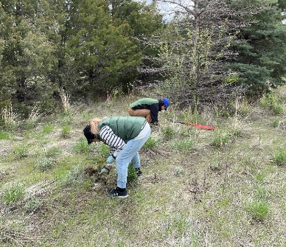
- May 23rd, 2025 – Grazing Training Billings
- May 28th, 2025 – Pollinator Fair Meeting 4H Building
- May 29th, 2025 – Bozeman Area Hydraulics Training
- June 16-20th, 2025 – Pollinator Week
- June 20th, 2025 – Pollinator Fair
- June 23rd – 25th, 2025 – MT Range Days
- June 26th, 2025 – Riparian Assessment Training
- July 24th, 2025 – Soil Your Undies Billings Public Library
- August 7th, 2025 – Bozeman Area New Practices Training
- August 14th, 2025 – CCA Training w/ Soil Acidity

Updates –
- April 30th, 2025 – Shane Burton, LaVerne Ivie, and Zoe Craft planted the remaining Blue Spruce trees from YCD’s Arbor Day event.
- May 1st, 2025 – Guthre Ziebarth & Zoe Craft hosted a booth for the city of Billings Arbor Day event in South Park this year. Had multiple schools attend despite a cooler rainy day.
- May 6th & 9th, 2025 – Willow Harvesting/Planting at Stoltz Ranch (Fly Creek) that Crystal White put together. Great attendance and support from local and area office staff to harvest, prepare, and plant willows along 1 mile of Fly Creek.
- People’s Garden Metra Park (photos from April 23rd, 2025)
  - They have been doing a lot of work to get things seeded out:
    - Western Sugar has a plot of wheat, barley, and sugar beets.
    - Grandpa’s Farm has a plot of pumpkins and corn.
    - They are hosting working days throughout the spring/summer if you are interested in helping!

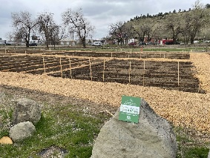
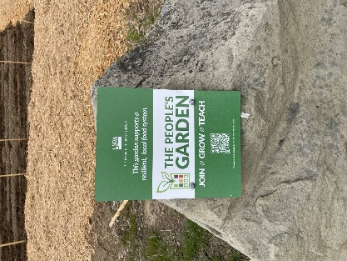



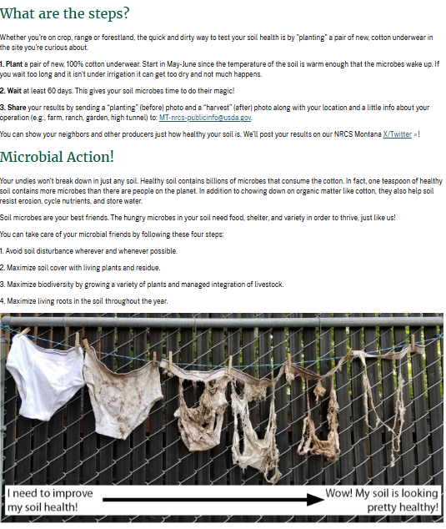
 It’s that time of year!!

