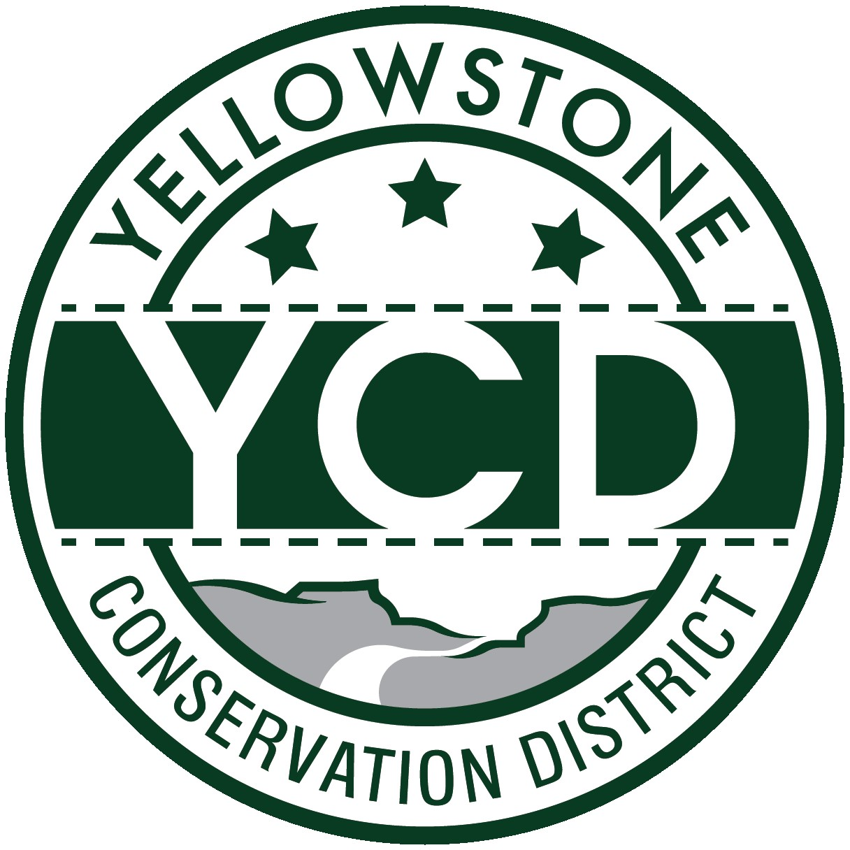 PO Box 80088, Billings MT 59108

YELLOWSTONE CONSERVATION DISTRICT 1670 48th St. W Suite 2 406.690.9326

yellowstoneconservationdistrict.org

YELLOWSTONE CONSERVATION DISTRICT BOARD MEETING
June/July meeting
AGENDA
July 22, 2025
YCD office, Suite #2, 1670 South 48th St. West, Billings, MT
9:30 a.m.

** 8:30 a.m. - Finance Committee will meet prior to the public meeting to conduct annual employee reviews and edit FY26 draft budget

- Call YCD board meeting to order – 9:30 am
- all issues will be addressed to the Chairman; public comments are always welcome but request that you wait until the issue is addressed on the agenda, asked to be recognized by the chair, and then limit comments to 3 minutes. No action will be taken on any item, not on the agenda. Attendees, please identify yourselves
- Agenda Changes
- Minutes Approval – May 21, 2025
- YCD Board member absences
- 310’s
  - Applications/Emergencies/Complaints/Work Completion forms
- YE-15-25 – Western Sugar Cooperative, Yellowstone River – 10 yr annual maintenance request to remove sediment and debris accumulation at existing water intake at pump house
- YE-27-22 - Gene Klamert – Time extension request for previously approved Yellowstone River riprap project
- YE-01-26 – Robert Castleberry – YR riprap maintenance
  - Other 310 Business & Committee Reports
- YR 310 tour
- Yellowstone River Conservation Districts Council – Leroy Gabel
- YCD/Agencies - supplementary information to agency reports received & provided to Supervisors before meeting
  - Administrator’s Report
  - YCD/PF Report
  - DNRC
  - FWP
  - NRCS
  - Yellowstone County
- Commissioners
- Extension
- Floodplain
- Weed District
- Business Meeting
  - Old Business
- Irrigation Leader Magazine interview – Gabel
- Annual Plan of Operations – Edit draft, finalize plan
  - New Business
- Future Land Use Map and Comprehensive Plan, Billings 2045 – YCD involvement?
- Evaluate PF/YCD Cooperative agreement & discuss extending through FY26 at current financial commitment or modify
  - Treasurer’s Report
- T-Report – May and June 2025
- FY26 YCD budget
- County Commissioners budget hearing report – Kraft, Ivie
- Consider recommendations of finance committee: employee compensation, additional edits and approval
- Dues and/or donation requests
- Travel and meetings approval
- Standing Committees/Programs
  - Westend Reservoirs – DNRC grant #RD-YCD-712 – grant extension request approved by DNRC for 2 years
  - Arbor Day & Lockwood FFA tree giveaway events – final reports
  - Pollinator Fair, June 20th - Crystal White & Jackie Haaland – final report
- Unscheduled matters
- PUBLIC COMMENT PERIOD – Any subject not on the agenda; discussion limited to 3 minutes
- Next meeting date
- Adjourn

