.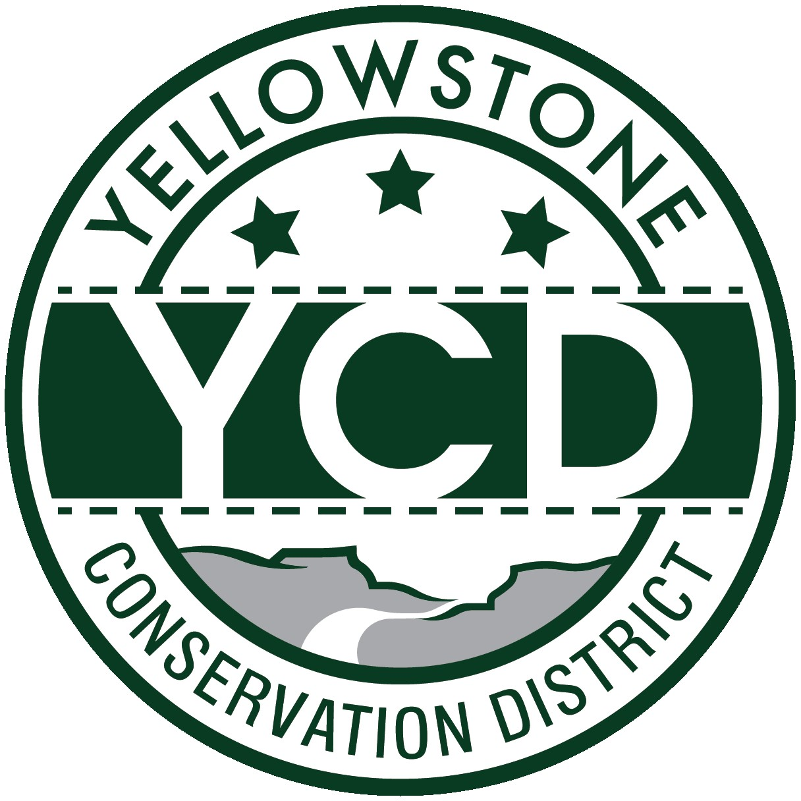 PO Box 80088, Billings MT 59108

YELLOWSTONE CONSERVATION DISTRICT 1670 48th St. W Suite 2 406.690.9326

yellowstoneconservationdistrict.org

YELLOWSTONE CONSERVATION DISTRICT BOARD MEETING
AGENDA
January 14, 2025
YCD office, Suite #2, 1670 South 48th St. West, Billings
1:00 pm

- Call meeting to order -- all issues will be addressed to the Chairman; public comments are always welcome but request that you wait until the issue is addressed on the agenda, asked to be recognized by the chair, and then limit comments to 3 minutes. No action will be taken on any item, not on the agenda.
- Agenda Changes
- 2025 YCD Board of Supervisors Oath of Office
- 2025 YCD Board of Supervisors election of officers
- Minutes Approval – November 20, 2024 and December 23, 2024 Conference call
- YCD Board member absences
- 310’s
  - Applications/Emergencies/Complaints/Work Completion forms
- Joy Stevens, Alkali Creek – Accept and/or discuss engineering design and feasibility
- YE-08-25 – Jim Hein, Yellowstone River riprap – sign 273
- YE-09-25 – Project Telephone Co. – multiple HDD sites in the Huntley area
- YE-10-25 – Edward Skierka, outside floodplain of Yellowstone River
- YE-11-25 – River Ranch Retreat, Yellowstone River riprap maintenance
- YE-22-44 – Briarwood Golf Course, Yellowstone River project completion form submitted
  - Other 310 Business & Committee Reports
- Yellowstone River Conservation Districts Council – Leroy Gabel
- YCD/Agencies - supplementary information to agency reports received & provided to Supervisors before meeting
  - Administrator’s Report
  - YCD/PF Report
  - DNRC
  - FWP
  - NRCS
  - Yellowstone County
- Extension
- Floodplain
- Weed District
- Business Meeting
  - Old Business
- Gallatin CD Resolution 24-01: As passed during the MACD convention
  - New Business
- Legislative Activities: Rotunda displays, Legislator Meet ‘n Greet – Helena – Jan. 23rd
- New equipment purchase – office cell phone
- 2025 Salt Cedar grant application support letter
  - Treasurer’s Report
- T-Report – November & December 2024
- Dues and/or donations
- Travel and meetings approval
- Standing Committees/Programs
  - City Lakes /Westend Reservoir – update – Stacey Robinson
  - Realtor Workshop update – January 28, 2025
- Unscheduled matters
- PUBLIC COMMENT PERIOD – Any subject not on the agenda; discussion limited to 3 minutes
- Next meeting date
- Adjourn

