Form 505 APPLICATION FOR EXTENSION OF TIME
YELLOWSTONE RIVER BASIN CONSERVATION DISTRICTS
2/96

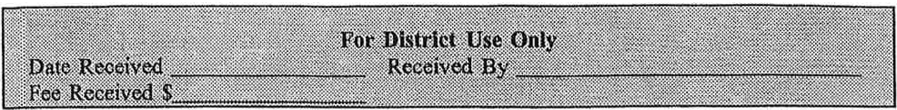

Please Print or Type:

1. Authorization Holder Name _ _ _ _ _ _ _ _ _ _ _ _ _ _ _ _ _ _ _ _ _ _ _ _ _
Authorization Number _
Mailing Address _ _ _ _ _ _ _ _ _ _ _ _ _ _ _ _ _ _ _ _ _ _ _ _ _ _ _ _ _
City or Town _ _ _ _ _ _ _ _ _ _ _ _ State Zip _

Home Phone (.,__
,)
Other Phone (....., _
_..,) _

- Reasons for Requesting Extension of Time:
D Insufficient funds, D Adverse Weather Conditions,

D Contractors Unavailable,

D Other (explain) _ _ _ _ _ _ _ _ _ _ _ _ _ _ _ _ _ _ _ _ _ _ _ _ _

- I hereby request the deadline for completion of my project to be extended to:

Month/Day,
-----Year

Signature Date

*************************************************************************************
CONSERVATION DISTRICT USE ONLY
D Approved, D Denied
(Chairman Signature) (Date)
Completion of Project Extended to: _ _ _ _ _ _ _ _ _ _ _ _ _ _ _ _ _ _ _ _ _ _ _
Notice of Completion of Water Development due: _ _ _ _ _ _ _ _ _ _ _ _ _ _ _ _ _ _ _

Comments: - - - - - - - - - - - - - - - - - - - - - - - - - - - - - - - - -

