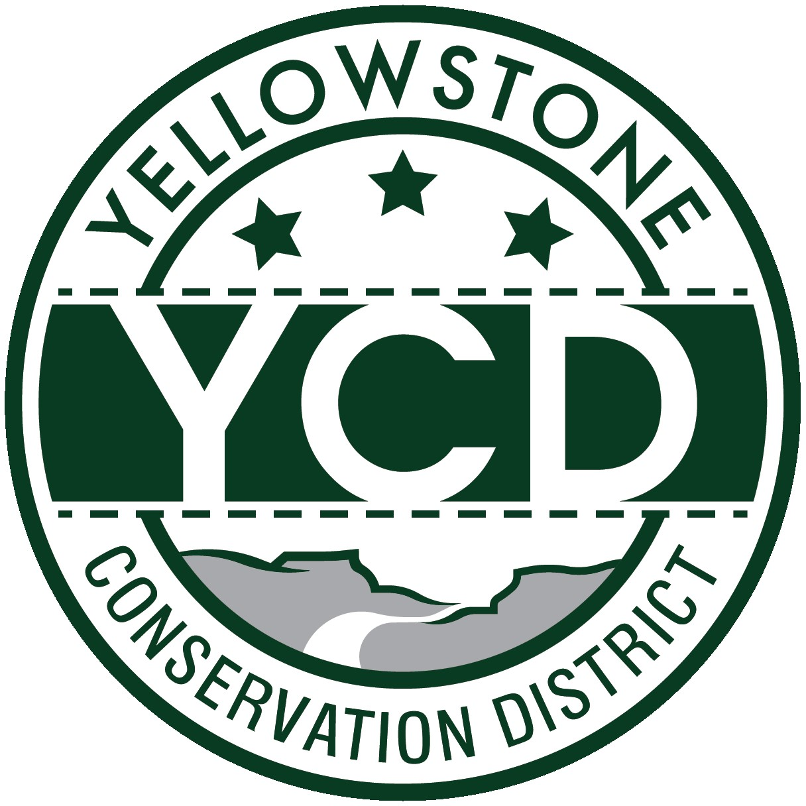YELLOWSTONE CONSERVATION DISTRICT 1670 48th St. W Suite 2, Billings, MT 59106

Phone: 406.690.9326 website: yellowstoneconservationdistrict.org PO Box 80088, Billings MT 59108

YELLOWSTONE CONSERVATION DISTRICT BOARD MEETING
AGENDA
January 9, 2024
Conference Room Suite #2, 1670 South 48th St. West Billings MT 59106
1:00 p.m.

- Call meeting to order -- all issues will be addressed to the Chairman; public comments are always welcome but request that you wait until the issue is addressed on the agenda, asked to be recognized by the chair, and then limit comments to 3 minutes. No action will be taken on any item, not on the agenda.
- Agenda Changes
- Minutes Approval – November 14, 2023
- YCD Board elections – open nominations
- Supervisors up for reelection in 2024 General Election
- 310’s
  - Applications/Emergencies/Complaints/Work Completion forms
- Joy Stevens, Alkali Creek – No current application but previous project is in violation status. Board action today: Review correspondence received relative to design status.
- YE-01-23-C -- Grayson violation, Clarks Fork River – violation remedial work completed
- YE-20-24 – Montana Rail Link – YR side channel restoration
- YE-21-24 – PAR Montana – YR boat ramp – updated design
- YE-22-24 Briarwood Golf Course – YR intake riprap maintenance
- YE-23-24 – Project Telephone Co., Pryor Creek -- HDD various locations
- Other updates
  - Other 310 Business & Committee Reports
- Yellowstone River Conservation Districts Council
- YCD/Agencies - supplementary information to agency reports received & provided to Supervisors prior to meeting
- Business Meeting
  - Old Business
- Supervisor ID forms
- YCD open house – consider rescheduling for spring?
- Realtor workshop
  - New Business
- YR Water Reservations workshop for upper and/or lower basin Yellowstone River CDs
  - Board member absences
  - Treasurer’s Report
- T-Report – November, December 2023
- Dues: Nile, Chamber of Commerce
- Travel and meetings approval
- Standing Committees/Programs
  - City Lakes /Westend Reservoir – update
  - Yellowstone CD Water Reservations – cancellation of 3 water reservations (property sold and new owners have not applied for a transfer when requested to do so)
- Unscheduled matters
- PUBLIC COMMENT PERIOD – Any subject not on the agenda; discussion limited to 3 minutes
- Next meeting date
- Adjourn

