.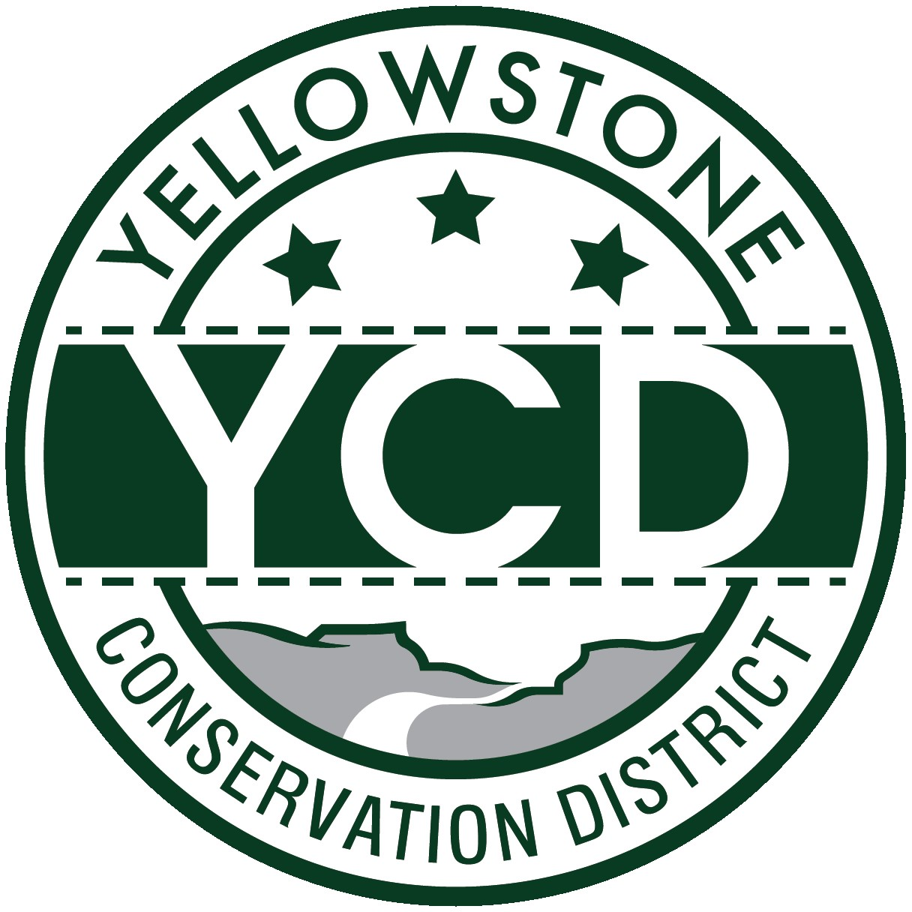 PO Box 80088, Billings MT 59108

YELLOWSTONE CONSERVATION DISTRICT 1670 48th St. W Suite 2 406.690.9326

yellowstoneconservationdistrict.org

YELLOWSTONE CONSERVATION DISTRICT BOARD MEETING
AGENDA
May 21, 2025
YCD office, Suite #2, 1670 South 48th St. West, Billings, MT
1:00 p.m.

- Call YCD board meeting to order
- Agenda Changes – move 310 agenda item Joy Stevens, Alkali Creek to a closed session to discuss litigation
- Close meeting to the public
- Open meeting to public – 1:30pm
- all issues will be addressed to the Chairman; public comments are always welcome but request that you wait until the issue is addressed on the agenda, asked to be recognized by the chair, and then limit comments to 3 minutes. No action will be taken on any item, not on the agenda. Attendees, please identify yourselves
- Oath of Office – Leroy Gabel
- Minutes Approval – April 8, 2025
- YCD Board member absences
- 310’s
  - Applications/Emergencies/Complaints/Work Completion forms
- Joy Stevens, Alkali Creek – Status update: Request for Judicial Review
- YE-14-25-E – Karen & George Yost, Canyon Creek
  - Other 310 Business & Committee Reports
- Yellowstone River Conservation Districts Council – Leroy Gabel
- YCD/Agencies - supplementary information to agency reports received & provided to Supervisors before meeting
  - Administrator’s Report
  - YCD/PF Report
  - DNRC
  - FWP
  - NRCS
  - Yellowstone County
- Commissioners
- Extension
- Floodplain
- Weed District
- Business Meeting
  - Old Business
- Legislature Session – SB472 final version
- Irrigation Leader Magazine – review draft interview - Gabel
  - New Business
- Grant Request from Rocky Mountain College for BBWA cleanup efforts
- Occupational Accident & Business travel insurance discussion
- New equipment: Discuss need for new printer
  - Treasurer’s Report
- T-Report – April 2025
- Dues and/or donation requests
- DNRC: Request 310 funds
- Travel and meetings approval
- Pollinator Workshop in Bozeman - Haaland
- Standing Committees/Programs
  - Westend Reservoirs – DNRC grant #RD-YCD-712 – discuss & approve time extension request
  - Arbor Day & Lockwood FFA tree giveaway events – final reports
  - Pollinator Fair, June 20th - Crystal White & Jackie Haaland
  - FY26 Annual Plan of Operations draft
- Unscheduled matters
- PUBLIC COMMENT PERIOD – Any subject not on the agenda; discussion limited to 3 minutes
- Next meeting date
- Adjourn

