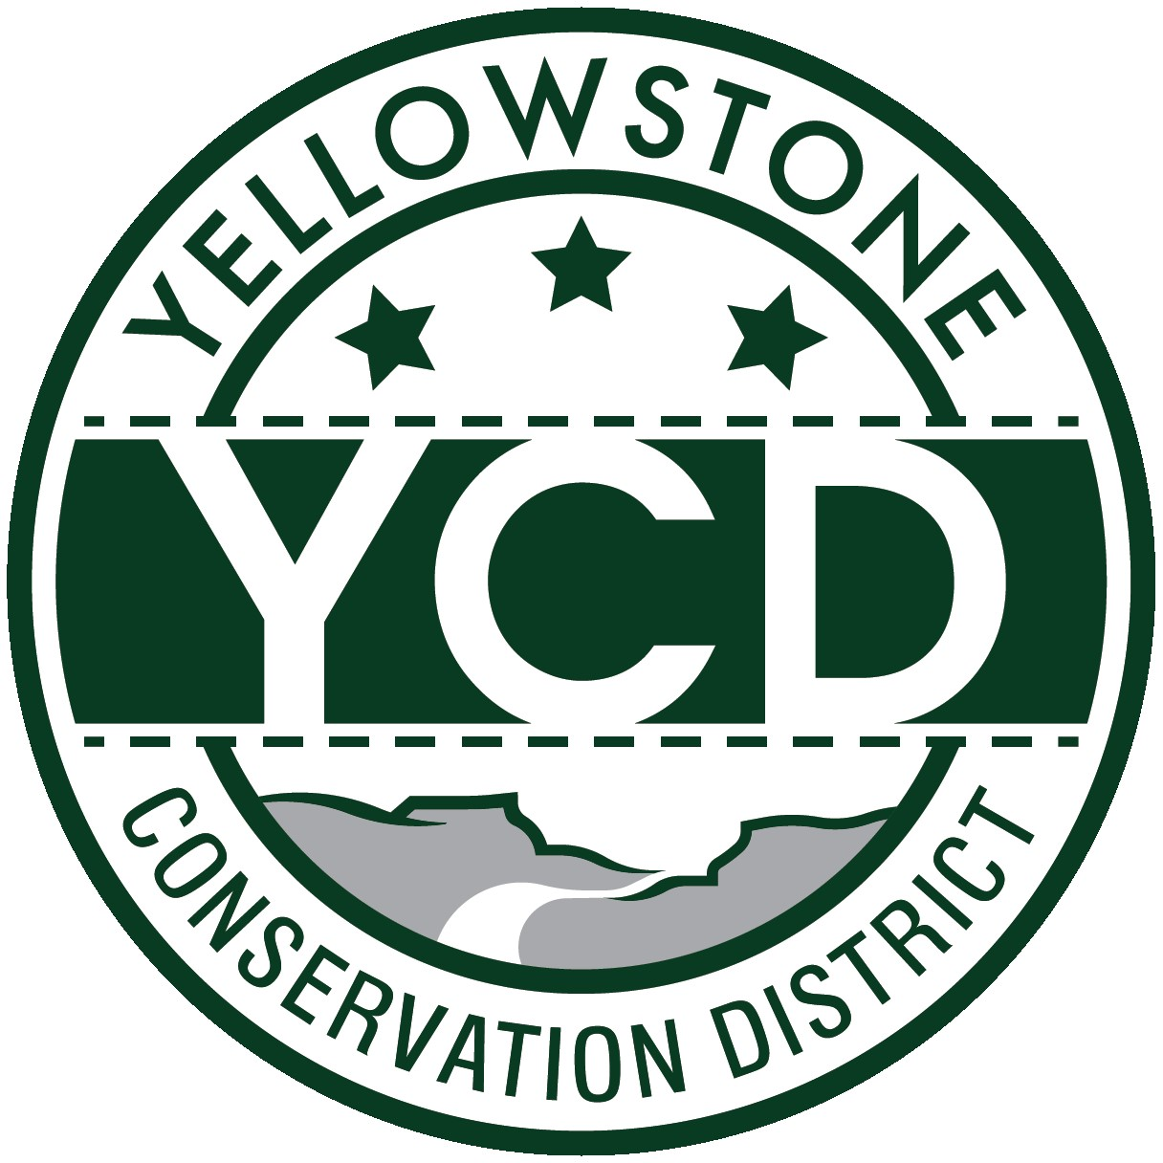YELLOWSTONE CONSERVATION DISTRICT

PO Box 80888, Billings MT 59108 1670 48th St. W Suite 2, Billings, MT 59106

Phone: 406.690.9326 email: livie@mt.gov

YELLOWSTONE CONSERVATION DISTRICT

May 21, 2024

May Board Meeting Minutes
1670 48th St. West Suite #2, Billings MT 59106
2:00 pm

BOARD MEMBERS PRESENT: Chad Sedgwick - Chair; Brad Kraft – Vice-Chair, Leroy Gabel, Jackie Haaland,
Bryan Mothershead Stacey Robinson

BOARD MEMBERS ABSENT: None

NON-BOARD PRESENT: LaVerne Ivie - YCD; Tim Miller & Ronni Tallerico – Yellowstone County Floodplain
Virtually: Demi Blythe - FWP
Public: Don Sasse

Chair Sedgwick called the meeting to order at 2:05 pm

Roll Call
After introductions, Chair Sedgwick informed attendees: All issues will be addressed to the Chair; public comments are always welcome
but ask that you wait until the issue is addressed on the agenda, ask to be recognized by the chair, and then limit comments to
3 minutes; no action will be taken on any item, not on the agenda. Attendees were reminded to sign the attendance sheet.

Agenda Changes: none

Minutes: Gabel made a motion to approve the April 23, 2024 Minutes as written, second by Robinson, motion passed.

Board member absences: None

YCD Supervisor Area 5: One (1) application was received to fill the vacancy. Mothershead made a motion to appoint Jackie Haaland to fill the vacancy that runs to Dec. 31, 2024, second to the motion by Gabel, the motion passed. Haaland will have the Oath of Office notarized and submitted to Yellowstone County Clerk and Recorder.

310’s
- Applications, Emergencies, Complaints & Violations:

- YE-11-22 Joy Stevens, Alkali Creek – On May 15, 2024, Gabel, Mothershead, Robinson, Ivie, & Attorney Steve Williams inspected the site with property owner Stevens and her contractor Jens. Stevens is still waiting for the Geo-Tech firm to carry out an initial site inspection that will hopefully be followed up by a report. Board discussion and decision today: Revisit at YCD’s June board meeting but remind Stevens to put pressure on the firm she hired to complete the report. Even though fines are accruing daily, Williams advises the board to not act on collecting until a geo-tech report and subsequent design are submitted, approved, and construction completed. At that time, the YCD board may reduce or eliminate the accrued fine total. The overall goal is for the project to be completed in a way that is best for the resource.
    - YE-31-24 – Par Rocky Mountain Midstream, LLC, Hogan’s Slough riprap project. Project completion form with before and after pictures was viewed by YCD board members. Kraft made a motion to accept the final report and consider the project complete, second by Robinson, motion passed.

Other 310 Issues & Projects
- Yellowstone River CD Council – Gabel reported the next council meeting will be held in Billings on June 3rd. In addition to Gabel’s attendance at the meeting, Beck will attend virtually in a coordinated effort with Dan Rostad to participate in the discussion regarding invasive woody plants and take an active role in the push to increase available funding in the Dept. of Ag Trust Fund program. Agency personnel will also be on hand to provide their perspectives and push for increasing the trust fund.

Agency Reports
- YCD Administrator Report – Report provided before today's meeting. No comments or questions were received.
- Army Corps of Engineers – unable to attend
- Beartooth RC&D – no current report
- DNRC – Mary Hendrix – report sent to YCD Supervisors before today’s meeting.
- Fish Wildlife and Parks – Demi Blythe
- Kids fishing days are happening at Lake Elmo
- The state Fisheries manager has been placed on administrative leave
- NRCS - The following Billings FO report was provided to YCD before the meeting and distributed by email.
FY24 EQIP/CSP Applications – The office received preapprovals for many of our applications for FY2024 projects and is working with applicants to finalize their contract documents. NRCS accepts applications anytime. Applications received from now until the next signup period will be considered for the FY2025 funding cycle.
Available fund pools for FY25 applications: Rooting for Soil Health TIP, Sage Grouse Initiative (SGI): Annual Invasive Grasses, Land Conversion, Woody Expansion, Riparian Degradation, Pivots for Pollinators TIP, Fly Creek TIP, Community Ag, Tribal, CSP Classic and Renewals
Other information included in the report: Personnel vacancies, training, and workshop sessions attended
- Yellowstone County
- Yellowstone Co. Extension – no report
- Billings/Yellowstone County Planning Board and City of Laurel Planning Board- Vacancy has not been filled.
- Yellowstone Co. Floodplain – Tim Miller & Ronni Tallerico office update: Hruska unauthorized concrete and other debris dumping in the YR floodplain is slowly being removed back further from the bank.
- Yellowstone Co. Weed Department – unable to attend the meeting. Supervisors instructed Ivie to contact the weed office and ask for a monthly report to keep YCD better informed.

BUSINESS MEETING

- Old Business –
- Supervisor ID cards – One of the work items not completed by former YCD employee is the Supervisor ID cards. Supervisors again signed the applications and updated their pictures -- Ivie will submit them to MT Counties.org.
- Consideration of YCD/PF cooperative employment partnership – Supervisors reviewed the final agreed-upon work parameters as drafted by PF and YCD. Gabel made a motion for YCD to enter into a contract with PF to hire Crystalina White as a contracted employee, second by Mothershead, motion passed. PF headquarters will draw up the contract and the board will sign at the June YCD board meeting.
- New Business
- MT Range Days camp – Huntley Project FFA has submitted a request for 5 student scholarships to attend the camp. Gabel made a motion for YCD to pay for registration by providing a $300 grant, second by Mothershead, motion passed.
- Letter of support request: The Billings Bench Water Association is submitting a Renewable Resource Grant application for the Rattlesnake Reservoir Diversion Upgrade and SCADA project. Robinson made a motion for YCD to sign and send a letter of support for the project, second by Kraft, motion passed. Yellows

- T-Report
- March T-Report: Kraft made a motion to accept the April Treasurer’s Report as written and reviewed, second by Mothershead, and the motion passed.
- Travel & Meetings – none

- Standing Committee Reports
- Yellowstone Conservation Area (aka West End Reservoirs/City Lakes) – Robinson reported the city has not contacted him with a timeline, which is not surprising because their current focus is on the new water treatment plant that is under construction on the southwest portion of the property.
- Arbor Day Tree Giveaway – A very successful day. People were lined up to get trees an hour before the original start time. When asked, Robinson encouraged the board to hold it on the Land Design grounds again. Next year we will tweak it by having more signs, traffic directors, and more trees because we ran out in 2 hrs.

- FY25 Annual Plan of Operations – Edits and additions were considered in the final draft and approved. Kraft made a motion to approve as edited today, second by Mothershead, motion passed. The full plan is included in these Minutes.
- Unscheduled Matters – The appreciation plaque that was ordered for Peck’s 10 years of service on the YCD board will be delivered this week

- Public comments – none

- Next YCD Board Meeting – Next YCD meeting will tentatively be held June 18, 2024

- Mothershead made a motion to adjourn at 3:17 pm

__________________________________________________________________________________________________
Chad Sedgwick, Chair LaVerne Ivie, YCD Administrator

YELLOWSTONE CONSERVATION DISTRICT

FY25 ANNUAL WORK PLAN

Conservation Districts are:
- Locally elected volunteers whose role is to oversee and positively affect natural resource management.
- The conduit for accessing federal dollars and technical assistance to make state dollars go farther.
- The voice for private lands that benefit our environment and our economy.
- Educate our state’s youth in understanding plant, animal, soil, and water resources and their relationships to each other and our communities.

This annual work plan was developed to provide financial, technical, and educational assistance to land users in the district and promote the proper management of soil and water resources. It is structured to bring resource allocation and decision-making to the local level thus ensuring solutions are tailored to specific needs. It is for helping the Yellowstone Conservation District meet its obligations promptly and will serve as a major guide through fiscal year 2025.

CONSERVATION ACTIVITY AREAS:

EDUCATION

NATURAL RESOURCES

DISTRICT MANAGEMENT

YELLOWSTONE CONSERVATION DISTRICT BOARD OF SUPERVISORS:
- CHAD SEDGWICK, CHAIR, ELECTED SUPERVISOR
- LEROY GABEL, ELECTED SUPERVISOR
- BRAD KRAFT, VICE-CHAIR, URBAN SUPERVISOR – LAUREL/BROADVIEW
- JACKIE HAALAND, ELECTED SUPERVISOR
- BRYAN MOTHERSHEAD, ELECTED SUPERVISOR
- STACEY ROBINSON, URBAN SUPERVISOR - BILLINGS

EMPLOYEES:
- LaVERNE IVIE, ADMINISTRATOR
- RAY BECK, PUBLIC POLICY SPECIALIST
- CRYSTAL WHITE – PROGRAM COORDINATOR, YCD/PHEASANTS FOREVER

CONSERVATION EDUCATION

PROMOTION OF AGRICULTURE IN MONTANA (Schools and General Public)
- Plan an agricultural public awareness campaign as issues arise by printing articles in the area media outlets, posting on the YCD website and social media accounts
- Make a financial contribution to Agriculture in MT Schools supporting the state bumper sticker contest

EDUCATION PROGRAMS at the NILE
- Coordinate and aid with partner agencies on station presentations which may include YCD’s stream table, NRCS soil tunnel, and weed education sessions
- Provide Conservation District recyclable bags to teachers filled with educational materials from each demonstration booth with emphasis on conservation/agriculture for 2200 4th graders during the 3-day event. Partial bussing sponsorship of the 4th grade Agriculture Education portion of the NILE program if budget allows

CONSERVATION CORPS DAY(S)
- Partner with Conservation Corps senior crews to carry out:
  - Living Snow Fence maintenance
- If a natural disaster happens in Yellowstone County, YCD will act as the liaison between landowners and government entities by providing educational materials and/or sponsoring grants to hire senior CC crews to rehabilitate lost natural resources.

CONSERVATION EDUCATION CENTER
- Support the mission of the Audubon Conservation Education Center and look for ways to cooperate on projects

CONSERVATION AT THE ZOO
- Promote viewing of the 223-grant-funded stream bank stabilization project by 310 applicants at Zoo MT
- Cooperate with Zoo officials on conservation projects
- Have the YCD program coordinator contact the Zoo and discuss creating a pheasant habitat education area

SCHOOL PROGRAMS
- Provide presentations to City, County, and Home schools with resource programs when requested
- Utilize the website conservation education request form to determine school needs/requests for conservation in Yellowstone Co. area schools/organizations possibly with Lewis & Clark Middle School teacher taking the lead
- Develop/enhance/increase Conservation Education programming including:
- Stream table/rolling river trailer – contact schools and set schedule
- Noxious Weeds – engaging students in habitat conservation
- Aquatic invasive Species Education/cleaning station demonstrations
- Continue encouraging and helping sponsor conservation education scholarships to natural resource camps as considered worthy
- Promote the Montana Envirothon program at the county level and continue to offer sponsorship of one team per county high school
- Continue sponsoring DNRC mini-grants
- Cooperate with city and county schools, and surrounding counties’ conservation field days by providing stream table and NRCS soil activities
- Offer natural resource scholarships as the budget allows
- Partner with Rocky Mountain College, MSU-B, MBMG, and Yellowstone County Weed District to provide stream table training, presentations at schools, and YCD outreach events
- Evaluate the feasibility of an added conservation day in the spring possibly at Zoo Montana

NATURAL RESOURCES

EROSION
- WATER
- Administer the Natural Streambed and Land Preservation Act (310 Law)
- Monitor incomplete permits, complaints, and repeated violators
- Post-project inspection by conducting a Yellowstone River tour
- Stream permitting mailing to landowners adjacent to perennial streams in Yellowstone County
- Support YCD playing an active role in conflict resolution between affected user groups and federal regulatory agencies
- WIND
- Address and work with parties concerned with erosion problems as needed

FOSSIL FUELS
- Support the coal industry in Colstrip and the State of Montana
- Encourage keeping current levels and/or increased production of Montana’s fossil fuels

LOCAL WORK GROUP
- Continue to cooperate with the Local Work Group for NRCS cost/share programs. Take an active role in identifying priority resource concerns and look for projects in the targeted areas
- Cooperate with conservation agencies to reinstate the Russian Olive Initiative in the NRCS cost/share program and add Salt Cedar as a cost/share program

RANGE
- Inform cooperators of the Rangeland Resource Loan Program
- Inform cooperators through the Extension and NRCS offices and the YCD website of the following:
- Total range acres in Yellowstone County, condition of the acres, and trend for range management

SMALL TRACT LAND OWNERSHIP
- Land Management
- Identify and educate the public on the following: Yellowstone River Recommended Practices and available equipment
- Continue to look for opportunities to educate small landowners living in urban settings on how to manage their private working lands and care for their resources
- Inform cooperators through the Extension and NRCS offices of various levels of land management available
- Backyard and Urban Conservation
- Continue promoting the program through media outlets, public meetings
- Promote native landscape information by acting as a conduit/liaison for the public to access information with agencies and other entities on specific problems
- Help sponsor a Rain Garden demonstration site possibly in the Laure or Broadview area
SPECIAL PROJECTS
- YELLOWSTONE RIVER CONSERVATION DISTRICTS COUNCIL
- 100% involvement with Yellowstone River Conservation Districts Council
- Provide technical and related support within available capability and established priorities
- Continue to support Council activities with Russian Olive & Salt Cedar eradication
- HECTOR PORTAGE PATH
- Check annually: sign condition in case of vandalism
3. URBAN CONSERVATION ISSUES
- Look for sites to install urban conservation projects in Billings, Laurel, and Broadview
- Take an active role in the City Reservoir conservation education component and assist the City of Billings with funding opportunities
- Lake Elmo
- AIS educational video – plan for distribution
NATURAL RESOURCES (continued)
4. HUNTLEY PROJECT IRRIGATION DISTRICT FISH PASSAGE
- Continue to monitor for fish species and fish usage
- Work with FWP to provide accurate fish counts to the public; help facilitate clearing the fish passage of debris buildup in conjunction with FWP
5. LANDOWNER WORKSHOPS/MEETINGS
1. Identify and plan pertinent and timely workshops throughout the county
- Pollinator workshop
- CE credit workshops for realtors
6. HB632 & NRCS’s Emergency Watershed Program – Appropriation of stimulus dollars to Montana entities (American Rescue Act)Assist Yellowstone County entities with eligibility criteria by being the liaison between the county and irrigation associations
7. WESTEND RESERVOIRS
- Administer DNRC grant to update the Master Plan Amenities and Conservation Layer
- Staff and board will work with the Legislature if funding opportunities arise

SOIL HEALTH
- Support and continue to provide soil health information to Yellowstone County landowners
- Plan and host Carbon Sequestration workshops as opportunities for landowners become available
- Work with and support the NRCS Soil Health program
  - Sponsor one or more demonstration sites through DNRC grant funding
  - Work with NRCS for a summer/fall tour of crops in Yellowstone County via a harvest workshop in the Broadview area
TREES
- LIVING SNOW FENCE
  - Ensure total maintenance of the Rehberg Living Snow Fence site by replacing trees in spring, mechanically tilling the site, needed fence repair, and working with the Yellowstone County Weed Department on weed control.
  - Schedule workday(s) for Conservation Corps if needed
- TREE PLANTING PROGRAM
- Work closely with the County Extension office for the expansion of tree plantings possibly through workshops, schools, and CRP
- Arbor Day Tree Give-a-Way program: Purchase trees and plan an event to provide trees to Yellowstone County residents including handouts with planting instructions and maintenance guidelines

WATER QUALITY/ QUANTITY
- NITRATES
- Support and actively participate with NRCS and Big Horn CD on the Implementation Plan for the Fly Creek watershed 2023 funding
- Address high nitrates and sulfates in the surface water
- Look for ways to develop off-stream stock water
- Offer agronomy practices upstream to treat water quality issues, and encourage use of RO systems
- Water quality monitoring on a consistent basis and a central compiling spot for those sample results
to then be analyzed
- Co-sponsor early fall workshop and training session
- SALINITY CONTROL
- Continue support of the Montana Salinity Control Association
- Continue to address Fly Creek salinity issues
- WATER QUANTITY
- Promote irrigation water management in Yellowstone County thru water measuring devices
- Aggressively promote off-stream storage in potential sites in the County (with an emphasis on the Westend Reservoir)
- Look for educational opportunities at the proposed West Billings Water Treatment Plant Water Learning Center
--Lay groundwork as it relates to funding water quality opportunities in cooperation with developers
- Actively pursue grants to augment funding
WATER RESERVATIONS
- Promote off-stream storage utilizing a portion of YCD reserved water right
- Continue to promote YCD’s reserved water to eligible irrigation projects

WEED CONTROL
- Cooperate with the Yellowstone County Weed Board and personnel in the Weed District
- Create a link in the YCD website for the salt cedar monitoring project in cooperation with RMC and the weed district

DISTRICT MANAGEMENT

BUDGET
- YCD budgets for the following programs as funds become available and at the discretion of the Board:
- MT Range Tour, Rocky Mountain College YR cleanup, YR Salt Cedar infestation
- Organization Dues: NACD; Soil & Water Conservation Society; Plant Materials Center; Beartooth RC&D; Billings Chamber of Commerce; Employees Association; NILE; Yellowstone River Parks Assoc.
- Legislative Session activities
- Develop a strategic plan to use as a major guide for YCD lobbyist and Yellowstone Co. Legislators
- YCD administers the following pass thru or YCD project grants
- DNRC - Mini Grants, 223. Renewable Resource Grants, Resource and Development Grants; AIS grant

COOPERATING AGENCIES and/or ORGANIZATIONS
- Montana Department of Natural Resources & Conservation
- National Association of Conservation Districts
- USDA Natural Resources & Conservation Service and Farm Service Agency
- Montana Department of Fish, Wildlife & Parks
- Yellowstone County Offices: Commissioners, , Weed Board, Floodplain, City/County Planning, Extension
- MT Association of Conservation Districts
- Billings Chamber of Commerce
- Beartooth RC&D
- Bureau of Mines & Geology
- FFA, 4-H Chapters and County Schools
- Ag in Montana Schools
- US Forest Service
- Montana Salinity Control Association
- Rocky Mountain College
- Montana State University – Billings
- NILE
- Yellowstone River Parks Association
- Yellowstone River Basin Water Reservation Council
- Yellowstone River Conservation Districts Council
- Review MOUs with the above agencies when applicable and check on updating the status

STATE COMMITTEES
- Support Future Fisheries Panel with special emphasis on Yellowstone County projects

PUBLIC AWARENESS
- Increase public relations efforts
- Update website weekly
- Post all Board meeting notices for public review
- Annual Plan distributed to all cooperating agencies
- Radio and television spots, news releases for special projects/tours, post on social media sites
- YCD information posted on the YRCDC, City of Billings and Yellowstone County websites
- YCD Stream Table available for educational training – promote/highlight public awareness

TRAVEL of SUPERVISORS and/or EMPLOYEES
Board members and employees attend County, State, Regional, and National meetings as budget allows

