.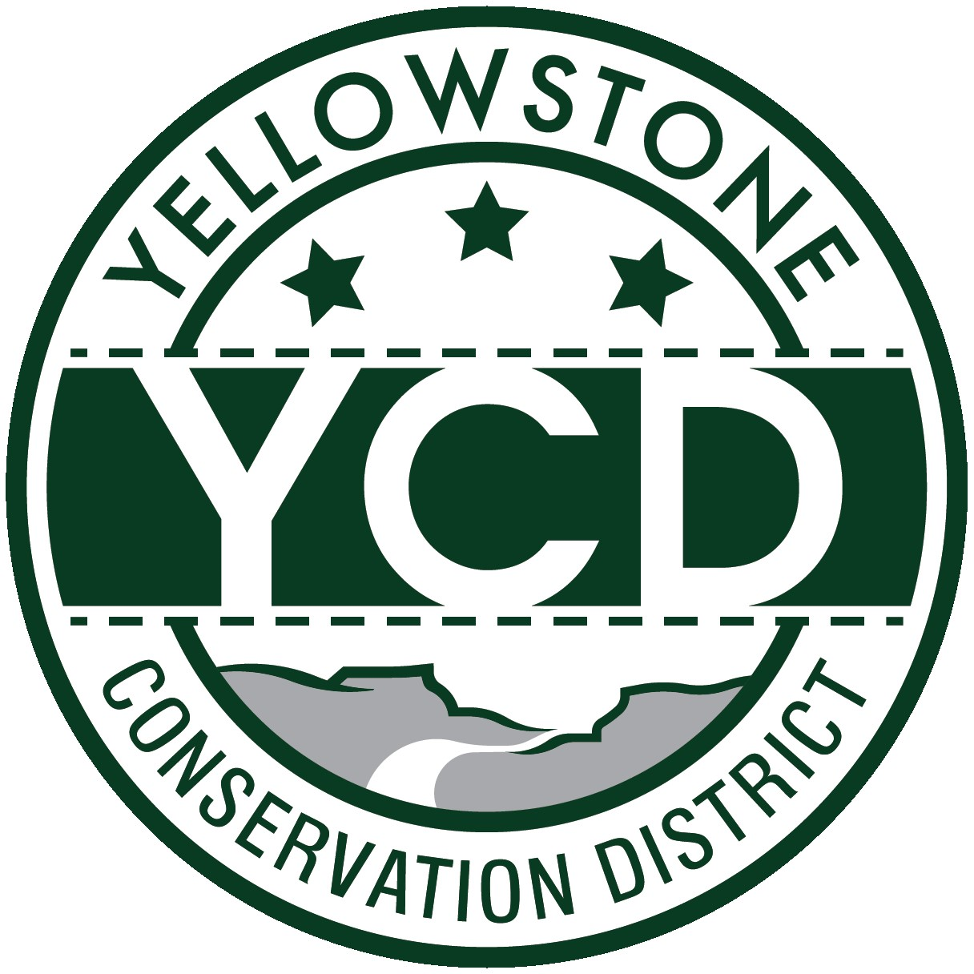 PO Box 80088, Billings MT 59108

YELLOWSTONE CONSERVATION DISTRICT 1670 48th St. W Suite 2 406.690.9326

yellowstoneconservationdistrict.org

YELLOWSTONE CONSERVATION DISTRICT BOARD MEETING
AGENDA
March 6, 2025
YCD office, Suite #2, 1670 South 48th St. West, Billings
1:00 pm – LOCAL WORK GROUP MEETING
2:00 pm – YCD Board meeting

1:00 pm -- Local Work Group meeting -- Assess Yellowstone County conservation needs; Identify priority resource concerns of the county; Identify high-priority areas needing assistance; Identify Natural Resources Conservation Service conservation practices

2:00 pm
- Call YCD board meeting to order -- all issues will be addressed to the Chairman; public comments are always welcome but request that you wait until the issue is addressed on the agenda, asked to be recognized by the chair, and then limit comments to 3 minutes. No action will be taken on any item, not on the agenda. Attendees please identify yourselves
- Agenda Changes – addition of Double L Ranch, LLC Yellowstone River Water Reservation application & BBWA letter of support
- Minutes Approval – January 14, 2025
- YCD Board member absences
- 310’s
  - Applications/Emergencies/Complaints/Work Completion forms
- Joy Stevens, Alkali Creek – Accept and/or discuss engineering design and feasibility & schedule onsite inspection
- YE-13-25 -- Northwestern Energy – North Fork of Alkali Creek – replace power poles
  - Other 310 Business & Committee Reports
- Yellowstone River Conservation Districts Council – Leroy Gabel
- YCD/Agencies - supplementary information to agency reports received & provided to Supervisors before meeting
  - Administrator’s Report
  - YCD/PF Report
  - DNRC
  - FWP
  - NRCS
  - Yellowstone County
  - - Extension - Floodplain
  - - Weed District
- Business Meeting
  - Old Business
- Realtor Workshop evaluation and plans going forward with additional realtor workshops
  - New Business
- A practical approach to stream permitting – ‘a dummy down version’ – Brad Kraft
- Support letter requests – 1) CEMIST grant application for an all-taxa Education and Outreach effort
2) BBWA – Jim Stott
- Legislature Session bills discussion
- Yellowstone River Reserved Water Reservation application – Double L Ranch, LLC – 3:00 p.m.
  - Treasurer’s Report
- T-Report – January & February, 2025
- Dues and/or donation requests: Chamber of Commerce, Beartooth RC&D, NACD (dues)
MT Forest products (donation)
- Travel and meetings approval
- Standing Committees/Programs
  - Westend Reservoirs – Land Design: presentation of finalized amenities mapping layer
  - Report: Soil Health Symposium – Bryan Mothershead
  - Arbor Day tree species discussion
- Unscheduled matters
- PUBLIC COMMENT PERIOD – Any subject not on the agenda; discussion limited to 3 minutes
- Next meeting date
- Adjourn

