Please have your registration in before MAY 15th
2022 COLORADO STATE
TAXIDERMY CHAMPIONSHIPS
REGISTRATION FORM

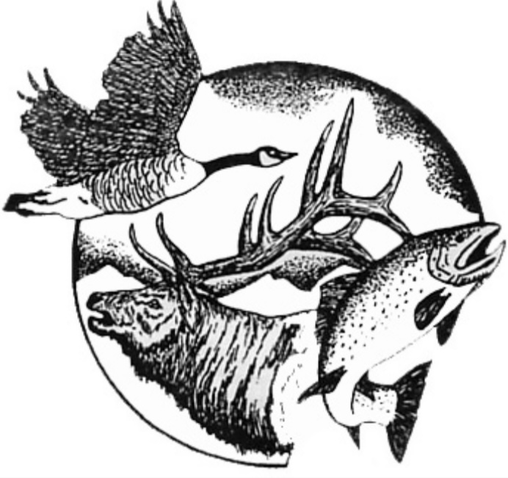
(DO NOT SEND PAYMENT, ALL FEES TO BE COLLECTED AT COMPETITION)
Name: _________________________________________________________________________________
Business: ______________________________________________________________________________
Address: _______________________________________________________________________________
City: _________________________________State: ____________________ Zip: ____________________
Phone: ______________________________ Email: ____________________________________________

CTA Membership (required by all competitors, unless already paid) $50.00 __________
Registration Fee includes 1 mount (after May 15th $90.00) $75.00 __________
Mounts (before May 15th) (# of) ___ mount(s) x $10.00 __________
Mounts (after May 15th) (# of) ___ mount(s) x $15.00 __________
Seminars: Competing Member & Immediate Family Member(s) $0.00 __________
Non-Competing Members (if 2022 membership fee is paid) $0.00 __________
Non-Member ($80/seminar) (# of) ___ seminars x $80.00 __________
Competitors Award (eligible if at least 4 mounts entered, 70% to winner) $10.00 __________
All Around Taxidermist (Bird, Fish, GH, LS – 70% to winner) $10.00 __________
Conservation Award (Any Category/Species: mount must have a story) $10.00 __________

Dinner will be a combination plate of Prime Rib and Chicken Marsala
Adults($38.00) Kids($15.00) (# of)___adults x $38 + (# of)___kids x $15 = __________
KIDS ENTRIES - FREE (Add another page if necessary for additional entries)
Name: ______________________________ Entry: ____________________________________
Name: ______________________________ Entry: ____________________________________

If you are entering anything into competition award, please indicate which 4 mounts you would like judged.

DIVISION CATEGORY SPECIES COMP AWARD SPECIFY
(EX: Professional GH/Antlered Deer X wall, table, floor)

If you are entering into competition for awards, please indicate which 4 mounts you would like to enter.
If you have more than four mounts, please mail registration to:
Cliff Carney || 121 E 12th St. Delta, CO 81416 (970) 234-0262 || cliffnttaxidermy@gmail.com

