**Averill Recreational Camp Owners, Inc**

**\*\*\*NOTICE OF ANNUAL MEETING\*\*\***

**PLACE OF MEETING:** Little Averill Boat Launch, Averill, VT

**DATE & TIME:** Saturday, August 1, 2020 at 10:00AM

**TYPE OF MEETING:** Regularly Scheduled Annual Meeting of the Membership

***NOTES:***

1. ***Action will be taken on all agenda items, unless otherwise noted.***
2. ***The agenda is a tentative schedule. The Board of Directors may act upon agenda items in a different order than is stated in this notice to affect the membership’s business in the most efficient manner possible.***
3. ***The Board of Directors may combine two or more agenda items for consideration, remove an item from the agenda, or delay discussion relating to an item on the agenda at any time.***
4. ***In the interest of time, the Board of Directors reserves the right to impose uniform time limits of not more than three minutes upon matters devoted to member comment.***
5. ***Voter registration is from 9:30 to 9:50AM. Tables will be set up and manned with volunteers to authenticate voters and to provide ballots and assigned proxies.***
6. ***Absentee voting for Directors to the Board will not be available. Voters must be present to vote on the slate of nominees.***
7. ***Proxy ballots have been included with the meeting packet.*** 
   1. ***Proxies are valid for August 1, 2020 Annual Meeting voting and only for those matters listed on the form.***
8. ***ARCO property owners in good standing are eligible to vote on all matters that come before the membership at the annual meeting.***
   1. ***Good standing means your current assessment and any interest charges, if accumulated, are paid prior to the annual meeting***
   2. ***One (1) vote per lot.***

To help prevent the spread of COVID-19, we strongly encourage the use of facial coverings. We will not be providing refreshments and encourage you to bring your own beverages and snacks. Also, please bring your own chair.

Contact ARCO Secretary Kimberly Hart with any questions.

Thank you,

Kimberly M Hart, ARCO Secretary

96 Hart Rd, Williamstown, VT 05679

(802) 272-5401 | kmhrrh@gmail.com

Enclosures:

• Copy of 2020 Annual Meeting Agenda

* Copy of 2019 Annual Meeting Minutes
* June 30, 2020 Balance Sheet
* 2019-2020 Monthly Financial Report

• 2020-21 ARCO Proposed Annual Budget

• Copy of ARCO Bylaws with proposed changes

• Copy of ARCO Rules, Regulations & Guidelines with proposed changes

• 2020 Annual Meeting Proxy Ballot

**ARCO 22nd Annual Meeting Agenda**

**August 1, 2020**

1. **Call to Order** Kim Lampert, President
2. **Pledge of Allegiance**
3. **Moment of silence** for those who have passed away since the August 2019 Annual Meeting
4. **Secretary’s Report** Kim Hart
5. **Treasurer’s Report** Kim Lampert
6. **Auditor’s Report** Audit Committee
7. **President’s Annual Report** Kim Lampert, President
8. **Old Business**
   1. Review and Adoption of Minutes: Minutes of the 2019 Annual Meeting
   2. Road Report: Kim Lampert
   3. Water Test Results on both wells: Peter Palmer
   4. Sustainable Harvesting & Maintenance Project
   5. Sheriff’s Contract
   6. District 7 Environmental Commission Complaint update: Kim Lampert
9. **New Business**
   1. Proposed 2020-2021 Annual Budget presentation: Kim Lampert
   2. Proposed 2020-2021 Annual Budget Vote
   3. Nominating Committee Report: Rowdy Doyon and Paul Perry
   4. Nominations and elections for 2020-2021 Nominating Committee
   5. Elections of Directors by ballot: 4 Directors for 2-year terms, 1 Director to complete remaining year of a 2-year term
   6. Proposed ARCO Bylaws amendment discussion, and vote*: Bylaws Committee
   7. Proposed ARCO Rules, Regulations & Guidelines amendment discussion, and vote*: Bylaws Committee
   8. Nominations and elections for 2020-2021 Audit Committee
   9. Election Results Announcement
10. **Meeting Adjournment**

*\*This will be a Yay or Nay vote. No revisions can be made and voted on during the meeting. Any revisions will need to be re-warned and presented to the membership for a re-vote.*

**ARCO NEWSLETTER**

**August 3, 2019**

**21st Annual Meeting Newsletter**

President – John Hull 802 371-7301 Vice President – Greg Blake 802 371-8659

Secretary – Donna Fuller 802 479-3191 Treasurer – Kimberly Lampert 802 228-4808

Director – Kimberly Hart 802 272-5401 Director- Missy Benson 802-558-4697

Director – Albie Borne 802 522-6129

ARCO Website – [www.arcoinc.org](http://www.arcoinc.org) Facebook - Averill Recreational Camp Owners Corporation

The 21st Annual ARCO meeting was held at the Little Averill Board Launch on August 3, 2019. The meeting was called to order by President John Hull at 10:11 a.m. The weather couldn’t have been better, and it was wonderful to see 45 enthusiastic camp owners in attendance.

President John Hull welcomed everyone to the annual meeting and wanted to thank the Board of Directors for all their hard work this year. He said that there is much work done behind the scenes and he appreciated the time and commitment that each member of the Board displayed.

Marion Gray, one of the first ARCO Board members, was in attendance and asked that she be allowed to speak regarding the ARCO Bylaws and Rules & Regulations. These were designed to cover all 140 members of ARCO and the Board of Directors is expected to follow them. It appears that there has been a decision by some board members that the Rules & Guidelines are no longer applicable and do not need to be followed. Some of the things being noticed is the high volume of proxies and this is a major voting issue. Proxies are not intended to be absentee ballots and there is a high degree of inconsistency. Some have been altered, some had names or signatures left off. Proxy use is governed by the Vermont State Statutes 11B regarding non-profit organizations. As agent for the Corporation, the Secretary is authorized to accept or reject any proxy that does not meet proper criteria. John thanked Marion for her comments and progressed with the meeting agenda.

John welcomed new owners, Daryl Johnson, Patrick and Sharon Ryan, Kim Hubbard, Jared Hart, Robert and Ann Marie McCallum, Tom and Mary Frazier, and Pete Whittemore. Welcome new ARCO members and thank you for attending our annual meeting.

John asked for a moment of silence for ARCO members who have passed and for their families.

**Secretary’s Report – Donna Fuller**

The warning letter for the annual meeting and the June BOD meeting minutes were mailed to all 140 ARCO members. It was pointed out that the last 34 copies that were printed had one page omitted in error by the printer. This impacted the annual meeting minutes from 2018. She apologized for any inconvenience. She requested that email addresses be sent to the ARCO Secretary as meeting minutes are no longer mailed in paper form; they are emailed and posted on the ARCO website. Paul Perry made a motion to accept the report and Harvey George seconded. Motion carried. Kim Lampert requested that all in attendance fill out the ARCO information sheet and be returned to her following the annual meeting.

**Treasurer’s Report – Kimberly Lampert**

Kim reported there are no outstanding bills at this time. Financial reports were forwarded to the membership in the meeting packets for review. ARCO has three accounts; a checking account, a savings account, and a money market account with a total of $34,834.58 in total assets showing on the balance sheet. There was discussion regarding Weyerhauser contributions and bill backs with how amounts were billed and paid. Weyerhauser donated gravel and donated four (4) culverts at a value of $2,000. Weyerhauser’s total donation was $6,300. Three (3) washouts were repaired with one requiring two (2) culverts. ARCO paid contractors for the replacement of these culverts and repairs to washout damage. Sue Lepine and Doug MacDonald requested that, in the future, road maintenance billing be broken down into line items so the membership can better understand what is billed and what is paid for.

ARCO received $1,000 from the State for the boat launch that was not shown as income for 2019 as it was received after June 30, which is the fiscal year end. It will be reflected in the 2020 Balance Sheet. Craig Wiggett made a motion to accept the Treasurer’s report, Daryl Johnson seconded. The motion carried.

**Auditor’s Report – Audit Committee**

Linda Daignault received and audited ARCO’s checking, savings and money market accounts on August 1, 2019 for 7/2018-6/2019 and found no discrepancies. At the time of the meeting a written report was not available, but was forwarded to the Secretary after the meeting.

**President’s Annual Report – John Hull, President**

The President’s Report was presented as follows:

*“Good Morning,*

*Welcome everyone to the ARCO annual meeting and I want to thank you for attending. I want to first thank the Board of Directors for all their hard work dedication and commitment to ARCO. It’s been quiet in the Averill’s this past year other than a few complaints on dog control. If you cannot talk to your neighbors and come to an agreement, I suggest you call the UTG as they have law to keep your animal under control at all times, it is not a leash law. I want to stress we are not a governing board. I want to thank all those that help keep the area picked up buy cutting trees and brush back from the roads and picking up trash left by others. Thank you all for attending and we will do our best to get you all out of here on time to enjoy your day.”*

The Sherriff has been in the ARCO area a lot lately. Not only are they in there on official business patrolling, they stop by if they are in the area. He contacted John on several occasions with findings on his patrols; chimney concerns, decks, and a vehicle that had been left for an extended period of time. Amy Perry had indicated that she had not received a card from the Sherriff in the last five years. She was concerned as they were stopped by the road waiting to get into their camp, the Sherriff drove by with a wave, but not stopping to inquire about why they were there. Donna Fuller stated how important it was for the Sherriff to go around the gate to check these camps as it is the perfect opportunity for thieves to access via boat or snowmobile if these camps aren’t also watched. All properties behind gates should be checked.

There were questions regarding ATVs and golf carts on ARCO and Weyerhauser roads. John stated that the use of these vehicles on ARCO roads was prohibited. A point was raised about the Sherriff stopping this activity and Marion Gray pointed out that this is trespassing on private property and should be treated that way. Another member raised a concern about minors operating these vehicles and who would be liable if there were an accident. John answered that it would be the owner of the golf cart, the owner of the vehicle and ARCO may be pulled into the incident.

**Unfinished Business**

**Road Commissioner’s Report – Patrick Kerin**

RoxAnn Labelle had a question regarding names of people who would be interested in plowing driveways. ARCO does have a list of people who bid last year on ARCO road plowing who may be interested in plowing driveways. Dale Gilman thanked Patrick Kerin for all his hard work on the roads this winter making it easy for him to access his camp all winter long.

**Water Test Results (both wells) – Patrick Kerin**

The wells on Hatchery Brook Rd and Point Rd both passed with the water being deemed as drinkable. While the water is drinkable, we keep the signs about water from the wells being non-potable as a protective measure.

**Common Land/Sustainable Harvesting & Maintenance – Patrick Kerin**

LandVest has promised this project will happen this year. It has been passed up in the past in favor of larger projects. The forest is ready to be managed. Doug McDonald asked when the cutting will begin and what will be taken. He feels LandVest will only take trees they can make money on. It will be a benefit for LandVest with only a small dollar value for ARCO. Patrick stated that ARCO will have the benefit of a managed, sustainable, healthy forest that will not die. Doug was concerned about the messes that loggers have made in the past. Danny Lepine stated there are concerns about downed trees in the event of a lightning strike and the potential for a forest fire. Danny Lepine asked a question about where the landing would be. Patrick explained that it would be on Hatchery Brook Rd near the Bjorkman camp. He’s not sure of the monetary value of the logging operation, but it is believed there will be some small amount of value to ARCO.

Ann Marie McCallum asked a question about the number of times the area had been logged. Patrick explained that the foresters have walked the area with him three times now, but no logging has been done yet. Marion Gray asked a question about the existence of a fully-negotiated contract with LandVest. Doug McDonald asked if the membership could get a copy of the contract once it is signed. John Hull stated that a copy will be made available on the ARCO website once a contract has been signed.

**New Business**

**Nominating Committee Report – Rowdy Doyon & Paul Perry**

Rowdy Doyon reported that there were three positions open for the upcoming Board with four people running; Kimberly Lampert, Patrick Kerin, Kimberly Hart, and Albie Borne. There were no nominations from the floor.

**Election of Directors by Ballot or Hands –** 3 Directors for 2-year terms

Election of Directors was held by ballot, not by hands, for the three open Director positions.

**Proposed 2019-2020 Annual Budget – Kimberly Lampert**

The proposed 2019-2020 annual budget was included in the annual meeting packet that was mailed out to all ARCO members. Proposed annual assessment was $380. Kim Hart presented changes to the budget as requested of her by Peggy Lajeunesse who could not attend the meeting to lower the proposed assessment to $350. Danny Lepine asked about the $525 assessment that included $20,000 for the widening of Cowan Rd. John Hull spoke about the concern for Cowan Rd camp owners to have access all winter. However, there were several people on Cowan Rd who expressed appreciation for the work that had been done with the ten loads of gravel, but felt that no further work was needed. As such, the decision for further activity on Cowan Rd was tabled and will not be pursued resulting in the $20,000 not being needed. This is why we weren’t voting on the budget resulting in a $525 annual assessment. A member asked that the boulders removed from Cowan Rd so that plowing could happen.

George Ackerson asked what it would cost to have someone other than Norm do the roads. Patrick stated that last year bids were received from three people that were within a few dollars of each other, with Norm being the lowest. Bids ranged from $120/mile to $122/mile for 6.5 miles plus the cost of sanding and the cost of winging snow banks.

Sue Lepine asked if Weyerhauser paid to plow the road. John explained that Weyerhauser plowed Jackson Rd to where the dumpster used to be when they were in the area. If they weren’t in the area when it snowed, Norm did it when we needed it. We have been told that Weyerhauser will be logging again this winter and our expectation is that they will plow again this coming winter. John was thankful that Weyerhauser was in there and expressed gratitude for the grader being there.

Craig Wiggett said there were 220” of snow that was not normal and that we can’t plan on that amount of snow fall next year. Marion Gray stated if we vote on this today (with Peggy Lajenuesses’ suggestions), that the Board has no authority to spend more for roads than is budgeted. Doug McDonald asked why we continue to budget for legal fees when we don’t use them and that although we budget for it, we don’t spend it and it goes back in to reserves. Patrick explained that the time could come that we would need legal. Doug also expressed that the Sherriff doesn’t do much, so why do we budget for that and expressed concern over the frequency of brush hogging and that he thinks it should be done every other year and not once a year. Alan Farmer expressed that he feels it should be done every year to keep brush from growing and impeding traffic flow and that if we do it every three years, it would cost more money to do it. Pete Whittemore said that if we don’t spend money on something, it doesn’t go away. If anything is currently in the budget for something, we should keep it.

Ann Marie McCallum suggested that we carry over the previous year’s budget amounts as we had a surplus of $3,328.64 that was added to the reserves. She also felt that $325 to $380 was a pretty big jump. We need a reduction [from what was proposed] and a slower increase in annual assessments. If we keep the upcoming budget level, then assessments would remain at $325 and we would still have money going into reserves. Kim Lampert expressed that it is the intent of the Board to always have one year’s budget in reserve.

Danny Lepine talked about the rate of increase in our property taxes along with an increase in annual assessments would create a hardship for those on fixed incomes. Another member spoke about the increase in annual assessments and that does impact those who are trying to keep their camps to pass down to their families. He agreed with Ann Marie that the budget, and therefore the annual assessment should remain flat. Marion asked a question about how money was credited to reserves and Kim Lampert explained how the remaining $3,328.64 from the 2018-2019 budget was placed into reserves.

**Proposed 2019-2020 Annual Budget Vote**

A motion was made to accept the budget as proposed, with a second. A hand vote voted the proposed budget down. A motion was made by Ann Marie McCallum and seconded by Craig Wiggett to keep the budget from level from 2018-2019 to 2019-2020 and therefore keep annual assessments also level at $325.

A question was asked about the use of proxy votes for the amended budget proposal. Marion read the following from the ARCO Bylaws; Article 7, Section 3 of the ARCO Bylaws state, “The members present at any annual or special meeting of the membership shall constitute a quorum. Any action, other than the amendment of these Bylaws, taken at an annual or special meeting shall require a simple majority vote of those present.” Marion explained that proxy votes could not be used as those members were not warned with the new budget amount.

A paper ballot vote was taken for the motion on the floor to keep the budget and annual assessment level. The final count in the votes cast for the budget resulting in a $325 annual assessment were 26 in favor and 19 against. The motion passed leaving the budget and annual assessments for 2019-2020 the same as the previous year.

**Election Results – John Hull, President**

Ballots were counted and the following members were elected to serve on the Board of Directors; Kimberly Lampert, Kimberly Hart, and Albie Borne.

**Nominations and Elections for 2019-2020 Nominating Committee**

John Hull commented that Rowdy Doyon and Paul Perry did a great job and asked if they would like to do it again. They accepted and will remain on the committee.

**Nominations and Elections for 2019-2020 Auditor’s Committee**

Amy Perry and Don Kline will serve on the Audit Committee for 2019-2020.

**Additional Business**

Jared Hart asked how to get a copy of the current ARCO Bylaws. Donna Fuller said she could send him an electronic copy, but Kim Lampert added that they are also available on the ARCO website. He agreed to get them there. Marion stated that the Rules & Regulations were never voted on to discontinue their use and should be posted on the ARCO site and included in all new member packets with the welcome letter and a copy of the Bylaws. She proposed a review of the Bylaws as there are some gaps that weren’t anticipated when they were first written.

Marion made a motion to have a committee to review the Bylaws. Seconded by Ann Marie McCallum. Marion was asked to serve as chairperson of a newly established Bylaws Committee and will serve on that committee with other volunteers, Ann Marie McCallum, Robert Grant and Rowdy Doyon. Rowdy suggested that term limits be considered as part of the Bylaws revision.

**Adjournment**

A motion was made Tonya Wheelock and was seconded by Gayle Ackerson to adjourn at 12:20PM.

***As a reminder, paper copies of meeting minutes are no longer being mailed. All minutes are sent via email and are posted on the ARCO website. If you wish to receive minutes by email, please contact ARCO Secretary, Kim Hart at*** [***kmhrrh@gmail.com***](mailto:kmhrrh@gmail.com)***, with your email address.***

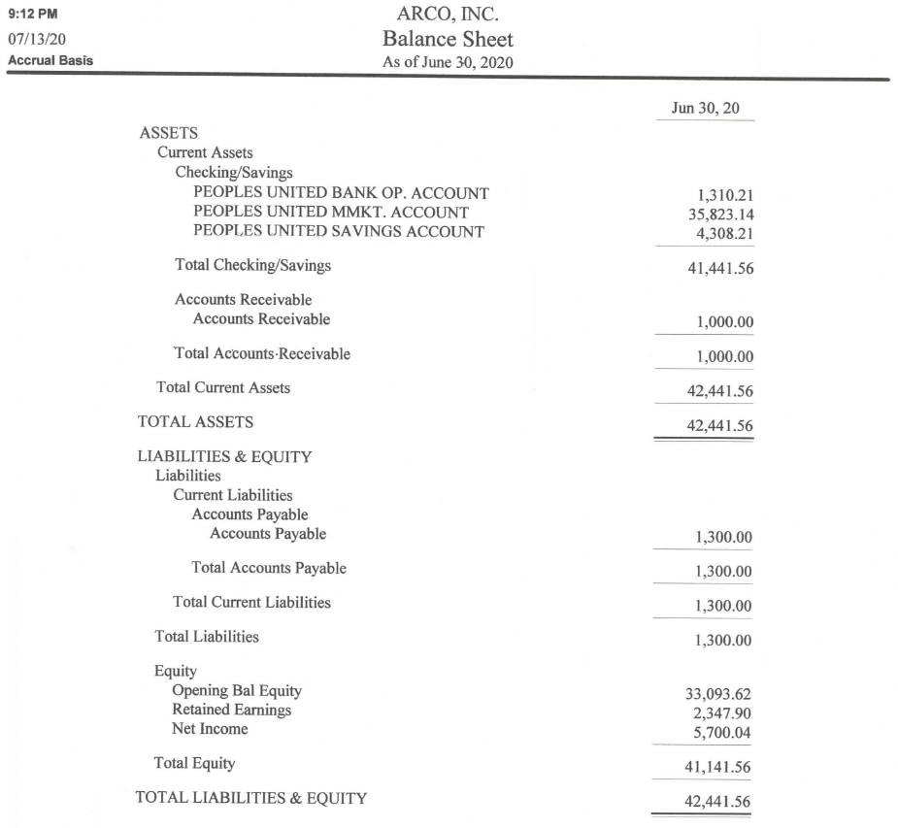

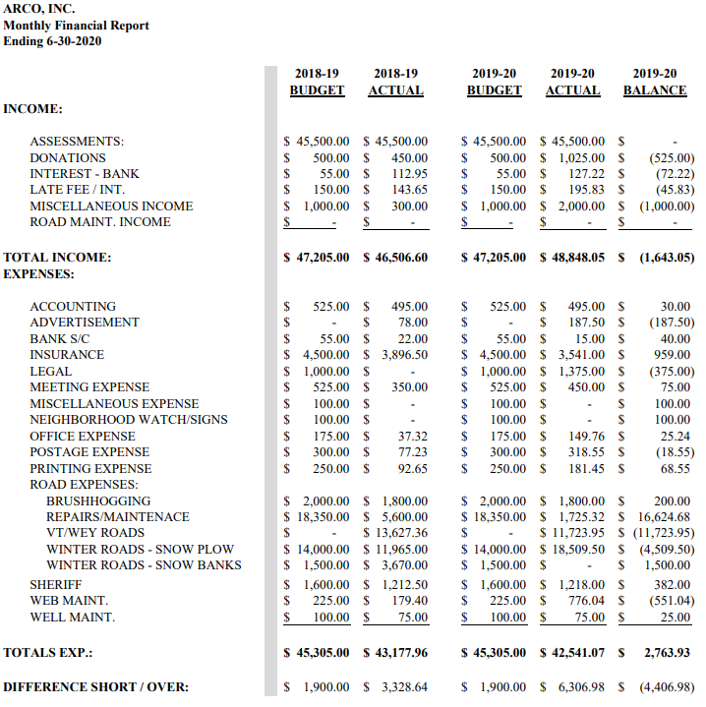

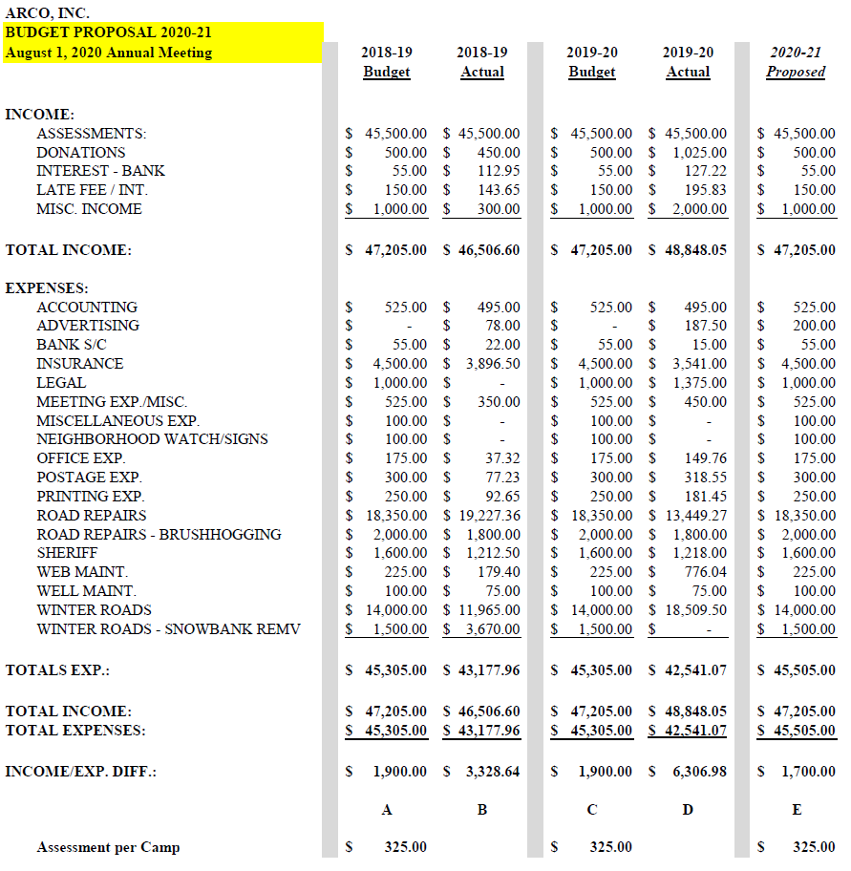

**BYLAWS**

**OF**

**Averill Recreational Camp Owners, Inc.**

Adopted May 30, 1999

Revised September 3, 2000

Revised September 2, 2001

Revised September 5, 2004

Revised August 31, 2008

Revised August 6, 2016

Revised August 1, 2020



**ARTICLE 1**

**PURPOSES AND NAME**

**SECTION 1. (PURPOSES) add**

The purpose of this member-benefit non-profit Corporation are to provide centralized representation to all the camp owners of those 140 lots, located in the unincorporated town of Averill, Vermont, conveyed to such owners or their predecessors by Champion Realty Corporation, and currently collectively known as "AVERILL RECREATIONAL CAMP OWNERS, INC." ("ARCO"), to provide continued management of the area known as the "common areas" as established by and in accordance with the grant of Champion Realty Corporation to the Corporation dated September 15, 2000 for the good of all the owners; to collect assessments as deemed necessary or appropriate for maintenance of the "common areas" to include but not limited to roads, water pumps, and beach areas; to procure general liability insurance as deemed necessary to appropriate to protect the Corporation and its members, to promote and preserve the integrity of the area as it now exists, in accordance with guidelines as were stipulated in the above-mentioned conveyances and prior lease agreements from Champion Realty Corporation; and to conduct any legal business that comes before the Corporation.

**SECTION 2. (NAME) add**

The name of this Corporation is "Averill Recreational Camp Owners, Inc."

**ARTICLE 2**

**MEMBERSHIP**

**SECTION 1. Membership (remove)**

The Corporation shall be a membership Corporation, with membership consisting of the owners of record of the ARCO lots.

**ARTICLE 3**

**BOARD OF DIRECTORS**

**SECTION 1. (BOARD) add**

The Corporation shall be managed by a Board of Directors consisting of a minimum of five (5) and a maximum of seven (7) members. All Directors must be members in good standing, with all assessments imposed by the Corporation paid in full. The Board of Directors shall have authority to manage the affairs of the Corporation in accordance with the Corporation's Articles of Incorporation, the Bylaws, and applicable rules, regulations, covenants, and laws. (ARCO Rules Regulations and Guidelines) Approved May 5, 2001 Amended September 2, 2001 (Add)

**SECTION 2. (DIRECTOR TERMS) add**

Directors shall be elected for two-year terms by the membership at annual meetings thereof. Directors may only hold office for three (3) consecutive terms (Add) After severance for one election cycle, members can run again and return to the Board.

**SECTION 3. (DIRECTOR ELECTIONS) add**

The Board of Directors shall elect from among its members a President, Vice President,

Secretary, and (add) Treasurer. and road commissioner (remove)

**SECTION 4. (BOARD QUORUM) add**

A simple majority of the Board of Directors shall constitute a quorum at any meeting of the Board of Directors.

**SECTION 5. (BOARD VACANCY) add**

A vacancy on the Board of Directors, unless such vacancy results in fewer than five (5) members, shall be filled by the membership at the next meeting thereof. If a vacancy on the Board of Directors’ results in fewer than five (5) members, the Board shall fill such vacancy with the (remove) an (add) appointee, serving only until the next meeting of the membership. Any successor elected by the membership shall serve for the unexpired term of his or her predecessor. At no time shall there be six (6) Directors as it creates an even number of Directors.

**ARTICLE 4**

**OFFICERS**

**SECTION 1. PRESIDENT**

The President shall be the chief executive officer of the Corporation in the management of its affairs. The president shall preside at all meeting(s) (add) of the Board(s) (remove) of Directors and the membership and perform such other duties as may be required under the laws of this state and the bylaws of the Corporation. The President shall be elected annually by the Board of Directors from among the Directors. In case of a vacancy in the office of President, the Board of Directors shall elect a President to hold office for the remainder of the un- (remove) expired term.

**SECTION 2. VICE PRESIDENT**

The Vice President shall assist the president in the performance of his/her (remove) their (add) duties and shall perform the duties of President during his/her (remove) their (add) absence or disability. The Vice President shall be elected by the Board of Directors from among the Directors. In the case of a vacancy in the office of Vice President, the Board of Directors shall elect a Vice President to hold office for the remainder of the unexpired term.

**SECTION 3. TREASURER**

The Treasurer shall maintain all accounts of the Corporation and have charge of its funds. The Treasurer shall keep all funds in such banks (remove)or banks as the Board of Directors may designate. The Board of Directors shall designate check signing authority in such manner as is appropriate. The Treasurer (add) shall keep correct books of account and shall make a report in detail to the Board of Directors and the membership at the annual meeting and at such other times as the Board of Directors shall require. The Treasurer shall file all appropriate annual reports, corporate, federal and state tax, to the respective agency (Add) The Treasurer shall be elected annually by the Board of Directors from among the Directors. In the case of a vacancy in the office of Treasurer, the Board of Directors shall elect a Treasurer to hold office for the remainder of the unexpired term.

**SECTION 4. SECRETARY**

The Secretary shall keep all records pertaining to the Corporation and shall record all votes and proceeding of the membership and Directors. It shall be the duty of the Secretary to give notice of all meetings to the membership and Board of Directors when notice is required for such meetings and to keep custody of the corporate records. The Secretary shall keep a book containing a record of the name of the members and their places or residences. This book shall always be open to the inspection of the membership. The Secretary shall be elected annually by the Board of Directors from among the Directors. In case of a vacancy in the office of Secretary, the Board of Directors shall elect a Secretary to hold office for the remainder of the unexpired term.

SECTION 5. ROAD COMMISSIONER (Remove as an Officer)

The Road Commissioner shall be appointed by Board of Directors from the membership, annually. (Add)

The Road Commissioner shall, in coordination with and assistance from the other officers, (remove) Board of Directors (Add) oversee the maintenance and improvements of the Corporation's roads in accordance with the budgets approved by the membership. The Road Commissioner shall be elected (Remove) appointed (Add) annually by the Board of Directors from the membership (Add) among the Directors (Remove). In case of a vacancy in the office of Road Commissioner, the Board of Directors shall elect (remove) appoint (ADD) a Road Commissioner to hold office for the remainder of the unexpired term.

**SECTION 6. OFFICER TERM LIMITS**

All terms of office (remove) as an Officer (Add) shall be for a period of one year or until a successor is elected.

**ARTICLE 5**

**AUDITORS**

**SECTION 1. (COMMITTEE) add**

At least two auditors shall be elected by the membership at each annual meeting. The auditors shall each be a member of the Corporation and shall serve for a term of one year.

**SECTION 2. (RESPONSIBILITIES) add**

It shall be the duty of the auditors to conduct an internal review of the accounts of the

Corporation and provide a report of such review to the Board of Directors upon its completion and to the membership at the annual meeting.

**ARTICLE 6**

**BUDGET AND ASSESSMENTS**

**SECTION 1. (BUDGET YEAR) add**

The fiscal and membership year of the Corporation shall be from July l to June 30.

**SECTION 2. (BUDGET) add**

The Board of Directors shall submit to the membership, at each annual membership meeting, a proposed budget of expenditures covering the total anticipated expenditures for the fiscal year. This budget shall be considered by the membership and may be approved with or without revision. It may be reviewed and subject to revision at any annual or (remove) special meeting of the membership thereafter. The officers and/or Board of Directors are prohibited from incurring any indebtedness beyond current cash assets without prior approval of the membership.

**SECTION 3. (ASSESSMENTS) add**

Assessments payable in equal amounts by each member shall be established by the Board of Directors each year to assure adequate funds for maintenance of the common areas. Such annual assessments shall be based upon a budget approved by the membership, voted on at an annual or special meeting. The Board of Directors may also establish, from time to time, special assessments to fund special projects as deemed necessary. Special project~~s~~ expenditures projected to cost more than $10,000. (Remove) shall require prior approval of the membership at an annual or special meeting thereof. Any special assessment shall be payable in equal amount(s) (add) by each member.

Annual and special assessments are due within thirty (30) (Add) days of invoice. Failure to pay any assessment, as and when due, may result in a judg(e)ment (Remove) lien being placed against the delinquent member's lot. Judg(e)ment (Remove) liens for unpaid assessments may be foreclosed under the laws of the State of Vermont and delinquent member shall be responsible for interest at the legal rate and all costs of collection, including reasonable attorney's fees incurred by the Corporation. A member not current with any annual or special assessment on the date of an annual or special meeting of the membership shall not be eligible to vote at such meeting.

**ARTICLE 7**

**MEETINGS / VOTE**

**SECTION 1. (ANNUAL MEETING) add**

The Annual Meeting of the membership shall be held on the first Saturday of August. Special meetings of the membership may be called by the President, the Board of Directors, or five (5) percent of the membership. All meetings must be held within the State of Vermont.

**SECTION 2. (MEETING WARNINGS) add**

Written notice of the place, day, hour and purposes of the annual meeting and all special meetings of the membership shall be prepared and distributed to the membership by the secretary at least fifteen (Add) (15) days prior to the meeting.

**SECTION 3. (MEETING QUORUM) add**

The members present at an annual or special meeting of the membership shall constitute a quorum. Any action, other than the amendment of these Bylaws taken at an annual or special meeting shall require a simple majority vote of those present. Jointly held lots must designate a representative for voting purposes.

**SECTION 4. PROXY VOTING**

Proxy voting by State of Vermont Statutes, limits Directors’ ability to vote by proxy in any matter. Further, no Director may vote proxy for any member of ARCO. New proxy forms for the purpose of Bylaw revision in 2020 shall read in part "the solicitation of proxies from voting members is prohibited". Solicited proxies will not be accepted. No voting interest as a member of ARCO, shall hold or exercise proxies for more than one voting member at any meeting of ARCO.

Following Bylaws and Rules, Regulations and Guidelines revisions (2020), proxies will no longer be accepted for voting purposes in any matter before the membership.

**ARTICLE 8**

**AMENDMENT OF BY~LAWS**

**(SECTION 1.) remove**

These bylaws may be altered, amended or repealed by a two-thirds vote of the membership present at any properly noticed (annual or) remove special meeting(s) remove of the membership.

**ARTICLE 9**

**MISCELLANEOUS**

**SECTION 1. (ITEMS NOT COVERED IN BYLAWS) add**

Any matter which may arise related to the governance or operation of the Corporation (that are) remove not covered by the Corporation's Articles of Incorporation or these Bylaws, shall be governed by Title 11B of the Vermont (State) Add Statutes Annotated, relating to non-profit Corporations.

**SECTION 2. (INDEMNIFICATION) add**

The Corporation shall indemnify and save harmless its Directors and Officers

from liability pursuant to and in accordance with the provisions of Title 11B of the Vermont (State) add Statutes Annotated.

Averill Recreational Camp Owners, Inc.

Rules, Regulations & Guidelines

**Adopted 05/27/2001**

**AMENDED September 2, 2001**

**REVISED August 1, 2020**

**INTRODUCTION**

For the benefit of ARCO members who may not be familiar with the history and current governance of the Averill Lakes area, the following information is provided.

All the land now owned by the ARCO membership was originally owned by Champion Realty Company (camp lots & common land) (,) (i)Remove. Individual lots were leased by campers from Champion Realty Company.

The maintenance of roads, water wells, etc., was the responsibility of Champion Realty Company- rules regarding use of camp lots and other lands were established by Champion in addition to local, state, and (national) Remove, (federal) ADD regulations as established.

An informal campers’ organization started talks with Champion for purchase of lots in 1994. As negotiations progressed, it became evident that a formal organization was needed to represent all campers in the buyout negotiations and also serve as a governance to oversee management of the area after the purchase was complete. A total of (142) Remove, add (140) camp lots and over 200 acres of common land were included in the buyout. Each camp owner paid a cost established by Champion, which included the camp lot and an equally prorated share of the common lands.

Therefore, ARCO (Averill Recreational Camp Owners) association was established in 1998 with approval of campers in attendance at the 1998 annual meeting. Each member of the seven (7) Add member Board of Directors was elected by the membership for staggering terms of 2 and 3 years.

ARCO derives its authority from a consensus of members in attendance at each annual meeting and from special meetings that may be held if necessary. All policy decisions and other matters carried out by ARCO are approved by the membership.

ARCO has the legal responsibilities that were approved by the membership and are included in the buyout (agreements) Remove (deeds) Add. They are as follows:

1. Required membership in ARCO by all lot owners
2. Management of the common lands (owned by members) Add
3. Management of the water wells (owned by members, located on common lands (Add)
4. Management of rubbish removal and dumpster) Remove, no longer provided
5. Maintenance of the roads owned by ARCO and those ARCO has deeded rights of way.
6. Establish an annual budget and annual fees to carry out the responsibilities of ARCO which includes costs for the above items and others as approved by the membership, such as liability insurance, snowplowing, postage, supplies, etc.
7. Establish and collect annual assessments based on the budget approved by members and prorated equally to all (campers) Remove (lot owners) Add
8. Administer rules and regulations as approved by the membership to carry out the responsibilities outlined above.
9. Authority to assess liens on camps delinquent in payment of assessments.

We encourage each ARCO member to become actively involved in activities and responsibilities required for (the) Add management of ARCO and this pristine part of Vermont

**RULES AND REGULATIONS FOR COMMON LANDS**

As indicated in the introduction, ARCO has legal responsibilities for management of common lands, roads, water wells, (rubbish removal) Remove, and others. These responsibilities require rules and regulations to protect all of our interests, as is the case in any jurisdiction where governance is required to protect the environment, individual members and the association. The rules and regulations are approved by the membership. It is the responsibility of all members to be familiar with, understand and abide by them.

**Rules and Regulations** pertaining to common lands, including Big Averill Beach, Little Averill boat access area, roads, water wells, and (rubbish removal) Remove:

1. In general, the use of common land other than foot traffic (or) Remove for recreational purposes, requires approval from the Board of Directors.
2. Removal, cutting or destruction of live trees, plants, shrubs, etc on common lands is prohibited.
3. No permanent construction, improvements, or fixtures of any type (is) Remove (are) ADD allowed on common land including roads.
4. No powered vehicles such as ATVs (All Terrain vehicles), UTV’s, golf carts unregistered vehicles, off highway recreation vehicles, dirt bikes, 3&4 wheelers, doodlebugs, or snowmobiles are permitted on any roads, rights of way or common lands. This is to prevent costly repairs to roads and environmental damage as well as for safety. (Snowmobiles are permitted on approved snowmobile trails)
5. Pollution of any source of water is prohibited, no drains, sewers or wastewater outlets shall empty on to the ground surface or into any lake, pond, bog, stream or other water source
6. No (private) Add water wells can be located, constructed, or operated on common land. (Our commonly held water wells are located on common lands)
7. No garbage or debris shall be disposed of on common lands, roads, and beach or fishing access areas.
8. Use of common lands, beach areas, roads etc., shall not be such as to constitute a nuisance or annoyance to others in the vicinity or cause a diminution of the value of property in the area. (Amended 9/02/01 to read: All dogs are to be on a leash and/or under the control of the owner at all times while on beach areas.)
9. No fires of any type are permitted on common lands.
10. No barriers, gates, etc., are allowed which would restrict access over roads, rights of way, or common land. (Except as stipulated in our deeds, by owners of roads for which we have only rights of way) Add
11. No signs or other displays are allowed within any of the roads, rights of way, or common lands. Temporary weekend function signs may be used; however, they must be removed within 24 hours after the function.
12. Corner posts and property pins indicating boundaries shall not be disturbed or removed.
13. Parking must be off the roadway so as to not obstruct traffic flow. (or Maintenance of the roadway) Add
14. All members are responsible to inform their invitees, guests, employees, and agents, of ARCO rules and regulations and insure that they abide by them when visiting.
15. Exceptions to some of the rules and regulations may be made by ARCO. The exceptions will generally be specific and short term only. Requests for exception to any rule must be made in writing to the Board of Directors 30 days prior to a scheduled meeting.
16. Members are responsible to ensure that any activity conducted by them or their legal guests, on common lands, roads, right of way, beaches, access areas, etc., are in compliance with ARCO rules, federal, state, county and local laws, ordinances and rules.

**RULES AND REGULATIONS PERTAINING TO PRIVATELY OWNED LOTS**

ARCO’s legal responsibilities relating to each member’s privately-owned lot is limited. The Board of Directors and membership are not inclined to manage the use of each member’s lot. The need to apply common sense in the use of each member’s lot is nevertheless obvious. For these reasons, the use of each member’s lot is based on a set of guidelines, which have been approved by the membership. Some legal responsibilities are required of ARCO and the membership as part of the (buyout agreements) Remove, deeds Add Other laws, rules and regulations have been in place for many years that do place restrictions on the use of privately-owned lots. Those are as follows:

1. Lots shall be limited to non-commercial and non-professional recreational purposes and is further limited to such uses so as to not conflict with any applicable local ordinances, federal, or state statutes, rules or regulations including without limitation, zoning ordinances and regulations.
2. Property owners shall not use the property as a year-round residence.
3. Owners shall not request any public or private utility to provide electrical, telephone, cable or television or other services to or on the property.
4. Corner posts and property pins indicating boundaries of each lot or the common lands may (not) Add be removed or disturbed.
5. Owners shall not pollute or create a source of pollution of any waters on or adjacent to the property. Existing toilet facilities and wastewater disposal systems must comply at all times with all federal, state, and local requirements. No drains, sewers, or wastewater outlets shall empty onto the surface of the ground or empty into any lake, pond, bog, or stream.
6. All water wells shall be located, constructed and operated on the lot in strict compliance with all applicable federal, state and local rules, regulations, statutes and ordinances.
7. Parking for each lot must be off the roadway as to not obstruct travel or maintenance of the roadway.
8. Owners have the right to remove trees from their lot in order to create a clearing thereon in which to perform any improvements on the property so long as owner’s removal of such trees, etc., does not cause waste upon the common land. Any other removal, cutting, or destruction of live trees, plants or shrub growth on their lot within 75 feet of any lake or stream is prohibited. Owner recognizes and acknowledges that state laws strictly regulate any shoreline alteration or improvements such as docks, piers, beaches, dredging or filling that could affect water quality or wildlife habitat.
9. Owners shall be familiar and fully comply with all federal, state and local statutes, rules and regulations relating to outdoor fires or burning of any type on the property and shall be familiar and fully comply with all hunting, fishing and other games laws applicable in the area in which the property is situated.
10. It will be the lot owner’s responsibility to inform their invitees, guests, employees and agents of the rules, regulations and guidelines and ask them to abide by them while visiting.
11. Solid wastes shall be deposited in municipal or other approved (not the dumpster) solid waste disposal areas. Solid wastes are items such as windows, scrap metal, old grills, iron pipes, toilets, appliances, etc.

**GUIDELINES FOR USE OF PRIVATELY-OWNED LOTS**

The following guidelines have been carefully developed, reviewed and approved by the membership in order to have consistency, safety, and proper maintenance of the aesthetics and general orderliness of the area.

1. Each lot owner is asked to work with ARCO and the other lot owners in maintaining the area as it has been for several years in the past. The past preservation of this area as a remote recreational camp area is what makes this spot so unique. It is important to notify the Board of Directors of violations of the bylaws, policies, procedures, and guidelines in an attempt to protect each ARCO member and the environment. Fires out of control can affect us all. Trash, when not disposed of property can affect us all. Abuses of the environment can affect us all. So, we need to work together to keep this beautiful corner of the world intact.
2. In order to prevent uncontrolled fires on our lots or common lands, any and all chimneys on the property shall be equipped with adequate spark arresters. The opening of any chimney shall be at least three feet (3’) horizontally and ten feet (10’) vertically from any overhanging tree or tree branches. Brush resulting from the clearing of any property shall not be piled upon adjacent lands or along bank of any stream or shore of any lake or pond. Owner acknowledges and agrees that the owner shall dispose of brush, by reduction to small size or chip form and scattering of residue over this lot, or by removal to an approved landfill
3. Owners shall keep their property neat and clean at all times and shall dispose of all garbage and debris by removing all such material from the property and properly disposing of same in accordance with applicable federal, state, county and local laws, rules and regulations. Solid wastes shall be deposited in municipal or other approved (not the dumpster) solid waste areas. Under no circumstances shall garbage, trash or any other waste be dumped into or otherwise disposed of on the common lands, in lakes, ponds, or streams or along any road.
4. The use of property by owner shall not be such as to constitute a nuisance or annoyance to other owners in the vicinity, or of such a nature as to cause a diminution in the value of the other property owners in the vicinity
5. The use of tents, campers, travel trailers or other types of recreational equipment on the property for permanent accommodations is discouraged. Owners may use such recreational equipment on the property during the period starting with spring opening of the roads to November 30 of each calendar year, providing that such equipment shall be removed from the property from December 1 until the spring opening of the roads, each calendar year. Temporary living quarters of any sort, including but not limited to trailers, and travel trailers are permitted only while permanent living quarters are being constructed and shall comply with all federal, state, and local statutes, rules, ordinances and regulations.
6. Please be considerate of your neighbors in running generators late at night or early in the morning. (Recommended hours are 7am to 10pm)
7. Owner(s) are responsible for all their invitees, guests, employees, or agents’ actions during their visit to the area. It will be the lot owner’s responsibility to inform their invitees, guests, employees, and agents of the rules, regulations and guidelines and ask them to abide by them while visiting.
8. For emergency purposes, it is suggested that each lot owner place a sign, with the assigned lot remove 911 add number, where clearly visible from the road. For aesthetic purposes, we suggest that sign size not be larger that Remove than Add 18” in length and 12” in height.

This form must be handwritten BY THE VOTING MEMBER ASSIGNING THE PROXY (not typed)

**PROXY FORM**

For ARCO Inc Annual Meeting August 1, 2020

I hereby authorize to serve as my proxy and to vote on my behalf at the ARCO Annual Meeting to be held on August 1, 2020.

This Proxy is valid for voting on the specific matters of:

ARCO Inc 2020-21 Annual Budget, as proposed

ARCO Inc Revision of Bylaws last revised August 6, 2016

ARCO Inc Revision of Rules, Regulations and Guidelines last revised September 2, 2001

A voting member wishing to vote at an Annual Meeting of ARCO via proxy shall designate a member from the membership of ARCO Inc. A voting member wishing to vote via proxy shall personally contact the member whom the voting member wishes to exercise the proxy and must complete the proxy form in its entirety. Failure by the member to sign the form and complete all sections by hand will invalidate the proxy. The duly executed hand written proxy form shall be mailed or emailed as a scanned document by the voting member or hand delivered to the Agent of the Corporation (ARCO Secretary). Proxy can also be accepted by the Agent of the Corporation (ARCO Secretary) via telephone call from the voting member assigning the proxy. Properly completed proxy forms must be received by the ARCO Secretary **no later than** **July 29, 2020.**

*NOTES: Proxies not returned to the Agent prior to the deadline will not be honored.*

*Hand-delivered proxies will NOT be accepted the day of the meeting.*

*Proxies cannot be used for Board member elections.*

A separate proxy form shall be completed for each ARCO Inc Annual/Special Meeting and valid for the designated time period stated on the proxy. The solicitation of proxies from voting members is prohibited. Solicited proxies will not be accepted. No voting interest shall hold or exercise proxies for more than one (1) voting member at any Annual/Special Meeting of ARCO Inc. ARCO Board members cannot serve as a proxy voter.

Your signature attests the above has been strictly followed.

Name E911#

Signature Date

Witness Signature Date