**Averill Recreational Camp Owners, Inc**

**\*\*\*NOTICE OF ANNUAL MEETING\*\*\***

**PLACE OF MEETING:** Little Averill Boat Launch, Averill, VT

**DATE & TIME:** Saturday, August 7, 2021 at 10:00AM

**TYPE OF MEETING:** Regularly Scheduled Annual Meeting of the Membership

***NOTES:***

1. ***Action will be taken on all agenda items, unless otherwise noted.***
2. ***The agenda is a tentative schedule. The Board of Directors may act upon agenda items in a different order than is stated in this notice to affect the membership’s business in the most efficient manner possible.***
3. ***The Board of Directors may combine two or more agenda items for consideration, remove an item from the agenda, or delay discussion relating to an item on the agenda at any time.***
4. ***In the interest of time, the Board of Directors reserves the right to impose uniform time limits of not more than three minutes upon matters devoted to member comment.***
5. ***Voter registration is from 9:30 to 9:50AM. Tables will be set up and manned with volunteers to authenticate voters and to provide ballots and assigned proxies.***
6. ***Absentee voting for Directors to the Board will not be available. Voters must be present to vote on the slate of nominees.***
7. ***Proxy ballots have been included with the meeting packet.*** 
   1. ***Proxies are valid for August 7, 2021 Annual Meeting voting and only for those matters listed on the form.***
8. ***ARCO property owners in good standing are eligible to vote on all matters that come before the membership at the annual meeting.***
   1. ***Good standing means your current assessment and any interest charges, if accumulated, are paid prior to the annual meeting***
   2. ***One (1) vote per lot.***

Please print your own copies of this warning and related documents; there will be no extra copies available at the meeting.

We will not be providing refreshments and encourage you to bring your own snacks. Also, please bring your own chair.

Contact ARCO Secretary Kimberly Hart with any questions.

Thank you,

Kimberly M Hart, ARCO Secretary

96 Hart Rd, Williamstown, VT 05679

(802) 272-5401 | kmhrrh@gmail.com

Enclosures:

• Copy of 2021 Annual Meeting Agenda

* Copy of 2020 Annual Meeting Minutes
* June 30, 2021 Balance Sheet
* 2020-2021 Monthly Financial Report

• 2021-2022 ARCO Proposed Annual Budget

• 2021 Annual Meeting Proxy Ballot

**ARCO 23rd Annual Meeting Agenda**

**August 7, 2021**

1. **Call to Order** Kim Lampert, President
2. **Pledge of Allegiance**
3. **Moment of silence** for those who have passed away since the August 2020 Annual Meeting
4. **Secretary’s Report** Kim Hart
5. **Treasurer’s Report** Kim Lampert
6. **Auditor’s Report** Audit Committee
7. **President’s Annual Report** Kim Lampert, President
8. **Road Report** Patrick Ryan
9. **Old Business**
   1. Review and Adoption of Minutes: Minutes of the 2020 Annual Meeting
   2. Water Test Results on both wells: Patrick Ryan
   3. Sheriff’s Contract
   4. District 7 Environmental Commission Complaint update: Kim Lampert
10. **New Business**
    1. Proposed 2021-2022 Annual Budget presentation: Kim Lampert
    2. Proposed 2021-2022 Annual Budget Vote
    3. Nominating Committee Report
    4. Nominations and Elections for 2021-2022 Nominating Committee
    5. Elections of Directors by ballot: 3 Directors for 2-year terms
    6. Nominations and elections for 2021-2022 Audit Committee
    7. Election Results Announcement
    8. Other new business
11. **Meeting Adjournment**

**ARCO NEWSLETTER**

**August 1, 2020**

**22nd Annual Meeting Newsletter**

Kimberly Lampert (802) 779-7194

Kimberly Hart (802) 272-5401

Jared Hart (802) 249-0586

Dale Gilman (802) 249-0655

Gregg Normandin (978) 270-1532

Lori Lockwood (205) 447-8408

Patrick Ryan (802) 334-5277

Vermont State Police, Derby - 802 334-8881 or call 911 Customs Point of Entry – Norton, VT 24/7 or call 911

Sheriff - Trevor Colby 802 676-3500 Facebook - Averill Recreational Camp Owners, Inc

Border Patrol – 800 689-3362 24/7 ARCO Website – [www.arcoinc.org](http://www.arcoinc.org)

The 22nd ARCO Annual Meeting was held at the Little Averill Board Launch on August 1, 2020.

The meeting was called to order by President Kim Lampert at 10:04AM. The weather was very pleasant and there were 61 members present using masks and practicing social distancing. Kim led members in the Pledge of Allegiance and asked for a moment of silence to honor those ARCO members, family and friends who passed away since our last meeting.

**Secretary’s Report – Kimberly Hart**

*All regular meeting minutes have been sent to the membership. The warning letter for the annual meeting was emailed to 124 voting members (five members own two lots) and mailed to 11 ARCO members who do not have an email address for on 7/15/2020. Included with the warning were eight (8) documents:*

* *Copy of 2020 Annual Meeting Agenda*
* *Copy of 2019 Annual Meeting Minutes*
* *June 30, 2020 Balance Sheet*
* *2019-2020 Monthly Financial Report*
* *2020-21 ARCO Proposed Annual Budget*
* *Copy of ARCO Bylaws with proposed changes*
* *Copy of ARCO Rules, Regulations & Guidelines with proposed changes*
* *2020 Annual Meeting Proxy Ballot*

*If a member wishes to update contact information, see me after the meeting and I’ll supply you with a Contact Information sheet.*

*We have been working to create a list of contractors and propane suppliers to include in our welcome packet for new owners. This list will be included in the minutes from this meeting for member reference. Email me if you think a provider should be added to the list and be sure to include their contact information.*

*Just a reminder that meeting minutes and other ARCO related documents are no longer sent via the postal service, they are emailed and posted on the ARCO website.*

*Respectfully submitted,*

*Kimberly Hart, ARCO Secretary*

**Treasurer’s Report – Kimberly Lampert**

Everyone was sent a copy of the Treasurer’s Report with the annual meeting minutes and it was reviewed by the membership. Mike Farmer asked about $1,000 outstanding from the State of Vermont for the Little Averill boat launch. Kim explained that we invoice the State that amount every year for maintenance of the boat launch and they have not yet paid it.

Duncan Hastings commented on the $41k in cash and asked if it was an undedicated balance. Kim explained it’s what we have in cash and that we do not have a dedicated account for reserves. It has always been the goal of the Board to keep one year’s budget in reserves for emergency purposes.

He recommended that we consider establishing a reserve fund and to report it back to the membership this way next year and suggested we have one open-ended reserve fund for unanticipated operating expenses. Kim explained that we previously had a CD that we cashed in to repair a road wash out in a prior year and that it was never re-established.

Pete Richardson motioned to discuss and approve. Melissa Benson seconded. The motion passed.

**Auditor’s Report – Audit Committee**

Linda Daigneault, Amy Perry and Don Klein served on the auditor’s committee. Linda and Amy sent individual messages to Kim Lampert with their findings and approval.

*From: Amy Perry, July 30, 2020*

*Subject: Re: ARCO Audit*

*I have reviewed the reports and back up material and do not find any discrepancies.*

*I will not be attending the meeting and since I am new to this process, I will defer to Linda to make the report.*

*Kind regards,*

*Amy*

*July 27, 2020*

*Arco Audit Report*

*I have received and audited Arco’s checking, savings, and MMA accounts on July 27, 2020, for 06/2019 through 06/2020 and there are no discrepancies.*

*Linda Daigneault*

Harvey George made a motion to accept, Craig Wiggett seconded. The motion was voted and passed.

**President’s Annual Report – Kim Lampert, President**

The President’s Report was presented as follows:

*Welcome to the 21st Annual ARCO membership meeting. I appreciate your attendance to this meeting. I hope you are all well and stay safe during this COVID-19 pandemic.*

*I would like to thank the current board of directors for their time and dedication to ARCO and its membership. The current board of directors consists of myself, Donna Fuller, Kim Hart, Jared Hart and Peter Palmer. Peter was unable to be with us today due to a knee surgery rescheduling on August 4, 2020. We wish you well Peter! Dale Gilman was recently appointed to the board.*

*We have had a very trying year but continue to strive for the benefit of the ARCO members.*

*Our long-time snowplow contractor and friend Norm Labrecque lost his battle with cancer recently. He will be missed by many.*

*The roads have been well-maintained as you can see. Road contractor Laurent Rancourt continues to work with the board and addresses issues as needed. Brush hogging has been completed. Water tests have been completed. The sheriff continues to monitor the ARCO area. They contact me directly with any issues found and I immediately contact the camp owners with any findings.*

*The Sandy Beach is always an important subject. It is crucial to remember that the beach property to the left is owned by ARCO members and the area to the right is owned by Quimby Country. I recently spoke with Gene Devlin from Quimby. He assures me that vehicles parked at ARCO’s private parking lot are not from Quimby. ARCO has vehicle stickers and it is heavily suggested that you have a sticker on your vehicle for identification. It is reminded that all items brought in must be brought back out by those using the beach. Glass is frowned upon at the beach area. If you see trash or issues of concern, please contact any board member.*

*Please also remember that all dogs are always required to be leashed. Please be mindful of generators. Suggested quiet hours are 11 p.m. to 7 a.m.*

*It is a requirement for any camp additions/renovations to contact the UTG directly for permits and zoning approval.*

*We have several new camp owners in ARCO and welcome them to the area.*

*I would like to thank the by-law committee, Marion Gray, Rowdy Doyon, Robert Grant and Anne McCallum for their time and dedication. I would also like to thank the auditor and nomination committees. Amy Perry, Linda Daigneault, Don Klein auditors; Rowdy Doyon and Paul Perry nominating committee.*

*I would like to thank Doug Fuller for helping maintain the well area and this area for the meeting and arranging the table set-up. I would also like to thank Danny Lepine and Pat Kerin for assistance with the road this past year. Their knowledge and time spent is appreciated.*

*Once again, thank you for taking time from your schedule to be here. Stay well and be safe.*

*Respectfully submitted, Kim Lampert, President*

Patrick Kerin was not in attendance, but the Board had a plaque to present to him for his many years of service to the ARCO Board and ARCO members. We will be sure he gets that later.

There were concerns about trash and other activities on Sandy Beach. Jim Clemons spoke and said It was discovered that the North Country Chamber of Commerce suggested in their newsletter and website that folks visit and enjoy a picnic on the beach. Quimby contacted President Kim Lampert and told her that they asked the Chamber to take this down and to print a retraction stating that there was an error and that Sandy Beach on Big Averill is private property. It is believed that outside folks are creating the issues that we are having on the beach. Jim was suggested that we may want to coordinate with Quimby to replace existing signage with more aggressive ones; larger print, etc.

Joe Martaniuk asked about the Sheriff patrolling the beach. Susan Sullivan suggested that it may be hard for the Sheriff to distinguish between ARCO and Quimby folks from others. Larry Larkin suggested we should remind everyone that you carry in and carry out and that we can’t rely on the Sheriff to ensure this happens.

**UNFINISHED BALANCE**

**2019 Annual Meeting Minutes – Kim Lampert, President**

**There was no discussion.** AnnMarie McCallum motioned to accept meeting minutes as presented with a second from Patrick Ryan. Motion was carried.

**Road Commissioner’s Report – Kim Lampert, President**

We continue to monitor and maintain the roads that lead to your camps to the best of our efforts. Our most recent maintenance includes the following:

27 loads of crushed gravel

2 culvert replacements

1 culvert reset

Grading, rock raking and calcium

Fall grading has been suggested by our current road contractor and will be scheduled accordingly. Snow plowing is always a struggle for the camp road. We will be putting the plowing out to bid soon and will decide from those received.

There are logging operations within the ARCO area as we speak, and we ask that you drive slowly as they have the right-of-way. Winter logging will be happening in the area as well.

As a reminder ATV’s/golf carts are only allowed on your camp property and are not allowed on the roads. We have had some concerns expressed with this issue regarding safety and legality.

At any time, members can contact any board member with any questions and concerns.

We thank Danny Lepine and Pat Kerin for their help with the road projects. We greatly appreciate their efforts.

**Water Test Results (both wells) – Kim Lampert, President**

Peter Palmer contacted Capital Wells and they came to do our tests. The wells on Hatchery Brook Rd and Point Rd both passed with the water being deemed as drinkable. Next year the testing costs will almost double. The Board feels we should stay with Capital as we have history with them. Costs will be taken into consideration in next year’s budget conversations.

**Forestation Project – Kim Lampert, President**

The forestation project that was discussed in prior year’s meetings has been tabled for the time being. The Board and members have a lot of unanswered questions and concerns. Kim invited members to reach out to the Board with their questions and concerns as well.

**Sheriff’s Report – Kim Lampert, President**

Terry Mitchell asked why we are seeing the Sheriff in ARCO on the weekends. Kim explained about an incident that happened during the Spring road closure and the Sheriff’s office investigated. The patrol on the weekend is a continuing concern.

Missy Benson expressed concern about paying for the patrol when we are in our camps on the weekends. Terry asked how much we pay per hour; $28. The contract ended June 30th and has not yet been renewed. The Board will discuss contact renewal at the first Board meeting after the Annual Meeting taking member concerns into consideration.

**District 7 Environmental Commission – Kim Lampert, President**

Kim explained that on August 2, 2019, the day before the annual meeting, the Board received a request for additional information from District 7 about several topics based on a complaint received at their office. The ARCO Board responded to the request for additional information on October 10, 2019. Members asked what the concerns were, and Kim read the message from District 7 and the Board’s reply to it (shown in italics below).

*ARCO, Inc.*

*Attn:      John Hull, President*

*Greg Blake, Vice President*

*Dear Mr. Hull and Mr. Blake,*

*I am writing to make you aware of a complaint that my office has received, and to request initial information.  The complainant reports land uses and requests Act 250 compliance review.  The reported activities of interest and concern to the complainant include:*

* *Year-round residency*
* *Road improvements (e.g. widening)*
* *Usage of ATVs and UTVs*

*I am writing to request that ARCO please provide answers to the following initial questions:*

1. *Is there any known occupancy of the ARCO recreational camps, by persons who have, or plan to, establish status as a resident, at their recreational camp?*
2. *Have any road improvements (e.g. widening, other) been completed, and are any road improvements currently planned?*
3. *Is ARCO allowing ATV and/or UTV use on the land that ARCO manages or is responsible for managing?  Is this activity occurring, and if so, where?*

*I understand that the annual meeting is tomorrow, hopefully this message reaches you in time to allow its consideration at the annual meeting.  Thank you in advance for your reply.  After I receive a reply, I will review some related Act 250 documents, and look forward to a continued dialogue about these questions.*

*Should you deem that this communication, in whole or in part, should have been directed to a different contact, please feel free to forward it, and let me know who the correct person is - thank you in advance.*

*I note that I am copying other ARCO officers that I identified via your website; an ANR Forests & Parks contact (Louis Bushey); the Act 250 State Coordinator (Aaron Brondyke), who has previously been involved in preliminary review of activities at the ARCO properties; and lastly, the UTG.*

*Again, thank you for your assistance, and please do not hesitate to contact me with any questions.*

*Sincerely,*

*Kirsten*

**ARCO’s Reply to the Inquiry**

*October 7, 2019*

*District 7 Environmental Commission*

*Attn: Kirsten Sultan, P. E., District Coordinator via email*

*Dear Ms. Sultan:*

*Please find below our response in reference to your email dated August 2, 2019 regarding a complaint received by your office.*

***1. Is there any known occupancy of the ARCO recreational camps, by persons who have, or plan to, establish status as a resident, at their recreational camp?***

*Our ARCO members are familiar with our bylaws, rules and regulations as well as their deeds. We currently know of a few situations where owners are claiming residency.*

***2. Have any road improvements (e.g. widening, other) been completed, and are any road improvements currently planned?***

*Most of the roads in the ARCO area are owned by the State and Weyerhauser. There are no current or future for road improvements.*

***3. Is ARCO allowing ATV and/or UTV use on the land that ARCO manages or is responsible for managing? Is this activity occurring, and if so, where?***

*ARCO rules and regulations for common lands list that no powered vehicles such as ATVs, unregistered vehicles, off-highway recreation vehicles, dirt bikes, three-and four-wheelers, doodlebugs, or snowmobiles are permitted on any roads, rights of ways or common lands.*

*ARCO has a contract with the Essex County Sheriff’s office to regularly patrol the roads in and around camps and common lands.*

*We look forward to working with you. In the meantime, please feel free to reach out with any questions you may have.*

*Regards,*

*Kimberly Lampert, President*

*ARCO, Inc.*

*cc: Aaron Brondyke, Agency of Natural Resources, Forest and Parks*

*cc: Louis Bushey, Act 250 State Coordinator*

*cc: UTG Board of Governors*

*cc: ARCO Board of Directors*

There was discussion and concern from the membership regarding the legality of camp owners using their camps as their primary residence as doing so violates deed restrictions and ARCO Rules, Regulations & Guidelines. Craig Wiggett pointed out that there are also property tax implications. The differences between 180-day occupancy restriction and residency were also discussed. Dale Gilman shared his experience with obtaining a wastewater permit for his camp where it states on the permit that his septic is approved for seasonal use only as an example.

Kim Lampert explained that the Board hired an attorney to help with clarifying the language in our deeds and interpret the restrictions in the documents associated with them. When we have a full understanding from the lawyer, it will be shared with the membership.

**NEW BUSINESS**

**Nominating Committee Report (Rowdy Doyon and Paul Perry)**

Neither Rowdy nor Paul were in attendance, however, there were five (5) people who volunteered to serve on the Board; Gregg Normandin, Dale Gilman, Patrick Ryan, Jared Hart, and Lori Lockwood.

**Election of Directors by Ballot**

4 Directors for 2-year terms, 1 Director to complete the remaining year of a two-year term

**Proposed 2019-2020 Annual Budget – Kimberly Lampert**

Discussion began with a motion from Missy Benson to not renew the Sheriff’s contract and remove that expense. Greg Normandin seconded. Darlene Gilman wanted to know what that does to people who do not come to camp every weekend. Dale Gilman proposed that we change the contract to a charge/visit as opposed to paying an hourly rate. Lori Lockwood agreed.

John Hull stated that people are here during the week and on the weekends. He thinks there are enough people here and we do neighborhood watch. Asked why we pay taxes for a sheriff and pay on a contract. Duncan Hastings noted that taxes do not pay for sheriff/law enforcement. Taxes pay for bailiffs; they do not contribute to county budget. Jared Hart felt that a sheriff’s patrol limited theft and damage. Diane Moore stated that it only costs each camp owner $11/month per camp to pay for a sheriff.

A hand vote was taken. 10 voted to remove the Sheriff’s contract from the budget, 26 voted in favor of keeping the Sheriff’s contract in the budget.

John Hull said that we do not have winter roads bids yet. He suggested we raise the assessment by $20/lot. He noted that we need culverts and grading and need to prepare for any unplanned expenses. Dale Gilman referred to what Duncan said about expenses.

There was discussion about exhausting last winter’s road budget. Jared Hart talked about how the contractor that was hired sanded and plowed when we only received a dusting. He believed the contractor was not working with the budget that he was given. That contractor also did not have the capability to wing banks back.

Duncan Hastings made a motion to increase the annual assessment from $325 to $350 and to dedicate the $25 increase to a reserve roads fund. Craig Wiggett commented that we already have reserves and the Board could make a judgement call to use them and why raise the dues.

Jim Clemons commented that there is an access easement and that ARCO needs to pursue more help from Weyerhauser and the State for the maintenance of Jackson Rd.

**Proposed 2020-2021 Annual Budget Vote**

A show of hands vote was taken on the motion to increase the annual assessment from $325 to $350 with $25 of that assessment to be placed in a roads reserve fund. 35 were in favor of the increase and 7 were against. The motion passed. The 2020-2021 annual assessment will be $350.

**Proposed Bylaws Amendments – Kim Lampert, President**

Most of the proposed Bylaws changes were grammatical. Jim Clemons stated his disappointment that there would be no proxy or absentee ballot voting. He noted that V. S. A. title 11A allows for proxy and absentee ballots. Duncan Hastings asked that we consider mail-in voting on public questions. George Ackerson commented that a 2/3 majority vote was needed to amend corporate documents, not a simple majority vote.

A hand vote was taken whether to accept changes or not. 8 were in favor of the changes, 33 were opposed, 1 abstained. Changes where defeated.

Jared Hart asked if the membership could address and vote on each individual change rather than an all-or-none approach. Duncan Hastings suggested to approach voting by article. Adam Spaulding asked if we should have a Special Meeting. (NOTE: The Board had scheduled a Special Meeting of the membership for June and it had to be cancelled due to COVID).

**Proposed ARCO Rules, Regulations & Guidelines Amendments – Kim Lampert, President**

A motion was made by Missy Benson to address these changes in the same fashion we’ll be addressing the Bylaws amendments. Linda Daigneault seconded the motion. A voice vote was taken, and the motion passed.

**Nominations and Elections for 2020-2021 Auditor’s Committee**

Linda Daigneault, Don Kline, and Amy Perry will be asked to serve again this year.

**Nominations and Elections for 2020-2021 Nominating Committee**

Rowdy Doyon and Paul Perry will not be serving on the Nominating Committee. This topic will be added to the first Board meeting’s agenda for discussion.

**Election Results – Kimberly Lampert, President**

Ballots were counted and the following members were elected to serve on the Board of Directors;

Gregg Normandin – 2-year term

Dale Gilman – 2-year term

Patrick Ryan – 2-year term

Jared Hart – 2-year term

Lori Lockwood – completing final year of a 2-year term

**ADDITIONAL BUSINESS**

Alan Farmer commented on the road closure notice being posted on public social media. ARCO is letting people outside of the membership that the road is closed so camps will be empty and that there may be valuables left behind. We will look at making the ARCO Facebook page and website private.

John Hull questioned an email that was sent without hiding email addresses. This was done in error and we apologize for that happening. We ask that members to please not use that information for email blasts or for addressing the membership. Concerns should be sent directly to the Board to be properly addressed and shared.

Martha Allen suggested we find ways to hold Board meetings electronically.

Linda Daigneault expressed concern over birch trees that are dead and pose a potential threat. The Board will investigate and determine appropriate action.

A concern was raised about the Hunting by Permission Only signs near the Hanging Rock path. Suggested that those be changed to Safety Zone. This topic will be added to an upcoming Board meeting agenda.

Members inquired about a list of local contractors and fuel providers. Below is the list we have currently. If you know of a business you believe should be included, please forward name and contact information to the ARCO Secretary at [kmhrrh@gmail.com](mailto:kmhrrh@gmail.com).

Propane providers:

|  |  |  |
| --- | --- | --- |
| Rhymes Propane & Oil | Lancaster, NH | (603) 788-4490 |
| Amerigas | Canaan, VT | (866) 243-5470 |
| Bourne’s Energy | Lyndonville, VT | (802) 626-9859 |
| Fred’s Propane & Heating Oil | Derby, VT | (802) 766-4949 |
| Lyndonville, VT | (802) 626-4588 |
| CN Brown | Colebrook, NH | (603) 237-5561 |
| Lancaster, NH | (603) 788-2012 |

Snow plowing contractors:

|  |  |  |
| --- | --- | --- |
| Garrett Graves  *(Norm Labrecque’ s son-in-law)* | Canaan, VT | (603) 331-1761 |
| Laurent Rancourt | W. Stewartstown, NH | (603) 246-7232 |
| James Belknap | W. Stewartstown, NH | (603) 246-7057 |
| Corey Rancloes | Columbia, NH | (603) 915-1464 |

**Adjournment**

At 12:03 Connie High made a motion to adjourn, Greg Blake seconded and the meeting adjourned.

***As a reminder, paper copies of meeting minutes are no longer being mailed. All minutes are sent via email and are posted on the ARCO website. If you wish to receive minutes by email, please contact ARCO Secretary, Kim Hart at*** [***kmhrrh@gmail.com***](mailto:kmhrrh@gmail.com)***, with your email address.***

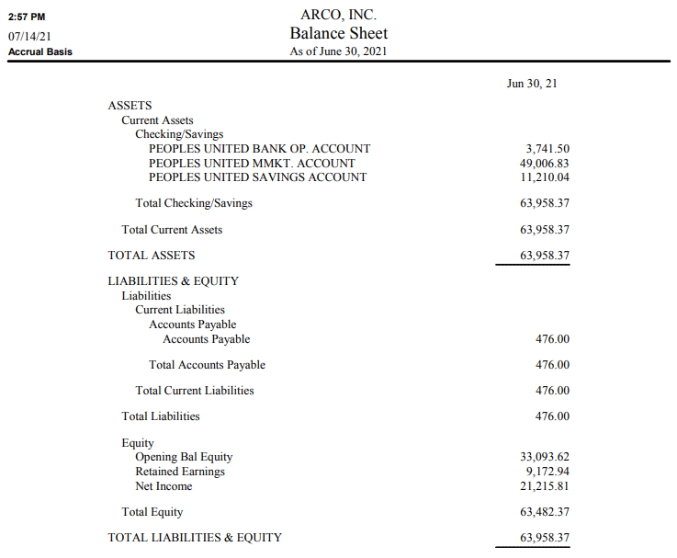

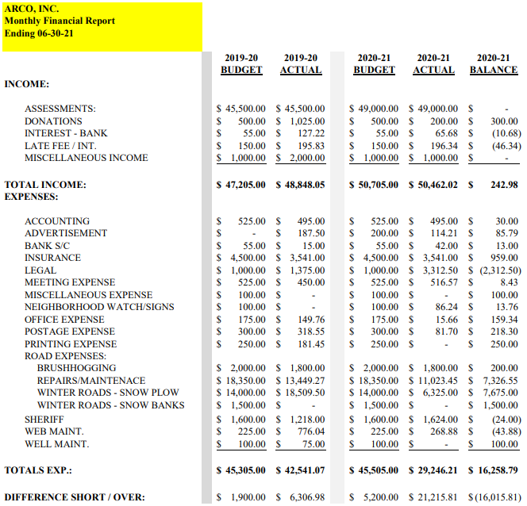

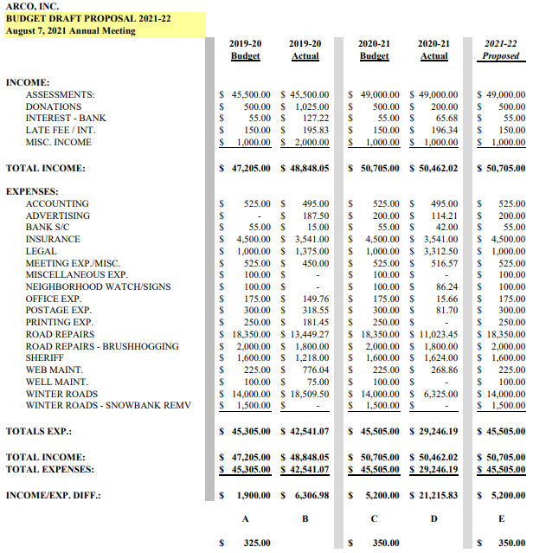

This form must be handwritten BY THE VOTING MEMBER ASSIGNING THE PROXY (not typed)

**PROXY FORM**

For ARCO Inc Annual Meeting August 7, 2021

I hereby authorize to serve as my proxy and to vote on my behalf at the ARCO Annual Meeting to be held on August 7, 2021.

This Proxy is valid for voting on the specific matters of ARCO Inc 2021-22 Annual Budget, as proposed

A voting member wishing to vote at an Annual Meeting of ARCO via proxy shall designate a member from the membership of ARCO Inc. A voting member wishing to vote via proxy shall personally contact the member whom the voting member wishes to exercise the proxy and must complete the proxy form in its entirety. Failure by the member to sign the form and complete all sections by hand will invalidate the proxy. The duly executed handwritten proxy form shall be mailed or emailed as a scanned document by the voting member or hand delivered to the Agent of the Corporation (ARCO Secretary). Proxy can also be accepted by the Agent of the Corporation (ARCO Secretary) via telephone call from the voting member assigning the proxy. Properly completed proxy forms must be received by the ARCO Secretary **no later than** **July 30, 2021.**

*NOTES: Proxies not returned to the Agent prior to the deadline will not be honored.*

*Hand-delivered proxies will NOT be accepted the day of the meeting.*

*Proxies cannot be used for Board member elections.*

A separate proxy form shall be completed for each ARCO Inc Annual/Special Meeting and valid for the designated time period stated on the proxy. The solicitation of proxies from voting members is prohibited. Solicited proxies will not be accepted. No voting interest shall hold or exercise proxies for more than one (1) voting member at any Annual/Special Meeting of ARCO Inc. ARCO Board members cannot serve as a proxy voter.

Your signature attests the above has been strictly followed.

Name E911#

Signature Date

Witness Signature Date