**Averill Recreational Camp Owners, Inc**

**\*\*\*NOTICE OF ANNUAL MEETING\*\*\***

**PLACE OF MEETING:** Little Averill Boat Launch, Averill, VT

**DATE & TIME:** Saturday, August 6, 2022 at 10:00AM

**TYPE OF MEETING:** Regularly Scheduled Annual Meeting of the Membership

***NOTES:***

1. ***Action will be taken on all agenda items, unless otherwise noted.***
2. ***The agenda is a tentative schedule. The Board of Directors may act upon agenda items in a different order than is stated in this notice to affect the membership’s business in the most efficient manner possible.***
3. ***The Board of Directors may combine two or more agenda items for consideration, remove an item from the agenda, or delay discussion relating to an item on the agenda at any time.***
4. ***In the interest of time, the Board of Directors reserves the right to impose uniform time limits of not more than three minutes upon matters devoted to member comment.***
5. ***Voter registration is from 9:30 to 9:50AM. Tables will be set up and manned with volunteers to authenticate voters and to provide ballots and assigned proxies.***
6. ***Absentee voting for Directors to the Board will not be available. Voters must be present to vote on the slate of nominees.***
7. ***Proxy ballots have been included with the meeting packet.*** 
   1. ***Proxies are valid for August 6, 2022 Annual Meeting voting and only for those matters listed on the form.***
8. ***ARCO property owners in good standing are eligible to vote on all matters that come before the membership at the annual meeting.***
   1. ***Good standing means your current assessment and any interest charges, if accumulated, are paid prior to the annual meeting***
   2. ***One (1) vote per lot.***

Please print your own copies of this warning and related documents; there will be no extra copies available at the meeting.

We will not be providing refreshments and encourage you to bring your own snacks. Also, please bring your own chair.

Thank you,

Kimberly M Hart, ARCO Secretary

96 Hart Rd, Williamstown, VT 05679

(802) 272-5401 | kmhrrh@gmail.com

Enclosures:

• Copy of 2022 Annual Meeting Agenda

* Copy of 2021 Annual Meeting Minutes
* June 30, 2022 Balance Sheet
* 2021-2022 Monthly Financial Report

• 2022-2023 ARCO Proposed Annual Budget

• 2022 Annual Meeting Proxy Ballot

**ARCO 24th Annual Meeting Agenda**

**August 6, 2022**

1. **Call to Order** Kim Lampert, President
2. **Pledge of Allegiance**
3. **Moment of silence** for those who have passed away since the August 2021 Annual Meeting
4. **Secretary’s Report** Kim Hart
5. **Treasurer’s Report** Kim Lampert
6. **Auditor’s Report** Audit Committee
7. **President’s Annual Report** Kim Lampert, President
8. **Road Report** Patrick Ryan
9. **Old Business**
   1. Review and Adoption of Minutes: Minutes of the 2021 Annual Meeting
   2. Water Test Results on both wells
   3. Sheriff’s Contract
   4. District 7 Environmental Commission Complaint update
10. **New Business**
    1. Proposed 2022-2023 Annual Budget presentation: Kim Lampert
    2. Proposed 2022-2023 Annual Budget Vote
    3. Nominating Committee Report
    4. Nominations and Elections for 2022-2023 Nominating Committee
    5. Elections of Directors by ballot: 4 Directors for 2-year terms
    6. Nominations and elections for 2022-2023 Audit Committee
    7. Election Results Announcement
    8. Other new business
11. **Meeting Adjournment**

**ARCO NEWSLETTER**

**August 7, 2021**

**23rd Annual Meeting Newsletter**

Kimberly Lampert (802) 779-7194

Kimberly Hart (802) 272-5401

Jared Hart (802) 249-0586

Dale Gilman (802) 249-0655

Gregg Normandin (978) 270-1532

Lori Lockwood (205) 447-8408

Patrick Ryan (802) 334-5277

Vermont State Police, Derby - 802 334-8881 or call 911

Sheriff - Trevor Colby 802 676-3500

Border Patrol – 800 689-3362 24/7

Customs Point of Entry – Norton, VT 24/7 or call 911

Facebook - Averill Recreational Camp Owners, Inc

ARCO Website – [www.arcoinc.org](http://www.arcoinc.org)

The 23rd ARCO Annual Meeting was held at the Little Averill Board Launch on August 7, 2021. There were 48 members present and the weather was pleasant with a nice breeze coming in off the lake.

The meeting was called to order by President Kim Lampert at 10:02AM. Kim led members in the Pledge of Allegiance and asked for a moment of silence to honor those ARCO members, family and friends who passed away since our last meeting.

**2021 ARCO Annual Meeting Secretary’s Report - Kimberly Hart**

*All regular meeting minutes have been sent to the membership. The warning letter for the annual meeting was emailed or mailed to all members 7/22/2021. Included with the warning were six (6) documents:*

* *Copy of 2021 Annual Meeting Agenda*
* *Copy of 2020 Annual Meeting Minutes*
* *June 30, 2021 Balance Sheet*
* *2020-2021 Monthly Financial Report*

*• 2021-2022 ARCO Proposed Annual Budget*

*• 2021 Annual Meeting Proxy Ballot*

*An ARCO Camp Owner Contact Information sheet was included in the packets mailed to members without email addresses. If you have had a change in address, phone number, email, etc., please see me after the meeting and I’ll supply you with a Contact Information sheet.*

*As a reminder, meeting minutes and other ARCO related documents are no longer sent via the postal service, they are emailed and posted on the ARCO website. So, if you want to receive newsletters and meeting minutes in your inbox, please be sure we have your email address.*

*Respectfully submitted,*

*Kimberly Hart, ARCO Secretary*

Motion to accept Dale Gilman, second from Terry Mitchell. No discussion. Motion passed.

**Treasurer’s Report – Kimberly Lampert**

Everyone was sent a copy of the Financial Report and Balance Sheet with the annual meeting minutes for review by the membership. Remaining accounts payable of $476 is for Sheriff’s invoice. Mike Farmer appreciated that the issue with QuickBooks had been found and corrected now making balances match.

Larry Blaney motioned to discuss. Jon Lampert seconded. The motion passed.

**Auditor’s Report – Don Klein**

Don received the materials in advance to perform the audit, but had not been allowed enough time to write the report. He did make a verbal report at the meeting indicating the books appear to be in good order with the exception of a minor discrepancy in expenses reporting of $140. Kim Lampert will research and resolve.

Missy Benson asked about there being more than one person on the Audit Committee; there are usually more. When we contacted the Audit Committee, Linda Daigneault had not received the reports in time to perform the audit, and Amy Perry said did not want to be on the Committee this year. Findings regarding the discrepancy will be provided to the membership.

Yvonne Rice made a motion to accept, Sonia Koehler seconded. Motion carried.

**President’s Annual Report – Kim Lampert, President**

*I would like to welcome you to the 23rd Annual ARCO membership meeting. I would like to thank each one of you for taking time from your busy life to attend this meeting. We all purchased our camps in this area for different reasons, but the beauty and isolation are two of the most common.*

*At this time, I would like to thank a few ARCO members for their assistance during this past year. Joe Martaniuk – thank you for your road updates; Danny Lepine and Pat Kerin – thank you for your road assistance when info was requested.*

*I would like to thank Mike farmer and donna fuller for stepping up to help with the nomination committee. And I would like to thank Linda Daigneault and don Kline for serving on the auditor committee.*

*We have had several properties sell within ARCO. Please stand and introduce yourself. Welcome to the area!*

*At this time, I would like to remind our memberships a few important issues.*

*Golf carts, 4 wheelers, off-road buggies are not permitted on any of the roads that travel to your camp properties.*

*Please remember the burning of all trees/brush requires a burh permit from the forest fire warden.*

*All dogs must be kept under the camp owner’s control. All dogs are to be leashed at all times when leaving your property. We have many little kids and adults walking or biking the rads within ARCO and their safety from dogs is extremely important. The Sandy Beach area on Beach Road is a private beach. Most of the area to the right of the path belongs to Quimby. ARCO owns the property to the left of the path. We continue to work with Quimby regarding the beach and any concerns that arise. Please remember glass is not permitted on the beach at any time. And please bring out what you bring to the beach.*

*The Little Avery boat launch area is owned by ARCO members directly. This area is designated for launching boats to the lake. Again, glass is frowned upon at this area also. No parking in the areas as marked and no overnight camping is allowed.*

*Please be mindful of generators. Quiet hours are form 11PM to 7AM.*

*The roads that lead to your camp property have again been maintained by Laurent Rancourt. He is always in contact with the board regarding any road issues, repairs or maintenance needed. He is a very honest man and looks out for the benefit of ARCO. If at any time you see any road issues, I as that you please contact Road Agent, Patrick Ryan or any board member.*

*The sheriff continues to patrol the ARCO area. They are under contract with ARCO annually and report any issues that need immediate attention to me directly.*

*For those who may be considering a building addition; please contact the UTG regarding a permit and zoning.*

*The ARCO BOD meets approximately 6 times per year plus the annual meeting. We try to meet in Averill but we did meet via Zoom this past year due to Covid-19. I would like to thank each board member for their time and efforts. We currently have a great board that works well together and is always willing to listen and help when asked.*

*Please refer to ARCO bylaws and ARCO rules and regulations for information that pertains to your camp property. Information is also listed on our web.*

*Please be advised that the ARCO web was down for several weeks. I had a very trying time with our host company with transitioning the domain from a personal account to a business account.*

*If at any time you have questions, please contact me or any board member. Our phone numbers are listed at the top of the newsletters that you receive via email. Info is also posted on the web.*

*I would again like to thank all of those who are attending here today, my board of directors and members who help us when asked. Stay safe and well my friends.*

*Respectfully submitted,*

*Kim Lampert*

*President*

Donna Fuller was not in attendance, but the Board had an engraved crystal vase and flowers to present to her for her many years of service to the ARCO Board and ARCO members. We will be sure she receives it.

**Road Commissioner’s Report – Patrick Ryan, Road Agent**

*We continue to monitor and maintain the roads that lead to your camps to the best of our efforts.*

*Our most recent maintenance included the following:*

*21 loads of crushed gravel*

*2 culvert replacements*

*1 culvert reset*

*Grading, rock raking and calcium*

*Fall grading will be completed by Weyerhauser and will be scheduled accordingly.*

*Snow plowing is always a struggle for the camp road. We will be putting the plowing out to bid soon and will make a decision from those received.*

*There is logging operations within ARCO we ask that you drive slowly as they have the right-of-way. Winter logging will be happening in the area as well.*

*As a reminder ATV’s/golf carts are only allowed on your camp property and are not allowed on the roads. We have had some concerns expressed with this issue regarding safety and legality.*

Patrick outlined logging operations that may happen this winter on Dale Potter Rd and out toward Forest Lake Rd. Jackson Rd will not be used for access or logging operations.

Two culverts that were replaced were on Loop Rd before the Jello Shot camp. Brush hogging was done for about 35 hours work.

John Hull asked if Weyerhauser contributed toward any loads of gravel this year as had been done in previous years. Patrick had asked and Weyerhauser told him that they wouldn’t as they feel it necessary as they only minimally maintain the roads. What they would have done is what ARCO did, and that is to grade it. Because Weyerhauser pulled equipment out prior to grading roads last Fall, they will do that grading this Fall. Patrick will ask if Weyerhauser will do all roads and not just Jackson and Hatchery Brook. They will repair the damage they did with log trucks and replace two culverts this Fall when they do the grading.

Several members brought a concern that the brush hogging effort caused damage to a culvert head between Daigneault’s and the well. A large rock had been dislodged and pushed down into the ditch clogging the culvert creating standing water and leaving a hole in the road. Patrick will explore to determine course of action.

Mike Farmer asked about the remaining $7,000 in the road budget. We were prepared to do more work, but Rancourt said that no additional work was needed. Mike expressed concern over multiple culverts that are not low enough and there is standing water in ditches between Benson’s and Daigneault’s on Jackson Rd. He suggested we keep replacing culverts as we have time to do the work. Patrick will investigate and talk with Laurent to see if we can get the work done.

Patrick asked that if people see things, to contact him so we can see about getting the work done.

**Donna Fuller gift presentation – Kim Lampert**

Donna was not in attendance at this year’s meeting, but there was an engraved crystal vase that will be presented to Donna for her many years of devoted service to ARCO and our members. Thank you, Donna. Kim will be sure Donna gets this gift of our appreciation.

**OLD BUSINESS**

**Review and Adoption of Minutes: Minutes of the 2020 Annual Meeting**

John Hull motioned to accept and discuss the 2020 Annual Meeting minutes with a second from Brad Lockwood.

John Hull brought missing comments regarding the Saturday Sheriff’s patrol discussion to the floor. He indicated that several members had expressed concern about the Sheriff being in ARCO on the weekends and that this information was not relayed in the minutes.

George Ackerson brought discussion to the floor regarding the reply from the ARCO attorney to the Board regarding the questions we had about clarifying the language in ARCO deeds. That information will be shared along with the meeting minutes.

Discussion ended and a vote was taken to accept the meeting minutes.

**Water Test Results (both wells)**

At the time of the meeting Capital Wells had performed the test, but had sent us no results. That information will be passed along with the meeting minutes.

George Ackerson was concerned that no road maintenance had been done around the Point Rd well. Because it’s common land, there are restrictions to activities that can be performed there. Jon Lampert weed whacked the area to make it more accessible. George indicated that it was no different that Loop Rd or any other ARCO road and should be treated the same. The Board will look into this further.

**Sheriff’s Contract and District 7 Environmental Commission Complaint update**

We contract annually with the Sheriff and will renew that contract once the budget has been approved. We have asked him to go behind private gates to check those properties at least once or twice a year. We have also asked the Sheriff to patrol private properties beyond ARCO as they contribute to ARCO annually.

Lori asked why it was an issue that the Sheriff was in here on the weekends. Several members expressed concern that many members are in Averill often to protect their own property and they also perform neighborhood watch on their neighbors’ properties.

There was concern that a member of the Board had been calling asking the Sheriff to patrol on weekends. No member of the Board had been doing that so Kim will follow up with Trevor to find out who has been calling.

Dale explained that a lot of this activity is related to the August 2, 2019 complaint and how it opened up a bunch of other issues. He talked about legal vehicles travelling ARCO roads and how the investigation into the complaint has placed other activities in jeopardy. It’s the Board’s job to protect the entirety of ARCO’s interests and ensure that we are adhering to our own rules, regulations and guidelines. We aren’t law enforcement, but we have to ask for help to show the state that we are trying to enforce our own rules. He explained that we may not be able to continue to access our camps and ride snowmobiles on ARCO roads depending on the outcome of the investigation. Dale asked that all members please read the rules and regulations and abide by them so the activities we all enjoy aren’t taken away.

ARCO has put up signs, contacted the game warden and are trying to enforce our rules and regulations as best we can without being law enforcement. Nobody from the Board has called the Sheriff to patrol on Saturdays. We have contacted Randy Hazard and that information is in our meeting minutes.

Dale provided information on a previous attempt to get permission from the State to ride ATVs on roads and cross the short piece of land past the Budweiser camp to get to Forest Lake Rd. The State said, “No” very firmly.

He asked that we all work together instead of against each other until we get through this investigation. He encouraged anyone that wants to form a committee and help work on these issues to come forward and let us know.

**NEW BUSINESS**

**Proposed 2021-2022 Annual Budget Presentation**

Motion to discuss the proposed budget was made by Yvonne Rice with a second from John Hull. Discussion began with John Hull said that we need to spend money to get roads up to standard. He also suggested that we increase the assessment to $375 from $350 to help set aside money to cover any attorney fees that may arise as a result of the state investigation. He was not in favor of the Sheriff’s contract and thought the allotted budget amount for that should go to legal fees instead and suggested to increase an additional $25 for work on culverts, etc. He commented on the work done by Cunningham this winter and he thought there was still a lot of work on Beach Rd that could be done. An extra $25 and getting rid of the Sheriff would be a good idea to get through this issue with the State.

Terry Mitchell agreed with John to get rid of the Sheriff and asked about if anyone had been written up for a violation. Kim Lampert said that one camp owner had reported his neighbor riding a 4-wheeler and that person had received a citation. Terry had a conversation with the Sheriff and it was indicated the Sheriff was not up in Averill to ticket 4-wheelers because they were “registered vehicles”.

Dale Gilman had talked with Randy Hazard. Jackson, Hatchery Brook and E Branch roads are owned by the State and the paper company. In the State of Vermont’s eyes, those roads can be patrolled like all other state roads. If someone is riding on ARCO owned roads that’s considered trespassing as each rider would need the permission of 140 property owners.

Terry indicated the Sheriff was in ARCO on a Saturday when Terry stopped him and asked why he was in ARCO. Dale said if the Sheriff was in there and didn’t want to enforce the rules, there was nothing the Board could do about that. So, then the question was asked, “well then, why do we pay them?” Dale said it’s only $11/camp per year and that we need to reinforce with the Sheriff that they don’t patrol on the weekends. In lieu of what’s happening with the State, it wouldn’t look good to see us cancel law enforcement. Terry stated that the membership voted to not have the Sheriff in there on the weekends. The Board has called and talked with Trevor about the weekend patrols. Missy Benson stated that last year we talked about not paying them if they were here on the weekend. She said the Sheriff has told three members that a Board member called and asked them to patrol on Saturdays. Kim asked that these members get names of the people who supposedly called the Sheriff and let the Board know. Missy suggested that we reiterate the no Saturday patrols to the Sheriff. She also stated that she had not received a card from the Sheriff in a long time.

Dale said that we could call the Sheriff’s office and ask for the logs to find out who, from the Board, called to ask for the Sheriff to patrol on Saturdays and to see which properties had been visited and when.

Missy asked if these reports are still posted on the ARCO website.

Rita Laferriere thought that the $11/year for the Sheriff was worth it. She says many of the members that were speaking were younger than she and are at their camps more often. She stays at her camp alone and her Canadian neighbors do not have anyone able to check on their camps because the border remains closed. She feels a sense of security knowing the Sheriff does their periodic check ins.

George Ackerson stated there were a lot of other property owners around us that are not ARCO members. They have a right to call law enforcement to patrol their properties if they want. Most of the surrounding property is owned by Weyerhauser. There is a lot to be discussed. Mike Farmer added that there are three entities that also have easements.

Pete Whittemore suggested that ARCO get rid of the Board of Directors. The Board explained that it is written in our Articles of Incorporation that the membership be represented by a seven (7) member Board. George Ackerson explained that as part of the buyout from Champion, a corporation had to be formed by order of HUD because there were over 100 lots involved. Owners’ interests would have to be protected if the road washed out someone would maintain it so people could access their properties. It was not said that a separate management company could not be engaged. The Board can still exist, but we could engage an outside firm to help with that. Several members asked how much that would cost. Dale suggested that if Pete wanted to get a committee together to investigate and report back to the Board, we could bring the idea to an attorney for legality, then eventually to the membership for discussion.

Kim Lampert let members know that because we are a non-profit organization, there is a ceiling on how much money we can have in reserves. Yvonne Rice commented that this amount is $75k.

**Proposed 2021-2022 Annual Budget Vote**

A show of hands vote was taken on the motion to increase the annual assessment from $350 to $375 with $25 of that assessment to be placed in reserves for potential legal fees. 21 were in favor of the increase and 12 were against. The motion passed. The 2021-2022 annual assessment will be $375. Bills for the assessment will be sent in September and will be due on October 1, 2021.

**Nominating Committee Report – Mike Farmer**

Because he received the member list late, Mike did not have enough lead time before the meeting to reach out to members. He was notified that the three incumbents up for re-election wished to run again and are on the ballot. He suggested that the Board get the owner roll out to the committee well in advance of the annual meeting to allow time for the committee to reach out.

**Nominations and Elections for 2021-2022 Nominating Committee**

Mike Farmer and Rita Laferriere volunteered to be on the 2022 nominating committee. George Ackerson made a motion to accept with a second from Jared Hart. Motion carried. Thank you, Mike and Rita, for volunteering.

**Nominations and Elections for 2021-2022 Audit Committee**

Kim Hart nominated Peggy Lajeunesse. No other nominations were received. If you would like to volunteer to be on the Audit Committee, please reach out to any member of the Board. Ideally, there should be at least two auditors. In past years, we have had up to three.

**Election Results Announcement**

Ballots were counted and the following members were elected to serve on the Board of Directors;

Kimberly Lampert– 2-year term

Lori Lockwood – 2-year term

Kimberly Hart – 2-year term

**Other New Business**

Sandy Beach – Dale Gilman brought a concern to the floor regarding fires and trash on Sandy Beach. We have been working with the owner of Quimby Country to determine ways to keep the beach private and clean. Some options discussed have been signage, extra window clings for ARCO members to give to guests to identify their cars in the parking area, and hang tags to put on people’s vehicle windows not properly identified as ARCO or Quimby. Dale asked if there was any interest by the membership in the Board pursuing some options. A hand vote indicated that members agree with the Board exploring options and reporting back to the membership.

State Investigator Property Visits – John Hull expressed concern that a Board member and the state investigator appeared on camera as being on his property. He said he would have appreciated prior notice so that he could be there when the investigator viewed his property and took pictures. Kim Lampert explained that we had little notice and were asked to guide the investigator to all properties that were listed on the UTG JO. The Board will reach out to the investigator for clarification.

**Adjournment**

At 11:48AM Jared Hart made a motion to adjourn, Peggy Lajeunesse seconded and the meeting adjourned.

***As a reminder, paper copies of meeting minutes are no longer being mailed. All minutes are sent via email and are posted on the ARCO website. If you wish to receive minutes by email, please contact ARCO Secretary, Kim Hart at*** [***kmhrrh@gmail.com***](mailto:kmhrrh@gmail.com)***, with your email address.***

ADDENDUM added 8/18/2021

Outstanding item follow up from 2021 ARCO Annual Meeting:

 1.     **Water Test Results** – The well water tests had been performed, but the results were not available at the time of the meeting. Since then, we have received the printed results with both wells testing negative for the presence of E. coli and Total Coliform.

 2.     **Lawyer reply to ARCO Board questions regarding UTG Act 250 Jurisdictional Opinion** – George Ackerson asked about the reply from the ARCO attorney regarding the questions the Board had about the UTG Jurisdictional Opinion (JO). That reply, in its entirety, is also attached to this message.

If you have questions please reach out to any member of the Board. Of, if you have questions that you would like to address directly with District 7 Environmental Commission, you can contact Coordinator, Kirsten Sultan at (802) 751-0126 or via email: [kirsten.sultan@vermont.gov](mailto:kirsten.sultan@vermont.gov).

3.     **$140 discrepancy in ARCO Audit reported by Don Klein** – Don noticed a $140 difference in expense amounts on the financial statement and check register. Kim L was able to reconcile and find the error. Information about the error and the related documents were provided to Don for his review. All looks good and the audit has been completed.

 4.     **Road concerns about culverts and a rock displaced during brush hogging –** Members brought a concern that the brush hogging effort caused damage to a culvert between Daigneault’s and the well. A large rock had been dislodged clogging the culvert creating standing water and leaving a hole in the road. Patrick Ryan and Dale Gilman visited the site and removed the rock replacing it so that it repaired the hole in the road. Water then started flowing freely. This area will be addressed this fall when we talk with the contractor about culverts.

 5.     **No notice given by State for property visits** – The Natural Resources Board (NRB) investigator visited 6 properties on July 21st that were part of the UTG JO. John Hull was upset that an ARCO Board member was on his property with the investigator and he had not been informed beforehand. Kim Hubbard and others also expressed concern over this issue. We reached out to the investigator to relay these concerns. She indicated that she will be calling each of the property owners listed in the JO.

 6.     **Missing comments from 2020 Annual Meeting minutes re: no Saturday Sheriffs visits** – John Hull brought discussion about missing statements in the 2020 Annual Meeting minutes from members concerned over Saturday visits. The Saturday Sheriff visits topic was revisited at this year’s meeting and those details will be addressed in the 2021 annual meeting minutes.

 7.     **Who, from the Board, has been calling to ask the Sheriff to patrol on Saturdays** – Several members were concerned over rumors that Board members had been calling the Sheriff’s office asking them to patrol ARCO areas on Saturdays when our contract stipulates those patrols should be carried out during the week.

Dale Gilman spoke directly with Trevor Colby who indicated that it was the UTG that had requested the Sheriff patrol all roads in UTG due to illegal ATV activity. The deputy also indicated that while on Jackson Road he was confronted by a person working on his lot on Jackson Road asking why he was in ARCO. The deputy never told the person that ARCO requested it.

**Act 250 Complainant** - An additional item has been followed up on regarding the person filing the original August 2, 2019 complaint to District 7. The original, unedited email conversation is included below. Again, if you have questions that you would like to address directly with District 7, please reach out to Coordinator, Kirsten Sultan at (802) 751-0126 or via email: [kirsten.sultan@vermont.gov](mailto:kirsten.sultan@vermont.gov).

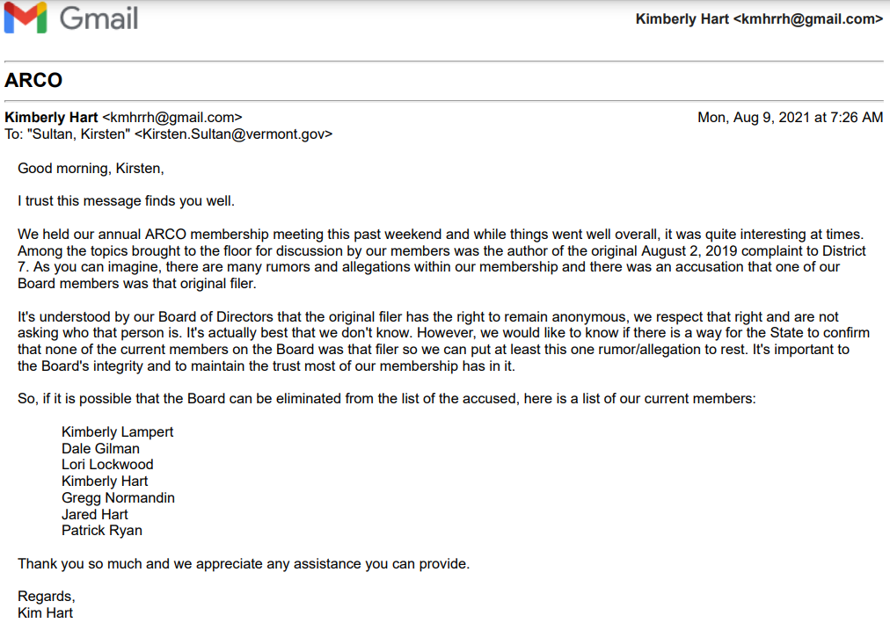

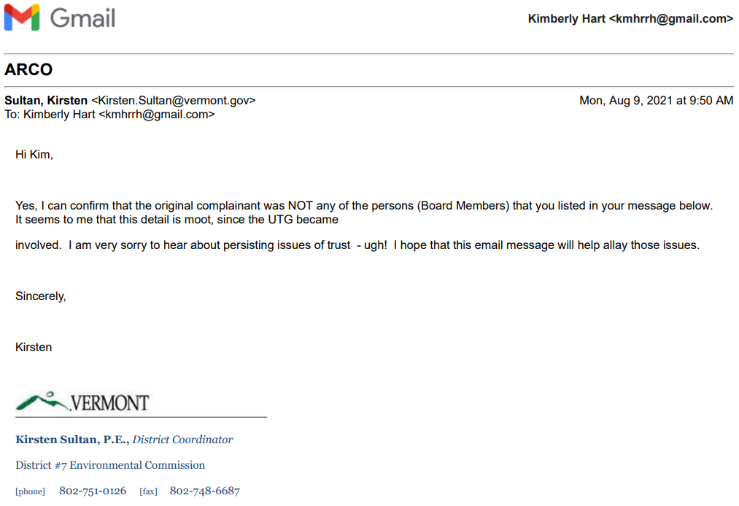

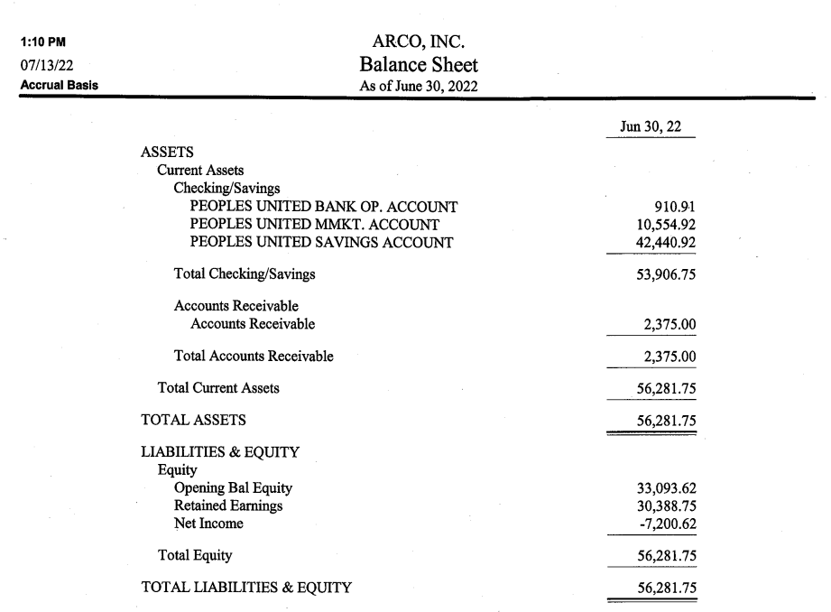

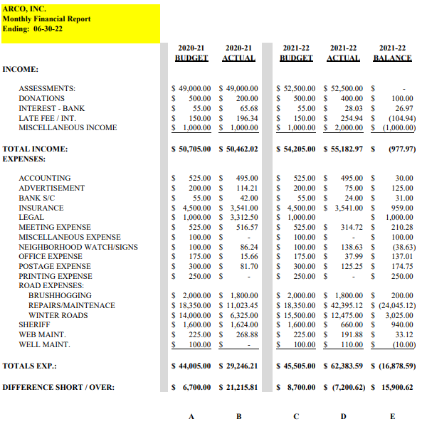

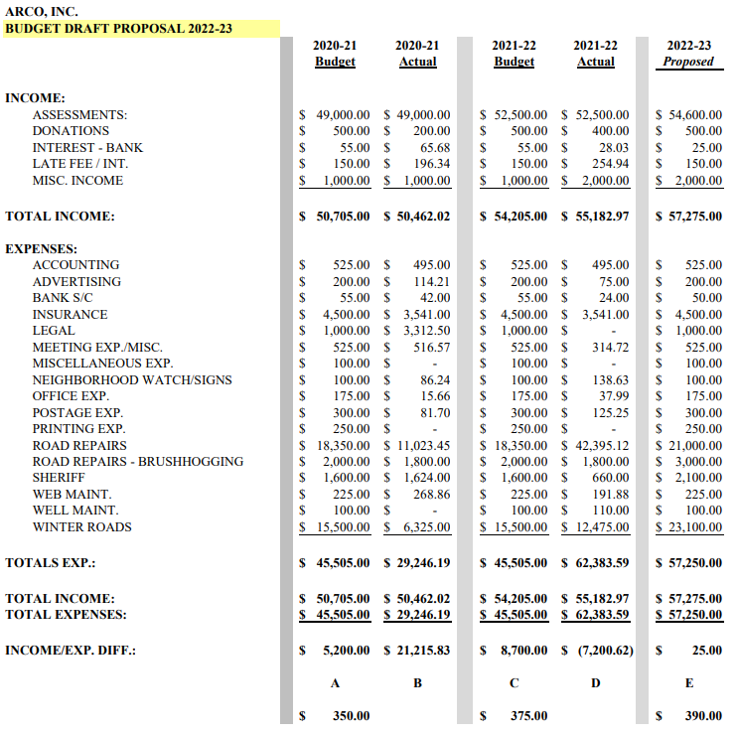

This form must be handwritten BY THE VOTING MEMBER ASSIGNING THE PROXY (not typed)

**PROXY FORM**

For ARCO Inc Annual Meeting August 6, 2022

I hereby authorize to serve as my proxy and to vote on my behalf at the ARCO Annual Meeting to be held on August 6, 2022.

This Proxy is valid for voting on the specific matters of ARCO Inc 2022-23 Annual Budget, as proposed. *Note: Proxies cannot be used to vote on subsequent floor amendments to the budget.*

A voting member wishing to vote at an Annual Meeting of ARCO via proxy shall designate a member from the membership of ARCO Inc. A voting member wishing to vote via proxy shall personally contact the member whom the voting member wishes to exercise the proxy and must complete the proxy form in its entirety. Failure by the member to sign the form and complete all sections by hand will invalidate the proxy. The duly executed handwritten proxy form shall be mailed or emailed as a scanned document by the voting member or hand delivered to the Agent of the Corporation (ARCO Secretary). Proxy can also be accepted by the Agent of the Corporation (ARCO Secretary) via telephone call from the voting member assigning the proxy. Properly completed proxy forms must be received by the ARCO Secretary **no later than** **July 29, 2022.**

*NOTES: Proxies not returned to the Agent prior to the deadline will not be honored.*

*Hand-delivered proxies will NOT be accepted the day of the meeting.*

*Proxies cannot be used for Board member elections.*

A separate proxy form shall be completed for each ARCO Inc Annual/Special Meeting and valid for the designated time period stated on the proxy. The solicitation of proxies from voting members is prohibited. Solicited proxies will not be accepted. No voting interest shall hold or exercise proxies for more than one (1) voting member at any Annual/Special Meeting of ARCO Inc. ARCO Board members cannot serve as a proxy voter.

Your signature attests the above has been strictly followed.

Name E911#

Signature Date

Witness Signature Date