**Averill Recreational Camp Owners, Inc**

**\*\*\*NOTICE OF ANNUAL MEETING\*\*\***

**PLACE OF MEETING:** Little Averill Boat Launch, Averill, VT

**DATE & TIME:** Saturday, August 5, 2023 at 10:00AM

**TYPE OF MEETING:** Regularly Scheduled Annual Meeting of the Membership

***NOTES:***

1. ***Action will be taken on all agenda items, unless otherwise noted.***
2. ***The agenda is a tentative schedule. The Board of Directors may act upon agenda items in a different order than is stated in this notice to affect the membership’s business in the most efficient manner possible.***
3. ***The Board of Directors may combine two or more agenda items for consideration, remove an item from the agenda, or delay discussion relating to an item on the agenda at any time.***
4. ***In the interest of time, the Board of Directors reserves the right to impose uniform time limits of not more than three minutes upon matters devoted to member comment.***
5. ***Voter registration is from 9:30 to 9:50AM. Tables will be set up and manned with volunteers to authenticate voters and to provide ballots and assigned proxies.***
6. ***Absentee voting for Directors to the Board will not be available. Voters must be present to vote on the slate of nominees.***
7. ***Proxy ballots have been included with the meeting packet.*** 
   1. ***Proxies are valid for August 5, 2023 Annual Meeting voting and only for those matters listed on the form.***
8. ***ARCO property owners in good standing are eligible to vote on all matters that come before the membership at the annual meeting.***
   1. ***Good standing means your current assessment and any interest charges, if accumulated, are paid prior to the annual meeting***
   2. ***One (1) vote per lot.***

Please print your own copies of this warning and related documents; there will be no extra copies available at the meeting.

We will not be providing refreshments and encourage you to bring your own snacks. Also, please bring your own chair.

Thank you,

Kimberly M Hart, ARCO Secretary

96 Hart Rd, Williamstown, VT 05679

(802) 272-5401 | kmhrrh@gmail.com

Enclosures:

• Copy of 2023 Annual Meeting Agenda

* Copy of 2022 Annual Meeting Minutes
* June 30, 2023 Balance Sheet
* 2022-2023 Monthly Financial Report

• 2023-2024 ARCO Proposed Annual Budget

* Bylaws of Averill Recreational Camp Owners, Inc
* VFA Vermont Forestry Associates Letter

• 2023 Annual Meeting Proxy Ballot

**ARCO 25th Annual Meeting Agenda**

**August 5, 2023**

1. **Call to Order** Dale Gilman President
2. **Pledge of Allegiance**
3. **Moment of Silence** for those who have passed away since the August 2022 Annual Meeting
4. **Secretary’s Report** Kim Hart
5. **Treasurer’s Report** Kim Lampert
6. **Auditor’s Report** Audit Committee
7. **Road Report** Patrick Ryan
8. **Presidents Annual Report** Dale Gilman, President
9. **Old Business** 
   1. Review and adoption of minutes: Minutes of the 2022 Annual Meeting
   2. Water Test Results: Patrick Ryan
   3. Sustainable Harvesting and Common Lands management discussion and vote
   4. Sheriff’s Report: Dale Gilman
10. **New Business** 
    1. Proposed 2023-2024 Annual Budget Presentation: Kim Lampert
    2. Proposed 2023-2024 Annual Budget Vote
    3. Nominating Committee Report: Mike Farmer and Missy Benson
    4. Nominations and elections for 2023-2024 Nominating Committee
    5. Elections of directors by ballot: 3 directors for 2-year term
    6. Proposed ARCO Bylaws amendment discussion, and vote
       1. Article 3, Section 5
       2. Article 6, Section 3
       3. Article 7, Section 4
    7. Proposed Contract for the Averill Boat launch, discussion, and vote
    8. Nominations and elections for 2023-2024 Audit Committee, Peggy Lajeunesse and Connie Jackson
    9. Election Results Announcement
    10. Proposed Zoom meeting account discussion and vote
    11. Proposed rules on Wake Boat use on Little Averill discussion and vote
11. **Meeting Adjournment**

**ARCO NEWSLETTER**

**August 6, 2022**

**24th Annual Meeting Newsletter**

Kimberly Lampert (802) 779-7194

Kimberly Hart (802) 272-5401

Jared Hart (802) 249-0586

Dale Gilman (802) 249-0655

Gregg Normandin (978) 270-1532

Lori Lockwood (205) 447-8408

Patrick Ryan (802) 334-5277

Vermont State Police, Derby - 802 334-8881 or call 911

Sheriff - Trevor Colby 802 676-3500

Border Patrol – 800 689-3362 24/7

Customs Point of Entry – Norton, VT 24/7 or call 911

Facebook - Averill Recreational Camp Owners, Inc

ARCO Website – [www.arcoinc.org](http://www.arcoinc.org)

The 24th ARCO Annual Meeting was held at the Little Averill Board Launch on August 6, 2022. There were 40 members present and the weather was pleasant with a nice breeze coming in off the lake.

The meeting was called to order by President Kim Lampert at 10:00AM. Kim led members in the Pledge of Allegiance and asked for a moment of silence to honor those ARCO members, family and friends who passed away since our last meeting.

**2022 ARCO Annual Meeting Secretary’s Report**

**Kimberly Hart**

*All regular meeting minutes have been sent to the membership. The warning letter for the annual meeting was emailed or mailed to all members by 7/19/2022. Included with the warning were six (6) documents:*

* *Copy of 2022 Annual Meeting Agenda*
* *Copy of 2021 Annual Meeting Minutes*
* *June 30, 2022 Balance Sheet*
* *2021-2022 Monthly Financial Report*

*• 2022-2023 ARCO Proposed Annual Budget*

*• 2022 Annual Meeting Proxy Ballot*

*An ARCO Camp Owner Contact Information sheet was included in the packets mailed to members without email addresses. If you have had a change in address, phone number, email, etc., please see me after the meeting and I’ll take your updated information.*

*We have welcomed about 9 new members to ARCO since the last annual meeting and new member information has been sent to all. The membership list and email contact lists have been updated with the most current information provided to us.*

*As a reminder, meeting minutes and other ARCO related documents are no longer sent via the postal service, they are emailed and posted on the ARCO website. So, if you want to receive newsletters and meeting minutes in your inbox, please be sure we have your email address.*

*Respectfully submitted,*

*Kimberly Hart, ARCO Secretary*

Motion to accept Yvonne Rice, second from Bill Elliott. No discussion. Motion passed.

**Treasurer’s Report – Kimberly Lampert**

Everyone was sent a copy of the Financial Report and Balance Sheet with the annual meeting minutes for review by the membership.

Bill Elliott motioned to accept the report as given. Terry Mitchell seconded. The motion passed.

**Auditor’s Report – Peggy Lajeunesse**

The books appear to be in good order with the exception of a $2,387 discrepancy that Kim will research and work with Peggy to report back to the membership their findings.

John Hull made a motion to accept, Jon Lampert seconded. Motion carried.

**President’s Annual Report – Kim Lampert, President**

*Good morning and welcome to the 24th Annual ARCO membership meeting. It’s hard to believe that we are entering our 25th year since incorporating.*

*We have had several properties change ownership again this past year within ARCO. Please stand and introduce yourself. Welcome to the area!*

*I would like to begin with a few thank yous. First, Joe Martaniuk. Joe has assisted us for several years with the road closure. His tractor efforts for clearing out the gate is a big help. Joe also keeps in close contact with the board and relays clear and accurate info regarding the road.*

*Thank you to Peggy Lajeunesse for her time auditing the ARCO books.*

*Thank you to Mike Farmer assisting us for board member nominations. My apology to Rita Laferierre for not connecting to her directly to assist. I am sorry.*

*Thank you to Yvonne Rice and Donna Fuller for assisting at the registration table.*

*A few reminders to all members:*

*Golf carts, 4 wheelers, off-road buggies are not permitted on any of the roads that travel to your camp properties.*

*Please remember the burning of all trees/brush requires a burn permit from the fire forest warden.*

*All dogs must be kept under the camp owner’s control. All dogs are to be always leashed when leaving your property. We have many little kids and adults walking or biking the roads within ARCO and their safety is extremely important.*

*The Sandy Beach area on Beach Road is a private beach. New signage was placed at the beach area in accordance with last year’s meeting discussion. ARCO owns to the left of the path from the parking lot. Most of the area to the right of the path belongs Quimby. We continue to work with Quimby regarding the beach and any concerns that arise. Please remember glass is not permitted on the beach at any time and no campfires. And please bring out what you bring to the beach. New signage has been hung in the parking area.*

*A reminder for those of you who use generators that quiet hours are 11 p.m. to 7 a.m. Please refer to the Rules & Regulations if any questions.*

*Many of you will notice that cell service has finally arrived within this area. I know many camps have wifi services, but it is nice to see cell service opening in and around the ARCO area. Please be sure to post your 911 address at the end of your camp driveway. If you need help with your 911 address, please see me after the meeting and I will help you directly.*

*The Little Averill boat launch area is owned by ARCO members directly. This area is designated for launching boats to the lake. Again, glass is frowned upon at this area also. No parking in the areas as marked and no overnight camping is allowed. New signage will be installed soon for parking/boat.*

*I think you will find the spring road repairs by Laurent Rancourt were wonderful! Laurent worked closely with Patrick regarding the road and its conditions. If at any time you see any road issues, I ask that you please contact ARCO Road Agent directly.*

*As a reminder the road that leads to your camp is owned by the timber company. We have a right-of-way to our camps. The road closes between 6-8 weeks each spring to allow thawing. This road when originally made was not built for year-round access.*

*For those who may be considering a building addition; please contact the UTG regarding a permit and zoning before beginning construction.*

*The ARCO Facebook page was recently turned off. Rude comments, negativity and misleading info will not be permitted. The board will be reviewing this topic at its next meeting.*

*The ARCO BOD meets approximately 4-6 times per year plus this annual meeting. All board members are required to adhere to the Board of Directors guidelines. Meetings are kept to a 2-hour limit. We try to meet in Averill but do continue to use Zoom still. I would like to thank each board member for their time and efforts. A special thanks to Gregg, Jared and Patrick who will be stepping down after this meeting. This current board has endured many situations but continues to be mindful and represent all 140 camp lot owners to the best of our ability.*

*Please refer to the ARCO bylaws and ARCO rules and regulations for information that pertains to your camp property. Information is also listed on our web.*

*If at any time you have any questions, please contact me or any board member directly. Our phone numbers are listed at the top of the newsletters that you receive via email. Info is also posted on the web.*

*I would again like to thank all of those who are attending here today, my board of directors and members who help us when asked.*

*Respectfully submitted,*

*Kim Lampert, President*

**Road Commissioner’s Report – Patrick Ryan, Road Agent**

This year the road opened May 15 and road work commenced.

Seven (7) culverts were replaced and 33 truck loads of gravel were added to Jackson, Hatchery Brook, and Cowan Roads.

Costs for materials and labor substantially increased due to high fuel prices and caused necessary road work costs to exceed what had initially been planned and budgeted for by $17,000.

During discussion, Julie Brochu pointed out that there are several prominent potholes and asked if anything can be done about them. Patrick explained that we could spot fill the holes and that we would look into a more permanent fix.

We have been informed by Weyerhauser that ARCO can use gravel from the Jackson Road pit. LandVest (who manages this section of land for Weyerhauser) only allows for gravel from that pit to be used on Jackson Road and can only be removed in amounts up to 12 yards per truck load. So, ARCO would be limited on how much we use that gravel and where. Albie Borne suggested we ask Laurent Rancourt to assess the quality of the gravel in the Jackson Road pit to determine if they are materials that would be good for us to use.

John Hull complimented the Board on the quality of the roads and said it was good to keep up with maintenance. He asked about what Weyerhauser had contributed to road work this year. Patrick said that they still owe us a grading and a culvert. He suggested we could also ask Jason Patenaude to assess the quality of the gravel in the Jackson Road pit.

Patrick asked that if people see things, to contact him so we can see about getting the work done.

**OLD BUSINESS**

**Review and Adoption of Minutes: Minutes of the 2021 Annual Meeting**

John Hull motioned to accept and discuss the 2021 Annual Meeting minutes with a second from Terry Mitchell.

Discussion ended and a vote was taken to accept the meeting minutes.

**Water Test Results (both wells)**

At the time of the meeting Capital Wells had performed the test, but had sent us no results. That information will be passed along with the meeting minutes.

**Sheriff’s Contract**

Dale Gilman presented that the Sheriff’s contract was initially rejected by the Essex County Sheriff’s office; they would not allow us to place patrol stipulations in the contract and they had a rate increase to $35/hour. The Sheriff further explained that they have an expanded territory now that includes Canaan and Island Pond, they lost a Deputy and are extremely busy. Lastly, they only have one standard contract they use for $2,500/year.

Julie Brochu asked about private security; do we have to have a cop? Not sure how to manage law breakers. She suggested that we introduce ourselves at the beginning of meetings so we can all get to know one another. She volunteered to run and neighborhood watch and John Hull volunteered to work with her on that.

**District 7 Environmental Commission Complaint update**

The Board had received a letter from Michaela Stickney, NRB Enforcement Officer just prior to the annual meeting, but did not have proper time to include in the warning. The letter includes a summary of her findings and remaining concerns. A copy of the letter is included at the end of these minutes.

If you have questions or concerns, please contact one of the members of the Board and we will carry those comments forward, collectively.

**NEW BUSINESS**

**Proposed 2022-2023 Annual Budget Presentation and Proposed 2022-2023 Annual Budget Vote**

The proposed increase in the annual dues is a result of inflation and rising expense costs. In order to help the Treasurer sends bills to the correct property owners, please be sure to let the Board know you are selling your camp and we can make sure our records are up to date after the sale.

Discussion started with John Hull going back to the Sheriff issue. He feels a neighborhood watch would be a good option to replace the Sheriff and made a motion to discontinue contracting with the Sheriff’s department.

Several members disagreed with getting rid of the Sheriff. Terry Mitchell asked if we need the Sheriff if we have the game warden in there patrolling around. Dale explained that we can’t contract with the warden and that he is only in there when he is in the area and that the Sheriff is contracted directly with ARCO.

Albie Borne stated that Ring home security devices do have a neighborhood watch network and that people could connect to each other’s security systems.

A vote was taken on whether to remove the Sheriff’s contract funding from the budget; 16 voted to remove, 19 voted to keep. John Hull’s motion failed. The Sheriff’s contracting will remain.

Julie Brochu motioned to accept the proposed budget as presented with a second from Bill Elliot. Motion passed.

**Nominating Committee Report – Mike Farmer**

July 16, 2022

ARCO Director Nominations report

The committee this year is just me--Mike Farmer but I worked with Secretary Kim Hart to send an email message to all members we have email addresses for. I also reached out to many owners individually in person or via email or phone.

We have four director positions that expire this year and three of the incumbents have decided not to run again. I want to thank the three of them Patrick Ryan, Gregg Normandin, and Jared Hart for their efforts.

With four openings, we have four candidates for Directors this year:

Julie Brochu, lot 144 259 Loop Road

Greg Donahue, lot 149 104 Loop Road

Dale Gilman,  lot 175 35 Loop Road Extension. Dale is an incumbent

Kent Koptiuch, lot 126 1700 Jackson Road

We have one incumbent but three new members willing to serve that have each become an owner in the last year. We have 140 lots and many of them have multiple owners so we have potentially almost 300 directors that can serve. Even if you only serve one or two terms it is important that we spread the work over all of us as it is 100% necessary that our ARCO Board exist and actively manages our assets. Please think about running next year or the year after to help all of us.

Sincerely

Mike Farmer

**Nominations and Elections for 2022-2023 Nominating Committee**

Mike Farmer and Missy Benson volunteered to be on the 2023 nominating committee. Thank you, Mike and Missy, for volunteering.

**Nominations and Elections for 2022-2023 Audit Committee**

Peggy Lajeunesse and Connie Jackson have volunteered to serve on the audit committee for the next annual meeting. We will be sure they have materials by July 15 to allow enough time for a thorough review. Thank you, Peggy and Connie for volunteering.

**Election Results Announcement**

One nomination from the floor by Dale Gilman to add Patrick Ryan to the ballot was accepted by the membership and Patrick agreed to serve, if elected.

Ballots were counted and the following members were elected/re-elected to serve on the Board of Directors;

Patrick Ryan – re-elected to a 2-year term

Dale Gilman – re-elected to a 2-year term

Julie Brochu – new Director elected to a 2-year term

Kent Koptiuch – new Director elected to a 2-year term

Thank you to our new Directors for your willingness to serve our ARCO membership.

**Other Old/New Business**

**Sandy Beach –** Dale Gilman provided an update on actions being taken by the Board to protect our access to Quimby/s beach. We have hung signs warning that the parking area and the beach are private property. We have been working with the owner of Quimby Country and have provided ARCO parking decals so their guests can affix them to vehicle windshields. Some members have expressed concern over the existence and number of signs in the parking area and Dale explained that these were topics presented to the membership last year. So far we have not had to tow any vehicles, but fires are still happening and trash is still being left.

Yvonne Rice asked about whether or not golf carts would be towed if found at the beach. This is a consideration and not outside the realm of possibility.

Norm Daigneault asked if there was anything we could do about speeders. We will do some research into using removable speed bumps and see what there are for other possibilities. We will also contact the UTG to see if there is anything we can do about posting a speed limit. Norm also suggested that we laminate the Safety Zone signs we post around the wells and trail accesses to keep them from falling down. Missy Benson said she has a laminator and Patrick will drop off the signs he has for laminating. Thank you to Missy for offering to help.

**Bylaws Changes -**

John Hull asked about pending bylaws changes. We had scheduled a bylaws review meeting for the membership, but it had to be cancelled because it was at the onset of COVID and members could not come from Canada. We will ask the Bylaws committee of Marion Gray, Rowdy Doyon, Robert Grant and AnnMarie McCallum to resend their recommendations to us. We will resend those proposed changes prior to a meeting that will be scheduled at a future date where we will discuss and vote on changes line-by-line. We will also have to look for a venue big enough to hold a meeting of the membership without costing a lot.

John also had a complaint about the road staying closed too long for mud season the last three years. He stated that we control the gate and we should all be able to get to our properties year-round. He will set up a sub-committee and research permitting, etc. surrounding road closure.

*For reference, the closing dates for the last three years are shown below. Yearly average since ARCO inception is 37.5 days (excluding missing date from 2015 and 2016).*

|  |  |  |
| --- | --- | --- |
| *Date Closed* | *Date Opened* | *Days Closed* |
| *3/29/2020* | *5/15/2020* | *47* |
| *3/28/2021* | *5/5/2021* | *33* |
| *4/10/2022* | *5/13/2022* | *33* |

**Forestation Project -**

John Hull asked about the status of the forestation project on the common land. He stated that there had been a contract worked out with LandVest and that everything was in place for that project to start, but it didn’t. That contract has since expired and a new one will need to be drawn up. John volunteered to work on that project with the Board on researching what it would take to get this project going again.

Jared Hart suggested we find uses for the common land such as hiking and biking trails for our members to use. He would welcome working with people to help clear paths.

Dale Gilman would like look into doing some daylighting the Point Road. Alan Farmer suggested we do the daylighting after the loggers are through with the common lands work.

**Adjournment**

At 11:36AM Harvey George made a motion to adjourn, Yvonne Rice seconded and the meeting adjourned.

***As a reminder, paper copies of meeting minutes are no longer being mailed. All minutes are sent via email and are posted on the ARCO website. If you wish to receive minutes by email, please contact ARCO Secretary, Kim Hart at*** [***kmhrrh@gmail.com***](mailto:kmhrrh@gmail.com)***, with your email address.***

ADDENDUM added 09/26/2022

Follow up items and information from 2022 ARCO Annual Meeting:

1. **Water Test Results**

Written water test reports for both wells were received from Capital Well Company. Both report that E.coli and Total Coliform results were negative and both wells passed.

1. **$2,378 discrepancy in ARCO Audit reported by Peggy Lajeunesse**

Revised ARCO Audit Report 6/30/2022

Reviewed by Peggy Lajeunesse

August 5, 2022.

After review of the documents provided found a discrepancy in ending balance of OP account. Kim Lampert to research the $2,300+- difference and provide feedback to audit committee. Invoices were reviewed to checks disbursed and all in order. The above discrepancy was identified as timing in transferring funds to the OP account that occurred at the bank on July 5, 2022. All records are in order.

Respectfully submitted by Peggy Lajeunesse.

1. **Road Closing Information**

*For reference, the closing dates for the last three years are shown below. Yearly average since ARCO inception is 37.5 days (excluding missing data from 2015 and 2016).*

|  |  |  |
| --- | --- | --- |
| *Date Closed* | *Date Opened* | *Days Closed* |
| *3/29/2020* | *5/15/2020* | *47* |
| *3/28/2021* | *5/5/2021* | *33* |
| *4/10/2022* | *5/13/2022* | *33* |

1. **Forestation Project**

* New Board member, Kent Koptiuch, has extensive experience working with foresters and forestation projects. He will be our primary point of contact and advisor to the Board in the matter of the common land forestation project. We would appreciate John Hull teaming up with Kent regarding this matter.
* The Board will work with the forester and logger to see how much extra effort and cost it would take to do the daylighting on Point Road while the equipment is in there working the common land. We will keep the membership up to date as activities warrant.

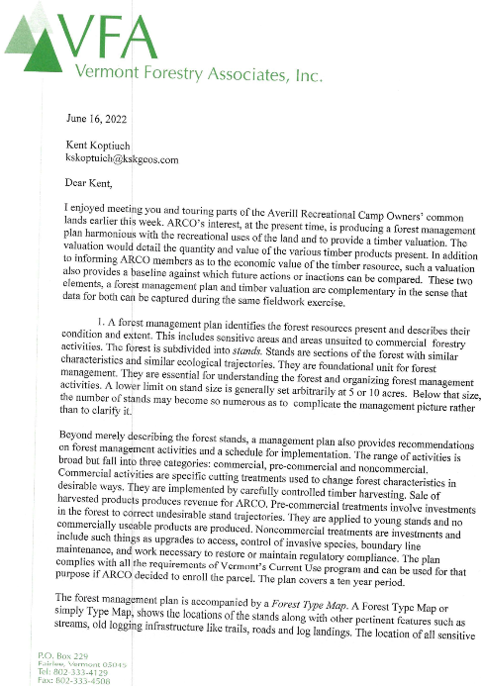

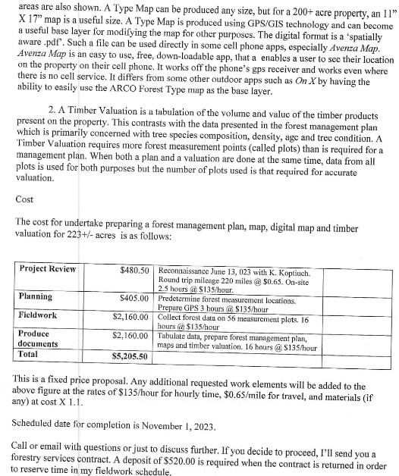

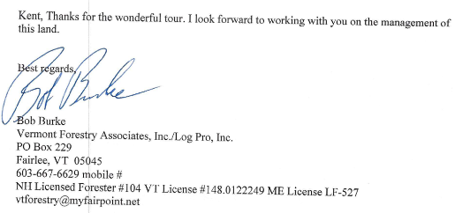

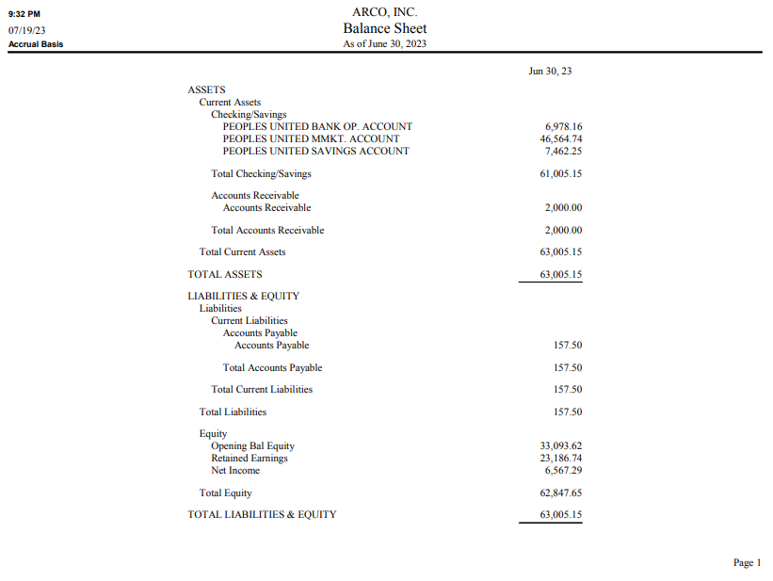

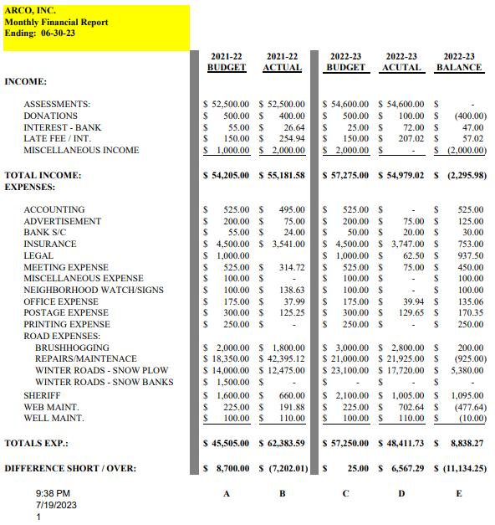

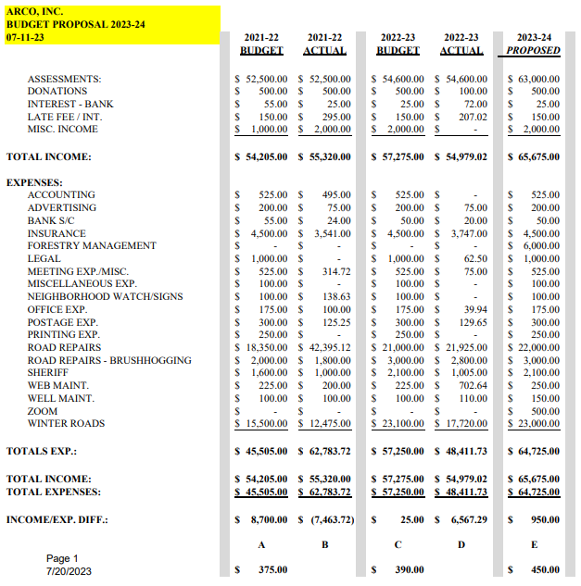

**BYLAWS**

**OF**

**Averill Recreational Camp Owners, Inc.**

Adopted May 30, 1999

Revised September 3, 2000

Revised September 2, 2001

Revised September 5, 2004

Revised August 31, 2008

Revised August 6, 2016

Revised June 17, 2023

**CONTENTS**

**ARTICLE 1** 4

**PURPOSES AND NAME** 4

**SECTION 1** 4

**SECTION 2** 4

**ARTICLE 2** 4

**MEMBERSHIP** 4

**SECTION 1** 4

**ARTICLE 3** 5

**BOARD OF DIRECTORS** 5

**SECTION 1** 5

**SECTION 2** 5

**SECTION 3** 5

**SECTION 4** 5

**SECTION 5** 5

**ARTICLE 4** 6

**OFFICERS** 6

**SECTION 1** **PRESIDENT** 6

**SECTION 2** **VICE PRESIDENT** 6

**SECTION 3** **TREASURER** 6

**SECTION 4** **SECRETARY** 7

**SECTION 5** **ROAD COMMISSIONER** 7

**SECTION 6** **TERMS of OFFICE** 7

**ARTICLE 5** 8

**AUDITORS** 8

**SECTION 1** 8

**SECTION 2** 8

**ARTICLE 6** 9

**BUDGET AND ASSESSMENTS** 9

**SECTION 1** 9

**SECTION 2** 9

**SECTION 3** 9

**ARTICLE 7** 10

**MEETINGS / VOTE** 10

**SECTION 1** 10

**SECTION 2** 10

**SECTION 3** 10

**SECTION 4** 10

**ARTICLE 8** 10

**AMENDMENT OF BY~LAWS** 10

**SECTION 1** 10

**ARTICLE 9** 11

**MISCELLANEOUS** 11

**SECTION 1** 11

**SECTION 2** 11

# **ARTICLE 1**

## **PURPOSES AND NAME**

### **SECTION 1**

The purpose of this member-benefit non-profit Corporation are to provide centralized representation to all the camp owners of those 140 lots, located in the unincorporated town of Averill, Vermont, conveyed to such owners or their predecessors by Champion Realty Corporation, and currently collectively known as "AVERILL RECREATIONAL CAMP OWNERS, INC." ("ARCO"), to provide continued management of the area known as the "common areas" as established by and in accordance with the grant of Champion Realty Corporation to the Corporation dated September 15, 2000 for the good of all the owners; to collect assessments as deemed necessary or appropriate for maintenance of the "common areas" to include but not limited to roads, water pumps, and beach areas; to procure general liability insurance as deemed necessary to appropriate to protect the Corporation and its members, to promote and preserve the integrity of the area as it now exists, in accordance with guidelines as were stipulated in the above-mentioned conveyances and prior lease agreements from Champion Realty Corporation; and to conduct any legal business that comes before the Corporation.

### **SECTION 2**

The name of this Corporation is "Averill Recreational Camp Owners, Inc."

# **ARTICLE 2**

## **MEMBERSHIP**

### **SECTION 1**

The Corporation shall be a membership corporation, with membership consisting of the owners of record of the ARCO lots.

# **ARTICLE 3**

## **BOARD OF DIRECTORS**

### **SECTION 1**

The Corporation shall be managed by a Board of Directors consisting of a minimum of five (5) and a maximum of seven (7) members. All Directors must be members in good standing, with all assessments imposed by the Corporation paid in full. The Board of Directors shall have authority to manage the affairs of the Corporation in accordance with the Corporation's Articles of Incorporation, the Bylaws, and applicable rules, regulations, covenants, and laws.

### **SECTION 2**

Directors shall be elected for two-year terms by the membership at annual meetings thereof. Directors may only hold office for three (3) consecutive terms.

### **SECTION 3**

The Board of Directors shall elect from among its members a President, Vice President,

Secretary, and Treasurer.

### **SECTION 4**

A simple majority of the Board of Directors shall constitute a quorum at any meeting of the Board of Directors.

### **SECTION 5**

A vacancy on the Board of Directors, unless such vacancy results in fewer than five (5) members, shall be filled by the membership at the next meeting thereof. If a vacancy on the Board of Directors results in fewer than five (5) members, the Board shall fill such vacancy with an appointee, serving only until the next meeting of the membership. Any successor elected by the membership shall serve for the unexpired term of his or her predecessor.

# **ARTICLE 4**

## **OFFICERS**

### **SECTION 1 PRESIDENT**

The President shall be the chief executive officer of the Corporation in the management of its affairs. The president shall preside at all meetings of the Board of Directors and the membership and perform such other duties as may be required under the laws of this state and the bylaws of the Corporation. The President shall be elected annually by the Board of Directors from among the Directors. In case of a vacancy in the office of President, the Board of Directors shall elect a President from the remaining Directors to hold office for the remainder of the unexpired term.

### **SECTION 2 VICE PRESIDENT**

The Vice President shall assist the president in the performance of his or her duties and shall perform the duties of President during his or her absence or disability. The Vice President shall be elected by the Board of Directors from among the Directors. In the case of a vacancy in the office of Vice President, the Board of Directors shall elect a Vice President from the remaining Directors to hold office for the remainder of the unexpired term.

### **SECTION 3 TREASURER**

The Treasurer shall maintain all accounts of the Corporation and have charge of its funds. The Treasurer shall keep all funds in such bank or banks as the Board of Directors may designate. The Board of Directors shall designate check signing authority in such manner as is appropriate. The Treasurer shall keep correct books of account and shall make a report in detail to the Board of Directors and the membership at the annual meeting and at such other times as the Board of Directors shall require. The Treasurer shall file all appropriate annual reports, and corporate federal and state tax, to the respective agency. The Treasurer shall be elected annually by the Board of Directors from among the Directors. In the case of a vacancy in the office of Treasurer, the Board of Directors shall elect a Treasurer from the remaining Directors to hold office for the remainder of the unexpired term.

### **SECTION 4 SECRETARY**

The Secretary shall keep all records pertaining to the Corporation and shall record all votes and proceeding of the membership and Directors. It shall be the duty of the Secretary to give notice of all meetings to the membership and Board of Directors when notice is required for such meetings and to keep custody of the corporate records. The Secretary shall keep a book containing a record of the name of the members and their places or residences. This book shall always be open to the inspection of the membership. The Secretary shall be elected annually by the Board of Directors from among the Directors. In case of a vacancy in the office of Secretary, the Board of Directors shall elect a Secretary from the remaining Directors to hold office for the remainder of the unexpired term.

### **SECTION 5 ROAD COMMISSIONER**

The Road Commissioner shall be appointed by Board of Directors from the membership, annually.

The Road Commissioner shall, in coordination with and assistance from the Board of Directors oversee the maintenance and improvements of the Corporation's roads in accordance with the budgets approved by the membership. The Road Commissioner shall be appointed annually by the Board of Directors from the membership. In case of a vacancy in the office of Road Commissioner, the Board of Directors shall appoint a Road Commissioner to hold office for the remainder of the unexpired term.

### **SECTION 6 TERMS of OFFICE**

All terms as an Officer shall be for a period of one year or until a successor is elected.

# **ARTICLE 5**

## **AUDITORS**

### **SECTION 1**

At least two auditors shall be elected by the membership at each annual meeting. The auditors shall each be a member of the Corporation and shall serve for a term of one year.

### **SECTION 2**

It shall be the duty of the auditors to conduct an internal review of the accounts of the

Corporation and provide a report of such review to the Board of Directors upon its completion and to the membership at the annual meeting.

# **ARTICLE 6**

## **BUDGET AND ASSESSMENTS**

### **SECTION 1**

The fiscal and membership year of the Corporation shall be from July l to June 30.

### **SECTION 2**

The Board of Directors shall submit to the membership, at each annual membership meeting, a proposed budget of expenditures covering the total anticipated expenditures for the fiscal year. This budget shall be considered by the membership and may be approved with or without revision. It may be reviewed and subject to revision at any special meeting of the membership thereafter. The officers and/or Board of Directors are prohibited from incurring any indebtedness beyond current cash assets without prior approval of the membership.

### **SECTION 3**

Assessments payable in equal amounts by each member shall be established by the Board of Directors each year to assure adequate funds for maintenance of the common areas. Such annual assessments shall be based upon a budget approved by the membership, voted on at an annual or special meeting. The Board of Directors may also establish, from time to time, special assessments to fund special projects as deemed necessary. Special projects projected to cost more than $10,000. (Remove) shall require prior approval of the membership at an annual or special meeting thereof. Any special assessment shall be payable in equal amounts by each member.

Annual and special assessments are due within thirty (30) (Add) days of invoice. Failure to pay any assessment, as and when due, may result in a judg(e)ment (Remove) lien being placed against the delinquent member's lot. Judg(e)ment (Remove) liens for unpaid assessments may be foreclosed under the laws of the State of Vermont and delinquent member shall be responsible for interest at the legal rate and all costs of collection, including reasonable attorney's fees incurred by the Corporation. A member not current with any annual or special assessment on the date of an annual or special meeting of the membership shall not be eligible to vote at such meeting.

# **ARTICLE 7**

## **MEETINGS / VOTE**

### **SECTION 1**

The Annual Meeting of the membership shall be held on the first Saturday of August. Special meetings of the membership may be called by the President, the Board of Directors, or five (5) percent of the membership. All meetings must be held within the State of Vermont.

### **SECTION 2**

Written notice of the place, day, hour and purposes of the annual meeting and all special meetings of the membership shall be prepared and distributed to the membership by the secretary at least fifteen (15) days prior to the meeting.

### **SECTION 3**

The members present at an annual or special meeting of the membership shall constitute a quorum. Any action, other than the amendment of these Bylaws taken at an annual or special meeting shall require a simple majority vote of those present. Jointly held lots must designate a representative for voting purposes.

### **SECTION 4**

Proxy voting by State of Vermont Statutes, limits Directors’ ability to vote by proxy in any matter. Further, no Director may vote proxy for any member of ARCO. New proxy forms shall read in part "the solicitation of proxies from voting members is prohibited". Solicited proxies will not be accepted. No voting interest as a lot owner of ARCO, shall hold or exercise proxies for more than two (2) additional lot owners at any meeting of ARCO.

# **ARTICLE 8**

## **AMENDMENT OF BY~LAWS**

### **SECTION 1**

These bylaws may be altered, amended, or repealed by a two-thirds vote of the membership present at any properly noticed annual or special meetings of the membership.

# **ARTICLE 9**

## **MISCELLANEOUS**

### **SECTION 1**

Any matter which may arise related to the governance or operation of the Corporation that are not covered by the Corporation's Articles of Incorporation or these Bylaws, shall be governed by Title 11B of the Vermont State Statutes Annotated, relating to non-profit Corporations.

### **SECTION 2**

The Corporation shall indemnify and save harmless its Directors and Officers

from liability pursuant to and in accordance with the provisions of Title 11B of the Vermont State Statutes Annotated.

This form must be handwritten BY THE VOTING MEMBER ASSIGNING THE PROXY (not typed)

**PROXY FORM**

For ARCO Inc Annual Meeting August 5, 2023

I hereby authorize to serve as my proxy and to vote on my behalf at the ARCO Annual Meeting to be held on August 5, 2023.

This Proxy is valid for voting on the specific matters of ARCO Inc 2023-2024 Annual Budget, as proposed. *Note: Proxies cannot be used to vote on subsequent floor amendments to the budget.*

A voting member wishing to vote at an Annual Meeting of ARCO via proxy shall designate a member from the membership of ARCO Inc. A voting member wishing to vote via proxy shall personally contact the member whom the voting member wishes to exercise the proxy and must complete the proxy form in its entirety. Failure by the member to sign the form and complete all sections by hand will invalidate the proxy. The duly executed handwritten proxy form shall be mailed or emailed as a scanned document by the voting member or hand delivered to the Agent of the Corporation (ARCO Secretary). Proxy can also be accepted by the Agent of the Corporation (ARCO Secretary) via telephone call from the voting member assigning the proxy. Properly completed proxy forms must be received by the ARCO Secretary **no later than** **July 28, 2023.**

*NOTES: Proxies not returned to the Agent prior to the deadline will not be honored.*

*Hand-delivered proxies will NOT be accepted the day of the meeting.*

*Proxies cannot be used for Board member elections.*

A separate proxy form shall be completed for each ARCO Inc Annual/Special Meeting and valid for the designated time period stated on the proxy. The solicitation of proxies from voting members is prohibited. Solicited proxies will not be accepted. No voting interest shall hold or exercise proxies for more than one (1) voting member at any Annual/Special Meeting of ARCO Inc. ARCO Board members cannot serve as a proxy voter.

Your signature attests the above has been strictly followed.

Name E911#

Signature Date

Witness Signature Date