

**Fundraiser Flavors**

**Savory** **Sweet**  **Sweet Premium**

**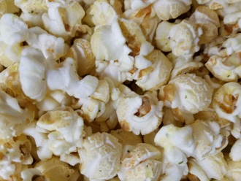 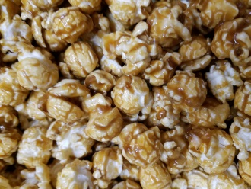 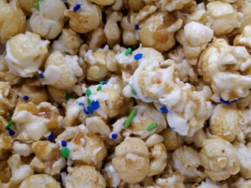**

Garlic Parmesan Caramel Happy Cake

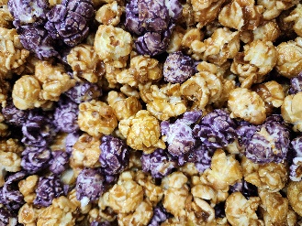 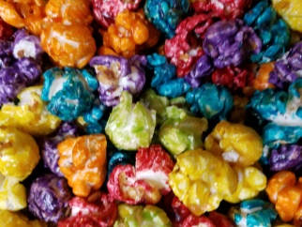 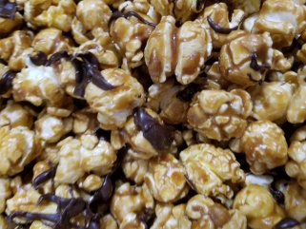

Eagles Style Rainbow Fruit Salted Caramel Dark Chocolate

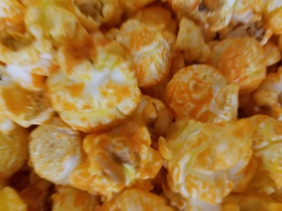 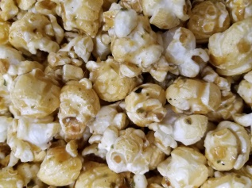 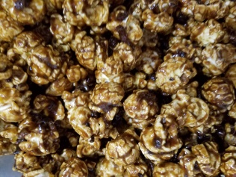

Cheddar Sweet Jalapeno Maple Bacon

|  |  |  |  |  |  |  |  |  |  |  |  |  |  |  |  |  |  |  |  |
| --- | --- | --- | --- | --- | --- | --- | --- | --- | --- | --- | --- | --- | --- | --- | --- | --- | --- | --- | --- |
|  | CF_logo_bw.jpg   |  | | --- | |  | | |  |  | |  |  |  | Participants Name: | | | |  |  |  |  | | | |
|  |  |  | |  |  | Participants Phone Number: | | | | |  |  |  |  | | | |
|  |  |  | |  |  |  | Organization Name: | | | |  |  |  |  | | | |
|  |  |  | |  |  | Return Order Due Date: | | | | |  |  |  |  | | | |
|  |  |  | |  |  |  | Delivery Date: | | | |  |  |  |  | | | |
|  |  |  |  | |  |  |  | Checks Payable to: | | | |  |  |  |  | | | |
|  | Talking Points: Why you are selling CornFusion | | | **Original Caramel** | | | **Rainbow Fruit** | **Sweet Jalapeno** | **Cheddar** | **Garlic Parmesan** | **Eagles Style**  **(caramel & grape)** | **Maple Bacon** | **Happy Cake** | **Salted Caramel Dark Chocolate** | **Total Due** | | **Paid** | **Date Delivered** |
|  | 1 | | |
|  | 2 | | |
|  | 3 | | |
|  | **Customer Name** | **Phone #** | | **Price Per Bag** | | | | | | | |  |  |  |  | | | |
|  | Payment is due at the time the order is placed | | | **$12** | | | **$12** | **$12** | **$12** | **$12** | **$12** | **$12** | **$12** | **$12** | *all flavors are gluten free* | | | |
| 1 |  |  | |  | | |  |  |  |  |  |  |  |  |  |  | |  |
| 2 |  |  | |  | | |  |  |  |  |  |  |  |  |  |  | |  |
| 3 |  |  | |  | | |  |  |  |  |  |  |  |  |  |  | |  |
| 4 |  |  | |  | | |  |  |  |  |  |  |  |  |  |  | |  |
| 5 |  |  | |  | | |  |  |  |  |  |  |  |  |  |  | |  |
| 6 |  |  | |  | | |  |  |  |  |  |  |  |  |  |  | |  |
| 7 |  |  | |  | | |  |  |  |  |  |  |  |  |  |  | |  |
| 8 |  |  | |  | | |  |  |  |  |  |  |  |  |  |  | |  |
| 9 |  |  | |  | | |  |  |  |  |  |  |  |  |  |  | |  |
| 10 |  |  | |  | | |  |  |  |  |  |  |  |  |  |  | |  |
| 11 |  |  | |  | | |  |  |  |  |  |  |  |  |  |  | |  |
| 12 |  |  | |  | | |  |  |  |  |  |  |  |  |  |  | |  |
| 13 |  |  | |  | | |  |  |  |  |  |  |  |  |  |  | |  |
| 14 |  |  | |  | | |  |  |  |  |  |  |  |  |  |  | |  |
| 15 |  |  | |  | | |  |  |  |  |  |  |  |  |  |  | |  |
|  | **Total Bags Purchased** | | |  | | |  |  |  |  |  |  |  |  | **Add Together Total**  **Sales Per Flavor Row** | | | |
|  | **Multiplied By Cost Per Flavor** | | | **$12** | | | **$12** | **$12** | **$12** | **$12** | **$12** | **$12** | **$12** | **$12** |
|  | **Total Sales Per Flavor** | | | $ | | | $ | $ | $ | $ | $ | $ | $ | $ |  | $ | | |