Putting 4 Paws
Service Dogs on Site
Golf Tournament
Sign up for a special celebration for all our Heroes – Never Forget
We will have a veteran to tell their story, a DJ during registration then and Dallas Hayden will sing us a song, have a moment of silence before starting our event.
FoxCliff Golf Club
1970 E Maple Turn Rd,
Martinsville, IN 46151
b

2024
Wednesday
Sept 11

Registration - Begins at 11:30 am - Shotgun -Starts at 1:00 pm
Dinner & Prizes - Starts at 5:30 pm

Silent Auction - Live Auction - Raffles

Cost - $75 Per person or $300 Per Team (Dinner included)
Wildlife Fun Package - $400 – Includes: Team of 4, 1 shot per member AR Golf Ball Launcher, yard stick and 8 mulligans. Dinner
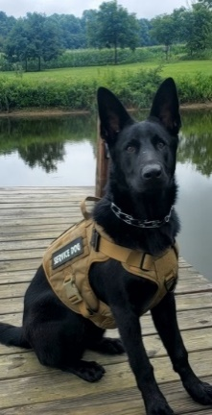
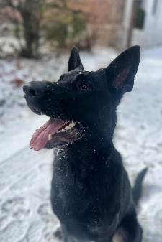
Closest Pin, Closest to the Line

SPONSORSHIP OPPORTUNITIES
$100 Hole Sponsor
$500 Beverage Cart (2)
$500 Dinner Sponsor (2)
$1,000 Silver Sponsor (5)

All proceeds go to helping our Heroes with a service dog, service dog training, and/or outdoor adventures. HWA helped seven of our Heroes with Service Dogs and Training along with 7 Elk hunts and 2 Antelope hunts in 2023. For more information, please contact heroeswildlifeadventures@yahoo.com or call 317-294-6230

