WNYSORC 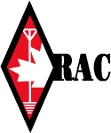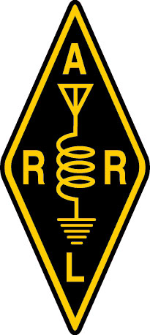
Western New York - Southern Ontario Repeater Council http://www.wnysorc.net
W.N.Y.S.O.R.C. W.N.Y.S.O.R.C.
P.O. Box 123 Post Office Box 93074,
Athol Springs, NY 14010-0123 Newmarket, ON L3Y 8K3

From: Western New York Southern Ontario Repeater Council
To: Members of WNYSORC, Repeater Trustees, and other interested parties
We would like to invite you to attend the next meeting of WNYSORC
to be held at the Erie County Division of Fire Safety,
Department of Emergency Services, Training & Operations Center,
3359 Broadway Avenue in Cheektowaga, New York 14227.
on Sunday, April 19, 2020 at 11:30 am. (see website at www.wnysorc.net
and click on "Next Meeting" link for a detailed map)

Talk-in will use WB2ECR (linked) on 146.865 with +600 KHz and 443.525 MHz
with +5 MHz offset. Both repeaters use a PL of 151.4 Hz.
A coordination form should be submitted annually for each repeater
that you are the trustee for.
If you have not filed a coordination form in the last twelve months
then please take the time to do so.
The coordination form, as well as the agenda for the upcoming meeting,
can be found on the WNYSORC website at www.wnysorc.net
This information is vital for us to properly coordinate other repeaters,
either co-channel or adjacent, as well as submitting information to the
adjacent Repeater Councils.
Please be sure to include your latest, most used, email address so that
we can send information to you via the Internet. This will help cut the costs
of regular mail significantly.
We have noticed many email addresses that we have on our list are no longer active.
I am looking forward to seeing everyone at the meeting.
Joe Tedesco KC2DKP
WNYSORC Secretary / Treasurer
wnysorc_sec@verizon.net

