The Arts Centre

1 Hasler’s Lane

Great Dunmow. Essex

CM6 1XS

Tel: 01371 878020

KIDS@ROMTHEATREARTS.CO.UK

ROM THEATRE ARTS – BABY BALLET AND ISTD APPLICATION FORM & GUIDELINES

|  |
| --- |
|  |
|  |

TODAYS DATE:

PARENT / GUARDIANS NAME:

1.

Personal

details

CHILDS First Name:

CHILDS Last Name:

|  |
| --- |
|  |
|  |
|  |

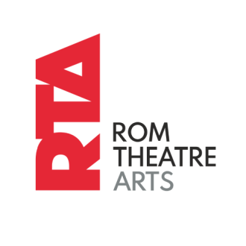Address:

|  |
| --- |
|  |

Postcode:

|  |  |  |  |  |
| --- | --- | --- | --- | --- |
|  | | Mobile No: |  | |
|  |  | | |  |
|  | | |
|  | | |

Home

Telephone No:

E-mail address:

Date of Birth:

Age:

IF YOU DO NOT WANT PICTURES OR VIDEO OF YOUR CHILD TO BE USED FOR

MARKETING PLEASE TICK HERE



Class and costs:

|  |  |  |  |  |  |
| --- | --- | --- | --- | --- | --- |
| Day/Days |  | Class name | Times |  | Cost |
|  |  |  |  | £ |  |
| Total Termly Fee |  |  | To Pay (Month/Date): |  |  |
| Payments to RTA are as Follows: | |  |  |  |  |

All fees are due on the 1st of each calendar month at the beginning of the term. We are closed for 2 weeks at Easter, 4 Weeks in Summer and 2 weeks at Christmas. Please see above for the total of your termly fee. Please pay your termly fee and joining fee if required, via your bank using the following details:

Barclays, Account Name: ROM Theatre Arts School, Account Number: 23902447 Sort code: 20-19-97 Reference: Childs Full Name/Class Name

A one off £10 joining fee is charged for all new students.

Terms & conditions must be accepted by all students and parents/guardians.

1. Fees are payable each term on the 1st of the 1st month in full.
2. A student may take a class on a free taster basis for 1 week. Should the student decide to join the class, the monthly balance is then payable for the weeks remaining.
3. Termly fees must be received during the 1st week of officially joining the class, after the taster session. A 10% surcharge will be added if payment is late. Your child’s space will be suspended if the fee is unpaid by the 3rd week of joining. You will be notified by email to advise you if the fee is outstanding, as we hope to avoid a suspension to your child’s class.
4. There are no refunds if a student is absent from a class and no reductions for part term attendance.
5. On the rare occasion that a class is cancelled, it will be rescheduled, usually during the school holidays.
6. If it is necessary to cancel a class due to adverse weather conditions class fees will not be refunded.
7. The preferred method of payment for regular tuition fees is via bank transfer. Please email: kids@romtheatrearts.co.uk for your child’s correct monthly amount if unknown. When tuition ceases, Standing Orders should be cancelled by the payee one month AFTER the student ceases to attend. It is the payer's responsibility to cancel the Standing Order. Refunds will not be issued if the payer fails to cancel the Standing Order. RTA details can be found on the bottom of all invoices.
8. We prefer that any other invoices, e.g. examination fees, costumes etc. are paid either by bank transfer/cash. You will be advised at the time of being notified of the fees due, how to pay in these instances. Please ensure that you quote the child's surname and invoice number in the reference. Our bank details are quoted at the bottom of all invoices.
9. All monies paid in cash or by cheque must be received in a sealed envelope with the student’s full name, amount enclosed and invoice number or reason for payment, clearly written on the front. If a tear off slip is provided it must be enclosed within the envelope.

1. If monies are paid by cheque the students full name must be written on the reverse of the cheque.

1. In the event that cheques have to be represented to the bank or are declined totally the student/students' parents must pay the costs incurred.

Section 2 - Uniform

1. Class uniforms are as described in the uniform list - Uniform Details. Class uniforms are mandatory after a student's first half term of attendance.
2. All students must wear their hair in a bun for all ballet classes with fringes clipped out of their face. Students with short hair should wear an 'Alice' band to keep their hair off their face for all other classes hair must be tied in a ponytail.

1. If a student is wearing inappropriate footwear or clothing the student will not be permitted to participate in the class.
2. Jewellery items (including watches), which the teacher feels may cause injury or feels inappropriate for the class must be removed or the student will not be permitted to participate in the class.

# Section 3 - Class Timing

1. Classes may run back-to-back on the timetable without a break. Students should be dressed ready to start their class before entering the studio and leave promptly at the end.
2. Students are asked to wait quietly outside the studio until their class begins.

# Section 4 – Conduct

1. Parents are not permitted to watch classes except in exceptional circumstances at the discretion of the class teacher.
2. Students are expected to demonstrate respectful behaviour towards their teacher and fellow students.
3. Students are not permitted to chew gum whilst in class.
4. Students are responsible for their own property and bring items at their own risk.
5. Students are not permitted to use mobile phones during a class. Any mobile phones brought into the class must be switched off or on silent mode.
6. Students are not permitted to leave the studio during a class without permission from the teacher.
7. Students are not permitted to sit out of a class unless they become unwell or injured during the lesson or written consent from the student's parent/guardian is given in advance.

# Section 5 – Miscellaneous

1. Invoices and other materials are presented online via email. Parents/Guardians should provide a valid email ad- dress for this purpose and ensure that such email from RTA is not considered SPAM. If promotion material from RTA is not welcome, Parent or Guardian should ask for removal from the RTA distribution lists.
2. The school timetable may be revised at any time.
3. A certain amount of risk is carried by any physical activity. Students taking part in any classes or events run by Rom Theatre Arts do so at their own risk.
4. Photographs and videos of students may be taken and used for promotion and on social media.
5. All costumes must be paid for in advance. Costumes will be individually invoiced.

# UNIFORM

Please see uniform list to purchase.

Rom Theatre Arts requires all students to wear dance attire for a dance classes, so tutors can check that your child is undertaking the right movement and is not going to injure themselves.

# KEEP IN TOUCH

Email – hello@rtakids.co.uk

Phone: 01371 878020/07720 651485

Please ask to join our What’s App group to keep up to date with all things RTA.

Facebook - Rom Theatre Arts kids

Instagram - @romtheatreartskids

Twitter - @romtheatreartskids

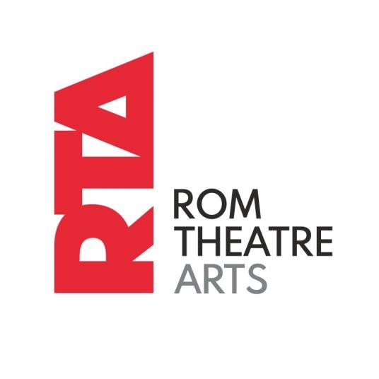

|  |  |
| --- | --- |
| I agree to abide by the Rom Theatre Arts Terms and Conditions | Signed by Parent/Guardian |
| Date: |  |

# OFFICE ONLY

|  |  |  |  |  |  |  |
| --- | --- | --- | --- | --- | --- | --- |
| Childs Nam | e | Class/Classes | | | Date class joined | |
|  |  |  | | |  | |
|  |  |  | | |  | |
|  |  |  | | |  | |
|  |  |  | | |  | |
|  |  |  | | |  | |
|  |  |  | | |  | |
|  |  |  | | |  | |
|  |  |  | | |  | |
|  |  |  | | |  | |
|  |  |  | | |  | |
| Taster Day | Admin fee | paid | | 1st Termly Fee received | | Alternative  Arrangement |
|  |  |  | |  | |  |
|  |  |  | |  | |  |
| Date of TD | Note |  | | Group | |  |
|  |  |  | |  | |  |
| Date: |  |  | Signed by Office Staff: | | | |
|  |  |  |  | | | |