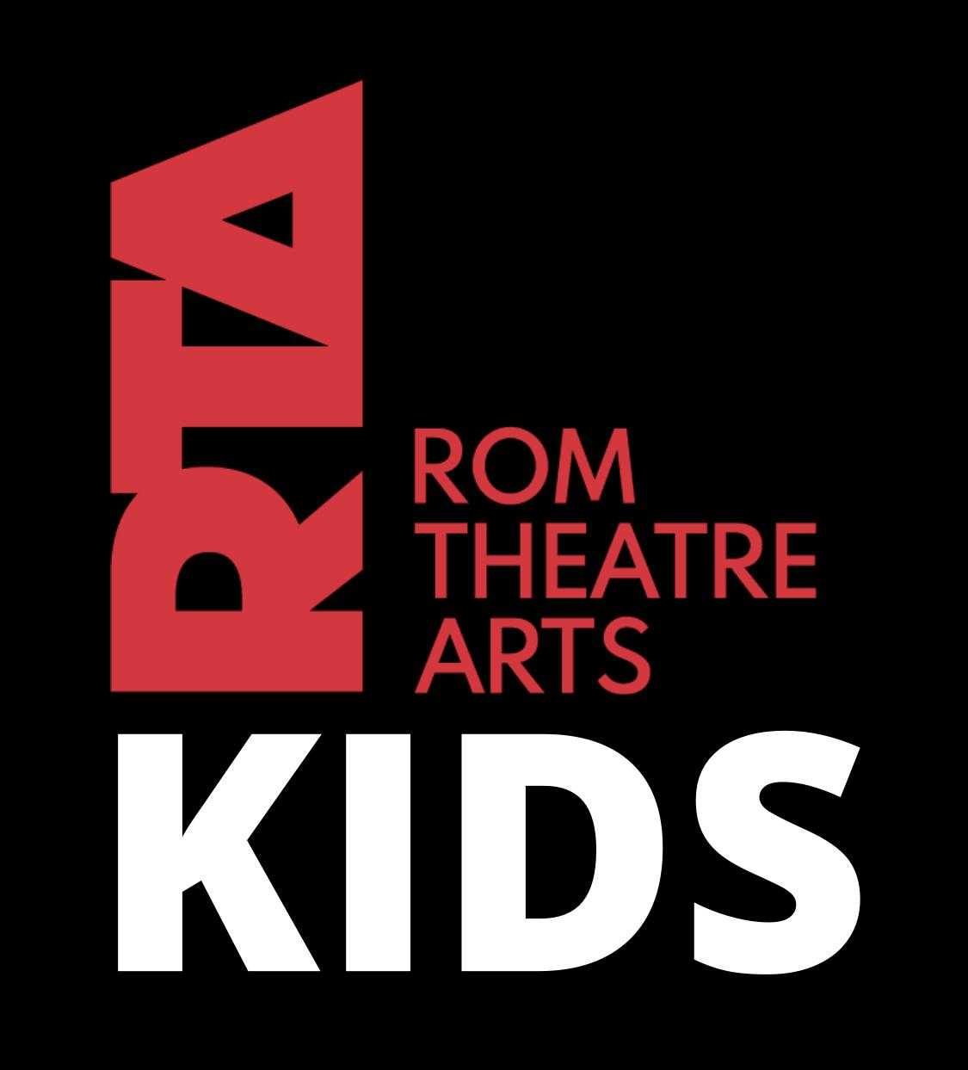RTA Kids – Terms & Conditions

Last updated: 10 April 2025

# **1. Acceptance of Terms**

These Terms & Conditions apply to all students enrolled in classes at Rom Theatre Arts (RTA Kids), and must be accepted by parents or legal guardians of students under the age of 18. By enrolling a child in classes, you agree to adhere to the policies outlined herein.

# **2. Fees, Payments & Withdrawal**

2.1 Fees are due on the 1st of each calendar month via direct debit or standing order.  
  
 2.2 Fees not received by the last calendar day of the month will incur a 10% late payment fee.  
  
 2.3 A free trial class may be offered for one week. If the student wishes to continue, a direct debit must be set up for the 1st of the following calendar month.  
  
 2.4 There are no refunds for student absences or part-term attendance.  
  
 2.5 Where a class is cancelled, a make-up session will typically be scheduled during school holidays.  
  
 2.6 In the event of a class cancellation due to adverse weather or force majeure, no refunds will be issued.  
  
 2.7 A minimum of 4 weeks’ written notice to hello@rtakids.co.uk is required to withdraw a student. It is the responsibility of the  
 payer to cancel the standing order or direct debit. Refunds will not be given if payment continues due to non-cancellation.  
  
 2.8 Examination fees, costumes, and other invoices must be paid separately, preferably by bank transfer or cash, using the student’s full name as reference.  
  
 2.9 Cash or cheque payments must be submitted in a sealed envelope clearly marked with the student’s name, the amount enclosed, and the invoice number. Cheques must have the student’s name on the reverse.  
  
 2.10 Any fees arising from declined cheques must be reimbursed by the parent or guardian.

# **3. Timetable**

3.1 Classes may run back-to-back. Students must arrive dressed and ready to begin promptly.  
  
 3.2 The timetable may be revised at any time.  
  
 3.3 Students must wait quietly outside the studio until their class begins.  
  
 3.4 During show rehearsals, classes may be scheduled by routine rather than regular groups.  
  
 3.5 Training groups may be combined at times to facilitate rehearsal or instructional needs.

# **4. Uniform & Costumes**

4.1 Class uniform, as described on the RTA Kids uniform list, is mandatory after 4 weeks of attendance.  
  
 4.2 Ballet students must wear their hair in a bun with fringes clipped back. Short hair must be secured with a band. Other classes require hair tied in a ponytail.  
  
 4.3 Students wearing inappropriate clothing or footwear will not be permitted to participate.  
  
 4.4 Jewellery, including watches, must be removed if deemed unsafe or inappropriate by the teacher.  
  
 4.5 Costume fees must be paid in full in advance. Each costume will be invoiced separately.

# **5. Conduct & Studio Rules**

5.1 Parents/guardians are not permitted to watch classes unless authorised by the teacher in exceptional circumstances.  
  
 5.2 Students must behave respectfully towards staff and peers.  
  
 5.3 Chewing gum is not permitted in class.  
  
 5.4 Students are responsible for their own belongings, which are brought at their own risk.  
  
 5.5 Mobile phones must be turned off or silenced during class and used only with permission.  
  
 5.6 Students may not leave the studio during class without teacher approval.  
  
 5.7 Students may only sit out of class if unwell, injured, or with written parental permission.  
  
 5.8 Participation in physical activity involves inherent risks. Attendance at classes is voluntary and at the student’s/guardian’s own risk.  
  
 5.9 All RTA Kids staff hold enhanced DBS checks. Our child safeguarding procedures are in line with national guidance and available upon request.

# **6. Marketing, Media & Communications**

6.1 Parents/guardians must provide a valid email address and mobile number for WhatsApp and school communications.  
  
 6.2 Photographs and videos may be taken during classes and events for use in promotional materials and on social media. Parents must email hello@rtakids.co.uk if they do not consent to their child’s image being used.  
  
 6.3 RTA Kids will never identify students by full name in promotional materials. Consent may be withdrawn at any time.

# **7. Data Protection & Privacy**

7.1 RTA Kids collects, stores, and processes data in accordance with its Data Protection & GDPR Compliance Policy. This includes emergency contact details, medical information, and safeguarding records.  
  
 7.2 Personal data will only be shared when legally required or necessary for safeguarding, medical treatment, or authorised educational purposes.  
  
 7.3 The full policy is available upon request or can be accessed via RTA Kids administration.

# **8. Agreement & Updates**

By enrolling a student in RTA Kids, parents and guardians agree to these Terms & Conditions. RTA Kids reserves the right to update or amend this document at any time. Notice will be given via email or WhatsApp when changes are made.