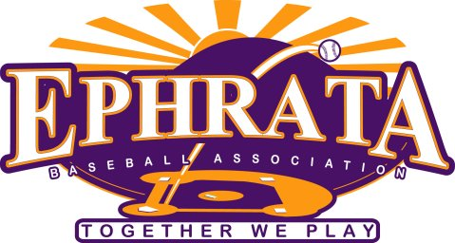
Ephrata 10U Section one Spring Tournament

Dates: April 21st and April 22nd.
Tournament Director: Ted Simes, email contact tsimes@lentzmilling.com Cell number: 717-824-6025
Location: Clay Township Fields #2 & #3, 230 Clay School Rd, Ephrata, PA
Format: Pool Play with participating teams for seeding, single elimination playoffs. 3 Game guarantee. 8 team cap.
Rules: No Inning will start after 1hour 45-minute time limit.
LCYBL Rules Apply.
Teams will receive 3 points for win, 1 point for tie, and 0 points for a defeat.
Home team for pool play will be determined by coin flip.
Home team for the Championship Game will be the team with the most points, head to head, or least amount of runs allowed in the pool play rounds.
The Championship Game will have no time limit.
There will be one paid umpire for pool play and two umpires for Championship game.
Cost: $250 per team
Awards: Awards will be presented to 1st and 2nd place teams.
Please contact Ted Simes for entry information or questions.

