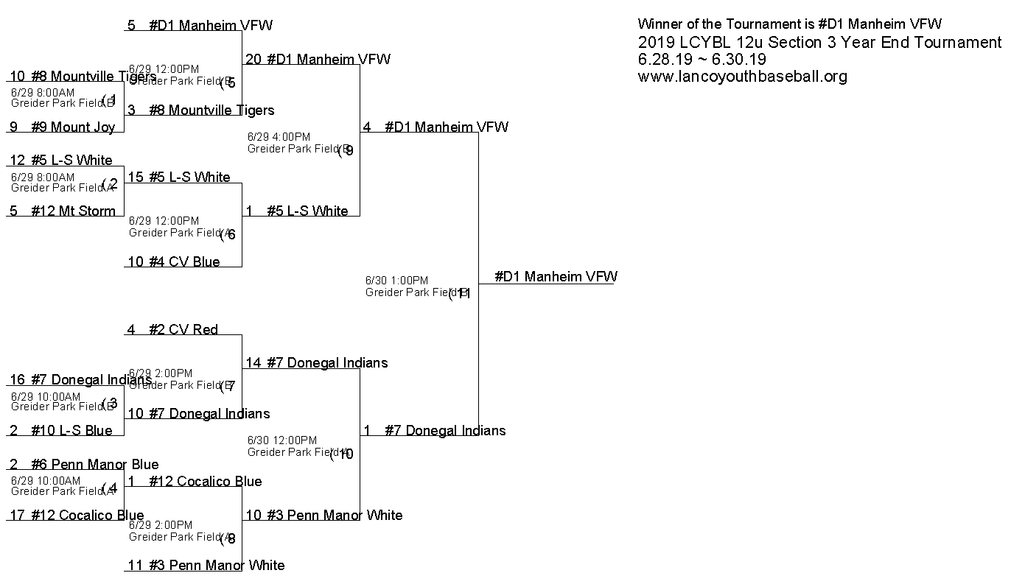
Game | Facility | Date | Time | Team | SCR | Team | SCR | Winner Goes | Loser Goes
1 | Greider Park Field B | Sat Jun 29 | 8:00AM | #9 Mount Joy | 9 | #8 Mountville Tigers | 10 | 5 | Done
2 | Greider Park Field A | Sat Jun 29 | 8:00AM | #12 Mt Storm | 5 | #5 L-S White | 12 | 6 | Done
3 | Greider Park Field B | Sat Jun 29 | 10:00AM | #10 L-S Blue | 2 | #7 Donegal Indians | 16 | 7 | Done
4 | Greider Park Field A | Sat Jun 29 | 10:00AM | #12 Cocalico Blue | 17 | #6 Penn Manor Blue | 2 | 8 | Done
5 | Greider Park Field B | Sat Jun 29 | 12:00PM | #8 Mountville Tigers | 3 | #D1 Manheim VFW | 5 | 9 | Done
6 | Greider Park Field A | Sat Jun 29 | 12:00PM | #4 CV Blue | 10 | #5 L-S White | 15 | 9 | Done
7 | Greider Park Field B | Sat Jun 29 | 2:00PM | #7 Donegal Indians | 10 | #2 CV Red | 4 | 10 | Done
8 | Greider Park Field A | Sat Jun 29 | 2:00PM | #3 Penn Manor White | 11 | #12 Cocalico Blue | 1 | 10 | Done
9 | Greider Park Field B | Sat Jun 29 | 4:00PM | #5 L-S White | 1 | #D1 Manheim VFW | 20 | 11 | Done
10 | Greider Park Field A | Sun Jun 30 | 12:00PM | #3 Penn Manor White | 10 | #7 Donegal Indians | 14 | 11 | Done
11 | Greider Park Field B | Sun Jun 30 | 1:00PM | #7 Donegal Indians | 1 | #D1 Manheim VFW | 4 | 11 | Done

