2022 Penryn 14U-1 Spring Classic Tournament

Date: April 9-10, 2022
Registration Deadline: March 15

Tournament Director: Kevin Connelly - 14U1 MC Lions Coach
Kevinc22@ptd.net
717-587-7966
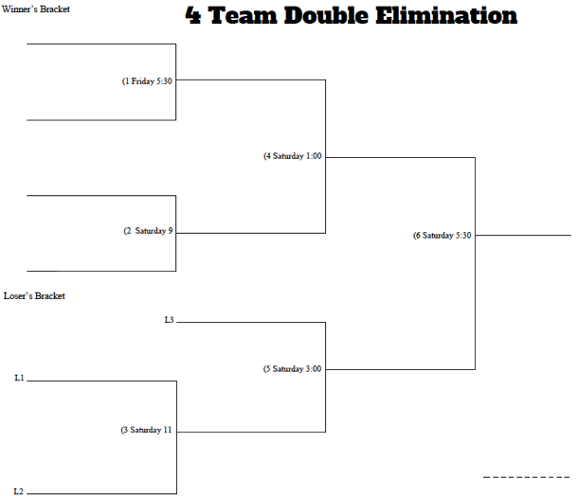
Location: All games will be played at Penryn field located behind Elm Ridge Construction (Newport Road). This is the field our 14u teams play at during league play. The field address is 1280 Meadow Road.
Format: 4 Team, Double Elimination 2-day Tournament. Final game is between the winner bracket finalist and loser bracket finalist.

Rules: Friday game: No inning will begin after 2 hours. Saturday games: No inning will begin after 1 hour 45-minute time limit. The Championship Game will not have a time limit.
14u Section 1 rules apply from LCYBL.
Additional game play rules will be distributed to registered teams.
Any rule changes will be communicated to all teams prior to April 9.
Cost: $400 per team.
Schedule: 1 Game Friday, April 9 at 5:30 pm. Saturday game times are 9, 11, 1:00, 3:00 and 5:30.
Awards: Single team trophy to first and second place teams.
Concessions: No planned concessions available (subject to change).

